Software Requirements Specification
for
Automated Collection and Check for Students’ Assignments (Project ACCSA)
Version 1.1 approved
Prepared by Romain Ducarrouge
University College Dublin
02/08/16
Table of Contents
Table of Contents ii
Revision History ii
1. Introduction 1
1.1 Purpose 1
1.2 Document Conventions 1
1.3 Intended Audience and Reading Suggestions 1
1.4 Project Scope 1
1.5 References 2
2. Overall Description 2
2.1 Product Perspective 2
2.2 Product Functions 2
2.3 User Classes and Characteristics 3
2.4 Operating Environment 3
2.5 Design and Implementation Constraints 3
2.6 User Documentation 3
2.7 Assumptions and Dependencies 4
3. External Interface Requirements 4
3.1 User Interfaces 4
3.2 Communications Interfaces 4
4. System Features 5
4.1 User Features for Students 5
4.2 User Features for Teachers 5
Appendix A: Workflow 7
Appendix B: Inserting or Updating Grades Error! Bookmark not defined.

Revision History
Name | Date | Reason For Changes | Version
Romain Ducarrouge | 02/15/16 | Missing ACCSA Flow Chart and code snippets | 1.0

Introduction

Purpose
This document is intended as a specification of the web-based application used to automate assignment collections and grading; Project ACCSA. The current collection and correction process for student’s programming assignment is long, tedious and handled manually. This projects aims to automate some of these tasks in order to increase efficiency for the correction of homework and improve teachers’ time management. This document is the Software Requirement Specification (SRS) for the Web Based Automated Collection and Check for Students’ Assignments (A.C.C.S.A.). This document is follows the IEEE conventions for software requirement specification.

Document Conventions
The objective of the platform created is to enable students to easily upload their source code projects (homework) and provide an automated compiler in order to check the correctness of the code submitted as well as allow text file uploads.
The application is currently in development so all the requirements stated here are not satisfied. The document will be updated continuously as more features get added to the software in order to keep this documentation relevant.

Intended Audience and Reading Suggestions
ACCSA is developed to help universities to improve the workflow of teachers, but will be used mostly by students and teachers, and it is key to address the end user to explain technicalities of the application. This document is intended for:
- developers,
- testers (teachers),
- Users (students and teachers) of various universities.
This documentation includes details regarding the workflow of the solution as well as its main technical requirements and various features. This document is intended as an overview of the system and not a final user manual. For additional details on the software please refer to the User Manual document on our home website.

Project Scope
The software will deliver a cloud based solution for automatically collecting students’ homework upload, based on various file format for different coding, programming languages including “.txt” as well as cloning branches from students’ GitHub accounts. The application’s Graphical User Interface currently has the main features intended for the solution to work properly in various operating environment. The benefits of the solution will enhance the workload capacity for correcting the code and maximize time efficiency and accuracy of grades.

References
This SRS refers to several external sources in order to understand the solution integration with underlying hardware and end-user software performances. These various sources are listed below as follows;

Information about underlying hardware supporting our Software as a Service (SaaS):
https://aws.amazon.com/codepipeline/
by Amazon PipeLine
Information about University Platform’s API for integration of the grading submission from ACCSA:
https://docs.moodle.org/dev/Web_services_API
by Moodle, version 3.0
https://docs.moodle.org/dev/Core_APIs
by Moodle, version 3.0
https://docs.moodle.org/dev/Gradebook_API
by Moodle, version 3.0

Overall Description

Product Perspective
The ACCSA project is a solution created to answer the need to improve the workflow for teachers collecting and grading programming assignments from students. Unlike other subjects, the grading for coding assignments can easily be achieved online by compiling the code and comparing results with correct answers. This removes the human from the equation and ensures a high workload capacity, a higher turnover and efficiency for both the students who get their grades earlier and for the teachers who does not need to constantly look for submissions online. This also provides a higher level of accuracy in the final grading of the homework being uploaded. It will be a solution that will be a standalone software, hosted on the cloud in order to ensure availability to users. The decision to host it on the cloud also reduces the initial investment cost as no specific hardware purchase is required and allows to focus all efforts on developing a robust and flexible Software as a Service for our end users. The company in charge of the hosting is Amazon Web Services which was chosen for its cost efficiency, reliability (in term of very low down time) and for flexibility in case of demand change from our platform or increasing hardware demand from our customers.

Product Functions
The project allows multiple clients to have sessions open in order to upload simultaneous assignments of their respective homework. The upload is handles upload of links to GitHub accounts as well as various file formats. The user session is protected by a user login and password. Once upload or fetch of file successful, the program format is compared to the answer file format. The file is then compiled to compare answers in order to grade submission efficiently.
- File upload
- File format check
  - Eventual file format modification
- Compiling Code
- Comparing Results
- Generating Grade
- Generating one single output file with all grades
- Upload file to Moodle Platform

User Classes and Characteristics
The main class of users for the platform will be the students who will need to upload their files or enter the URL link to their GitHub file location for the platform to fetch the file(s). This is our main user class as we expect several students to access the solution at various times and possibly simultaneously. This process will be ongoing and create a high interaction between students and our platform. Each student session security and privileges is allowed through a login and password access.
The second class of user will be the teachers. Indeed, we expect to have fewer teacher users than students. The teachers able to upload several files for each assignment as the basis for correction and students’ work comparison. The files’ format is not limited; the solution handles various programming languages as well as text files (provided that the language used in all is English). The teacher’s session has more privileges than the students. They can also login and make modifications to assignments, deadlines, timetables and grades in order to provide flexibility which is required in certain situations. The teachers may also decide to manually go over each individual grade or automate the process.

Operating Environment
The final project will integrate with Moodle’s learning platform and will be subject to the same integration requirements for various Operating Systems. Moodle integrates with the following operating environments:
- Mac OS X and previous versions,
- Windows 10 and previous versions
- Linux.
The solution will also be available for mobile access in order to increase user accessibility and usability. The objective of making the platform accessible from all operating systems and platform is to ensure students may always access the platform no matter what device is used to upload the files, URL or even access the site to make changes.

Design and Implementation Constraints
One key component of the design will be the allowed input formats to work with. In order to compile the code, the system will first check the file format. If the format is able to be run as code the program will run. If the solution uploaded by the student is a text file format, then the system will have to generate a copy of the correct solution in text file and then compare both files in order to
It is important that the output generated by our solution implements with Moodle’s API in order to transfer the relevant data, grades. The file will be formatted as a Comma Separated Value file (.csv) which can be uploaded in Moodle. The requirement for the grade file is that it includes the student ID, the student’s grade and assignment ID in order to integrate properly.
In terms of technology, the cloud hosting will require the use of HTTP protocols for both logging into the application as well as uploading the final grade file to the external final platform, Moodle. Amazon’s Relational Database Service (RDS) provides scalable database to ensure the application can extend to more users once testing period finalized. The application is developed using the Go Lang programming language, chosen for it quick compile time and emphasis on concurrency which ultimately offer better performances overall.

User Documentation
When accessing the cloudware, the user will have the option to browse or download the User Manual which contains a detailed overview of the working processes and features of the application. The User Manual is available in PDF and TXT format in order to suit all operating environments.
Aside from this document, an online step-by-step tutorial guide will be available online after the user logs into the application. Finally, a series of promotional and educational videos will be release on YouTube in order to offer a free preview of the system to prospecting customers.

Assumptions and Dependencies
Using the services from Amazon Web Services, we rely on their own hardware and are subject to the possible [minimal] down-time of their infrastructure. Using this cloud approach enables more safety features for the application as that will ensure database replication in order to keep the data safe and in different locations. Hosting the solution on the cloud means it relies on a robust and powerful underlying network allowing best performances possible for maximizing the throughput in a minimum response time while allowing a multitude of students connected simultaneously. The decision to use a third party platform to host our application also allows for more flexibility in terms of scaling later on.

External Interface Requirements

User Interfaces
The application’s user interface with be standardized in the majority of its design and functionalities with some customization for each universities and classes. The design of the application is simple and all functionalities are accessible from the profile page. The user will have access to a drop-down menu offering access to different classes taken by the student in the active window. Once the class selected a new window is opened reflecting each previous and current assignment submissions. It offers two separated options followed by an optional comment section for particular situations:
- input of a hyperlink to the GitHub repository or branch to clone
- a file upload section for the student to upload the file
The top navigation bar (menu) allows quick navigation between elements of the system, includes links to useful internal and external tutorials as well as offer a section for contacting the application’s developers team.
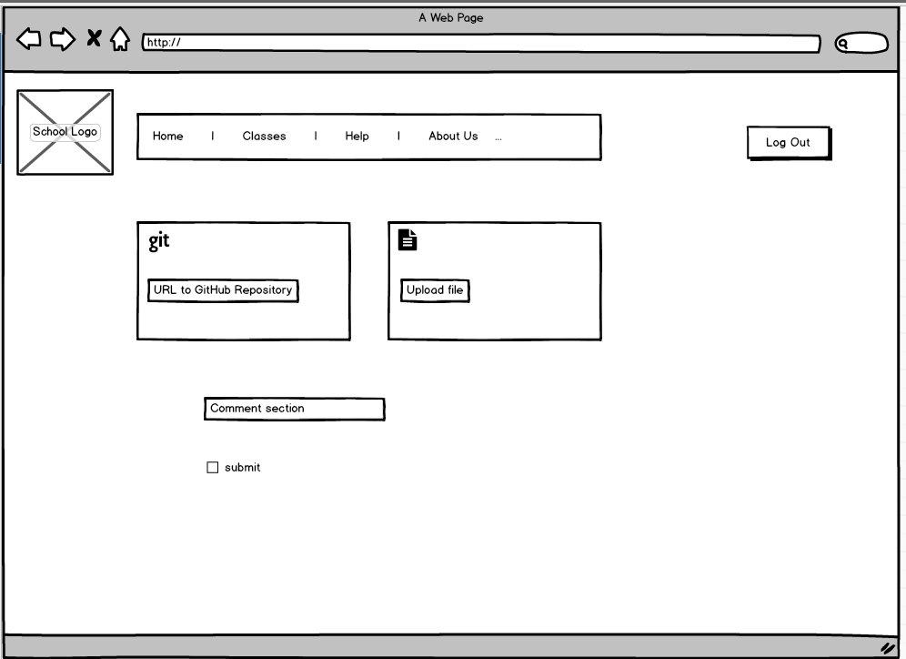
The interface is developed to be responsive and provide the same user experience across various devices

Communications Interfaces
The communication interfaces include the HTTP protocol in order for the user to get access to the application. It also includes email notifications, such as communications in order to retrieve forgotten user ID or user passwords, as well as notification email confirming a submission was successful. These communications are independent of the communication between the students and their respective universities.

System Features

User Features for Students
The students have access to the home section of the web-application, then submission page, the tutorial section and the “About Us” section in order to contact the team in case of malfunctions. The students are able to set email reminders based on each assignment based on the due date. They may also choose to receive confirmation emails once a file is successfully submitted.
The main two features present in the application for the students are the possibility to paste a link to a GitHub repository that the application will fetch and compile. The other possibilities for the students is to directly upload their file(s) using the submission part. Once the file is acquired in the application, it is compiled and compared to the teachers file(s) in order to assess the work and provide a grade.

User Features for Teachers
The teachers’ sessions have more privileges in the system. They can create slots for new assignments ahead of time or on ongoing basis. They can modify deadlines and allow upload of one or several links/files based on their requirements.
Another useful feature for teachers is that they can allow other users (teachers or teachers’ assistant) specific access to their session in order to address eventual situation arising. The flexibility of the application allows the teachers to plan better. This feature is set by the teacher through the user interface allowing access to part of the teacher’s features.
Appendix A: Workflow
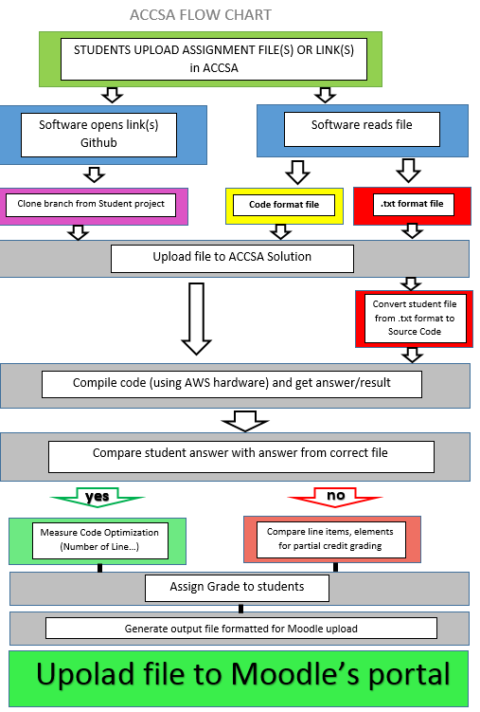
Appendix B: Inserting or Updating Grades
This is the forum activity module's implementation of this callback taken from /mod/forum/lib.php. Note that Moodle scales are stored as a positive integer if they are numeric, as a negative integer if they are a custom scale and 0 means the forum is ungraded (this system may be changed by MDL-17258).
function forum_grade_item_update($forum, $grades=NULL) {
global $CFG;
if (!function_exists('grade_update')) { //workaround for buggy PHP versions
require_once($CFG->libdir.'/gradelib.php');
}
$params = array('itemname'=>$forum->name, 'idnumber'=>$forum->cmidnumber);
if (!$forum->assessed or $forum->scale == 0) {
$params['gradetype'] = GRADE_TYPE_NONE;
} else if ($forum->scale > 0) {
$params['gradetype'] = GRADE_TYPE_VALUE;
$params['grademax'] = $forum->scale;
$params['grademin'] = 0;
} else if ($forum->scale < 0) {
$params['gradetype'] = GRADE_TYPE_SCALE;
$params['scaleid'] = -$forum->scale;
}
if ($grades === 'reset') {
$params['reset'] = true;
$grades = NULL;
}
return grade_update('mod/forum', $forum->course, 'mod', 'forum', $forum->id, 0, $grades, $params);
}
https://docs.moodle.org/dev/Gradebook_API#Inserting_or_Updating_Grades

