**Vmware Lab Basic launch**

After connect of RDP session of Lab, Go to Lab Docs folder.

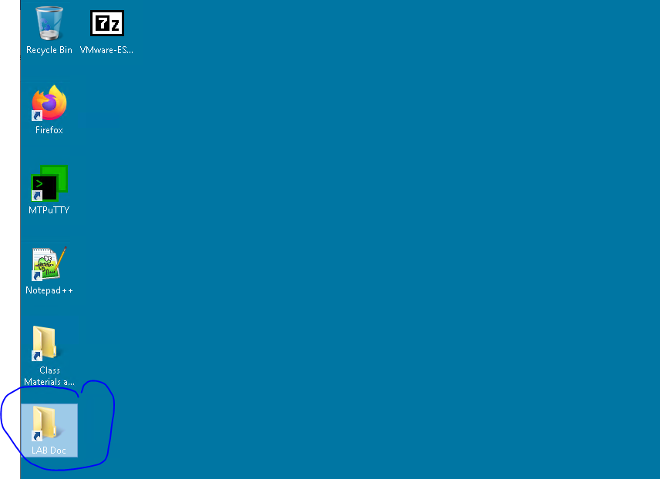

Open the available Lab document for follow the steps of lab practicals.

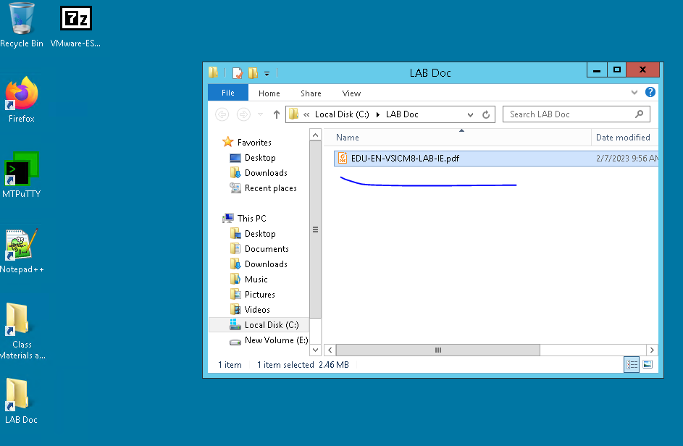

Open Google Chrome and follow the mentioned steps in lab document.

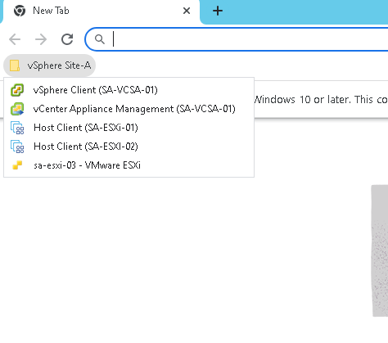

For vCenter access Click on vSphere Client (SA-VCSA-01) from Bookmark. And click on Advanced mentioned in below image

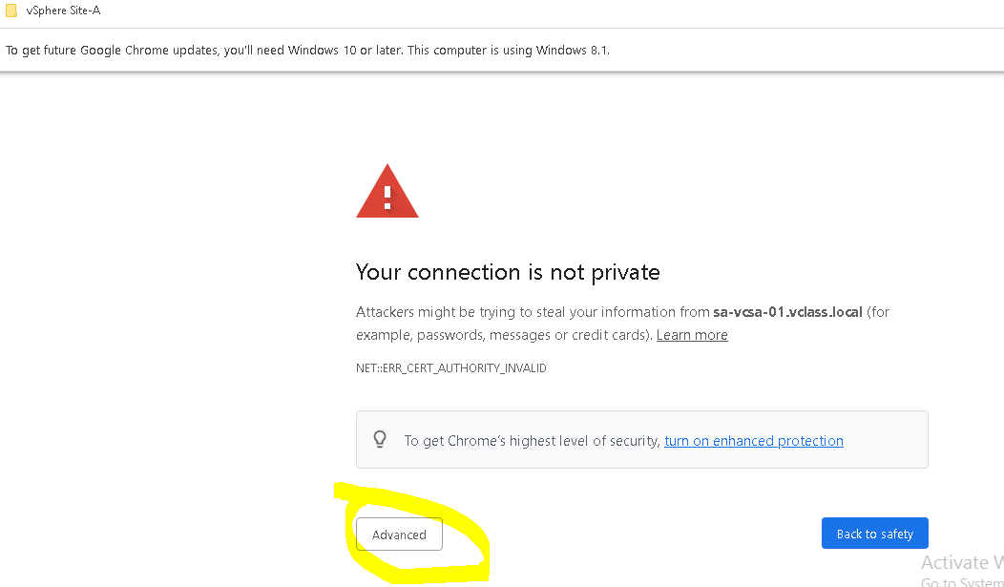

Click on Proceed for vCenter access as mentioned below image:

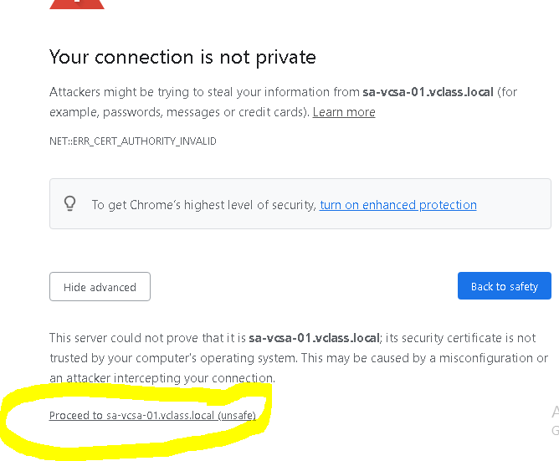

Login with the credential, mentioned in the lab document:

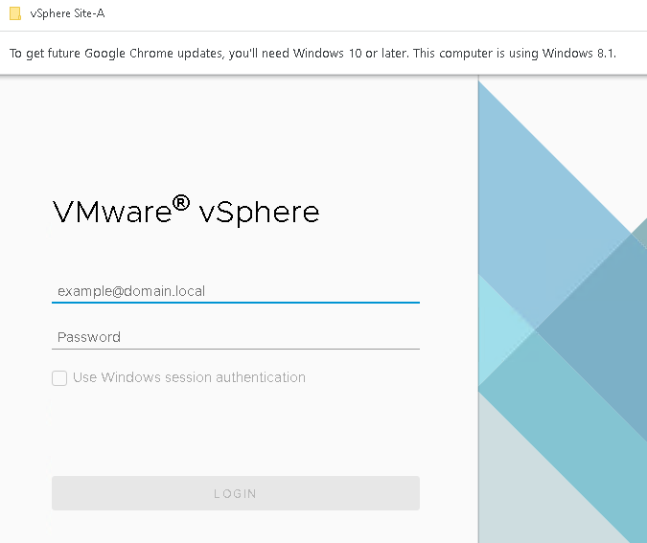

After enter credential, it will be logged in into the vCenter. Further follow the lab guide for all the practicals.

