DAD - Week 1 Tasks

Student ID: 101614415

Student Name: Emilios Kyprianidis

## Task 1.

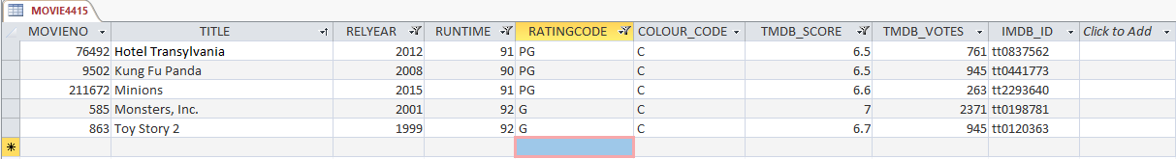

## Task 2

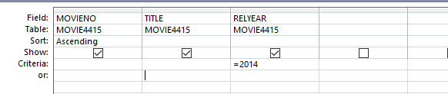

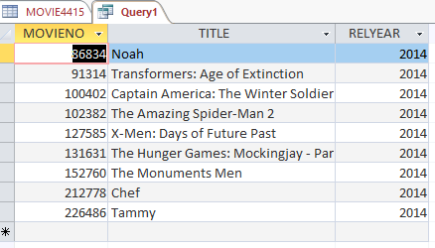

## Task 3

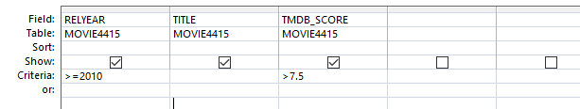

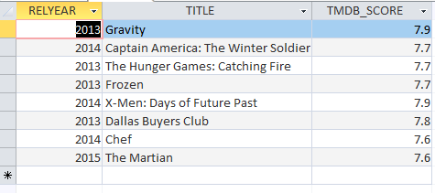

## Task 4

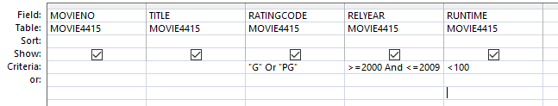

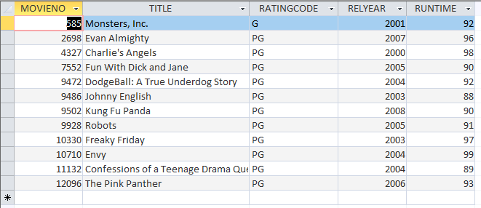

## Task 5

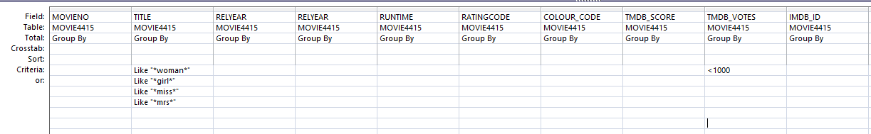

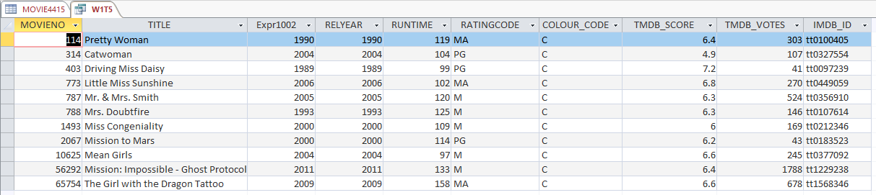

## Task 6

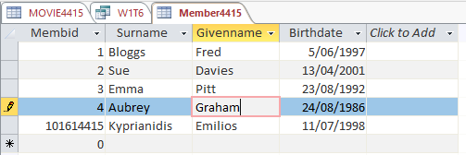

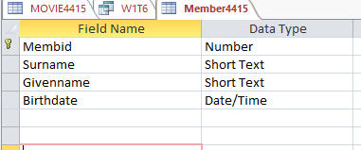

## Task 7

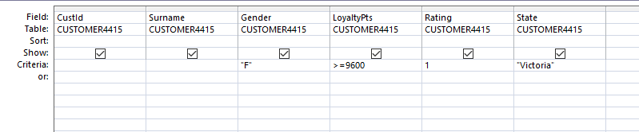

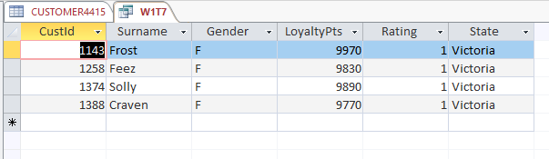

## Task 8

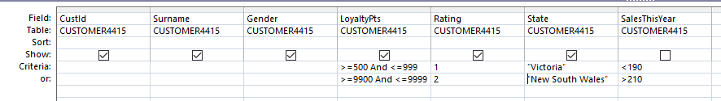

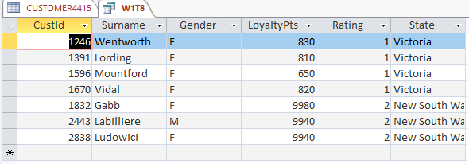

## Task 9

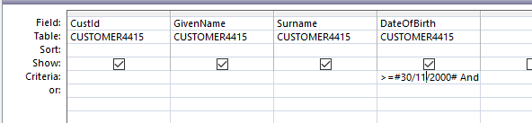

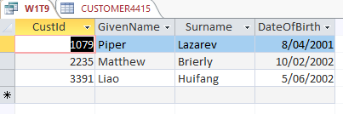

## Task 10

