**(Project 2 – Web Services)**

Software Design Document

Emílio Weba

Farhad Nasimi

Lailson Nogueira

Loyola University of Chicago

COMP 433 – WebServices

09/28/2015

**1. INTRODUCTION**

**1.1 Purpose**

This software design document describes the architecture of the Project 2 implementation of the course COMP 433 – WebServices from Loyola University of Chicago.

**1.2 Scope**

This software consists of two layers. The first layer is the database, where we use MySQL Azure for hosting. The second layer is the persistence layer, where we implemented in Java/Eclipse, using Hibernate.

**2. DIAGRAMS**

**2.1 ER Diagram**

We created ten database tables to complete the first layer. Here is the diagram correlated:

**2.2 Use Case Diagram**

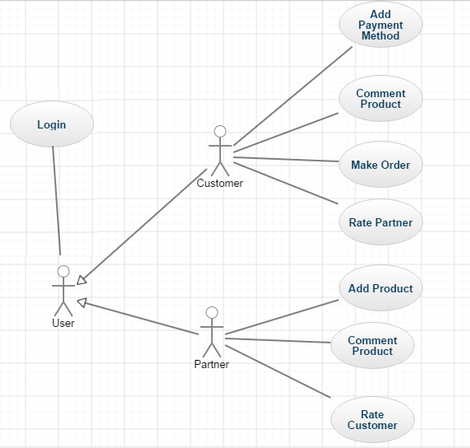

**2.3 Classes**

Below is a list of all classes of our project and the respective attributes and methods.

**2.3.1 Customer Class**

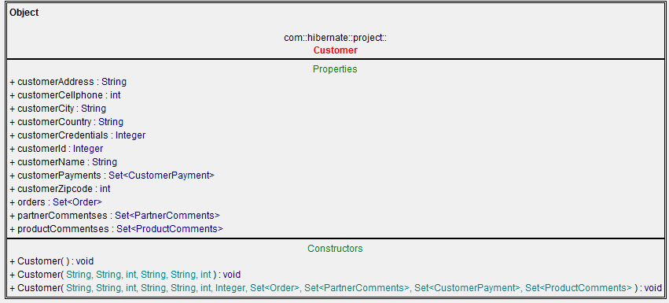

**2.3.2 CustomerPayment Class**

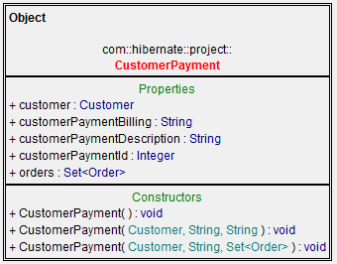

**2.3.3 Order Class**

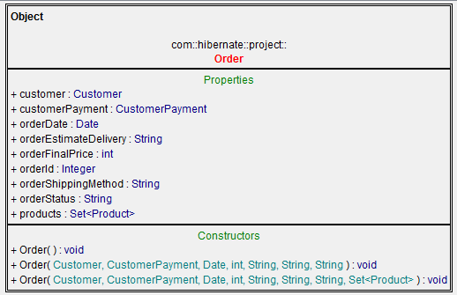

**2.3.4 Partner Class**

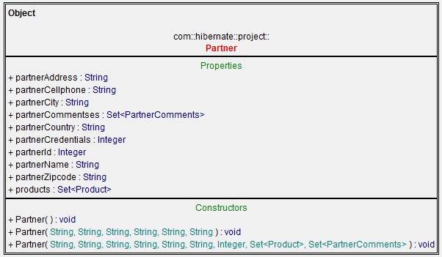

**2.3.5 PartnerComments Class**

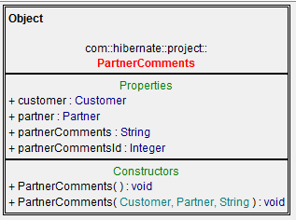

**2.3.6 Product Class**

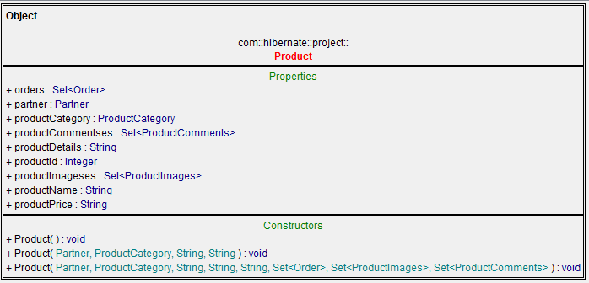

**2.3.7 ProductCategory Class**

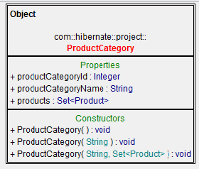

**2.3.8 ProductComments Class**

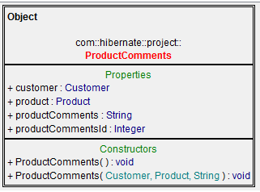

**2.3.9 ProductImages Class**

