### 为美化&统一Code Format，特引入代码格式化工具

###### 教程链接：<https://www.jianshu.com/p/c3f88316876e>

###### 有两点需要注意，与教程所示有所区别：

1. Llvm预编译包，请选择版本LLVM 9.0.0
2. Clang-format, 请按以下步骤配置：
3. 添加使用自定义格式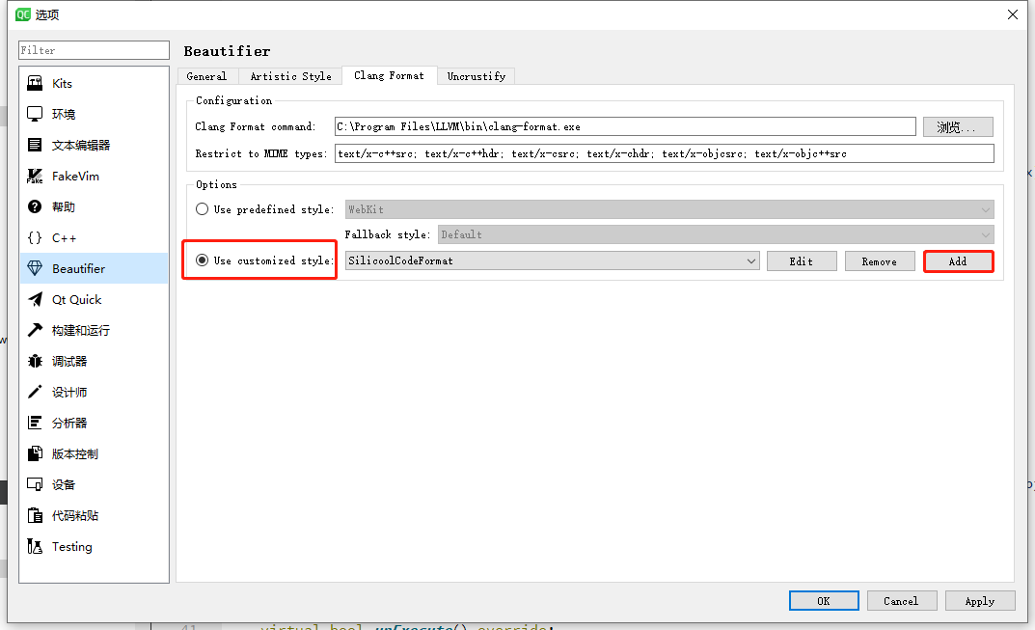
4. Name自由填写。Value中请填入以下内容：

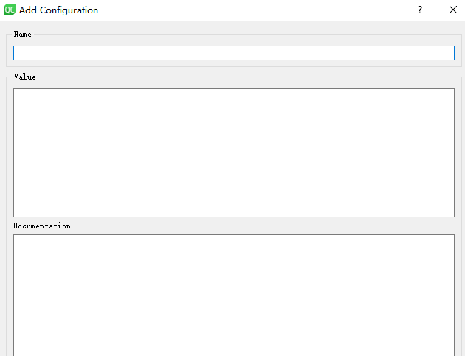

Language: Cpp

AccessModifierOffset: -4

AlignTrailingComments: true

AllowAllParametersOfDeclarationOnNextLine: true

AllowShortFunctionsOnASingleLine: Empty

AllowShortIfStatementsOnASingleLine: false

AllowShortLoopsOnASingleLine: false

AlwaysBreakBeforeMultilineStrings: false

AlwaysBreakTemplateDeclarations: true

BinPackParameters: false

BreakBeforeBinaryOperators: All

BreakBeforeBraces: Allman

BreakBeforeTernaryOperators: true

BreakConstructorInitializersBeforeComma: false

ColumnLimit: 120

CommentPragmas: '^ IWYU pragma:'

ConstructorInitializerAllOnOneLineOrOnePerLine: true

ConstructorInitializerIndentWidth: 4

ContinuationIndentWidth: 4

Cpp11BracedListStyle: false

IndentCaseLabels: true

IndentWidth: 4

MaxEmptyLinesToKeep: 1

NamespaceIndentation: All

ObjCSpaceAfterProperty: true

ObjCSpaceBeforeProtocolList: true

PenaltyBreakBeforeFirstCallParameter: 19

PenaltyBreakComment: 120

PenaltyBreakFirstLessLess: 120

PenaltyBreakString: 120

PenaltyExcessCharacter: 120

PenaltyReturnTypeOnItsOwnLine: 60

SpaceBeforeAssignmentOperators: true

SpaceBeforeParens: ControlStatements

SpaceInEmptyParentheses: false

SpacesBeforeTrailingComments: 4

SpacesInAngles: false

SpacesInContainerLiterals: true

SpacesInCStyleCastParentheses: false

SpacesInParentheses: false

Standard: Cpp11

TabWidth: 4

UseTab: Never

###### 效果展示

格式化前：

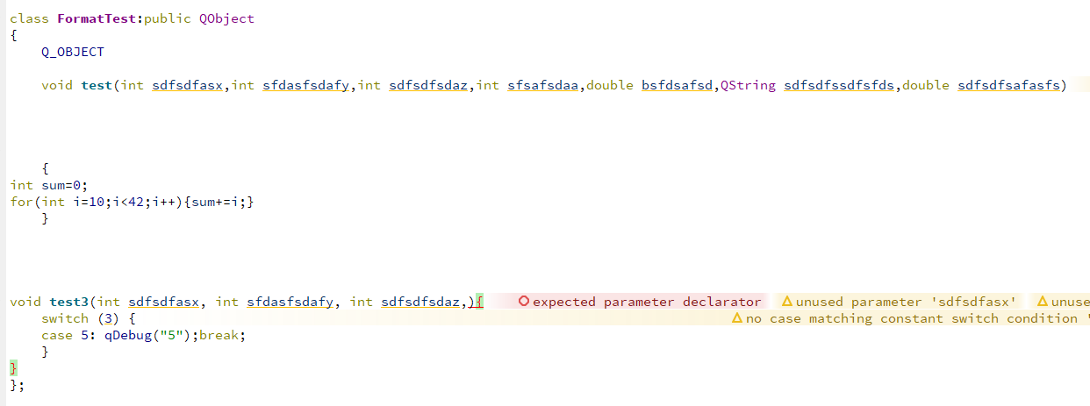

格式化后：

