PhUSE Cloud Server

User Guide for CDTasRDF Project Team

Version 0.1

June 2017

|  |  |  |  |
| --- | --- | --- | --- |
|  |  |  |  |

|  |  |  |  |
| --- | --- | --- | --- |
|  |  |  |  |
|  |  |  |  |

Contents

Introduction 2

Request for Access 2

Server Login 3

1. Working with TortoiseGit 4

1.1 Checkout to your work area 4

1.2 Create a Branch from Master 4

1.3 Merge From a dev branch to Master 5

# Introduction

Instructions in this document are specific to the PhUSE cloud server environment as used by the CTDasRDF project team.

## Request for Access

Send account creation/access requests to [tim.williams@phuse.eu](mailto:tim.williams@phuse.eu). You will receive an email with your username and a temporary password. Follow the instructions in the **Server Login** section. During your initial login you will be asked to change your password.

For any access or configuration problems related to the CTDasRDF project, send an email to: [tim.williams@phuse.eu](mailto:tim.williams@phuse.eu)

For general issues related to the server you may also contact: [hanming.tu@gmail.com](mailto:hanming.tu@gmail.com)

# Server Login

Login to the cloud server using Remote Desktop. Instructions assume Windows OS on your local machine. Mac users must obtain the free application called Microsoft Remote Desktop from the Mac App Store.

1. 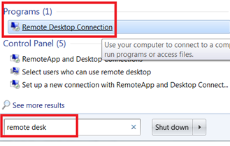In the search box on the taskbar on your laptop, type **remote desk,** then select **Remote Desktop Connection** from the Programs section.﻿
2. 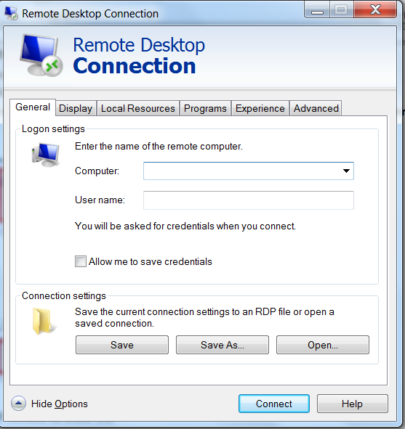Click **Show Options** if needed to show the fields for **Computer:** and **User name:**

You will be provided with an IP Address for the Computer: field. Everyone will use the same User name:

**Computer:** 52.14.114.74

**User name:** <provided by admin>

**Password:** <provided by admin>

1. Click **Connect** after entering the Computer IP address and your username for the session.
2. Enter the password supplied by the instructor and click **OK**.

# Working with TortoiseGit

Obtain a copy of the files in your personal folder.

# Checkout to your work area

Use TortoiseGit to obtain a copy of the project files

1. Open windows explorer to your person folder C:\Users\<your username>
2. Right click and choose Git Clone…

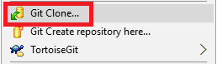

1. In the URL field, enter: <https://github.com/phuse-org/CTDasRDF>. The Directory field will fill in to include the new subfolder ../<usename>/CTDasRDF . Click OK to clone the project into your work area then Close when cloning is complete.

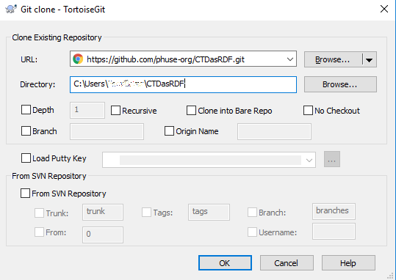

4. You now have a copy of the main (master) line of development. If you wish to make changes and commit them, you should **Create a Branch from Master**.

# Create a Branch from Master

*Assumes master is current in the sandbox.*

1. Right click on the folder /CTDasRDF
2. Choose TortoiseGit | Create Branch
3. In the dialog box enter the name for the new **Branch**. Use a descriptive name for the work you will be performing.
4. Ensure Base on = HEAD(master)
5. Check the box Switch to new branch
6. Enter a Description of what the branch will be used for.
7. Click OK.

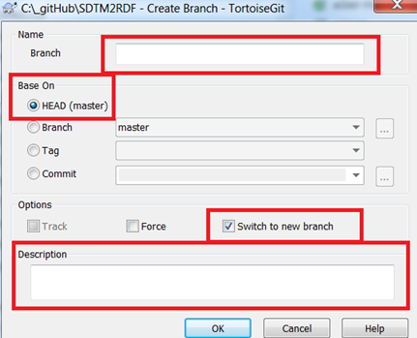

1. Click Close when command finished.
2. Confirm the branch is now in the sandbox:
   1. Right click on the /CTDasRDF and confirm that GitCommit shows the new branch name.
   2. Start coding!
   3. ***Commit*** whenever you have important changes, before you make important changes, etc.
   4. ***PUSH*** when you have working code.
   5. *MERGE to master* *when ready to share your code with the team.*

# Merge From a dev branch to Master

Assumes you are already on a branch, have completed your changes and want to merge your branch into the Master line.

1. Commit and PUSH all work from the branch in your sandbox.
   1. Right click on folder /CTDasRDF, select Git Commit
   2. Add a commit Message in the dialog box.
   3. From the drop down box at the bottom of the window, select Commit/Push
2. Switch to the Master development line in your sandbox:
   1. Right click, TortoiseGit | Switch/Checkout.
   2. Select Branch: "master" and OK.
   3. Right click on folder /CTDasRDF , Select TortoiseGit | Merge
   4. In the From, choose the branch you were working on (the name of your development branch – it may be present by default since you were just working on it prior to the switch to Master)
   5. Add optional Message. Click OK.
   6. Click Close when finished.
3. Push the merge to the repository
   1. Right click on /CTDasRDF, select TortoiseGit | Push
   2. Select from: **master** to: **master**. Click OK.
   3. Click OK, then close when finished.
4. Confirm on github website by opening <https://github.com/phuse-org/CTDasRDF> in a web browser. Confirm you new content is present and/or review the project history (Graphs, Pulse….)
5. **Proceed to** **Create a Branch from Master** **before making any local changes to the code base!**