Subtitle

Study Ontology User Guide

Armando Oliva, M.D.

Semantica LLC

Tim Williams

UCB

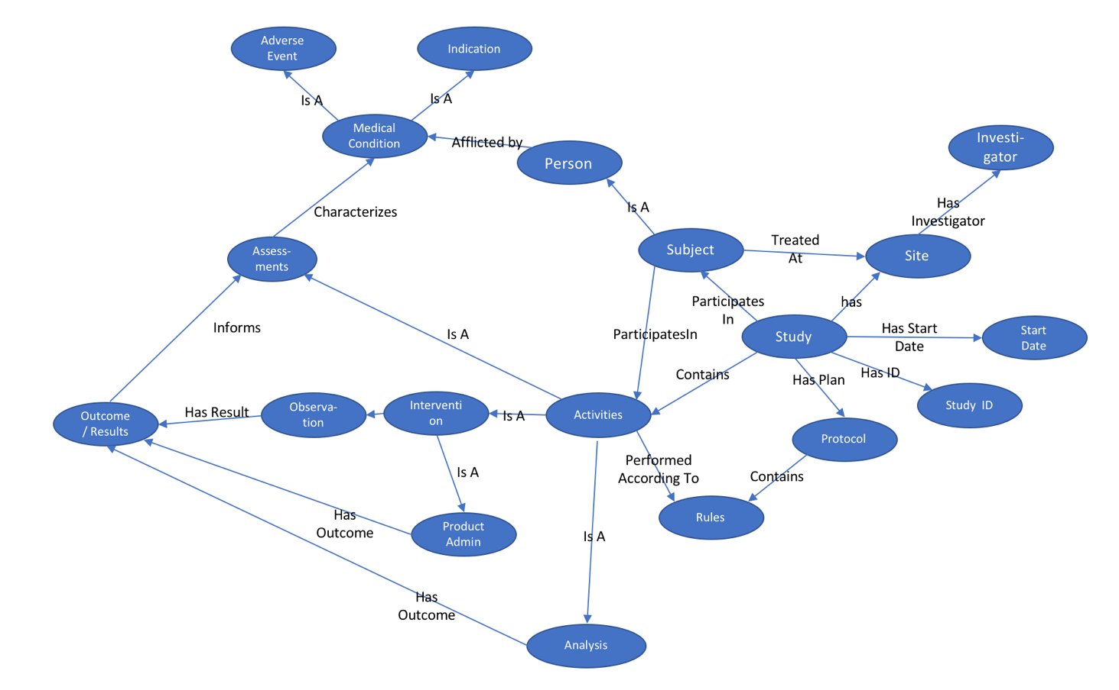

# Introduction

This document provides detailed information on the Study Ontology being developed for the Clinical Trial Data to RDF Project within PhUSE. Because of the narrow scope of that project, the Ontology is appropriately narrow in scope, but can be expanded in an iterative fashion to support future use cases. The classes and properties align with BRIDG and HL7 RIM wherever it makes sense to do so. The Study Ontology is available at GitHub as an RDF/OWL file study.ttl. This is a living document and subject to change at any time. For questions or comments, please contact [aoliva@semanticallc.com](mailto:aoliva@semanticallc.com).

# Study Ontology “Core Classes”

A study is a collection of Activities (e.g. Interventions, Observations, Analyses) performed on Human Study Subjects according to certain protocol-specified Rules. Human Study Subjects often have medical Events (e.g. Medical Conditions, Adverse Events), which are the target of medical Interventions. The Interventions often involve a Medical Product Administration, such as a Drug, These classes form the study ontology “core.” Additional related classes are shown here and explained later in this document.

As much as possible, Aristotelian definitions are used to define a class, e.g. a [subclass] is a [class] with certain [distinguishing features]. For example, a FordCar is a Car that is manufactured by the Ford Motor Company. Similarly, a HumanStudySubject is a Person who participates in any StudyActivity.

Figure 1: Study Ontology "Core Classes"

* Thing
  + StudyComponent
    - StudyActivity
      * Intervention
        + Observation
        + Product Administration
      * Analysis
        + Rule
      * Study
    - Entity
      * Event
        + MedicalCondition

AdverseEvent

* + - * MedicalProduct
      * Party
        + Person

HumanSubject

HumanStudySubject

## Class: Study Activity

Definition: Any activity associated with the planning, conduct, analysis, and interpretation of a Study.

Discussion: This is quite broad so StudyActivity has numerous subclasses. The key properties of a StudyActivity are the following: (i.e. ?property rdfs:domain study:StudyActivity triple exists)

* activityStatus
* derivedFlag
* groupID
* activityInterval
* category
* performer
* startRule
* subActivity
* subCategory
* laterality
* outcome
* reasonNotDone
* sponsorDefinedID

StudyActivities also are the target of certain important relationships…the most important of which is arguably a HumanStudySubject participatesIn a StudyActivity.

The StudyActivity class has three important core subclasses: Intervention, Analysis, and

## Class: Intervention

Subclass of: StudyActivity

Definition: A study activity that involves an interruption to the study subject's normal daily routine for the purpose of observing the subject's physical, psychological, or physiological state, and/or mitigating the effects of a medical condition.