What I used during the this task ”git commands ”
git clone
git add
git commit
git push
git branch
git checkout
git merge
git fetch
git pull

2.Differences between fetch and push
git fetch downloads changes from the remote repository but does not merge them automatically.

git pull downloads the changes and automatically merges them into the current branch.

3. SS from branch
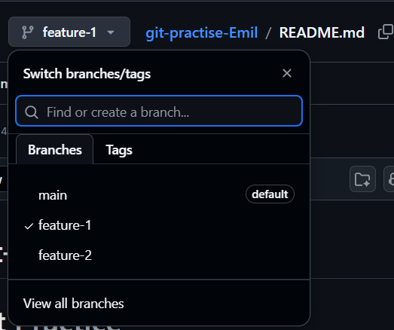
4.Conflict issue
A merge conflict occurred in the README.md file when pulling changes from the remote repository.
Both the local and remote versions had modifications.
The conflict markers (<<<<<<<, =======, >>>>>>>) were removed manually and the correct content was kept.
After that, the conflict was resolved using git add README.md and git commit.

