**Project 2: Proposal**

Since many of us may be interested in the availability of careers in data analytics, our project we will be utilizing Indeed’s API to gather data on Data specialist jobs around the country in order to visualize the hot spots for data jobs. Here is our link to the API: (<https://opensource.indeedeng.io/api-documentation/docs/job-search/#json-example>). In order to help gather an accurate portrayal of the jobs available, we will be using multiple different buzzwords tied to those jobs. We will then clean that data by removing any and all duplicates that may have arisen.

With this data we will create two separate choropleth map layers that will function like a heatmap, where they will be scaled based on the number of jobs in that location. The first one will be a state layer that will be interactive to where you can click on a state and it will zoom into the city layer for that specified state.

State View: City View:

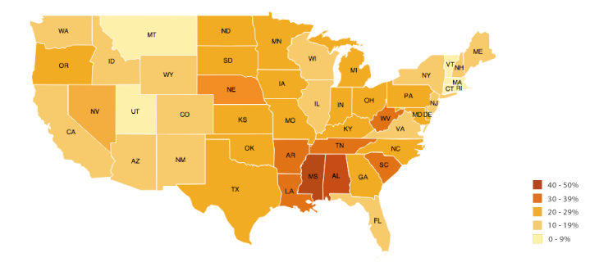 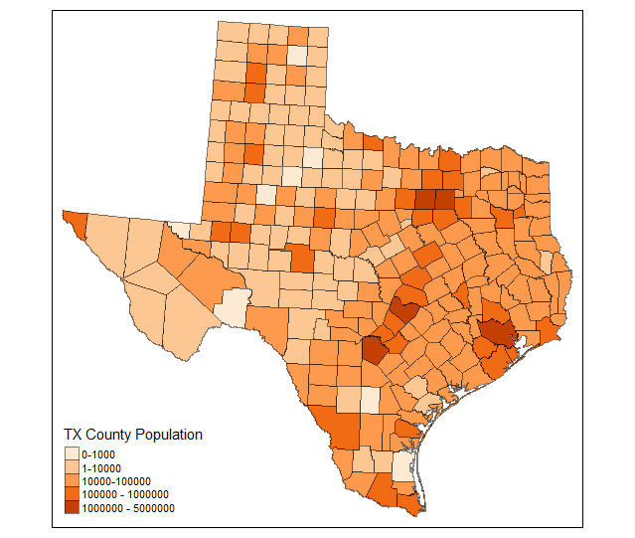

Both layers will have options to click on a respective state/city to have a tooltip show up with a brief breakdown of information (Number of job postings, average of how long jobs have been posted, amount of different job titles, etc.) on the selection, with the ability to click a link in the tooltip to a chart on a separate page for a table with further information on the jobs. This table will be able to be sorted down further based on different criteria that the user can specify (similar to the UFO homework).

We will also have an option to go to a different page where there is a bar graph displaying the 10 states and cities with the most job postings.