A landing page containing:

* An explanation of the project.

* Links to each visualizations page.

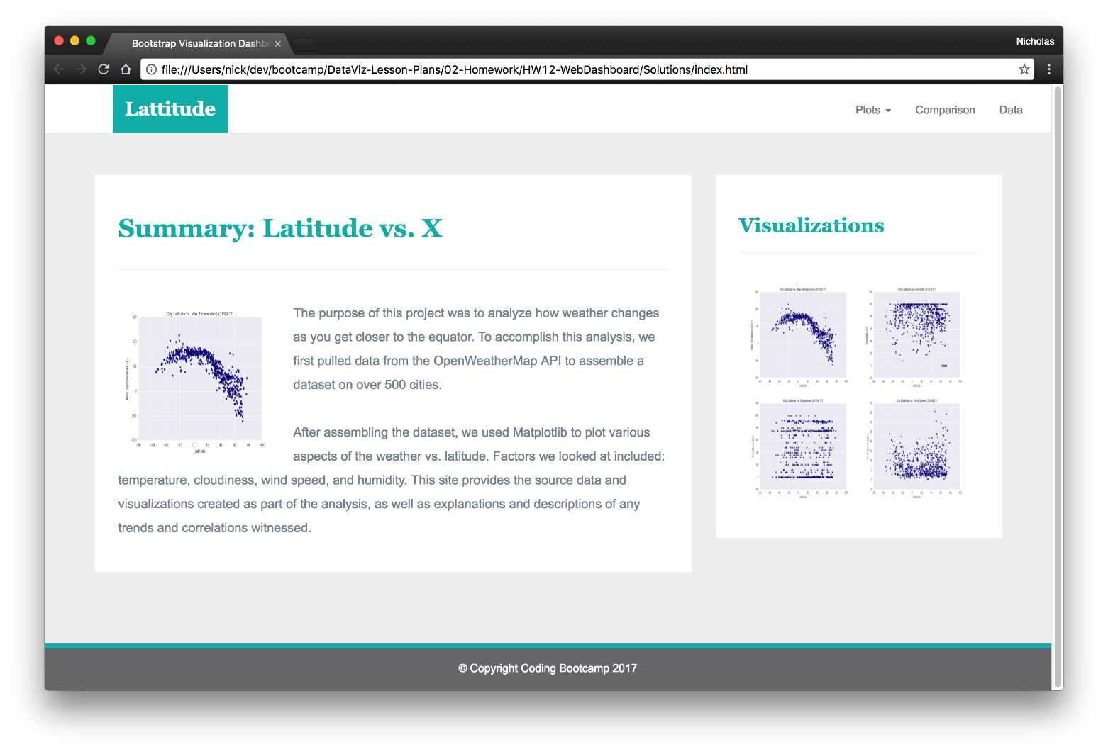

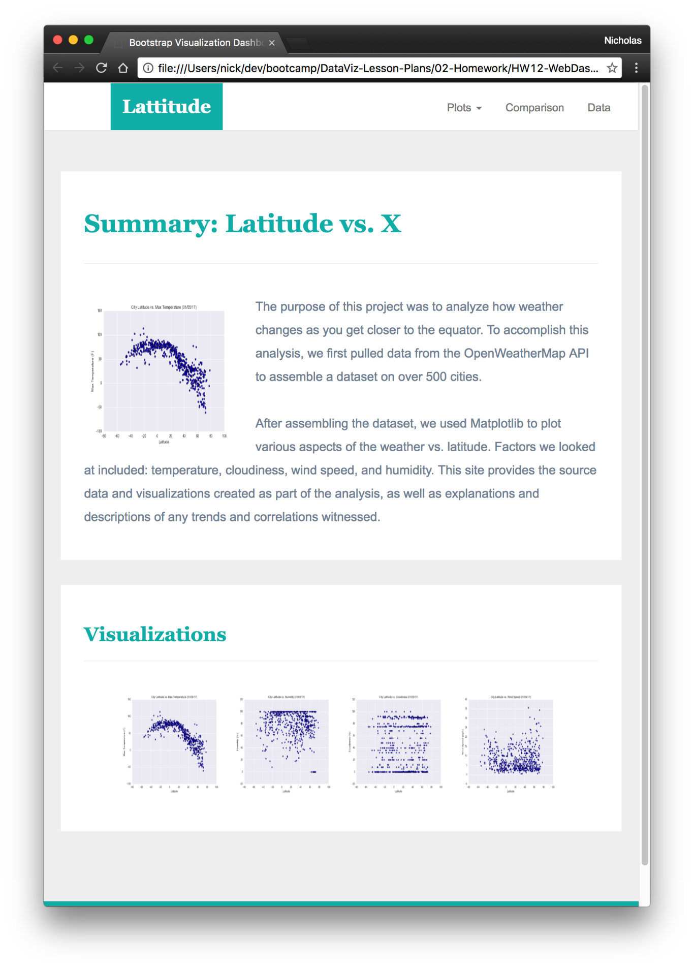

Four visualization pages each with:

* A descriptive title and heading tag.

* The plot/visualization itself for the selected comparison.

* A paragraph describing the plot and its significance.

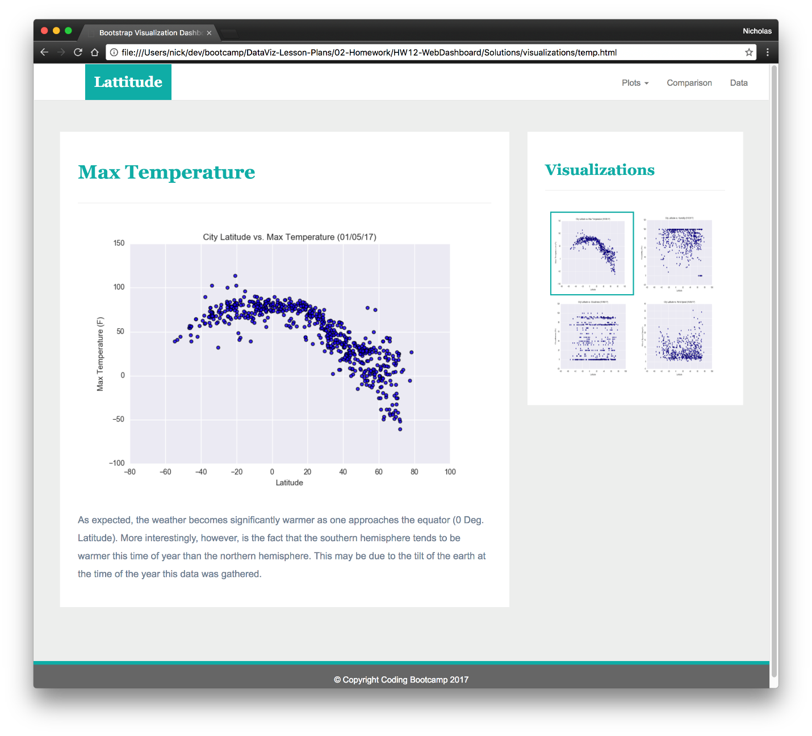

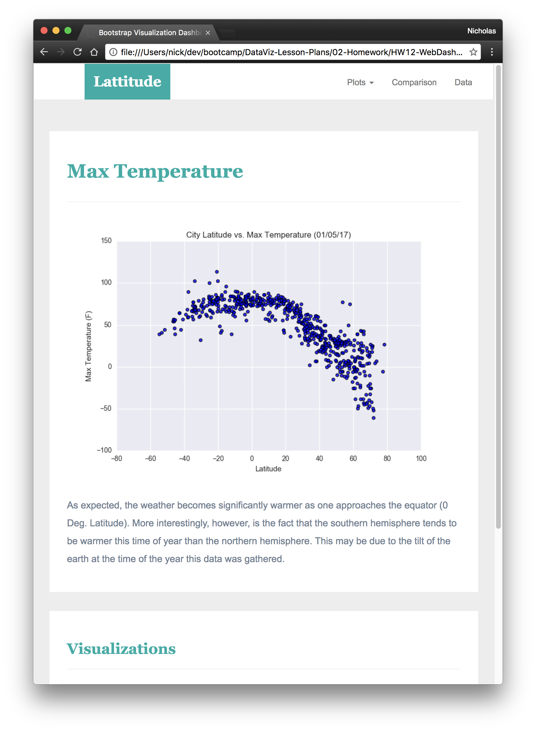A Comparisons page that:

* Contains all of the visualizations on the same page so we can easily visually compare them.

* Uses a bootstrap grid for the visualizations.

* The grid must be two visualizations across on screens medium and larger, and 1 across on extra-small and small screens.

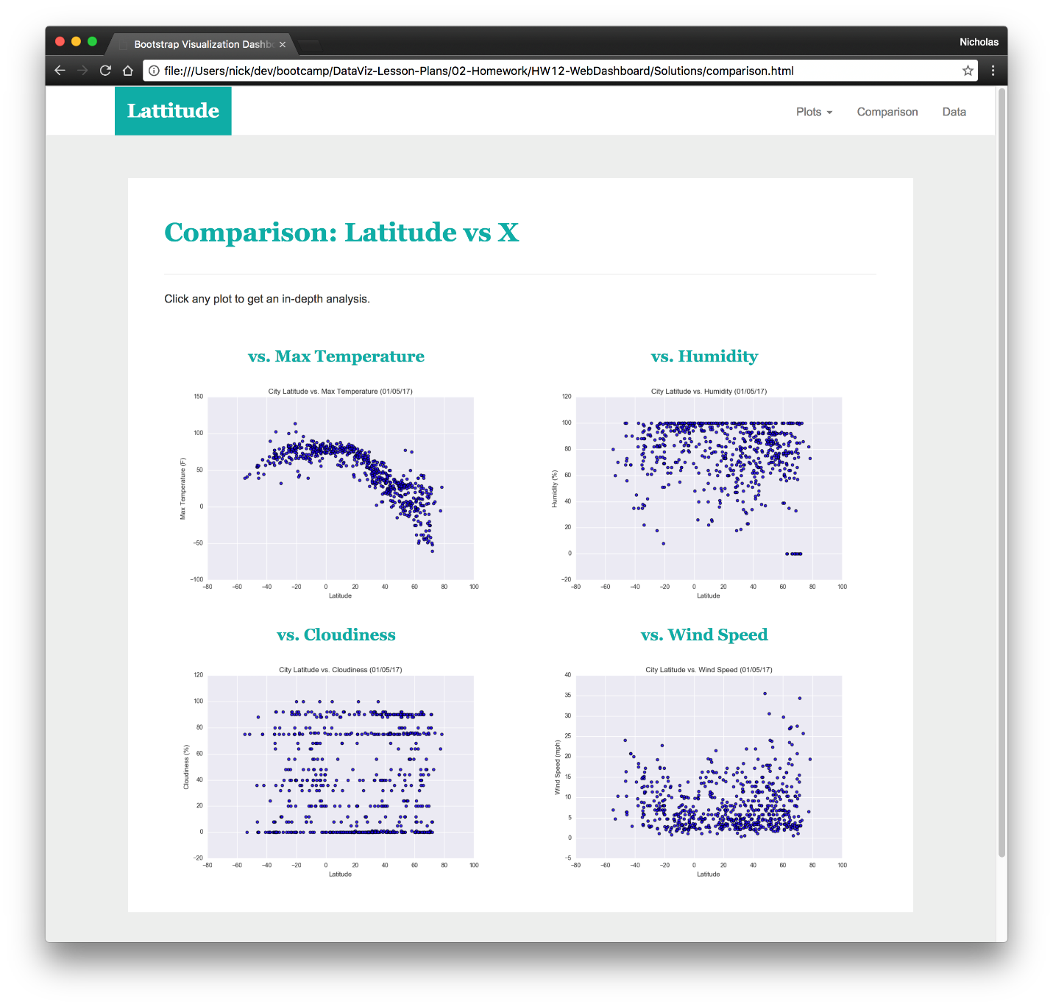

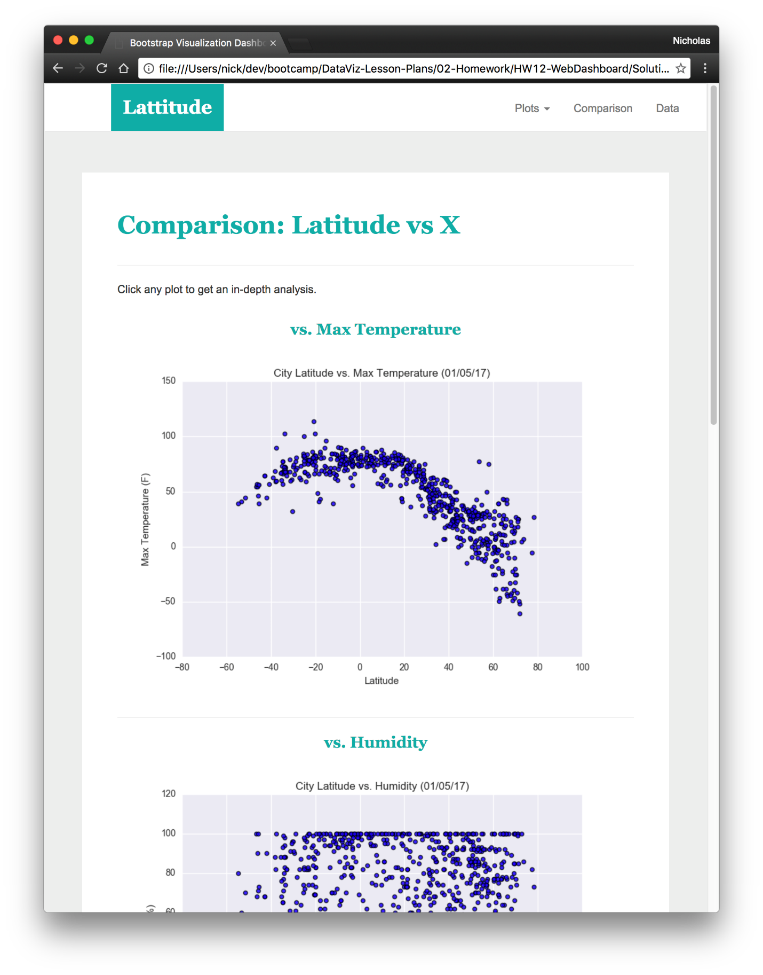

A Data page that:

* Displays a responsive table containing the data used in the visualizations.

* The table must be a bootstrap table component.

* The data must come from exporting the `.csv` file as HTML, or converting it to HTML. You may use a csv-to-html table conversion tool, e.g. [ConvertCSV](<http://www.convertcsv.com/csv-to-html.htm>).

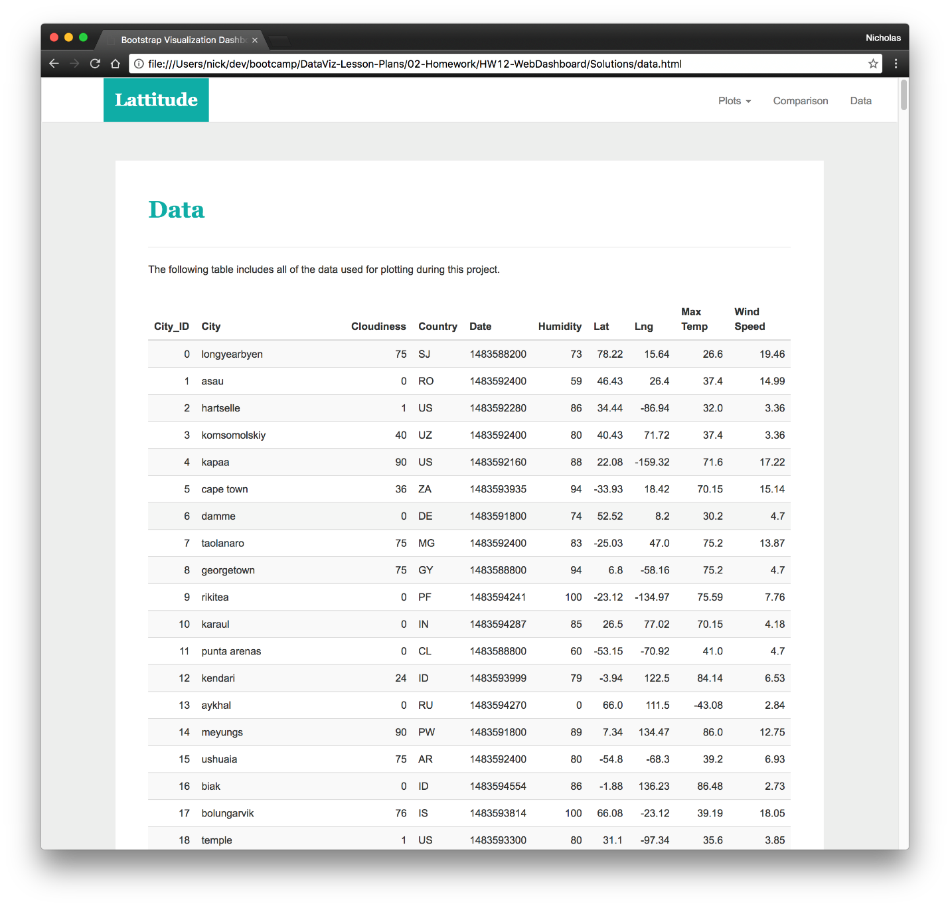

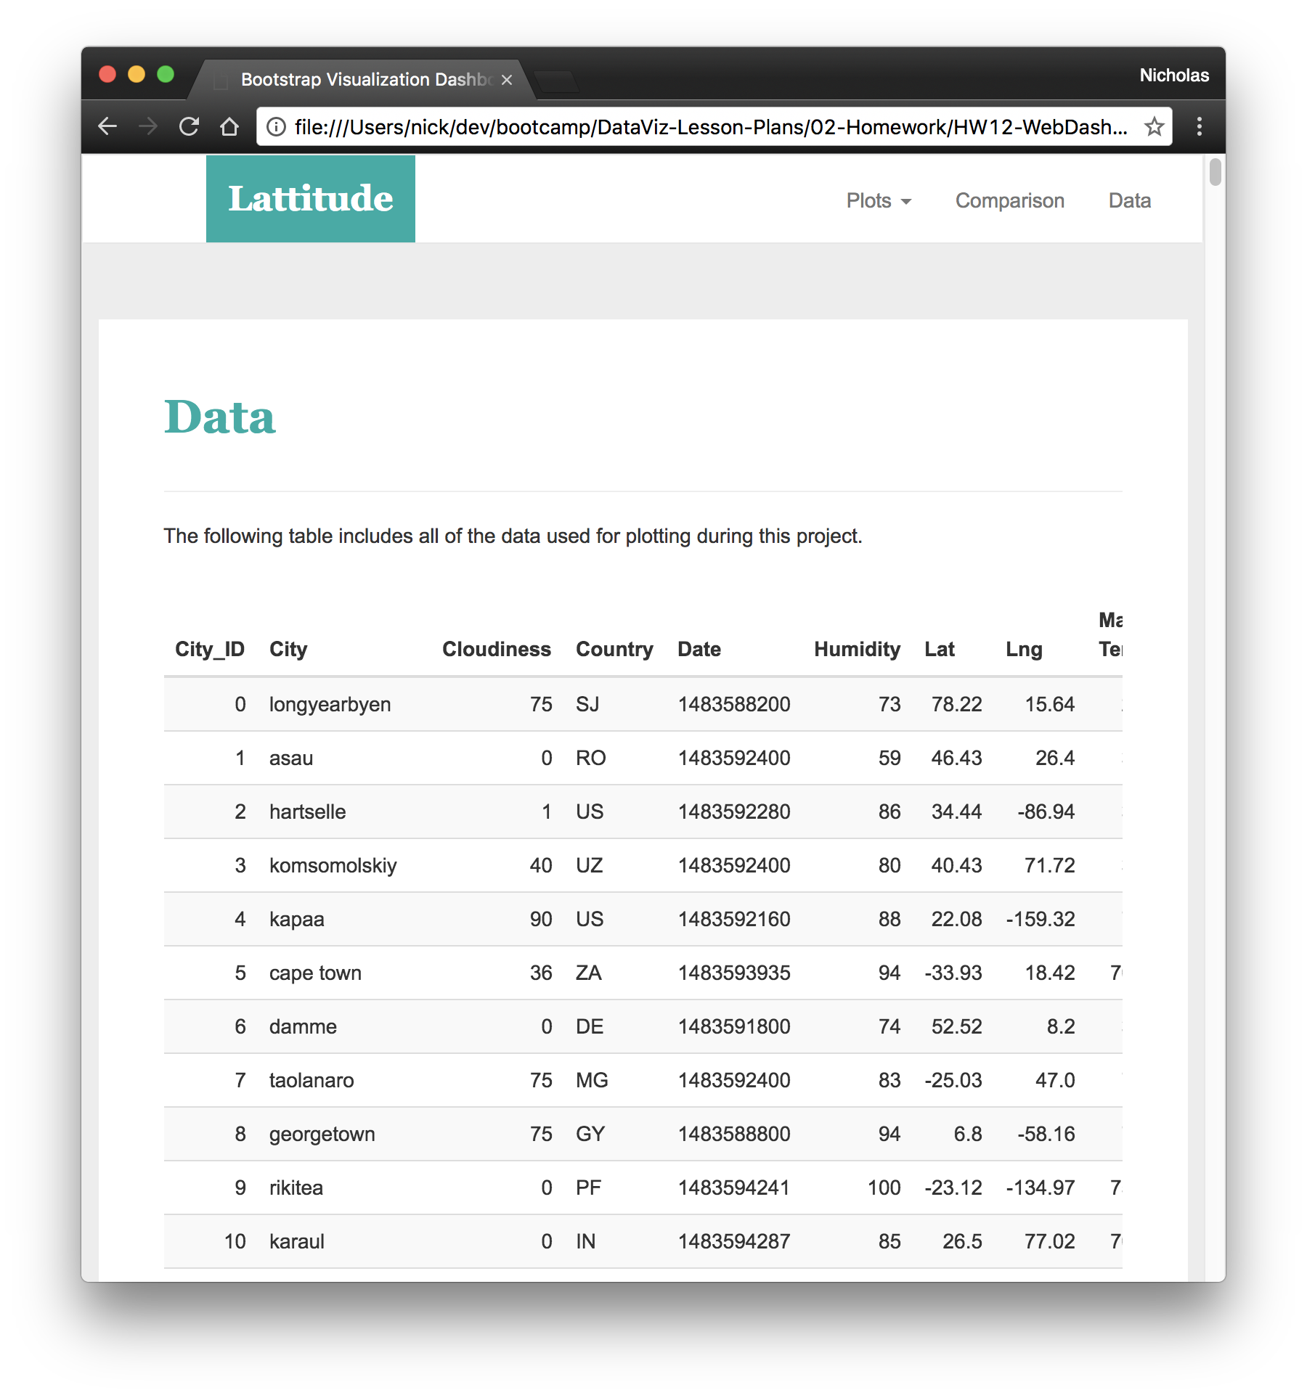

The website must, at the top of every page, have a navigation menu that:

* Has the name of the site on the left of the nav which allows users to return to the landing page from any page.

* Contains a dropdown on the right of the navbar named "Plots" which provides links to each individual visualization page.

* Provides two more links on the right: "Comparisons" which links to the comparisons page, and "Data" which links to the data page.

* Is responsive (using media queries). The nav must have similar behavior as the screenshots "Navigation Menu" section (notice the background color change).



