PROJECT 2.6
Smart Automatic Light and Warning System
Using LDR Sensor, Arduino Uno, Relay, LED & Buzzer

Student | Emil Rozenberq
Course | Basic Electronics
Project | 2.6 – Upgraded LDR System
Simulator | Wokwi (wokwi.com)
Date | 20 May 2026

1. Introduction
This project presents an automatic smart lighting and warning system built using an LDR sensor, Arduino Uno, relay module, LED, and buzzer. The system detects changes in environmental light and reacts automatically without any human input.
This is an upgraded version of the previous Project 2.5, which used only a basic LDR-relay circuit. Project 2.6 adds Arduino-based control logic, a buzzer for audio alerts, and an LED for visual feedback — making the system significantly smarter and more practical.

2. Objective
The main goal of this project is to design a system that automatically detects darkness and activates warning outputs. Specific objectives:
- Understand how LDR sensors work in real circuits
- Learn how to use Arduino to automate decisions based on sensor input
- Control multiple output devices (relay, LED, buzzer) simultaneously
- Gain practical experience with Wokwi circuit simulation
- Demonstrate improvement over the previous project (2.5)

3. Components Used

No | Component | Specification | Purpose
1 | Arduino Uno | ATmega328P, 5V | Main controller / brain
2 | LDR Sensor Module | Analog output | Detects light intensity
3 | Relay Module | 5V coil, 250VAC | Electronic switching
4 | LED | Yellow, 5mm | Visual light indicator
5 | Buzzer | Active, 5V | Audio warning output
6 | Jumper Wires | Male-to-male | Circuit connections
7 | Wokwi Simulator | Web-based | Circuit simulation platform

4. Circuit Description
The circuit was designed and tested using the Wokwi online simulator. Below is a description of how each component is connected:
- The LDR sensor module connects to Arduino analog pin A0. It continuously outputs a voltage value proportional to the detected light level.
- The relay module connects to digital pin 7. It acts as an electronic switch to control high-power loads.
- The LED connects to digital pin 8 with its cathode going to GND. It provides visual indication when the system is active.
- The buzzer connects to digital pin 9 and provides an audio alert when triggered.
- All components share common 5V and GND connections from the Arduino.
Circuit Diagram (Wokwi Simulation):
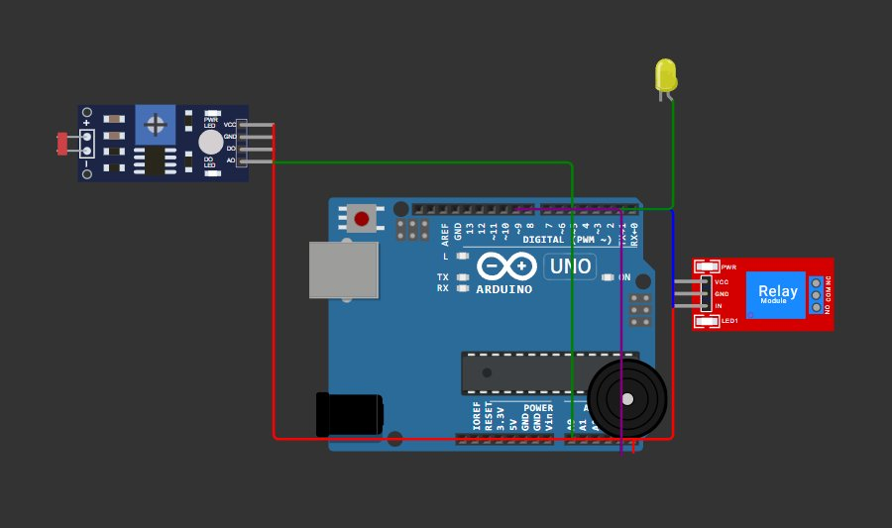
Figure 1: Wokwi simulation of the Smart Light and Warning System

5. Working Principle & Program Logic
The Arduino continuously reads the analog value from the LDR sensor (range 0–1023). A threshold of 500 is used to distinguish between light and dark conditions:

When dark (sensor value < 500):
- Relay turns ON → can switch an external load
- LED turns ON → visual indicator activates
- Buzzer sounds at 800 Hz → audio warning activates

When bright (sensor value ≥ 500):
- Relay turns OFF
- LED turns OFF
- Buzzer stops
The program also sends the light level value to the Serial Monitor every 100ms for real-time monitoring and debugging.
Program Code:
const int ldrPin = A0;
const int relayPin = 7;
const int ledPin = 8;
const int buzzerPin = 9;

void setup() {
pinMode(relayPin, OUTPUT);
pinMode(ledPin, OUTPUT);
pinMode(buzzerPin, OUTPUT);
Serial.begin(9600);
}

void loop() {
int lightLevel = analogRead(ldrPin);

if (lightLevel < 500) {
digitalWrite(relayPin, HIGH);
digitalWrite(ledPin, HIGH);
tone(buzzerPin, 800);
} else {
digitalWrite(relayPin, LOW);
digitalWrite(ledPin, LOW);
noTone(buzzerPin);
}

Serial.print("Light Level: ");
Serial.println(lightLevel);
delay(100);
}

6. Results and Conclusion
The project was successfully simulated in Wokwi. The system responded correctly to changes in light levels:
- When the simulated light level dropped below 500, the relay, LED, and buzzer all activated correctly.
- When the light level rose above the threshold, all outputs turned off automatically.
- The Serial Monitor confirmed real-time light level readings during simulation.

Compared to Project 2.5, this project demonstrates a clear upgrade — the addition of Arduino control logic, a multi-output response system, and audio feedback make it a more complete and practical solution.
This project improved understanding of sensor integration, conditional programming logic, and the control of multiple electronic outputs through a single microcontroller.

