GLOBAL AUTO INDUSTRY · 2026
The 2026 EV Reset
Almost everyone hit the brakes on EV-only.
After going “all-in” on battery-electric from 2021–2024, one major automaker after another walked it back in 2026 — writing down billions and pivoting to hybrids and flexible, build-anything factories. Toyota, which never abandoned its multi-pathway bet, suddenly looks right.

−27%  U.S. EV sales, Q1 2026 vs. a year earlier — demand growth stalled.  Cox Automotive |  | $51.5B  Combined EV write-downs at just Ford, GM & Stellantis.  Company filings |  | 5 of 7  Major automakers here that pulled back toward hybrids & ICE.  This report
The retreat, brand by brand
Each moved in the same direction — smaller battery bets, more hybrids, factories that can build gas, hybrid and electric on one line. Two held a different course.
Stellantis  PULLED BACK | $26B  WRITE-DOWN | Dropped the EV-only plan and put $13B into flexible U.S. “multi-energy” lines that build ICE, hybrid & EV together.
Ford  PULLED BACK | $19.5B  WRITE-DOWN | Unwound EV plans; hybrid options across the entire North American lineup by 2030, targeting 50% hybrid/EV output.
GM  PULLED BACK | $6B  WRITE-DOWN · +$1.6B EARLIER | Flipped Orion Assembly from EV back to ICE; PHEVs return to N. America by 2027; $888M for new V-8s.
Honda  PULLED BACK | −30%  EV & SOFTWARE SPEND | Cut planned EV and software investment, redirecting toward hybrids and more-efficient gas engines.
Volkswagen  PULLED BACK | ID.4 ended  IN TENNESSEE | Stopped ID.4 assembly at Chattanooga (Apr 2026); the line now builds the gas/hybrid next-gen Atlas.
BMW  STILL ALL-IN | Neue Klasse  GROUND-UP EV PLATFORM | Bucking the trend — pressing ahead with the most comprehensively reimagined premium EV platform in production.
Toyota  MULTI-PATHWAY | Vindicated  NEVER BET ON ONE TECH | ICE + hybrid + plug-in + electric + hydrogen, all at once. Now adding $912M into hybrids across five U.S. plants.
What the numbers say
The retreat was expensive — and the electric future didn’t vanish, it just slid a few years to the right.
The cost of walking it back · one-time EV write-downs, US$ billions
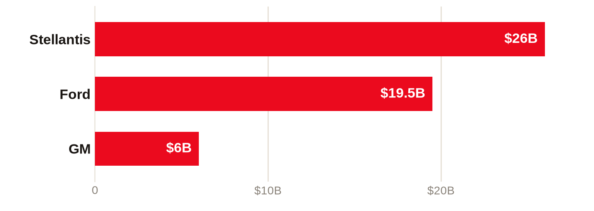
Honda instead cut EV & software spending by 30%; Volkswagen converted an EV line to gas/hybrid.
Where BEV output is actually headed · N. America BEV share of production (GlobalData)
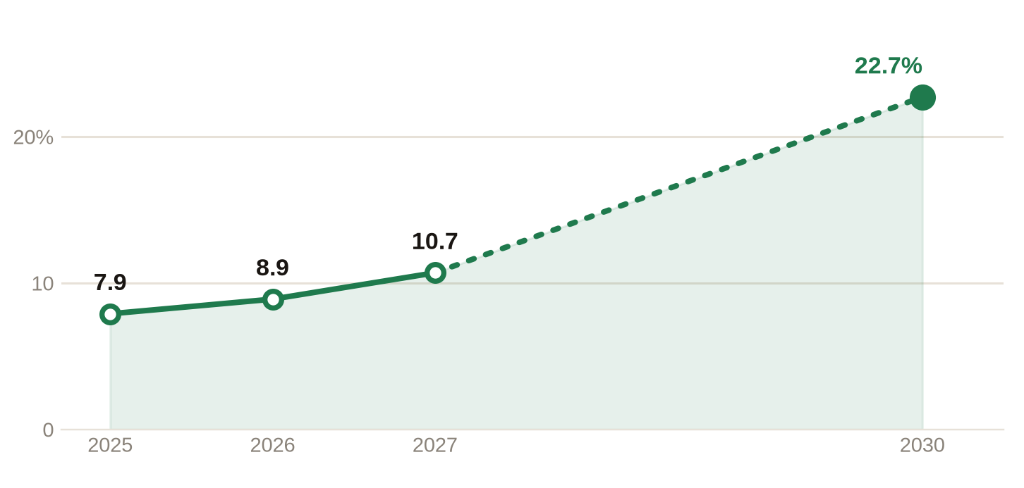
Dashed = projected. A slow climb now, then a jump — full EV-market recovery isn’t expected until 2028–2029.
Why hybrids won the year
The pivot wasn’t nostalgia — it was math. A hybrid keeps most of the climate win with far less cost and risk.
Smaller batteries  A hybrid needs a fraction of the cells a BEV does — less cost, less scarce material. |  | Proven profit  Built on decades-optimized ICE lines, hybrids carry margins that fund the transition.
No new infrastructure  They work at every gas station today — no charging network to wait for. |  | No behavior change  Customers just drive. Range anxiety never enters the room.
Toyota’s hedge, in full
Where rivals bet on one horse, Toyota ran five — matching the powertrain to each market’s infrastructure instead of forcing one everywhere.
PATHWAY 1  ICE  Trucks & markets that still demand gas. | PATHWAY 2  Hybrid (HEV)  The workhorse — 60%+ of Japan sales. | PATHWAY 3  Plug-in (PHEV)  The “practical BEV,” 200+ km electric. | PATHWAY 4  Electric (BEV)  10 new models; a dedicated “BEV Factory.” | PATHWAY 5  Hydrogen  Fuel-cell Mirai & Crown kept alive.

$70B  into electrified vehicles through 2030 — $35B of it for BEVs. | 3.5M  EVs targeted per year by 2030 (1.5M interim goal). | 40%+  of U.S. Toyota sales already hybrid or mild-hybrid. | ’27–’28  planned rollout of next-gen solid-state batteries.

Sources: Cox Automotive; GlobalData; MarkLines; company filings, earnings and press releases (Ford, GM, Stellantis, Honda, Volkswagen, BMW, Toyota). Figures as reported for 2025–2026; some are one-time charges or forward projections, not directly comparable line items. | Report by Claude · Jul 2026

