Forecasting Project
Process Documentation
V2.0

Contents
Introduction 1
Data Extraction Process 2
Data Diagnostics 2
Target Variable 3
Predictive Variable 3
Pre-modeling 4
Models 5
Comparisons of Algorithmic Solutions 5
Hyperparameters Selection of Algorithms 6
Evaluation Metrics 6
Team Information 10

Introduction
This report details the development and implementation of a forecasting system designed to optimize electricity load management across the Portuguese power grid. As modernized grids face increasing volatility and changing consumption patterns, typical forecasting methods are insufficient for precise operational planning, leading to wasted costs. To address this issue, our team developed a cluster-optimized system that provides 24-hour predictions for 370 unique grid clients, utilizing SOTA and showcasing development from base models to see improvement.

By segmenting our client base into four distinct behavioral clusters, we were able to deploy specialized models that outperform legacy baselines like SARIMA or Prophet. These specialized models capture non-linear consumption “bases” and seasonal shifts that traditional methods often misinterpret as noise, resulting in significantly reduced error rates (MAPE) across both residential and high-demand industrial sectors.

Lastly, this solution is integrated into an Agentic AI framework, allowing for real-time, natural language querying of forecasts. This transition from static reporting to an automated system provides grid managers with the ability to reduce energy procurement costs, minimize costly reserves, and maintain long-term grid stability. The following sections detail our data engineering process, modeling strategy, and evaluation that confirms this system’s predictive performance.

Data Extraction Process
This section will detail the transformation process of taking the raw data into a structured format suitable for forecasting. To ensure model robustness and prevent information leakage, the extraction process followed a pipeline of cleaning, resampling, and temporal segmentation.

1. Dataset Overview and Cleaning
The raw dataset, sourced from the UCI Electricity Load Diagrams (2011-20134), contains 15-minute load readings for 370 unique clients (MT_001 to MT_370). Initial preprocessing involved:
- Scheme Standardization: Semicolon delimiters and comma-based decimal notation were converted to a standard CSV format to ensure compatibility with Python-based data science libraries.
- Temporal Fixes: Data from 2011 was excluded due to a significant volume of null values and “0s” representing inactive meters, which would have introduced artificial bias into the training phase.

2. Resampling and Noise Reduction
While the original data is recorded at 15-minute intervals, the data was resampled to an hourly frequency. This serves two critical business and technical purposes:
- Signal Stabilization: Reducing high-frequency noise and volatility that does not contribute to 24-hour trend analysis
- Operational Alignment: Aligning the model output with the standard day-ahead forecasting requirements. This resulted in a total of 26,304 hourly observations per client across the remaining three year span.

3. Normalization and Scaling
To account for the vast difference in scales, ranging from small residential units to large industrial facilities, we applied a StandardScaler. Each client’s time series was transformed to have a mean of 0 and a standard deviation of 1. This ensures high-consumption clients do not dominate the loss function, allowing the models to learn the shape rather than the magnitude of load profiles.

4. Clustering
We implemented a cluster optimized architecture to ensure we are not treating all 370 clients as a single average or implementing 370 different problems.
- Segmentation: Clients were grouped into four distinct clusters using K-means clustering based on usage profiles (weekday/weekend patterns, etc)
- Windowing logic: For the deep-learning models, data was restructured into supervised input-output pairs using a 96-hour look-back window to predict a rolling 24-hour future.

5. Temporal Splitting
A chronological split was maintained to prevent data leakage:
- Training Set: 2012-2013 is used for model fitting and hyperparameter tuning
- Test Set: 2014 is reserved for out-of-sample evaluation.

Data Diagnostics
This section outlines the diagnostic procedures performed to understand the underlying structure of the Portuguese electricity grid data. These diagnostics were critical to justifying our move towards a cluster architecture rather than a global-average approach.

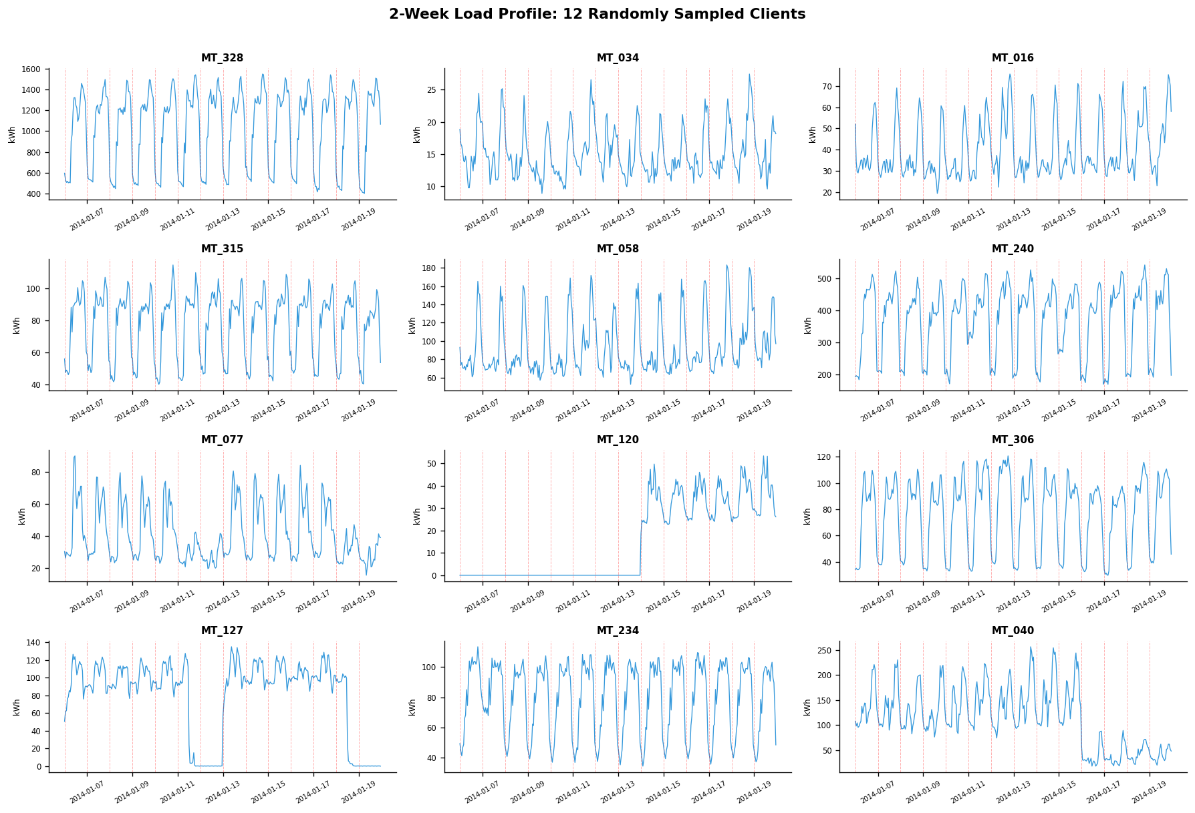
Figure 1: Time-series visualization highlighting the varying volatility and baseline consumption levels across the dataset.

Initial inspection of the 370 clients revealed significant diversity in consumption patterns. As shown in Figure 1, different metering plots display unique periodicity and magnitude. Some clients show highly regular, high volume daily cycles, while others show sudden activation following zero-use, justifying our decision to exclude 2011 data.

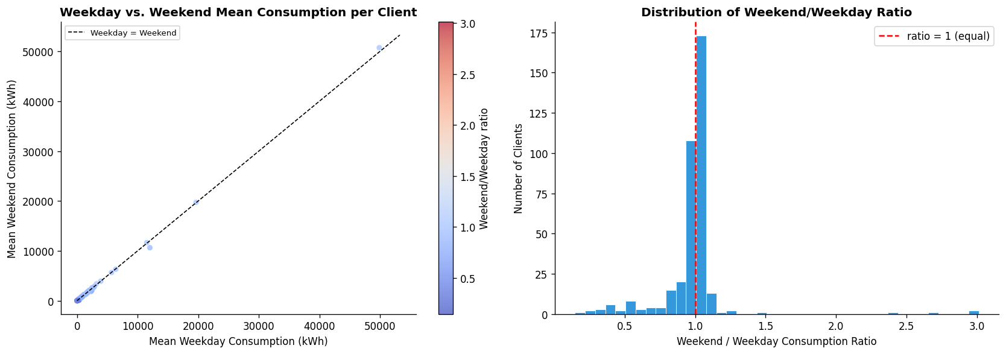
Figure 2: Analysis of weekly periodicity, confirming that a subset of the grid follows rigid industrial schedules.
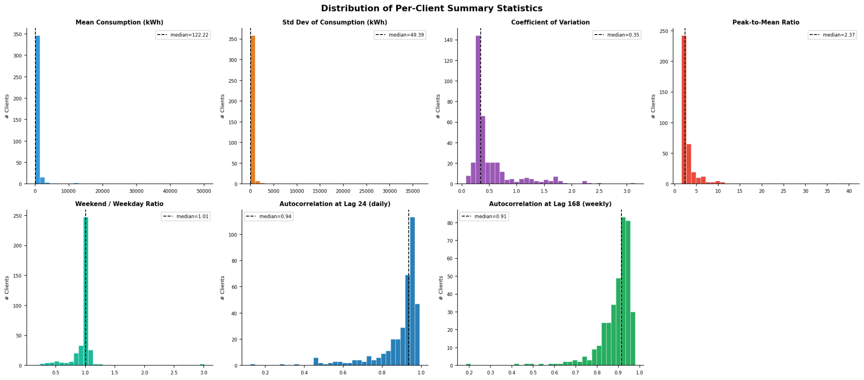
Figure 3: Histograms of Mean, Variance, Coefficient of Variation, and Autocorrelation across the 370 clients.
To quantify these differences, we generated summary statistics for each client. Figure 2 illustrates that while most clients consume equal amounts on weekdays versus weekends, there are significant outliers, likely attributable to industrial clients that drop to near-zero on weekends. Further, Figure 3 provides a deeper dive into the statistical characteristics of the clients. The autocorrelation at lag 24 and 168 (daily/weekly) is extremely high, confirming that the data is highly seasonal and well-suited for forecasting.
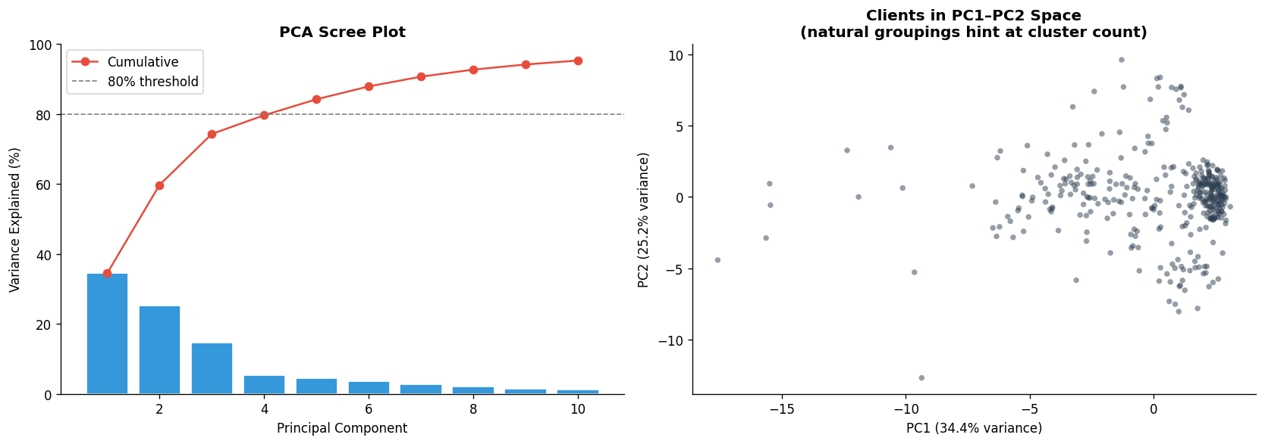
Figure 4: Left - PCA Scree plot showing variance explained. Right - 2D projection of clients highlighting natural density groupings.
To simplify the modeling task, we applied a Principle Component Analysis (PCA) to the 32-dimensional feature set (summary stats). Figure 4 shows that the first two principle components explain nearly 60% of the total variance, allowing us to visualize the natureal grouping of clients in a 2D space.
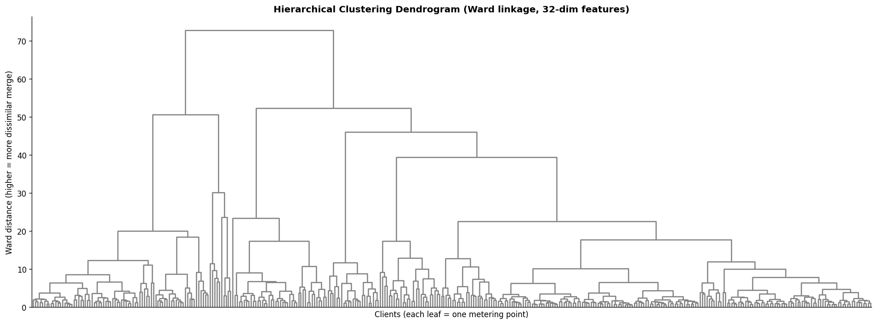
Figure 5: Hierarchical structuring
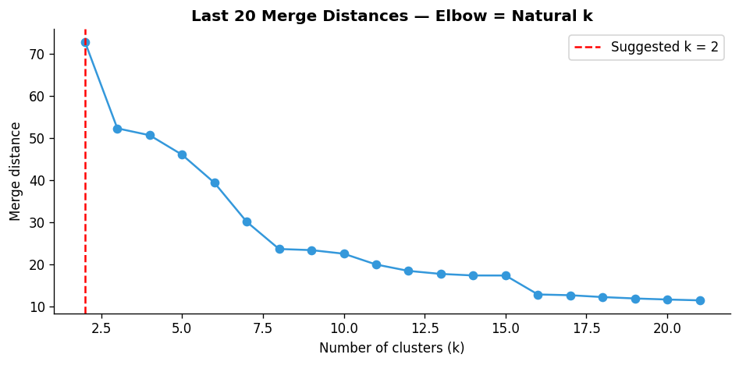
Figure 6: Quantitative validation of k=4
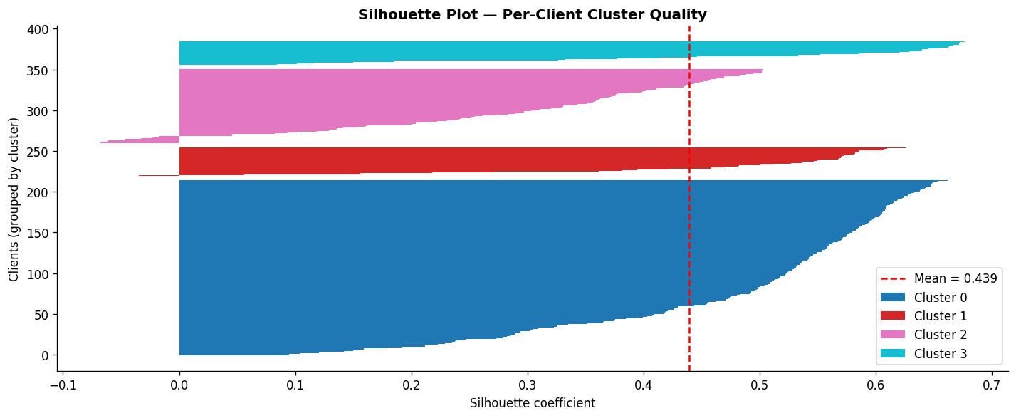
Figure 7: Per-cluster quality silhouette plot
We then utilized hierarchical clustering (Figure 5) and an elbow plot of merge distances (Figure 6) to determine the optimal number of groups. While the elbow plot suggested a potential k=2, we proceeded with k=4 to capture more granular behavioral nuances, supported by the silhouette plot in Figure 7, which shows strong cluster cohesion with the mean silhouette at .429.
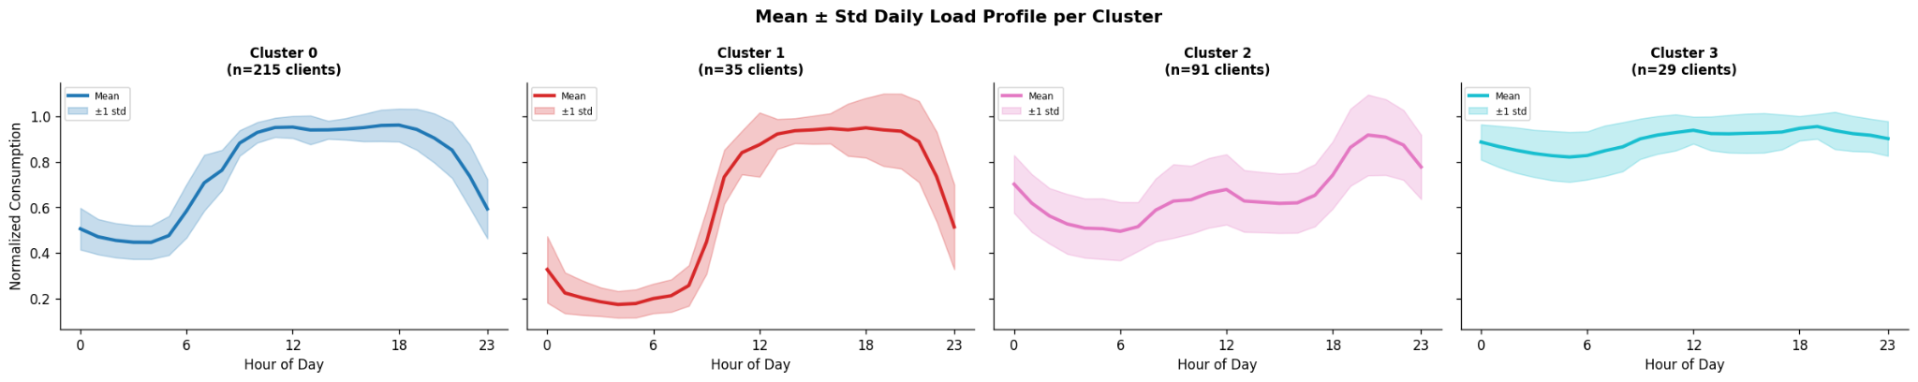
Figure 8: Signatures of each cluster, serving as the training foundation for our specialized model architecture
The final step was visualizing the daily profiles of our four resulting clusters seen in Figure 8.
- Cluster 0 = The standard residential profile with clear morning and evening peaks
- Cluster 1 = The industrial profile with 8am starts and sustained high loads
- Cluster 2 = The low load profile, showing high variance
- Cluster 3 = The smooth baseload profile with minimal daily fluctuations

These results established a good foundation by transforming raw, high-frequency telemetry into a standardized hourly dataset. Critical to this process was the pruning of the 2011 data period, which contained an unrepresentative volume of inactive meters. Additionally, to improve scalability and profile examination, we adopted a clustering architecture to address the behavioral heterogeneity observed across the 370 grid clients.

This segmentation was reinforced through PCA and Hierarchical Clustering, which identified our four primary consumption signatures: Residential, Industrial, Low-load, and Smooth load. The autocorrelation observed at 24-hour and 168-hour lags confirms the grids underlying temporal patterns are highly seasonal and well-suited for supervised learning. By validating these groupings, the project is set with a 96-hour lookback window optimized for predicting a 24-hour future load.

Target Variable

The primary target of this forecasting system is the hourly electricity consumption, measured in kilowatt-hours (kWh). Given the significant scale difference between a single household and a large manufacturing facility, the values were transformed using Z-score standardization. This ensures the target variable represents the relative consumption profile of each cluster. The models are then optimized for predicting shapes without being skewed by the magnitude of large industrial usage values.

Predictive Variables

To generate the 24-hour forecast, the models ingest a multi-dimensional feature set designed to capture both immediate and long term values. The most significant predictor is the 96-hour look back window. This provides the model with four days of historical context, allowing it to identify recent trends and the immediate momentum of the grid load. Next, the system utilized time of day and day of week indicators. These allow the SOTA models to distinguish between the sustained loads of a Tuesday afternoon and the reduced demand of a Sunday morning. Lastly, the cluster assignment acts as a categorical feature, helping the models to match the behavioral profile oft he group being forecasted.

Pre-modeling
Phase | Years Included | Purpose
Training | 2012 – 2013 | Learning long-term trends and seasonal structure in aggregate electricity demand.
Testing | 2014 | Final evaluation of out-of-sample forecasting accuracy.
The pre-modeling phase established the framework necessary for valid performance comparison across various models. To ensure that our results were not influenced by temporal leakage, we strictly partitioned the dataset into a training set (2012-2013) and an out-of-sample test set (2014). This setup was designed to evaluate how the models handle specific volatility of the 2014 grid, including the high-variance fourth quarter.
A key component of this setup was the target alignment. We finalized the definition of our primary target as the hourly kWh load, mapped specifically to the labels identified in our diagnostic phase (e.g., target column ‘0’). We configured our modeling environment to support both Prophet/SARIMA methods and deep learning methods (BasisFormer), ensuring the computational requirements of each solution were documented. It is worth noting that cost analysis would need to be executed in a business environment to ensure the models can be run within the budget allocated for this project.

Models
Now that the data foundation is built and cluster profiles are established, we have now moved on to the modeling phase. We employed a multi-model ensemble, since no single algorithm is a perfect match for all types of data. This suite includes traditional statistical baselines (SARIMA, Prophet), a high-performance regressor (Gradient Boosting), and state-of-the-art transformer architectures (Basisformer, PatchTST). This approach ensures that whether a client profile is characterized by smooth residential cycles or erratic industrial spikes, the system can pivot to the most mathematically appropriate model, serving as the base for our Agentic AI application.
0.Seasonal Naive
Ga Hyun Yoon
1. SARIMA
Ga Hyun Yoon
2. Prophet
Developed by Meta’s Core Data Science team, Prophet is a robust forecasting procedure designed to handle time series that display strong seasonal effects and several seasons of historical data, treating forecasting as a modular curve-fitting exercise. It consists of three main components and an error term:
$y(t) = g(t) + s(t) + h(t) + et$
- $g(t)$ Trend: this represents the non-periodic changes in the value of the time series. Prophet uses a piecewise linear logistic growth curve, allowing it to automatically detect and adapt to changes
- $s(t)$ Seasonality: This captures periodic changes, such as daily and weekly consumption cycles. These are modeled using the Fourier Series, which provides the flexibility needed to map the complex double-peak profiles present in the grid
- $h(t)$ Holidays: This component explicitly accounts for the effects of holidays or recurring events. This is vital for our analysis, since the energy consumption demand in the Portuguese market shifts significantly during national holidays.
- $et$ Error: Represents changes not accommodated by the model
This serves as our interpretable baseline. It performed fairly well in Cluster 2, with 24.79% sMAPE score. In these low-load environments, Prophet was able to smooth noise. However, it performed fairly poorly in Cluster 1, where its linear trend assumptions struggled to match the non-linear lift provided by BasisFormer and Gradient Boosting.
3. BasisFormer
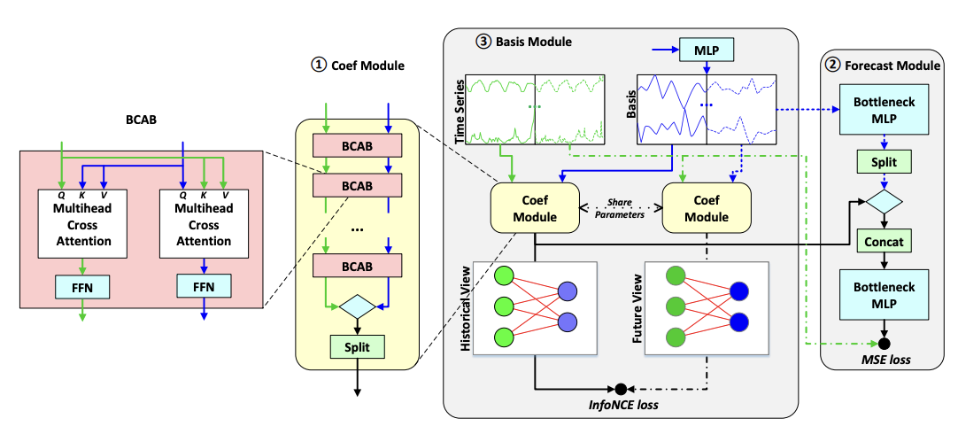
Figure 9: BasisFormer Architecture
To address the complex and non-linear segments of the Portuguese grid, we implemented BasisFormer. While traditional transformers struggle with the inherent noise of raw time-series points, BasisFormer utilizes an architecture designed to learn a global basis of consumption behaviors. It employs a coefficient-based mechanism where the model learns to represent input sequences as a weighted combination of learned basis functions:
- Basis Module: A self-supervised module that learns the library of fundamental patterns (Bases) directly from the 370-client historical data
- Coefficient Estimation: Instead of predicting values, the model calculates “coefficients” to determine how to mix the learned bases to match the 96-hour input window
- Forecast Module: Utilizes the learned bases and coefficients learned in the previous step to create an accurate forecast prediction perfect for the periodicity of the Electricity data

This allows the model to filter out the noise common in low-load periods and focus on the shape of the demand. We use a 96-hour look-back window to generate a 24-hour future forecast, and train using the AdaBelief optimizer, which combines the rapid convergence of Adam with the superior generalization of SGD to stabilize the acquisition of high-dimensional bases. It also uses three loss functions: prediction loss, contrastive loss (InfoNCE), and Smoothness loss. BasisFormer shows significantly lower MAPE scores in comparison to the statistical methods above.
4. GradientBoosting
Lavina Mital
5. PatchTST
Ga Hyun Yoon

Results
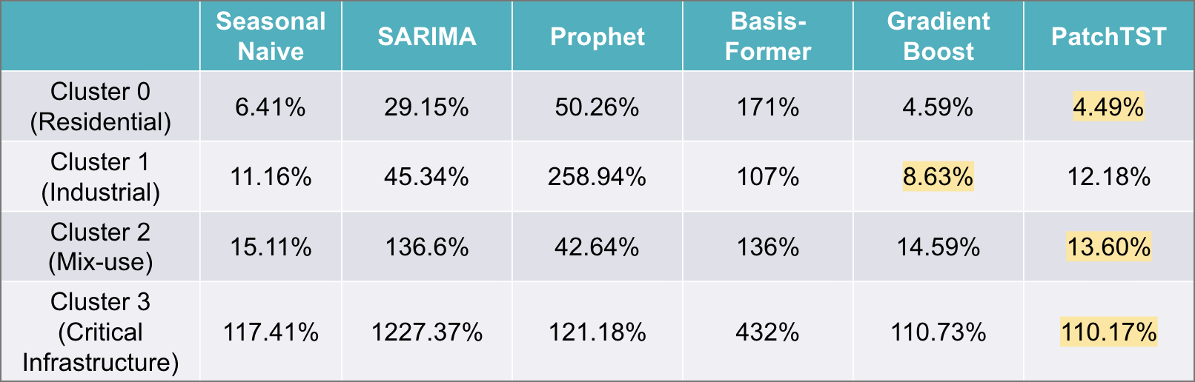
Figure 10: MAPE values for each model presented per cluster profile
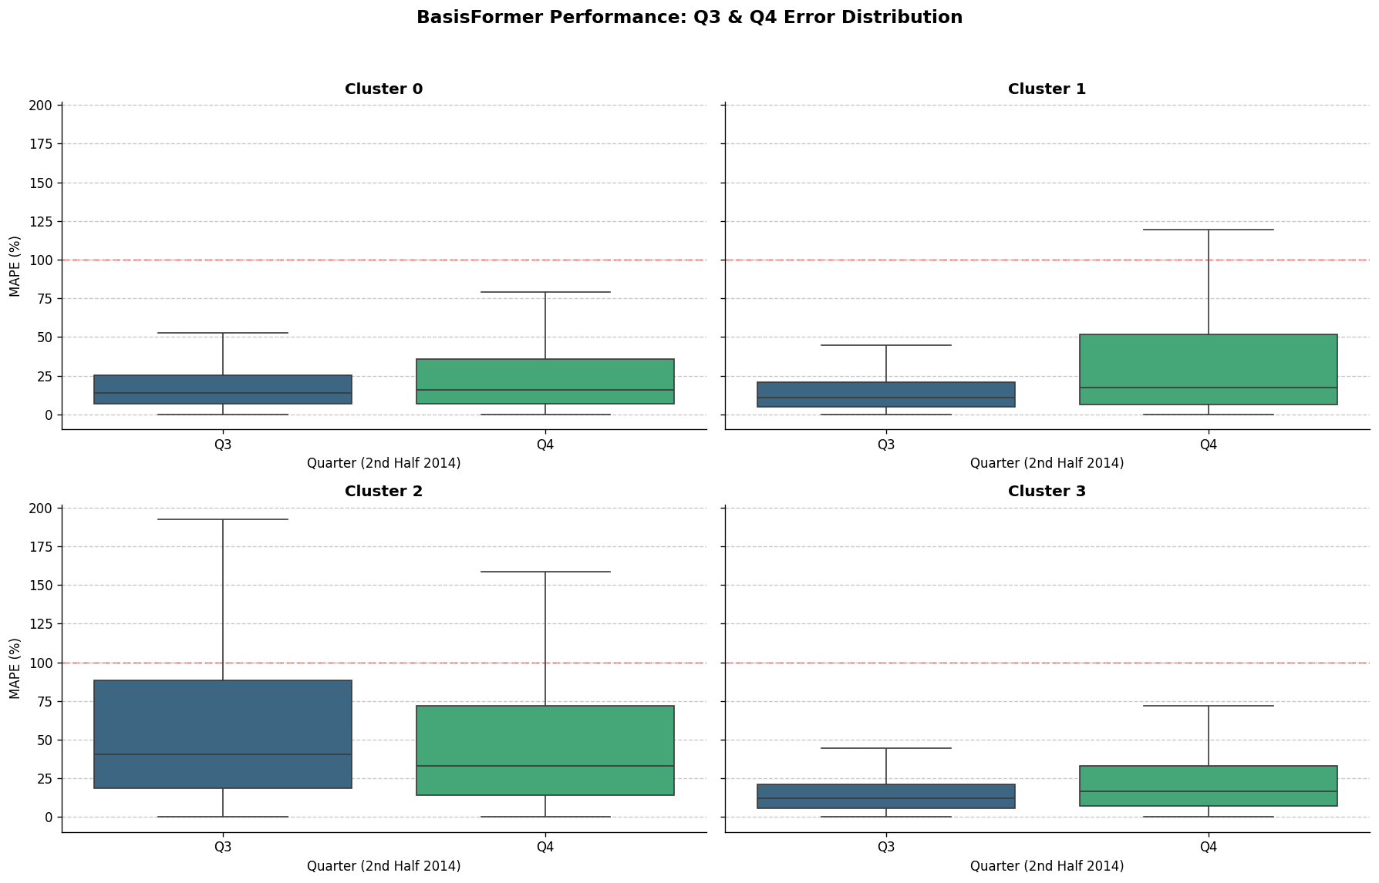

Figure 11: MAPE values for BasisFormer presented per cluster profile
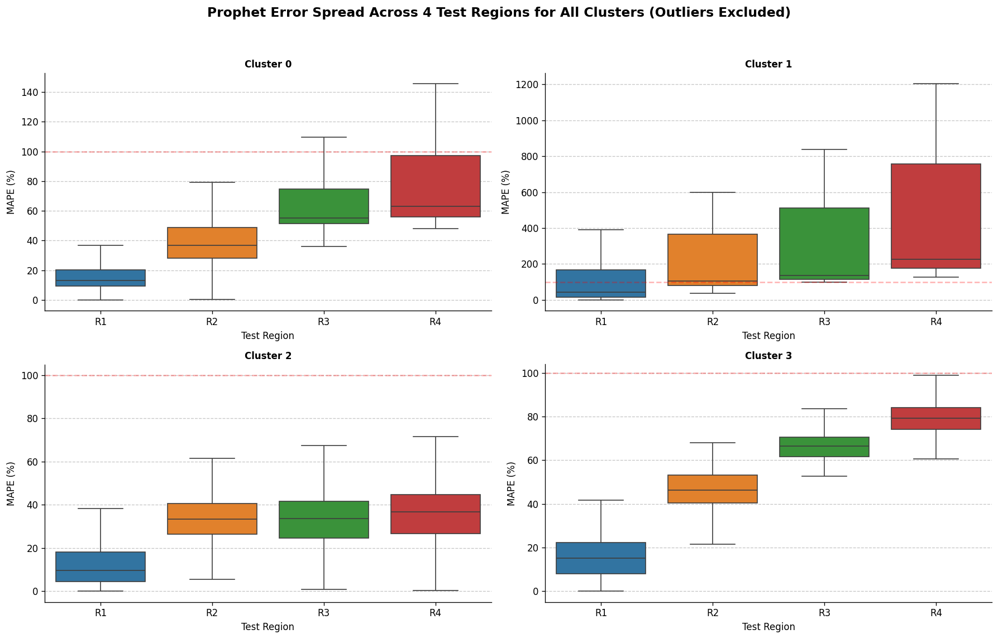
Figure 12: MAPE values for Prophet presented per cluster profile
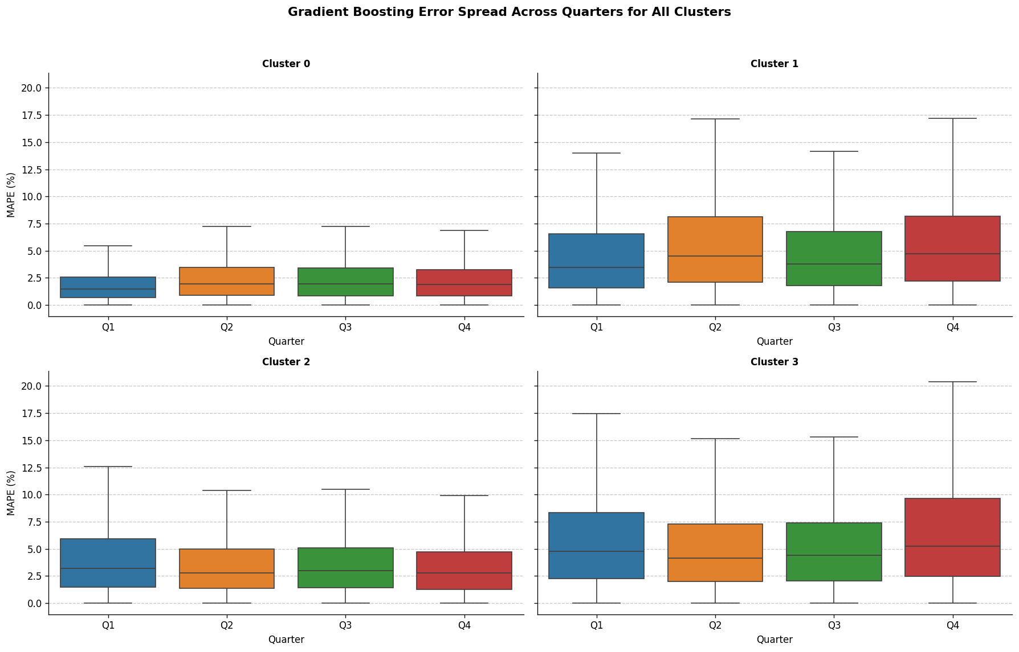
Figure 13: MAPE values for Gradient Booth presented per cluster profile
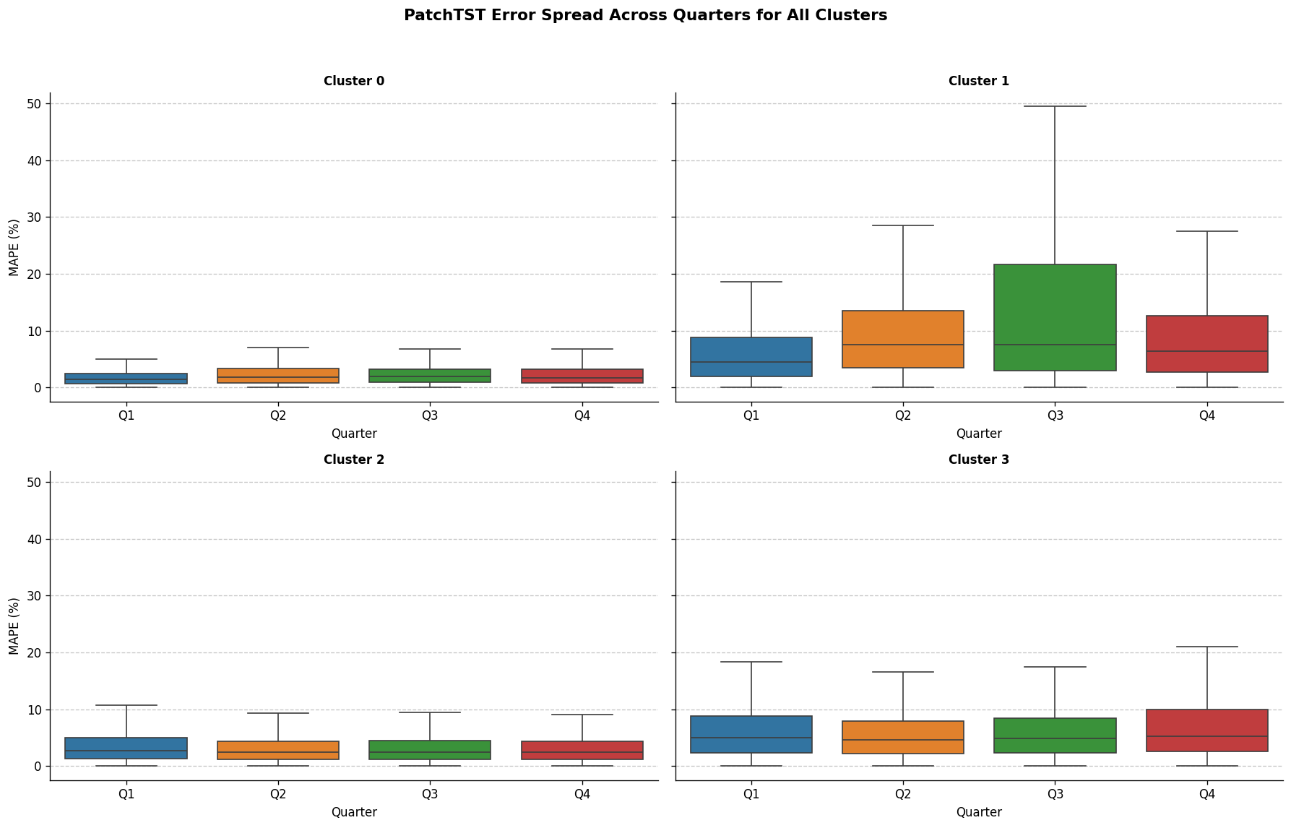
Figure 14: MAPE values for PatchTST presented per cluster profile

Future Work & Limitations
Lavina Mitalplease fill this out - include more detailed data, higher computation and more research into appropriate models. Keep everything business related.

Agentic AI Application

Ga Hyun Yoon
Please detail the n8n process here, and maybe a screenshot?

Team Information

Lavina Mital, lm4046@columbia.edu
Emily Ramond, er3294@columbia.edu
Ga Hyun Yoon, gy2354@columbia.edu

