Forecasting Project
Process Documentation
V2.0

Contents
Introduction 1
Data Extraction Process 2
Data Diagnostics 2
Target Variable 3
Predictive Variable 3
Pre-modeling 4
Models 5
Comparisons of Algorithmic Solutions 5
Hyperparameters Selection of Algorithms 6
Evaluation Metrics 6
Team Information 10

Introduction
- This project focuses on forecasting electricity consumption for 370 consumers using historical load data. We compare a statistical baseline model with a deep learning approach (BasisFormer) to capture different demand patterns. The data used is from an electricity load between 2011-14 dataset that was donated to UC Irvine.
- Our Slides: https://docs.google.com/presentation/d/13n-pSQINpMDxaQpeAQwLSY6j-8DWqsZYB2Lv7DD9VTM/edit?slide=id.g3cb1b4b420a_2_190#slide=id.g3cb1b4b420a_2_190

The purpose of this document is to provide a detailed technical overview of:
- Design specifications and parameters
- Data inclusions and exclusions
- Predictive variable creation process
- Target variable definition
- Iterative model building process
- Metric evaluation process

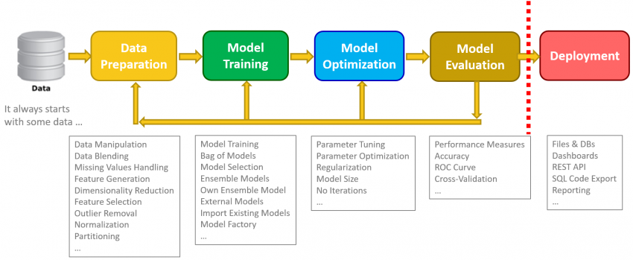

Data Extraction Process
The purpose of this section is to detail the data extraction process, data exclusions and transformations, and the diagnostics performed on data received
- The dataset includes 370 unique customers, identified by the labels MT_001 through MT_370
- Removed data from 2011 due to abundance of 0s.
- The dataset records the Standardized Electricity Load every 15 minutes, but we used hourly data so remove unnecessary noise.
- The data for training spanned from 2012-13 and the forecasting period stretched until 2014 Dec.
- The primary variable is the Standardized Electricity Load, which represents the hourly energy consumption per client.
Data Exclusions & Transformations
- Converted semicolon delimiters and comma-based decimals into a standard CSV format
- Ensured a continuous, properly ordered time index to support time-series modeling and chronological train–test splits
- Used earlier years for model training and reserved 2014 for out-of-sample evaluation to avoid information leakage
- Statistical Baseline Only
  - Averaged electricity load across all 370 clients at each timestamp to form a single system-level demand series
  - Addressed non-stationarity through model-based differencing within the ARIMA framework (d=1d=1), rather than explicit preprocessing steps
- BasisFormer Only
  - Resampled the original 15-minute data to an hourly frequency to reduce high-frequency noise and better match day-ahead forecasting needs.
  - Applied z-score standardization (mean = 0, standard deviation = 1) to each client’s time series so differences in usage scale would not dominate model training.
  - Created supervised input–output pairs using a 96-hour look-back window to predict the next 24 hours of electricity load.

Data Diagnostics
- Verified that the resampling process handled any gaps in the 2012–2014 timeline to ensure a continuous 18,294-sample training set
- Evaluated the diversity of load profiles across the 370 clients to ensure the Basis Acquisition module would receive enough varied signals to learn distinct "Basis Templates."
- Confirmed that the standardized test set (5,238 samples) format matched training set to have valid MSE (0.3353) and MAE (0.2998)

Target Variable
We are trying to predict the energy consumption over time for 370 power consumers

Predictive Variable
Predictive variable is historical energy consumption rates for each client

Pre-modeling

Statistical baseline model:
Phase | Years Included | Purpose
Training | 2011 – 2013 | Learning long-term trends and seasonal structure in aggregate electricity demand.
Testing | 2014 | Final evaluation of out-of-sample forecasting accuracy.
The baseline model is trained on several years of aggregate demand history and evaluated on a held-out future period, allowing us to assess how well learned seasonal patterns extrapolate over time.

BasisFormer:
Cross validation was used to train the models
Phase | Years Included | Purpose
Training | 2012 – 2013 | Learning the "seasonal bases" of the 370 clients.
Validation | Early 2014 | Fine-tuning the hyperparameters and preventing overfitting.
Testing | Late 2014 | Final evaluation of 24-hour forecasting accuracy.
Using a rolling 96-hour look-back and 24-hour forecast window, the model is exposed to thousands of different four-day segments, helping it learn how recent demand patterns translate into next-day usage.

Models

ARIMA
- Combines
  - AR (p): Autoregressive terms that use past values to predict current values
  - I (d): Differencing operations that remove trends to achieve stationarity
  - MA (q): Moving average terms that model forecast errors from previous time steps

SARIMA
- Extends ARIMA by adding seasonal components (P, D, Q, m) to explicitly capture repeating patterns at fixed intervals.
- For electricity data with hourly observations, m=24 captures the daily consumption cycle where usage patterns repeat every 24 hours.

BasisFormer
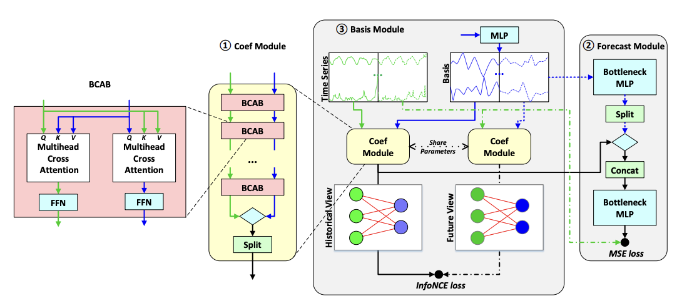
Figure 1: BasisFormer Architecture

- Basis Module: A self-supervised module that learns the library of fundamental patterns (Bases) directly from the 370-client historical data
- Coefficient Estimation: Instead of predicting values, the model calculates “coefficients” to determine how to mix the learned bases to match the 96-hour input window
- Forecast Module: Utilizes the learned bases and coefficients learned in the previous step to create an accurate forecast prediction perfect for the periodicity of the Electricity data

Comparisons of Algorithmic Solutions
Algorithm | Pros | Cons
ARIMA/SARIMA | Interpretable statistical foundation  Explicit trend and seasonality modeling  Minimal data requirements | Assumes linear relationships  Struggles with complex multivariate patterns  Manual parameter tuning required
BasisFormer | Better capture non-linear relationships | Overfitting

Hyperparameters Selection of Algorithms
One ARIMA model was trained on (p, d, 1) = (1, 1, 1) for the baseline. For another ARIMA model, we used the auto_arima function to stepwise search the parameters that optimized the AIC, which is a metric that balances model complexity and accuracy.
- Search Space: Non-seasonal parameters tested in range p ∈ [0,5], d ∈ [0,2], q ∈ [0,5]; seasonal parameters P ∈ [0,2], D ∈ [0,1], Q ∈ [0,2] with seasonal period m=24 (hourly to daily cycle)
- Best Model Selection: ARIMA(5,1,4) identified as optimal non-seasonal baseline; SARIMA configurations compared with varying seasonal complexity
The SARIMA model was trained with three different configurations:
- SARIMA(1,1,1)(1,0,0,24) — Seasonal AR only
- SARIMA(1,1,1)(1,1,0,24) — Seasonal AR with differencing
- SARIMA(1,1,1)(1,1,1,24) — Full SARIMA with seasonal MA
The BasisFormer model was trained using a self-supervised basis acquisition approach with the following optimized hyperparameters:
- Training approach: Self-supervised BasisFormer model that learns shared demand patterns across clients.
- Model size: ~594k trainable parameters with a hidden dimension of 100.
- Optimization: Trained using the AdaBelief optimizer with a learning rate of 1e-4 and weight decoupling.
- Input/output setup: Uses the previous 96 hours of load data to predict the next 24 hours.
- Training details: Trained for 10 epochs with a batch size of 32, using early stopping (patience = 3) to limit overfitting.

Evaluation Metrics
The model was evaluated on a 2014 hold-out test set consisting of 5,238 samples across 370 energy clients.

Forecast Accuracy (Magnitude)

ARIMA
ARIMA(5,1,4) — Auto-ARIMA Optimized
- Mean Squared Error (MSE): 1.064
  - Lowest MSE among all classical models tested
- Mean Absolute Error (MAE): 0.867
  - On average, the forecast deviates by approximately 0.87 standardized units from actual consumption
ARIMA(1,1,1) — Simple Baseline
- Mean Squared Error (MSE): 3.354
  - Approximately 3× higher than ARIMA(5,1,4), demonstrating that simple low-order ARIMA specifications struggle to capture temporal patterns
- Mean Absolute Error (MAE): 1.546
  - About 2× higher than the optimized model, indicating insufficient model complexity to adequately represent hourly pattern

SARIMA Models (Seasonal ARIMA with m=24 daily cycle)
SARIMA(1,1,1)(1,0,0,24) — Seasonal AR Only
- Mean Squared Error (MSE): 1,105.972
  - Elevated error indicating severe model convergence issues
- Mean Absolute Error (MAE): 32.531
  - Drastically higher forecast errors compared to non-seasonal ARIMA, suggesting the seasonal AR term introduced numerical instability rather than capturing meaningful daily consumption patterns.
SARIMA(1,1,1)(1,1,0,24) — Seasonal AR with Differencing
- Mean Squared Error (MSE): 22,455.107
  - Errors over 20,000× higher than optimal ARIMA; adding seasonal differencing on already-aggregated data caused complete loss of predictive signal
- Mean Absolute Error (MAE): 129.940
  - Forecasts deviate by over 100 standardized units on average
SARIMA(1,1,1)(1,1,1,24) — Full SARIMA
- Mean Squared Error (MSE): 1,805.846
  - High error indicating convergence difficulties; combining seasonal AR, differencing, and MA components on smoothed data led to over-parameterization and numerical instability
- Mean Absolute Error (MAE): 37.080
  - Consistently poor forecast accuracy across both error metrics
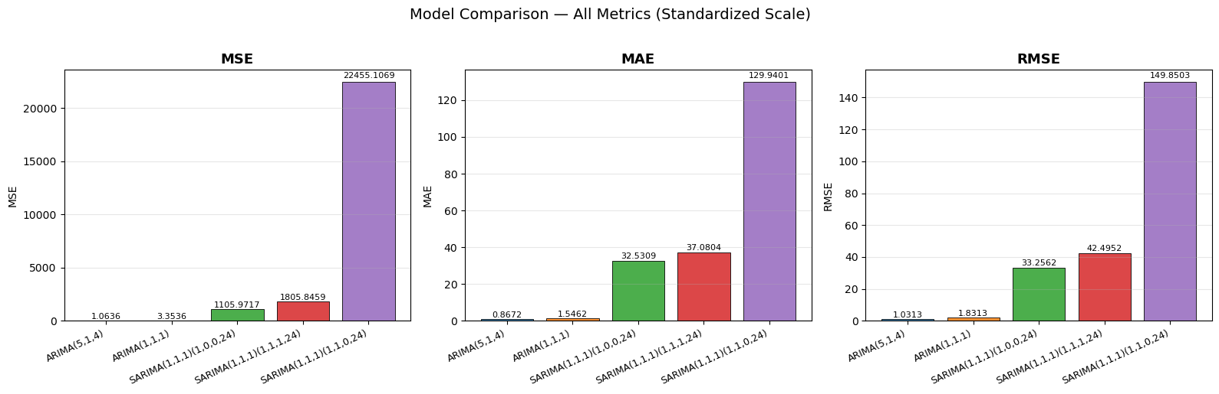

BasisFormer
- Mean Squared Error (MSE): 0.3353
  - Penalizes large errors more heavily, suggesting the model handles major demand spikes reasonably well.
- Mean Absolute Error (MAE): 0.2998
  - On average, predictions differ from actual load by about 0.3 standardized units.

Forecast Bias (Directionality)

ARIMA
- Visual inspection:
  - ARIMA(1,1,1) captures the daily oscillation pattern but consistently under-predicts by 2-4 units throughout the period. ARIMA(5,1,4) tracks actual consumption closely for the first few days but gradually drifts lower, under-predicting by 3-6 units by Day 14.
- Smoothness consistency:
  - Both ARIMA models maintain smooth, stable forecasts without erratic jumps, preserving realistic daily patterns throughout the 14-day period.

SARIMA
- Visual inspection:
  - All three SARIMA variants exhibit failure with severe downward drift. Forecasts start near actual values but rapidly collapse to -8 to -13 standardized units by Day 14, diverging from the ground truth.
- Smoothness consistency:
  - Despite maintaining smooth curves, SARIMA forecasts drift into negative regions. The consistent downward bias across all variants suggests the models failed to converge properly on averaged data, producing systematically incorrect predictions despite capturing the smooth, repeating seasonal patterns.

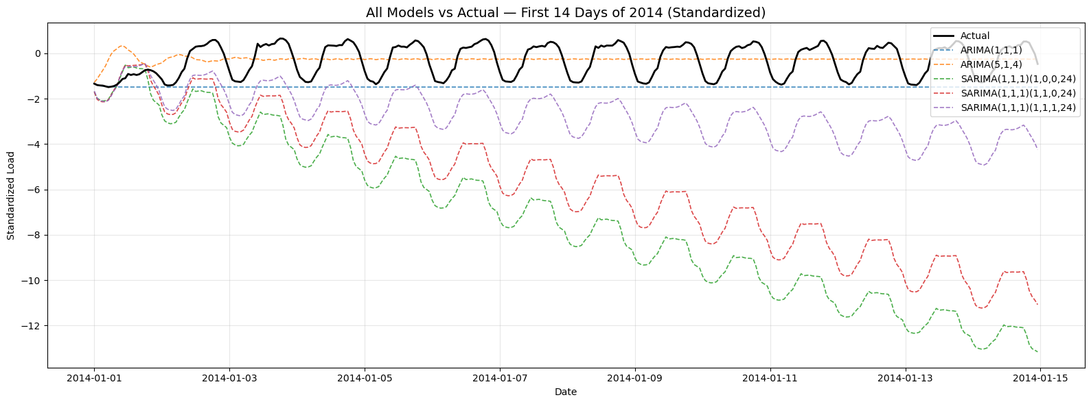

BasisFormer
- Visual inspection:
  - Forecast plots show a slight tendency to over-predict during peak evening hours (around Hour 22), while still closely following the overall daily load pattern.
- Smoothness consistency:
  - A low Smoothness Loss of 0.0020 indicates minimal erratic behavior, resulting in stable and realistic forecasts over time.

Algorithmic Solution Finalization
The BasisFormer model performs better over the Statistical baseline model thus we use it.

Team Information

Lavina Mital
Emily Ramond
Ga Hyun Yoon

