A Student Project Experience: A Virtual Campus Tour

John Peterson, Quinn Bryant, Jaden Terry, and Emily Tucker

Computer Science Department

Western State Colorado University

Gunnison, CO 81231

[jpeterson@western.edu](mailto:jpeterson@western.edu), [quinn.bryant@western.edu](mailto:quinn.bryant@western.edu), [jaden.terry@western.edu](mailto:jaden.terry@western.edu), [emily.tucker@western.edu](mailto:emily.tucker@western.edu)

**ABSTRACT**

This paper describes a class project combining web technology, communications, and graphic design to produce a virtual campus tour. This project combined interdisciplinary learning, modern web technology, and service to the institution. We believe that this serves as a case study in putting Computer Science into a larger context, allowing students to collaborate with outsiders that have expertise in a variety of areas. This project was “just right” in a number of ways: it was doable in a single semester, it surpassed the capabilities of an existing expensive software system, and could be implemented in a stand-alone manner.

**INTRODUCTION**

A main goal in building this project was creating a realistic software development experience for students. We needed an experience that would supply real world familiarity, and a working environment that is similar to a computer science profession. This was a good assignment for students because it gave the ability to work with the marketing department of the University. Working closely with them allowed us to gain a better understanding of the importance that a virtual campus tour has on an institution. The former virtual tour was expensive and outdated and didn’t offer future students an accurate interpretation of the institution.

Model View Controller was an important architectural pattern for the project. The model that manages the project consists of a database containing each item of the tour. This database is the foundation of the tour and enables us to easily modify the project. The view generates html and CSS code through JavaScript. The project was created through client side web programming. This was beneficial because it allowed us to make things happen dynamically on the web page. The controller updates the view whenever the location changes.

Creating a realistic software development experience for students that implemented real world problems was important. Communicating through other departments of the institution, and working in a team environment enabled students to gain knowledge on what a realistic project might be.

**Project Goals**

Design goals of the tour:

1. Incorporate the institutions marketing message into the tour
2. Create a tour that uses a variety of media to “tell the story” of the institution, including information about the location, the community, the surrounding area.
3. The tour should be personalized – information should come from student voices
4. The tour must work on most devices – from phones to full sized screens

**Design of the Virtual Tour**

This project was created when there was a need for an updated version of our current virtual tour. Every year the institution spent $20,000 for a tour on YouVisit. YouVisit is a service that creates a virtual tour for academic institutions. The YouVisit tour has animated audio recording of students guiding the user through the tour. Studies show that this is a bad thing **(Source and rephrasing Quinn).** When one navigated through the tour there was a superfluous amount of stops between each building/location. The map that YouVisit uses to help guide the user to their location had issues with movability and the display. When one tried to move the map it would disappear completely. As the user navigated around the tour, pop-ups would appear urging the future student to contact admissions. Any additional content such as panoramas, pictures, or videos were disconnected from the original tour. Users had to click different tabs to access this content and loose their spot on the tour. YouVisit advertised more for their site then our university. There was no branding from the university that connected with the virtual tour. As a class, the tour that YouVisit had produced did not suit what we believed future students should be experiencing and did not represent our university. From this discovery it became the classes mission to create a unique personalized tour for our university.

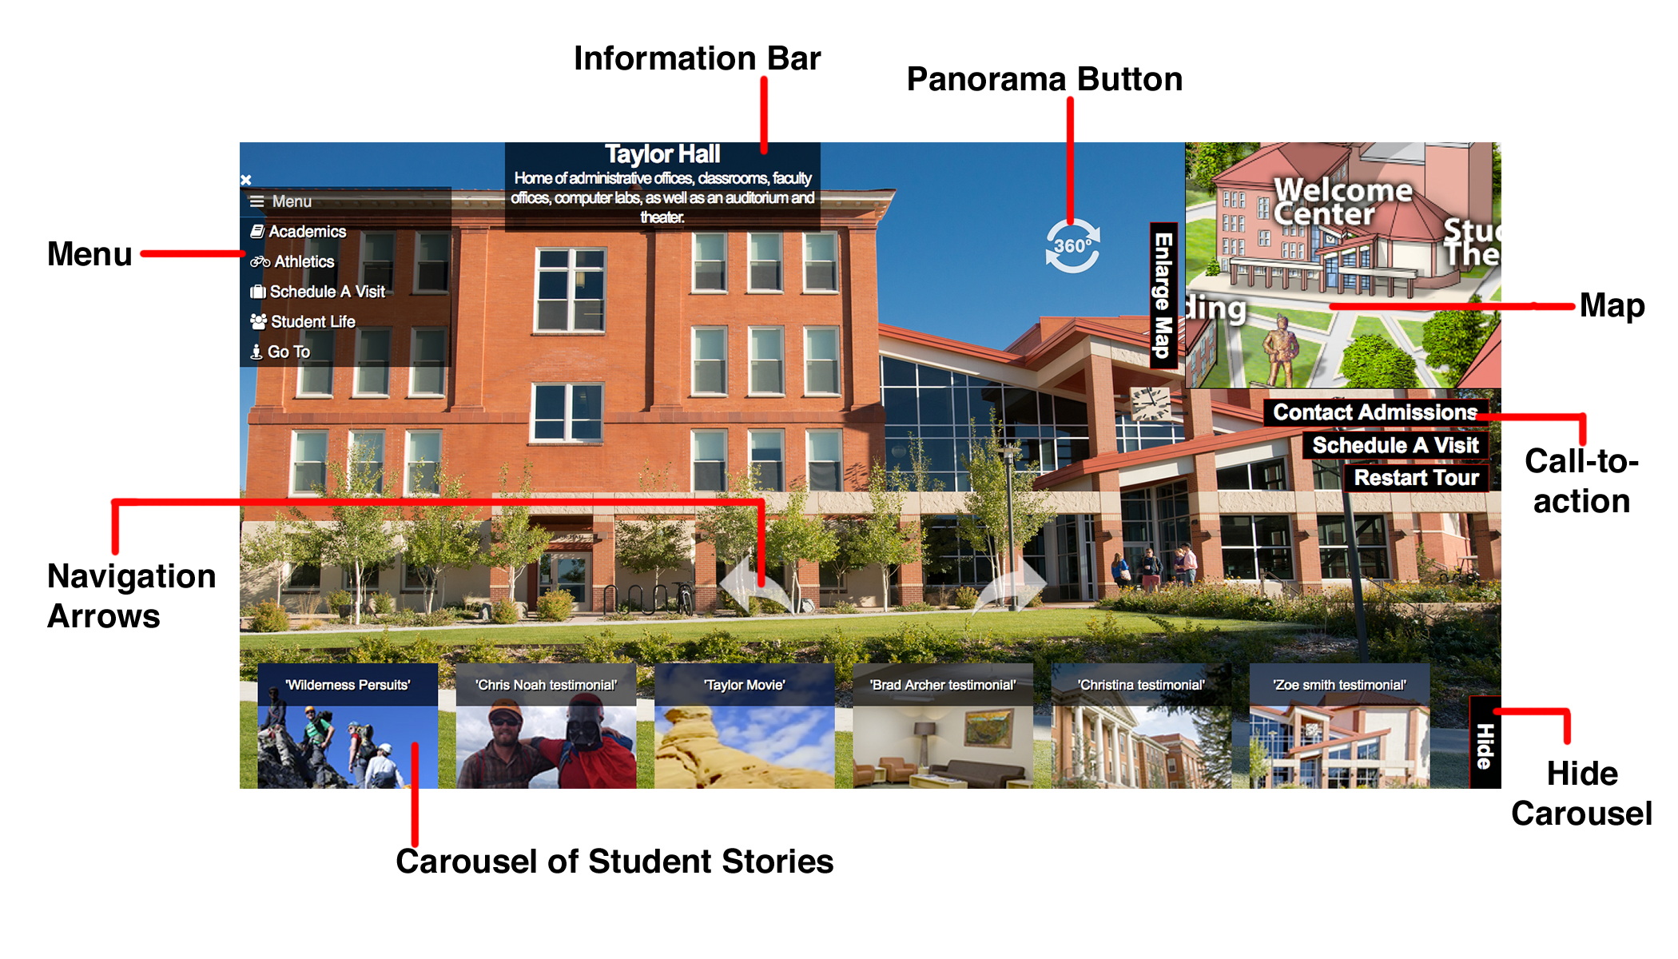

After observing the difficulties users had using the old virtual tour the class designed a new virtual tour. This virtual tour would be simpler and become aesthetically pleasing as well as user-friendly. We removed the audio clips, as we believed that they were unnecessary. To inform future students of what they were viewing we added a carousel of student stories and an information bar at the top. The carousel allows for students to connect with the different departments of studies, athletic programs, and student life around campus. This gave our tour a unique personalized feel that catered to individual students. If a student didn’t care to look at these stories they can hide the carousel. The information bar at the top gave the name of the location the user is currently at and a brief description of that place or building. To advertise our university properly we added several call-to-action buttons that will connect the user back to the website. Multiple tours were implemented so that students had a choice to explore what they were interested in. These included academic, student life, athletic, and an off campus tour. The menu was built to be a useful tool to help guide users to their specific interests and locations on our tour. The menu reconnects with the multiple tours along with additional information. The tour that was designed aimed at making a user-friendly simple design.

**Implementation**

In order to begin the Virtual Tour Project, the class needed to be divided up into groups to work on certain aspects. Some of the groups consisted of the menu, spy, carousel, testing, integration, etc. One of the main tasks for the spy was to investigate current campus tours and JavaScript libraries that other Universities were using. We found many great libraries and tours to choose from but we needed to narrow it down. This was a great place to start because it allowed us to figure out what and how we wanted to build our Virtual Tour. Eventually, the groups began coding separate parts of the tour and presenting them to the class. These groups were given input on their code and sent back to make improvements before the pieces were integrated together. The integration group was divvyed into about 4 people who were in charge of making sure all of the code fit together nicely. As you can imagine, with multiple groups creating their own code, this took some time. One of the individuals was in charge of the screen layout and making sure that the tour was suitable for everyone. Once we had the basic structure of the tour, we began testing in different browsers and difference devices. This process was very important because of the popularity of mobile devices. After multiple presentations to the marketing department, we reached the point where the tour was ready to present to the cabinet. The cabinet was impressed and gave positive feedback on the tour. They liked it enough to give us funding over the summer and continue making progress on the tour.

Steps in creating the project

1. Investigation of current Javascript technologies
2. Investigation of existing campus tours
3. Decision to put the logic at the client side
4. Coding of separate parts
5. Integration and testing
6. Use of meta-programming to customize the project and avoid using a remote database
7. Presentation to the cabinet and funding

Key technologies:

1. Javascript development environments – talk about browser-based development Different Internet browsers were used as JavaScript development environments.
2. Multiple JavaScript libraries were used to complete necessary features for the project. Instead of students spending hours writing code this allowed for energy to be focused elsewhere. These libraries varied in usefulness but showed students the perks and disadvantages of using code that was from a stranger. Bugs became harder to fix and implementing the individual JavaScripts did not always work. Allowing students to use any JavaScript library that they desired allowed for useful and not useless code to be produced.
3. GitHub was used as the main source code control. This allowed students to monitor insertions, deletions, and any changes being added into the project. Students that were assigned as moderators of the GitHub were constantly ensuring that any particular piece of code added would not destroy the rest of the project. GitHub provides an integrated issue tracker that helps identify any bugs or issues with the project. GitHub also made it so that collaborative code reviews could be possible. This enables students to ask any question, propose changes, and get involved with every aspect of the code. GitHub provided students with a way to collaborate on code to making a functional tour.

**RESULTS**

Describe the basic engineering of the system. Don’t go too deep into specifics – no need for massive code dumps.

1. Talk about the basic structure of the project: a single html file with javascript support that implements a state machine.
2. The layout on the screen was developed with static and dynamic content in mind. The static content was the content that we determined that needed to on the screen at all times. These constants were determined to be the map, the menu, the call-to-actions, a restart tour button, and the information bar. Having these features on the screen at all times enabled the user to have control over what they would like to do next. Dynamic content such as the carousel, location image, and navigation arrows would change based on the location. These features would need to be unique to each location so loading this content dynamically was the perfect solution. This layout allowed users to have familiarity as they changed scenes but more options as it did.
3. Talk about the data underlying the tour and the classes that represent it.
4. During development each student volunteered for roles that they wished to help develop. These roles included exploring high level navigation, contextual navigation, map-based navigation, information encoding, documentation and spies. All roles provided students with a unique perspective on the software being developed. As time progressed students merged into more advanced groups or switched groups completely. This allowed for every student to gain knowledge of what was happening in the project and how it was being developed.

**FUTURE WORK**

Work on this project is far from over. Once the basic tour has been completed there is multiple outlets to continue this endeavor. In the future, analytics will be added. This will allow for further information on how the users explore the tour. With this information, a personalized tour can be created as they explore or the tour will be updated based on data from the analytics. Analytics will also give marketing a way to monitor the success of the tour and if it is successful with future students. To continue developing and adding content to the tour once student have graduated a user-friendly option for the marketing team needs to be created. This will allow them to evaluate and add content in the future. Additional call-to-action buttons and interactions will be added to encourage users to contact the school or at least allow marketing to obtain an email from them. With these developments yet to be seen this will ensure the future employment of students and a perfect solution for a campus tour.

**CONCLUSIONS**

The tour is currently being developed so that all functionality will work flawlessly. Improvements are being made by student workers and will be replacing the current virtual tour by the fall. Having the tour work on mobile devices is of upmost importance and is currently the main objective of the programmers. Device testing is the last step before the basic version of the tour will be released on the website. Future developments will be continued after all major milestones are completed. This will include any additional features that are not necessary for the function but make the universities tour stand out. This virtual tour project was a unique opportunity to learn multiple aspects of web programming and proved as a successful software development environment for students.

**REFERENCES**

[1] Something about the web as a communications medium

[2] Something about the shift from server based to client based web logic

[3] Something about selecting good projects for students

[4] Something about student collaboration on an interdisciplinary project

[1] Abrams, J., A definitive proposal for solving all NP-complete graph problems, *Journal of the Impossible*, 10 (3), 34-35, 1999.

[2] Gray, I. M., Hyde, D. R., Jekyll, M. R., NP-complete problems with no known optimal solutions, *Proceedings of the First Conference on Hard, Hard Problems*, 1 (1), 100-799, 1999.

[3] More, N. O., *Handbook of Known Solutions to the Traveling Salesman Problem*, Amarillo, TX: Big House Publishing, 2000.