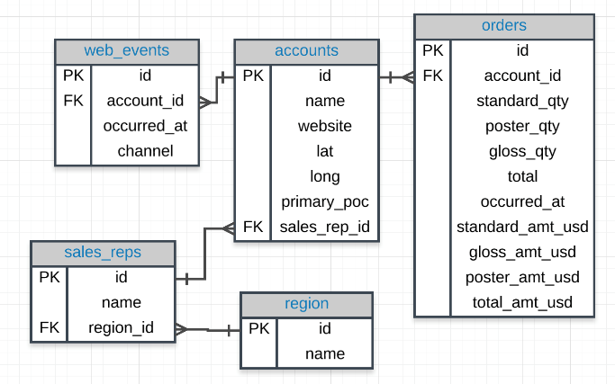

1. Provide the **name** of the **sales_rep** in each **region** with the largest amount of **total_amt_usd** sales. You will need to join the two tables!

SELECT s.name rep_name, r.name region_name, SUM(o.total_amt_usd) total_amt

FROM sales_reps s

JOIN accounts a

ON a.sales_rep_id = s.id

JOIN orders o

ON o.account_id = a.id

JOIN region r

ON r.id = s.region_id

GROUP BY 1,2

ORDER BY 3 DESC;

SELECT region_name, MAX(total_amt) total_amt

FROM(SELECT s.name rep_name, r.name region_name, SUM(o.total_amt_usd) total_amt

FROM sales_reps s

JOIN accounts a

ON a.sales_rep_id = s.id

JOIN orders o

ON o.account_id = a.id

JOIN region r

ON r.id = s.region_id

GROUP BY 1, 2) t1

GROUP BY 1;

SELECT t3.rep_name, t3.region_name, t3.total_amt

FROM(SELECT region_name, MAX(total_amt) total_amt

FROM(SELECT s.name rep_name, r.name region_name, SUM(o.total_amt_usd) total_amt

FROM sales_reps s

JOIN accounts a

ON a.sales_rep_id = s.id

JOIN orders o

ON o.account_id = a.id

JOIN region r

ON r.id = s.region_id

GROUP BY 1, 2) t1

GROUP BY 1) t2

JOIN (SELECT s.name rep_name, r.name region_name, SUM(o.total_amt_usd) total_amt

FROM sales_reps s

JOIN accounts a

ON a.sales_rep_id = s.id

JOIN orders o

ON o.account_id = a.id

JOIN region r

ON r.id = s.region_id

GROUP BY 1,2

ORDER BY 3 DESC) t3

ON t3.region_name = t2.region_name AND t3.total_amt = t2.total_amt;

1. For the region with the largest (sum) of sales **total_amt_usd**, how many **total** (count) orders were placed?

SELECT r.name, COUNT(o.total) total_orders

FROM sales_reps s

JOIN accounts a

ON a.sales_rep_id = s.id

JOIN orders o

ON o.account_id = a.id

JOIN region r

ON r.id = s.region_id

GROUP BY r.name

HAVING SUM(o.total_amt_usd) = (

SELECT MAX(total_amt)

FROM (SELECT r.name region_name, SUM(o.total_amt_usd) total_amt

FROM sales_reps s

JOIN accounts a

ON a.sales_rep_id = s.id

JOIN orders o

ON o.account_id = a.id

JOIN region r

ON r.id = s.region_id

GROUP BY r.name) sub);

1. **How many accounts** had more **total** purchases than the account **name** which has bought the most **standard_qty** paper throughout their lifetime as a customer?

**SELECT** a.**name** account_name, **SUM**(o.standard_qty) total_std, **SUM**(o.total) total

**FROM** accounts a

**JOIN** orders o

**ON** o.account_id = a.**id**

**GROUP** **BY** 1

**ORDER** **BY** 2 **DESC**

**LIMIT** 1;

**SELECT** a.**name**

**FROM** orders o

**JOIN** accounts a

**ON** a.**id** = o.account_id

**GROUP** **BY** 1

**HAVING** **SUM**(o.total) > (**SELECT** total

**FROM** (**SELECT** a.**name** act_name, **SUM**(o.standard_qty) tot_std, **SUM**(o.total) total

**FROM** accounts a

**JOIN** orders o

**ON** o.account_id = a.**id**

**GROUP** **BY** 1

**ORDER** **BY** 2 **DESC**

**LIMIT** 1) sub);

**SELECT** **COUNT**(*)

**FROM** (**SELECT** a.**name**

**FROM** orders o

**JOIN** accounts a

**ON** a.**id** = o.account_id

**GROUP** **BY** 1

**HAVING** **SUM**(o.total) > (**SELECT** total

**FROM** (**SELECT** a.**name** act_name, **SUM**(o.standard_qty) tot_std, **SUM**(o.total) total

**FROM** accounts a

**JOIN** orders o

**ON** o.account_id = a.**id**

**GROUP** **BY** 1

**ORDER** **BY** 2 **DESC**

**LIMIT** 1) inner_tab)

) counter_tab;

1. For the customer that spent the most (in total over their lifetime as a customer) **total_amt_usd**, how many **web_events** did they have for each channel?

**SELECT** a.**id**, a.**name**, **SUM**(o.total_amt_usd) tot_spent

**FROM** orders o

**JOIN** accounts a

**ON** a.**id** = o.account_id

**GROUP** **BY** a.**id**, a.**name**

**ORDER** **BY** 3 **DESC**

**LIMIT** 1;

**SELECT** a.**name**, w.channel, **COUNT**(*)

**FROM** accounts a

**JOIN** web_events w

**ON** a.**id** = w.account_id **AND** a.**id** = (**SELECT** **id**

**FROM** (**SELECT** a.**id**, a.**name**, **SUM**(o.total_amt_usd) tot_spent

**FROM** orders o

**JOIN** accounts a

**ON** a.**id** = o.account_id

**GROUP** **BY** a.**id**, a.**name**

**ORDER** **BY** 3 **DESC**

**LIMIT** 1) inner_table)

**GROUP** **BY** 1, 2

**ORDER** **BY** 3 **DESC**;

My Answer:

select sub2.acct, sub2.channel, sub2.counts

from

(select a.name acct, sum(total_amt_usd)

from accounts a

join orders o

on o.account_id = a.id

group by 1

order by 2 desc

limit 1) sub1

join

(select a.name acct, w.channel channel, count(w.id) counts

from accounts a

join web_events w

on a.id = w.account_id

group by a.name, w.channel) sub2

on sub1.acct = sub2.acct

order by counts desc;

1. What is the lifetime average amount spent in terms of **total_amt_usd** for the top 10 total spending **accounts**?

**SELECT** **AVG**(tot_spent)

**FROM** (**SELECT** a.**id**, a.**name**, **SUM**(o.total_amt_usd) tot_spent

**FROM** orders o

**JOIN** accounts a

**ON** a.**id** = o.account_id

**GROUP** **BY** a.**id**, a.**name**

**ORDER** **BY** 3 **DESC**

**LIMIT** 10) temp;

1. What is the lifetime average amount spent in terms of **total_amt_usd**, including only the companies that spent more per order, on average, than the average of all orders.

**SELECT** **AVG**(o.total_amt_usd) avg_all

**FROM** orders o

**SELECT** o.account_id, **AVG**(o.total_amt_usd)

**FROM** orders o

**GROUP** **BY** 1

**HAVING** **AVG**(o.total_amt_usd) > (**SELECT** **AVG**(o.total_amt_usd) avg_all

**FROM** orders o);

**SELECT** **AVG**(avg_amt)

**FROM** (**SELECT** o.account_id, **AVG**(o.total_amt_usd) avg_amt

**FROM** orders o

**GROUP** **BY** 1

**HAVING** **AVG**(o.total_amt_usd) > (**SELECT** **AVG**(o.total_amt_usd) avg_all

**FROM** orders o)) temp_table;

My answers:

select avg(name_avg)

from (

select a.name as names, avg(o.total_amt_usd) as name_avg

from orders o

join accounts a

on o.account_id = a.id

group by names

having avg(o.total_amt_usd) >

(select avg(total_amt_usd)

from orders o)) temp;