Emily Alexa Gotiangco
CMPS 250, Professor Jackowitz
16 February 2024
AS01
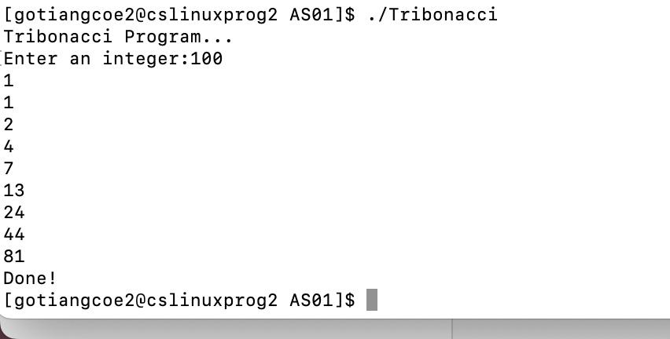
For the first Tribonacci program, I added a third term to be added together with the first and second terms. After each iteration of the while loop, the first term would be assigned the second term, the second term would be assigned the third term, and the third term would be assigned the most recent sum.

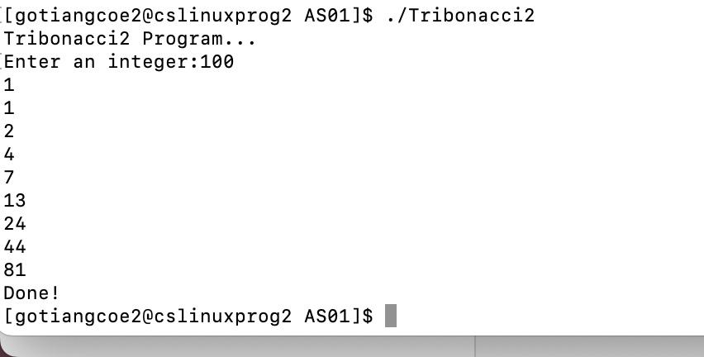
For the second Tribonacci program, I used the same type of solution as the first Tribonacci program, but I accounted for the addition of a “nextFibonacci” function.

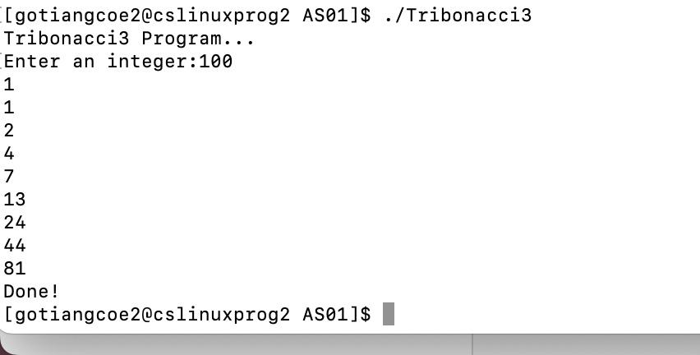
For the third Tribonacci program, I used the same type of solution as the last two Tribonacci programs, but I accounted for the use of the * and & operators.

Tribonacci2.c | Tribonacci2.s
#include <stdio.h>  int nextTribonacci(int term1, int term2, int term3) {  return term1 + term2 + term3;  }  // This part of the assembly code is pushing values (term1, term2, term3) onto the runtime stack and adding them together.  // “ret” → “return”, from the nextTribonacci program  // This part of the assembly code is making references for the strings in main.  // This part of the assembly code is pushing values (limit, term1, term2, term3, next) onto the runtime stack.  int main() {  int limit;  int term1 = 1;  int term2 = 1;  int term3 = 2;  int next;  printf("Tribonacci2 Program...\n");  printf("Enter an integer:");  scanf("%d", &limit);  if(term1 <= limit) {  // “jg” does work with comparisons (“g” = greater than)  printf("%d\n",term1);  if(term2 <= limit) {  printf("%d\n",term2);  // “jump”  while(term3 <= limit) {  printf("%d\n",term3);  next = nextTribonacci(term1,term2,term3);  // series of “movl” commands: moving data from one register to another  term1 = term2;  term2 = term3;  term3 = next;  // Executing the while loop.  // “jle” does work with comparisons (“le” means “less than”)  printf("Done!\n");  // “ret” = “return” | .file "Tribonacci2.c"  .text  .globl nextTribonacci  .type nextTribonacci, @function  nextTribonacci:  .LFB0:  .cfi_startproc  pushl %ebp  .cfi_def_cfa_offset 8  .cfi_offset 5, -8  movl %esp, %ebp  .cfi_def_cfa_register 5  movl 8(%ebp), %edx  movl 12(%ebp), %eax  addl %eax, %edx  movl 16(%ebp), %eax  addl %edx, %eax  popl %ebp  .cfi_restore 5  .cfi_def_cfa 4, 4  ret  .cfi_endproc  .LFE0:  .size nextTribonacci, .-nextTribonacci  .section .rodata  .LC0:  .string "Tribonacci2 Program..."  .LC1:  .string "Enter an integer:"  .LC2:  .string "%d"  .LC3:  .string "%d\n"  .LC4:  .string "Done!"  .text  .globl main  .type main, @function  main:  .LFB1:  .cfi_startproc  leal 4(%esp), %ecx  .cfi_def_cfa 1, 0  andl $-16, %esp  pushl -4(%ecx)  pushl %ebp  movl %esp, %ebp  .cfi_escape 0x10,0x5,0x2,0x75,0  pushl %ecx  .cfi_escape 0xf,0x3,0x75,0x7c,0x6  subl $36, %esp  movl $1, -12(%ebp)  movl $1, -16(%ebp)  movl $2, -20(%ebp)  subl $12, %esp  pushl $.LC0  call puts  addl $16, %esp  subl $12, %esp  pushl $.LC1  call printf  addl $16, %esp  subl $8, %esp  leal -28(%ebp), %eax  pushl %eax  pushl $.LC2  call __isoc99_scanf  addl $16, %esp  movl -28(%ebp), %eax  cmpl %eax, -12(%ebp)  jg .L4  subl $8, %esp  pushl -12(%ebp)  pushl $.LC3  call printf  addl $16, %esp  movl -28(%ebp), %eax  cmpl %eax, -16(%ebp)  jg .L4  subl $8, %esp  pushl -16(%ebp)  pushl $.LC3  call printf  addl $16, %esp  jmp .L5  .L6:  subl $8, %esp  pushl -20(%ebp)  pushl $.LC3  call printf  addl $16, %esp  subl $4, %esp  pushl -20(%ebp)  pushl -16(%ebp)  pushl -12(%ebp)  call nextTribonacci  addl $16, %esp  movl %eax, -24(%ebp)  movl -16(%ebp), %eax  movl %eax, -12(%ebp)  movl -20(%ebp), %eax  movl %eax, -16(%ebp)  movl -24(%ebp), %eax  movl %eax, -20(%ebp)  .L5:  movl -28(%ebp), %eax  cmpl %eax, -20(%ebp)  jle .L6  .L4:  subl $12, %esp  pushl $.LC4  call puts  addl $16, %esp  movl $0, %eax  movl -4(%ebp), %ecx  .cfi_def_cfa 1, 0  leave  .cfi_restore 5  leal -4(%ecx), %esp  .cfi_def_cfa 4, 4  ret  .cfi_endproc  .LFE1:  .size main, .-main  .ident "GCC: (GNU) 8.5.0 20210514 (Red Hat 8.5.0-10.1.0.1)"  .section .note.GNU-stack,"",@progbits

