Emily Alexa Gotiangco
Professor Jackowitz
CMPS 250
7 April 2024
AS03
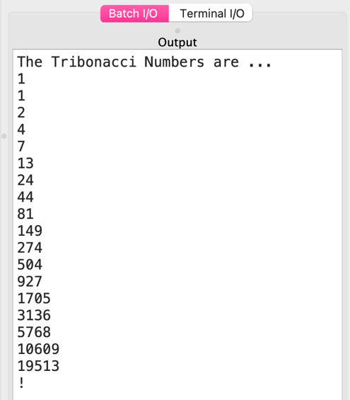  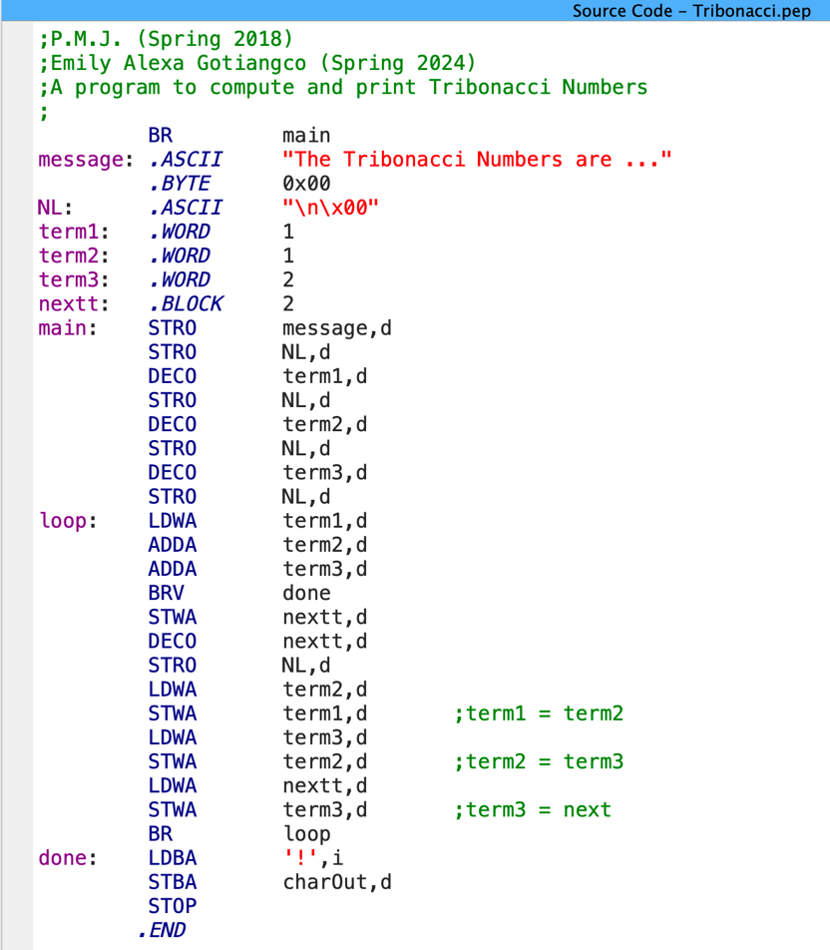  term2 is assigned the value of term3. term3 is assigned the value of next.  Add the value of term3 to what is in register A, namely term2.  Output the value of term3 as a decimal. Then output a new line.  term3 is assigned the value of the integer 2. | 