You should work on the following assignments in fixed teams of two. Please note that *every* team member must be able to explain *all* solutions of the team of two. Please submit only one solution for each team of two.

**Deadline to upload your solution for assignments 1 and 2:**

**Sunday, 11:59 pm bevor the laboratory.**

The remaining assignments can be done during the laboratory.

If you have questions or need any help, use the forum in our EMIL room und help each other.

*Assignment 1: ERD for a Student Information System*

A university wants to store information about its students and their courses in a database. The following requirements have been identified:

The university offers one or more study programs. Every study program has a program id, a name, and the required credit points to finish it.

A study program is made up of one or more courses. A course belongs to exactly one study program and has a course id, a name, a description, semester hours and credit points. A course can have none, one or more other courses as a prerequisite.

A student has a student id, first name, last name, date of birth and a year of enrollment. A student is enrolled in exactly one study program.

A student attempts courses, that are part of his/her study program. If a student attempts a course the year and term (summer or winter semester) and grade (between 0 and 15 points) are recorded.

* 1. Create an Entity-Relationship-Diagram in Chen notation according to these requirements. Add attributes where necessary. Take special care that you identify the entity types, relationship types, and key attributes.
  2. Draw an Entity-Relationship-Diagram in MC notation.
  3. Name two semantic integrity requirements, which make sense for the described model, but cannot be described in the Entity-Relationship-Diagram (e.g., a student cannot attempt a course he/she has already passed).
  4. Can you think of adding some additional composite, multivalued, or derived attributes in this example?

Solution: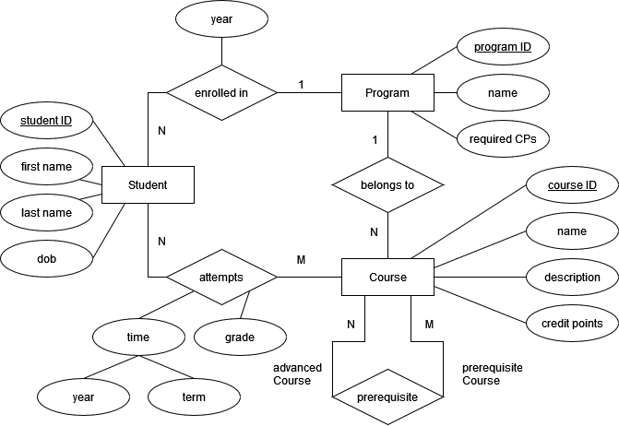

*Assignment 2: ERD for a Movie database*

Given is the following Entity-Relationship-Diagram in MC notation (actor is used as a generic term and includes actress):



* 1. Transform above Entity-Relationship-Diagram to Chen notation.
  2. Come up with reasonable attributes and keys and add them to your model.
  3. Assume this movie database is populated with data according to above constraints. Decide if the following statements are either true (***T***), false (***F***) or undecidable/maybe (***U***). “U” is used for statements that can either be true or false. Evaluate the statements purely based on the ERM and the included constraints.

|  |  |  |
| --- | --- | --- |
| No | Statement | ***T***, ***F*** or ***U***? |
| 1 | There are actors that have been performing in no movies. | F |
| 2 | There are some actors who have acted in more than ten movies. | U |
| 3 | Some actors have done a lead role in multiple movies. | U |
| 4 | Every director has been an actor in some movie. | F |
| 5 | Every actor performs in at least one movie. | T |
| 6 | A movie can have only a maximum of two lead actors. | F |
| 7 | Every movie has one director. | T |
| 8 | Every movie has at least one producer. | T |
| 9 | Some producers have been a director as well. | U |
| 10 | Some movies have two directors. | F |

*Assignment 3: ERD for a Bar Owner*

Draw an Entity-Relationship-Diagram in MC notation according to the following requirements. Add attributes where necessary. Take special care that you identify the entity types, relationship types, and key attributes.

The owner of several bars wants to supervise his business:

* First, each bar has a unique name and offers a variety of different drinks. A bar is located at a specific address.
* Different bars may serve the same drinks but with different pricing.
* The drinks are made of different ingredients. Since the drinks are sometimes improved by the different bars, these drinks have the same name but require some other kind of distinction.
* The only employees in the bars are bartenders. Every bartender is only employed in one bar. Each bar needs several bartenders to fulfil the job.
* Even though a bar may have different bartenders, these bartenders work only with a fixed partner (another bartender). Some bartenders don’t have a partner and thus work alone. Bartenders have a name, a social security number, a salary, and a phone number for contact purpose.

*Assignment 4: ERD for a Zoo*

Draw an Entity-Relationship-Diagram in MC notation according to the following requirements. Add attributes where necessary. Take special care that you identify the entity types, relationship types, and key attributes.

The director of the local zoo wants to track problems with his animals.

* The zoo has many animal types. Every animal type has a unique name and defines an age at which this type is determined reproductive.
* Every animal has a unique animal ID. Animals also have an age and a gender as well as an indicator if they are capable of reproduction.
* Animals may have diseases. The beginning time and the duration of a disease needs to be recorded. A disease has a unique name.
* A keeper takes care of only one animal type, but for every animal type there may be many keepers.
* A keeper may or may not be familiar with diseases. But every disease must be handled by at least one keeper. Keepers have name, employee ID, address, and phone number.

*Assignment 5: ERD for a Organization of Laboratory*

Draw an Entity-Relationship-Diagram in MC notation according to the following requirements. Add attributes where necessary. Take special care that you identify the entity types, relationship types, and key attributes.

A professor wants to save information about an upcoming laboratory next semester:

* The students are organized in teams. Every team elects a leader. A student can only be the leader of one team but participate in different teams.
* Teams are identified by a name, students by its matriculation number. We want to store students’ names as well.
* There are different lab sections, which are numbered and have a specific topic. The teams are formed to solve a specific lab section. So different teams solve the same lab section, but every team belongs to just one lab section.
* Within the lab the students should run experiments. Every team runs several experiments that have a run number and a result. These experiments are performed within a lab section.

Solution:

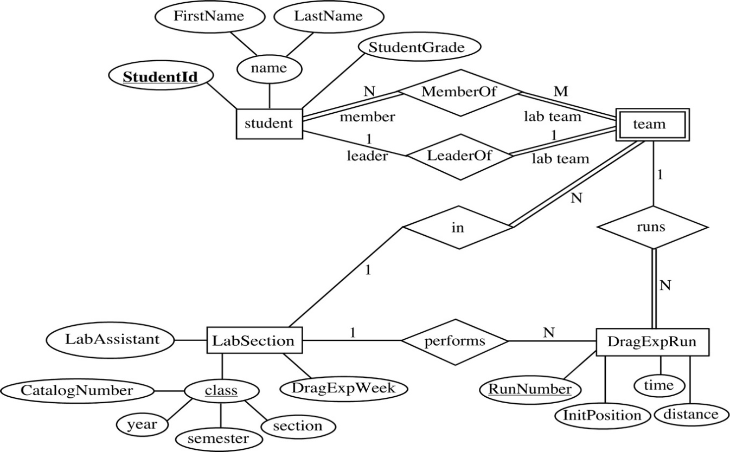

*Assignment 6: ERD for a Cooking Club*

Draw an Entity-Relationship-Diagram in MC notation according to the following requirements. Add attributes where necessary. Take special care that you identify the entity types, relationship types, and key attributes.

A cooking club organizes several dinners for its members. The purpose of the club is to allow several members to get together and prepare a dinner for the other members. The club president maintains a database that plans each meal and tracks which members attend each dinner and keeps track of which members create each dinner.

* Each dinner serves many members, and any member is allowed to attend. Each dinner has an invitation. This invitation is mailed to each member. The invitation includes the date of the dinner and location.
* Each dinner is based on a single entrée, a main course, and a single dessert. The recipes for the entrées and desserts can be used again for other dinners.