You should work on the following assignments in fixed teams of two. Please note that *every* team member must be able to explain *all* solutions of the team of two. Please submit only one solution for each team of two.

**Deadline to upload your solution for assignments 1, 2, 3, and 4:**

**Sunday, 11:59 pm bevor the laboratory.**

The remaining assignments can be done during the laboratory.

If you have questions or need any help, use the forum in our EMIL room und help each other.

*Assignment 1: Relational Model of a Student Information System*

Consider the following ERD for the Student Information System (analogous to Lab1 Assignment 1):

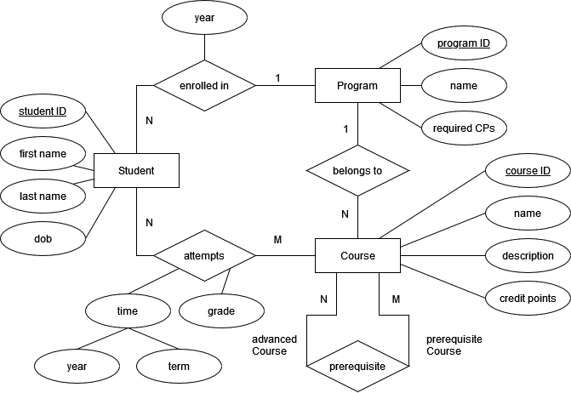

* 1. Convert the ERD into a relational schema. Follow the design guidelines from the lecture.
  2. Give example data for the relational schema you created (you could for example give rows for your own study program / courses / attempts or any fictional data).

*Assignment 2: Relational Model of a Hotel*

A hotel chain wants to use a database to keep track of their hotels and employees, described in the following ERD:

Ein Bild, das Zeichnung, Diagramm, Entwurf, Muster enthält.

In addition, take account of the following constraint: “Every stand-in is uniquely identifiable by the combination of the employee who replaces, the employee who is replaced and the date of the stand-in.”

Convert the ERD into a relation schema. Follow the design guidelines from the lecture.

*Assignment 3: Functional Dependencies and Normalization*

A university stores information about the quantities of copies of lecture notes sold by each professor. Lectures are taught by different professors, using different lecture notes.

The following sample database relation **SELLS** is used:

|  |  |  |  |  |  |  |  |
| --- | --- | --- | --- | --- | --- | --- | --- |
| **SELLS** | **lectId** | **lectName** | **profId** | **profName** | **noteId** | **price** | **quantity** |
|  | 24 | DB | 47 | Miller | 5 | 32 | 12 |
| 24 | DB | 272 | Adams | 1 | 35 | 15 |
| 24 | DB | 251 | Meyer | 5 | 32 | 17 |
| 25 | Java | 47 | Miller | 3 | 22 | 19 |

3.1 Determine the (full) functional dependencies. Keep in mind that FDs are determined by the model, not just by the actual data in the database relations.

3.2. Identify a primary key for the given relation **SELLS**. Explain your answer.

3.3. Transform the relational schema to 2NF. Your relation(s) should indicate PKs & FKs and contain all the data.

3.4. Transform the relational schema to 3NF. Your relation(s) should indicate PKs & FKs and contain all the sample data.

3.5. Create an ERD of the 3NF schema.

*Assignment 4: Relational Algebra*

The following excerpt of a database schema models a database of chess players. The relation **PLAYER** models a chess player, the relation **GAME** a game between two chess players. The attribute remis indicates whether the game is draw, it can be true or false.

**PLAYER**(PID, firstName, lastName, dateOfBirth)

**GAME**(GID, winnerID (FK), loserId (FK), remis)

The attributes winnerID and loserID are foreign keys to PID of **PLAYER**. Specify the following natural language queries as relational algebra queries.

4.1 Which chess players have won at least once? (Output: first name and last name)

4.2 What different chess players were born on the same day? (Output: PID1, PID2)

4.3 Which chess players have won in at least two games? (Output: WinnerID)

*Assignment 5 - Relational Model for Favorite Books*

Transform given ERD to an equivalent relational model.

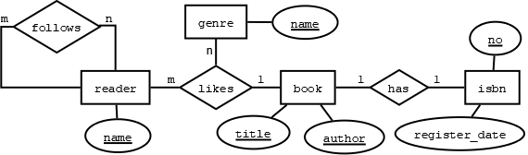

*Assignment 6 - Relational Model for the Organization of Laboratory*

Transform given ERD to an equivalent relational model. Note that a double line indicates optional participation. The team may be identified by an id.

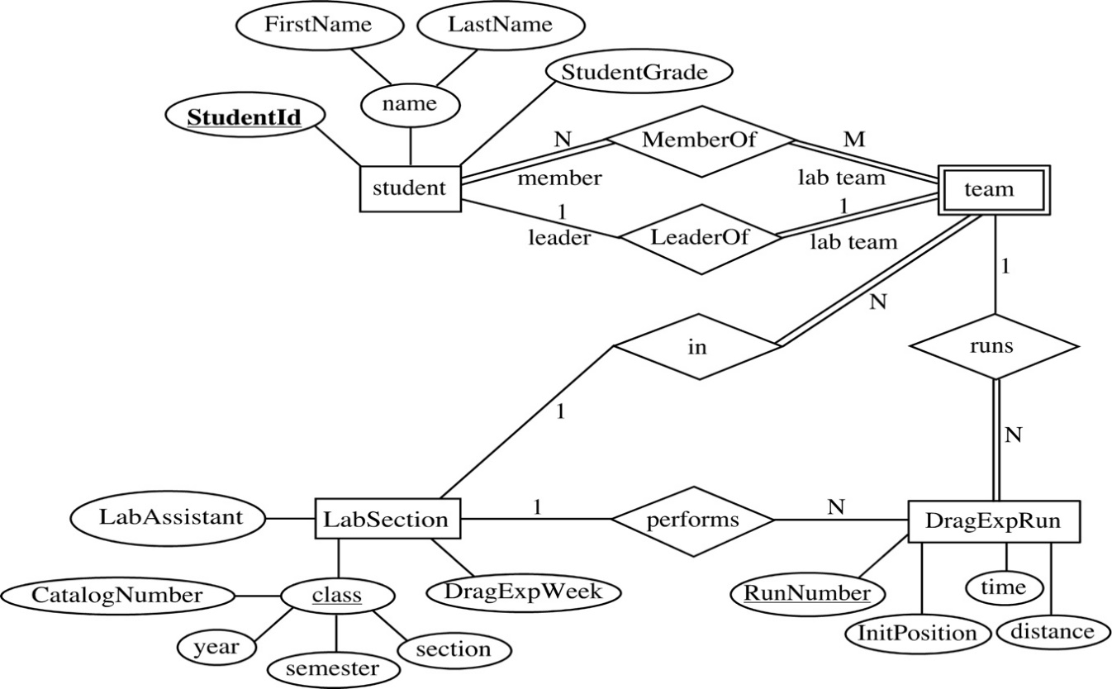

*Assignment 7 – Normalization of a Shop*

Consider the following relation **SHOP**:

**SHOP**(customerId, customerName, orderNr, orderedAt, articleNumber, description, quantity, price, articleName)

and functional dependencies **F** that hold over this relation:

customerId → customerName

orderNr → orderedAt, customerId, customerName

orderNr, articleNumber → quantity, customerId, customerName,

orderedAt, articleName, price, description

articleNumber → articleName, price, description

articleName → articleNumber

7.1 Determine all candidate keys (possible primary keys) of **SHOP**.

7.2 In which normal form is the relation **SHOP** (recall that a relation can be in multiple

normal forms), and why?

7.3 If relation **SHOP** is not in 1NF, 2NF or 3NF then decompose it, accordingly, taking care to denote possible keys (both PKs and FKs).

*Assignment 8 – Normalization for a General Example*

Consider the following relation **ANY**:

ANY (aid, bid, cid, aName, bName, cName, since, description, location)

and functional dependencies **F** that hold over the relation **ANY**:

aid → aName

aName → aid

bid → bName, location, cid, cName, description

cid → cName, description

cName → cId

aName, bid → aid, bid, cid, aName, bName, cName, location,

since, description

8.1 Determine all candidate keys (possible primary keys) of **ANY**.

8.2 In which normal form is the relation **ANY** (recall that a relation can be in multiple

normal forms), and why?

8.3 If relation **ANY** is not in 1NF, 2NF or 3NF then decompose it, accordingly, taking care to denote possible keys (both PKs and FKs).