# Lab 1 – IDE, Comments, Print and Ifs

First thing you will need for programming will be something to program in, which is an IDE!

An IDE stands for Integrated Development Environment. Basically, it allows you to type your code, correct syntax errors, run and test your code, and debug it. The IDEs also have the functionalities to *compile* and *interpret* the program. Some of the widely used IDs are Eclipse for Java programming development, Microsoft Visual Studio, Android Studio for Mobile Apps development, RStudio for R programs and PyCharm for Python programming.

1. You will need to download Python:
   1. On windows, in the *Files* section at the bottom of this page: <https://www.python.org/downloads/release/python-3110/>
   2. On linux, in the terminal: sudo apt install python3
2. Downloading Vscode:
   1. For Windows computers, go to <https://code.visualstudio.com/Download> and download the Windows version.
   2. If you are using a Pi or a Linux machine, you will be required to use Tar and change the file permissions to download it. I recommend using PyCharm on our raspberry Pis: It will be a bit more complex: <https://itsfoss.com/install-pycharm-ubuntu/>

Now that you have that installed, you can start a new project.

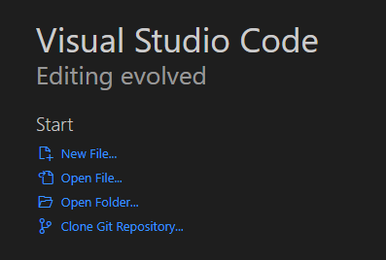

You will want to create a folder for all your coding files, then open that folder to work in. Or create your own Github repo to save your files to.

Start by creating a new file, Lab1.py. The file extension “.py” is for Python files.

1. **Comments**

Comments in your code allow you to type information without it being compiled.

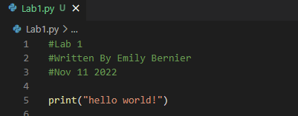

1. **Print**

Print(“”)allows you to print text in the console. Test it out by changing “hello world” to different chains of characters.

Be careful: if you want to print the character “, you will have to put a backslash in front of it:

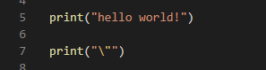

When running this code, it will output this:

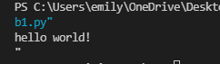

1. **If loops**

If loop is an important part of programming.

Check out the IF loops in the Lab1.py code in the github repo.

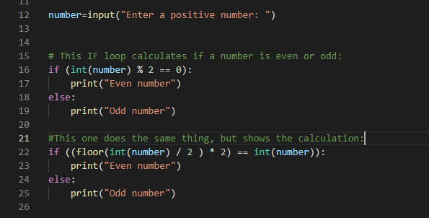

Now that you know how variables work, with this information and with the help of google, try to write a program that calculates an addition and substraction of two numbers.

You will need to use some inputs and Ifs + elifs.

If you would like, you can use ***Split***and ***Lists***to get shorter more efficient code: <https://pythonexamples.org/python-split-string-by-comma/>

The result should look like this:

