**Quantifying Assembly Processes**

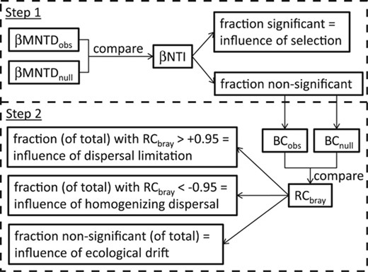

Stegen et al 2013 Stegen 2015

**Recommended reading:**

Nemergut, Diana R., et al. "Patterns and processes of microbial community assembly." Microbiology and Molecular Biology Reviews 77.3 (2013): 342-356.

Stegen, James C., et al. "Quantifying community assembly processes and identifying features that impose them." The ISME journal 7.11 (2013): 2069-2079.

Stegen, James C., et al. "Estimating and mapping ecological processes influencing microbial community assembly." Frontiers in microbiology 6 (2015): 370.

Graham, Emily B., and Joseph E. Knelman. "Implications of soil microbial community assembly for ecosystem restoration: patterns, process, and potential." Microbial ecology 85.3 (2023): 809-819.

Graham, Emily B., et al. "Deterministic influences exceed dispersal effects on hydrologically‐connected microbiomes." Environmental Microbiology 19.4 (2017): 1552-1567.

Knelman, Joseph E., et al. "Multiple, compounding disturbances in a forest ecosystem: fire increases susceptibility of soil edaphic properties, bacterial community structure, and function to change with extreme precipitation event." Soil Systems 3.2 (2019): 40.

**Notes:**

1. Make sure all of the following files are in a single folder:
   1. Scripts you will run:
      1. Assembly_Modelling_Tutorial.R
      2. Assembly_Modelling_Tutorial_Figures.R
   2. Data files:
      1. Knelman_2019_OTU_rarefied_10730.csv
      2. Knelman_2019_tree_matched_to_rarified_otu_table.tre
      3. mapping.csv
   3. Functions/scripts that are sourced:
      1. beta.nti.R
      2. Raup_Crick_Abundance_One_Comparison.r
2. The tutorial code is file: Assembly_Modelling_Tutorial.R. Run this file to work through the tutorial. I recommend starting this towards the end of the day and letting it run overnight. After it completes, Assembly_Modelling_Tutorial_Figures.R will generate some example figures from the output.
3. The tutorial will generate a lot of new output files that all go into a single folder. This can be adjusted to put each type of file into its own folder in if desired.
4. The tutorial uses a modified subset of data presented in Knelman et al. 2019.
5. The code can take a while to run, particularly the RCBray and betaMNTD implementation. For larger datasets, it may be necessary to run files on a super computer, in parallel, or locally overnight. Sometimes the bNTI implementation can be run locally even if the RCBray calculations need a super computer (or vice versa).
   1. Within the file Assembly_Modelling_Tutorial.R, steps 1-3 need to be run together and in order, as do steps 4-5. However, steps 1-3 can be run separately from steps 4-5. So, the code can be split into two scripts to help with computation (one with steps 1-3 and one with steps 4-5).
6. A few alternative R packages not covered in this tutorial:

<https://cran.r-project.org/web/packages/iCAMP/index.html>

<https://cran.r-project.org/web/packages/cati/index.html>