**Ch. 27-28 Study Guide**

**Vocab:**

**dēlectātiō, dēlectātiōnis (f)** = delight (Derivative: delectable)

**nepōs, nepōtis (m)** = grandson (Derivative: nephew)

**sōl, sōlis (m)** = sun (Derivative: solar)

**dīligēns, gen. dīligentis** = diligent (Derivative: diligence)

**dissimilis, dissimile** = different (Derivative: dissimilar)

**gracilis, gracile** = thin (Derivative: gracile)

**humilis, humile** = humble (Derivative: humiliate)

**maior, maius** = greater/older (Derivative: major)

**maiōrēs, maiōrum (m. pl.)** = ancestors (Derivative: major)

**prīmus, prīma, prīmum** = first (Derivative: prime)

**quot** = how many (Derivative: quota)

**similis, simile (+ gen. or dat.)** = similar (Derivative: simulate)

**superus, supera, superum** = above (Derivative: superior)

**superī, superōrum (m. pl.)** = the gods (Derivative: superior)

**ūtilis, ūtile** = useful (Derivative: utility)

**pōnō, pōnere, posuī, positum** = to place

**probō, probāre, probāvī, probātum** = to test (Derivative: probe)

**arma, armōrum (n. pl.)** = weapons (Derivative: army)

**cursus, cursūs (m)** = race/course (Derivative: cursive)

**lūna, lūnae (f)** = moon (Derivative: lunar)

**occāsiō, occāsiōnis (f)** = opportunity (Derivative: occasional)

**parēns, parentis (m or f)** = parent (Derivative: parental)

**stēlla, stēllae (f)** = star (Derivative: interstellar)

**vesper, vesperis or vesperī (m)** = evening (Derivative: vesperal)

**mortuus, mortua, mortuum** = dead (Derivative: mortuary)

**prīnceps, gen. prīncipis** = foremost (Derivative: prince)

**prīnceps, prīncipis (m or f)** = leader (Derivative: prince)

**ut** = (+ subj.) in order to/that, so that/that/to; (+ indic.) as, when

**nē** = not/in order that..not/in order not to

**cēdō, cēdere, cessī, cessum** = to go/withdraw/submit (Derivative: access)

**dēdicō, dēdicāre, dēdicāvī, dēdicātum** = to dedicate (Derivative: dedication)

**egeō, egēre, eguī (+ abl. or gen.)** = to need (Derivative: indigent)

**expleō, explēre, explēvī, explētum** = to fill/complete (Derivative: deplete)

**praestō, praestāre, praestitī, praestitum** = to excel/show/supply

**taceō, tacēre, tacuī, tacitum** = to be silent (Derivative: taciturn)

**Positive/Comparative/Superlative of -lis:**

Positive: **-lis, -e**

Comparative: **-ior, -ius**

Superlative: **-limus, -lima, -limum**

**Positive/Comparative/Superlative of -er:**

Positive: **-er**

Comparative: **-rior, -rius**

Superlative: **-errimus, -errima, -errimum**

**Jussive Clause:**

* Expresses a command/exhortation, especially in the first or third person.
* INDEPENDENT CLAUSE (Sentence has 1 verb)
* Negative commands are introduced by “nē”
* Translated starting with “Let ____”

There can be: jussive clause ut/nē purpose clause -> “let (not) ____ in order to _____”

**Purpose Clause:**

* A subordinate clause indicating the objective of the action in the main clause.
* DEPENDENT (Sentence has 2 verbs)
* Translated starting with “In order to/that”

**Other Irregular adjectives:**

* **facilis, facilior, facillimus** = (easy, easier, easiest)
* **difficilis, difficilior, difficillimus** = (difficult, more difficult, most difficult)
* **similis, similior, simillimus** = (like, more like, most like)
* **līber, līberior, līberrimus** = free, freer, freest)
* **pulcher, pulchrior, pulcherrimus** = (beautiful, more beautiful, most beautiful)
* **ācer, ācrior, ācerrimus** = (keen, keener, keenest)
* **bonus, melior, optimus** = (good, better, best)
* **magnus, maior, maximus** = (great, greater, greatest)
* **malus, peior, pessimus** = (bad, worse, worst)
* **multus, plūs, plūrimus** = (much, more, most)
* **parvus, minor, minimus** = (small, smaller, smallest)
* **prae, prō, prior, prīmus** = (before, former, first)
* **superus, superior, summus/suprēmus** = (that above, higher, highest furthest/last)

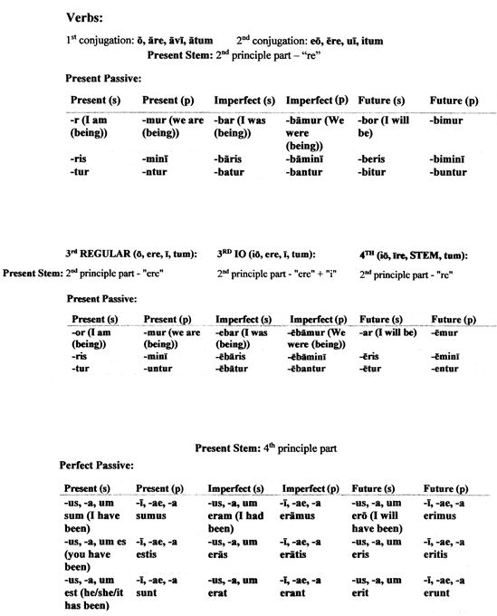

**Latin You Can Use:**

* “multum in parvo” = much in little
* “mutatis mutandis” = after making the necessary changes
* “ne plus ultra” = perfection
* “nihil per os” = nothing by mouth
* “nil desperandum” = never say ‘die’ (Horace)
* “nil sine numine” = nothing without divine will (Motto of Colorado)
* “noli me tangere” = touch me not (Jesus to Mary)
* “nolo contendere” = I do not wish to contend
* “non compos mentis” = not of sound mind
* “non ignara mali, miseris succurrere disco” = I’ve been there myself (Virgil, said by Dido)
* “non sequitur” = it does not follow
* “nostrum remedium” = a quack medicine/remedy