**Ch. 35, 36**

**Vocab:**

**aestās, aestātis (f)** = summer (Derivative: estivate)

**iānua, iānuae (f)** = door (Derivative: January)

**pectus, pectoris (n)** = heart (Derivative: pectoral)

**praemium, praemiī (n)** = reward (Derivative: premium)

**īrātus, īrāta, īrātum** = angry (Derivative: irate)

**antepōnō, antepōnere, anteposuī, antepositum** = to prefer

**foveō, fovēre, fōvī, fōtum** = to comfort (Derivative: foment)

**ignōscō, ignōscere, ignōvī, ignōtum (+dat.)** = to grant pardon to/to forgive

**imperō, imperāre, imperāvī, imperātum (+dat.)** = to give orders to/to command (Derivative: imperative)

**mīror, mīrārī, mīrātus sum** = to marvel at/to admire/wonder (Derivative: miracle)

**noceō, nocēre, nocuī, nocitum (+dat.)** = to do harm to/to harm (Derivative: innocent)

**nūbō, nūbere, nūpsī, nūptum (+dat.)** = to be married to/to cover/marry (Derivative: nubile)

**parcō, parcere, pepercī, parsūrum (+dat.)** = to be lenient to/to spare (Derivative: parsimony)

**pāreō, pārēre, pāruī (+dat.)** = to be obedient to/to obey (Derivative: apparent)

**persuādeō, persuādēre, persuāsī, persuāsum (+dat.)** = to persuade (Derivative: dissuade)

**placeō, placēre, placuī, placitum (+dat.)** = to be pleasing to/to please (Derivative: pleasure)

**sapiō, sapere, sapīvī** = to be wise (Derivative: sapient)

**serviō, servīre, servīvī, servītum (+dat.)** = to be a slave to/to serve (Derivative: service)

**studeō, studēre, studuī (+dat.)** = to be eager for/study (Derivative: student)

**subrīdeō, subrīdēre, subrīsī, subrīsum** = to smile upon

**cupīdō, cupīdinis (f)** = desire (Derivative: cupidity)

**lēctor, lēctōris (m)** = reader (Derivative: lecture)

**lēctrīx, lēctrīcis (f)** = reader (Derivative: lecture)

**vinculum, vinculī (n)** = bond/chain (Derivative: vinculum)

**cōtīdiē** = daily (Derivative: cotidian)

**fortasse** = perhaps

**accēdō, accēdere, accessī, accessum** = to come to/to approach (Derivative: access)

**carpō, carpere, carpsī, carptum** = to harvest/seize (Derivative: carpet)

**cōgō, cōgere, coēgī, coāctum** = to drive/force (Derivative: cogent)

**contemnō, contemnere, contempsī, contemptum** = to despise (Derivative: contempt)

**contundō, contundere, contudī, contūsum** = to beat/crush (Derivative: contuse)

**cūrō, cūrāre, cūrāvī, cūrātum** = to attend to/to cure (Derivative: curator)

**dēcernō, dēcernere, dēcrēvī, dēcrētum** = to decide/settle (Derivative: decretal)

**exigō, exigere, exēgī, exāctum** = to drive out/to perfect (Derivative: exactitude)

**fīō, fierī, factus sum** = to happen/become/be done (Derivative: fiat)

**oblectō, oblectāre, oblectāvī, oblectātum** = to please/pass time pleasantly (Derivative: oblectation)

**ōrō, ōrāre, ōrāvī, ōrātum** = to speak/beg (Derivative: oracle)

**recreō, recreāre, recreāvī, recreātum** = to restore/refresh/cheer (Derivative: recreation)

**requīrō, requīrere, requīsīvī, requīsītum** = to seek/miss/need/require (Derivative: request)

**serēnō, serēnāre, serēnāvī, serēnātum** = to brighten/cheer up (Derivative: serenity)

**Jussive Noun Clause:**

* Indirect command
* A kind of purpose clause (purpose is translated as: in order to/in order to not)
* Contains:
  + Intro verb: impero/oro/peto/etc. (could also contain subjunctive: let ___ ____)
  + Ut/ne (Translated as to)
  + Subjunctive verb

**Dative Case Nouns:**

* Adjective Examples: fidelis/similis => Translations: local to me/similar to me
* Verb Examples: servio/noceo/placeo => Translations: pleasing to me/etc.
* Compound Verb Examples: admitto = > Translation: to lose to
* Dative with Adjectives:
  + Noun in dative case + adjectives (usually indicates attitude/quality.relation/direction)
* Dative with Special Verbs:
  + Noun in dative case + special verbs (usually indicates attitude/relationship)
* Dative with Compound Verbs:
  + Noun in dative case + compound verbs (verbs with -ad/ante/con/in/inter/ob/post/prae/pro/sub/super in front of it)

**Forms of fīō, fierī, factus sum:**

* Treated as 3rd IO
* Present Stem: fie

Present Indicative Active:

|  |  |  |  |  |  |  |
| --- | --- | --- | --- | --- | --- | --- |
|  | Present(S) | Present(P) | Imperfect(S) | Imperfect(P) | Future(S) | Future(P) |
| 1st: | Fīō | Fīmus | Fīēbam | Fīēbāmus | Fīam | Fīēmus |
| 2nd: | Fīs | Fītis | Fīēbās | Fīēbātis | Fīēs | Fīētis |
| 3rd: | Fit | Fīunt | Fīēbat | Fīēbant | Fīet | Fīent |

Perfect Active:

|  |  |  |  |  |  |  |
| --- | --- | --- | --- | --- | --- | --- |
|  | Perfect(S) | Perfect (P) | Pluperfect(S) | Pluperfect (P) | Fut. P.(S) | Fut. P. (P) |
| 1st: | Factus sum | Factī sumus | Factus eram | Factī eramus | Factus ero | Factī erimus |
| 2nd: | Factus es | Factī estis | Factus eras | Factī eratis | Factus eris | Factī eritis |
| 3rd: | Factus est | Factī erunt | Factus erat | Factī erant | Factus erit | Factī erint |

Present Subjunctive:

|  |  |  |
| --- | --- | --- |
|  | Present(S) | Present(P) |
| 1st: | Fīam | Fīāmus |
| 2nd: | Fīās | Fīātis |
| 3rd: | Fīat | Fīant |

**Review (1st, 2nd, 3rd decln.):**

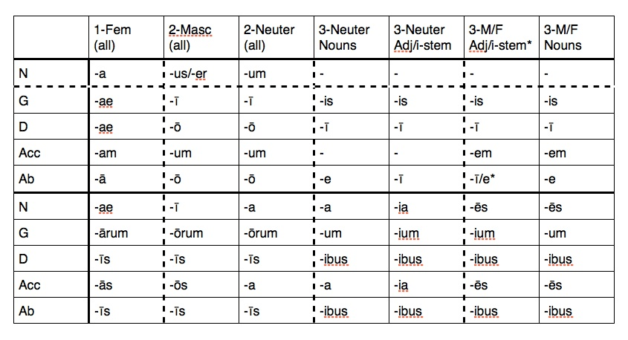

**Latin You Can Use:**

* Re ipsa loquitur = the facts speak for themselves
* Rigor mortis = the stiffness that follows death
* Salus populi suprema lex esto (Motto of Missouri) = let the welfare of the people be the supreme law
* Sanctum sanctorum = holy of holies
* Scilicet = namely
* Semper fidelis (Motto of the U.S. Marine Corps) = always faithful
* Semper paratus (Motto of the U.S. Coast Guard) = always prepared
* Senatus populusque Romanus (Motto of Rome) = the senate and Roman people
* Sic = thus