**FOR 5 KM VICINITY:**

OLS Regression Results:

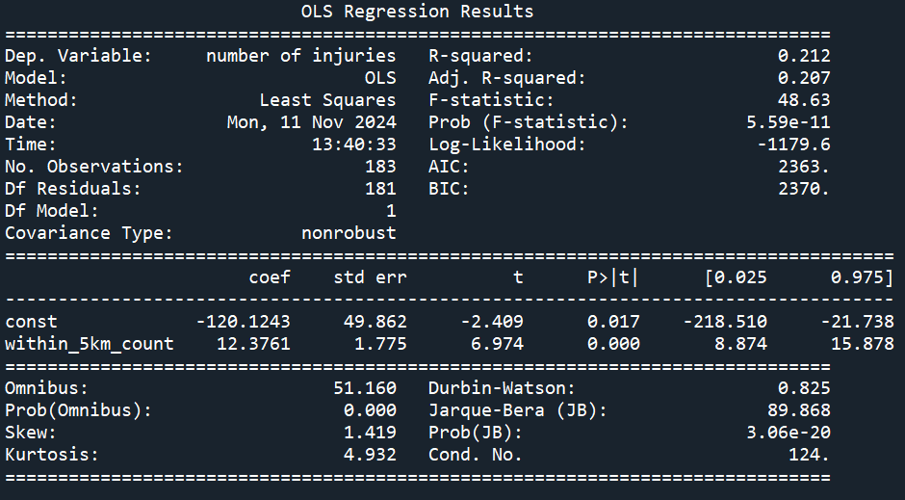

Plot showing linear regression of counts of attacks in 5 km vicinity vs # of injuries:

Residuals:

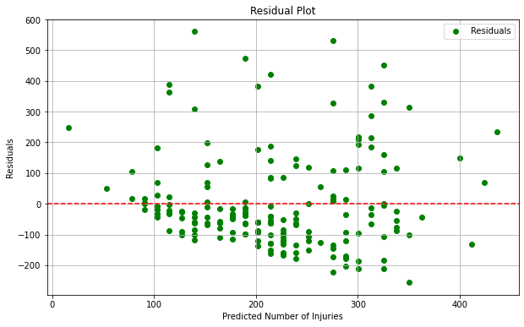

Count of each attack_type that make up the attacks in the 5 km vicinity:

Proportion of each attack_type that make up the attacks in the 5 km vicinity:

FOR 1 KM VICINITY:

OLS Regression Results:

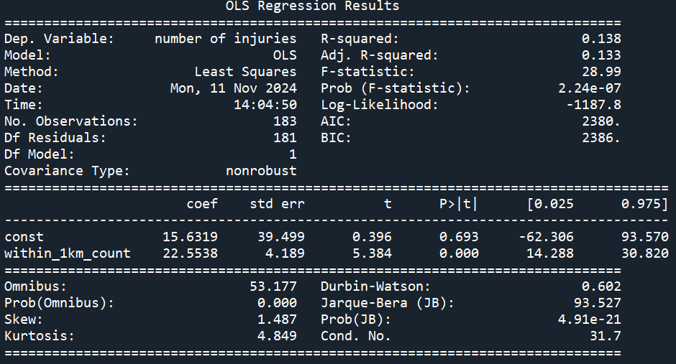

Plot showing linear regression of counts of attacks in 1 km vicinity vs # of injuries:

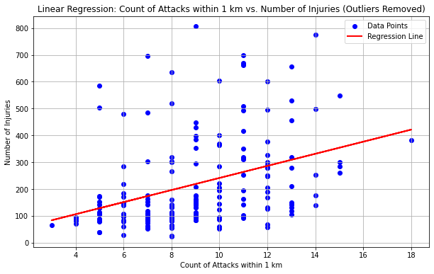

Residuals:

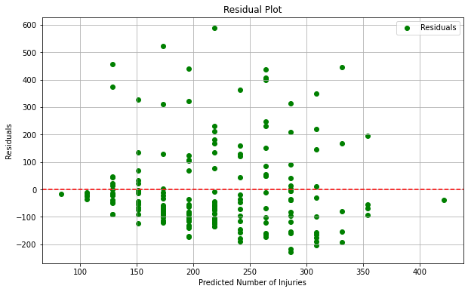

Count of each attack_type that make up the attacks in the 1 km vicinity:

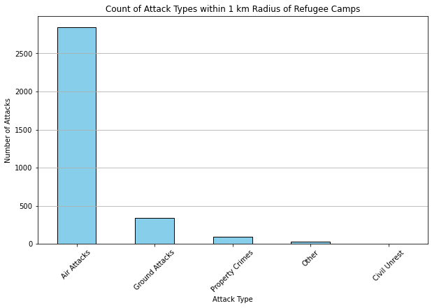

Proportion of each attack_type that make up the attacks in the 1 km vicinity:

