Instructions

Final Assignments

- Investigating disparities in Global Air Quality Monitoring
https://ssoubie.github.io/data_viz_air_quality_project/
images/sensors

Module: Urban Data Visualization (CASA0029)

Description: This HTML-based website explores the spatial distribution of air quality sensors across the globe. The site uses interactive maps and charts to tell a research-driven story about the inequalities that are present and investigates potential drivers of these inequalities. The site highlights a stark difference in urban analytics and data accessibility between the Global North and Global South – a topic I am deeply passionate about.

- Remote Sensing Learning Portfolio
https://emilydugmore.github.io/remote_sensing_portfolio/
images/rs

Module: Remote Sensing for Cities and Environments (CASA0023)
This portfolio consists of nine weekly learning diary entries for the module Remote Sensing for Cities and Environments. During the module, I used Google Earth Engine to apply satellite imagery across a number of …

- Using Pocket Parks to Address Climate and Health SDG goals in Arsenal
pdfs/SDG_Pocket_Parks.pdf
images/sdg

Module: Sustainable Development Goals, Climate Action and Spatial Planning (BPLN0114)

This report is the final submission for

- PlotShare – Making London’s Allotments a Shared Space and Resource
https://eckertniklasm.github.io/casa0028-assessment2/
images/plotshare

Module: Designing Spatial Data Stories (CASA0028)

- Potential Energy Savings across England and Wales

Modules: Quantitative Methods (CASA0007) and Urban Data Visualization (CASA0029)
https://emilydugmore.github.io/epc_interactive_map/
images/epc
pdfs/QM_Assignment.pdf

Other assignments/projects

- Municipal Service Delivery Performance in South Africa
https://emilydugmore.github.io/RSA_Service_Delivery_Map/
images/rsa_service

React based app that uses information from South African Census to …

Layout of website:
List of all the projects with:
- Title
- Platform/format
- Module
- Photo (which links to the site)
- Description (which sits on the right hand side of the photo)

Investigating disparities in Global Air Quality Monitoring
HTML Website
Urban Data Visualization (CASA0029)
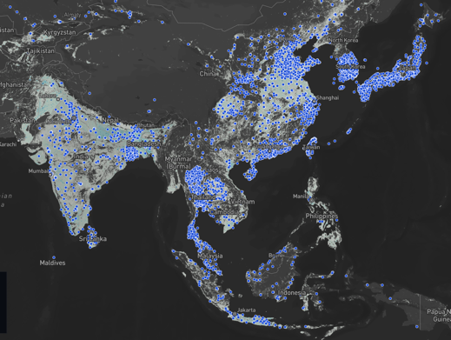
This HTML-based website explores the spatial distribution of air quality sensors across the globe. The site uses interactive maps and charts to tell a research-driven story about the inequalities that are present and investigates potential drivers of these inequalities. The site highlights a stark difference in urban analytics and data accessibility between the Global North and Global South – a topic I am deeply passionate about.

