Installation Guide for eShopCONNECT Magento Custom API:

Version 1.5

www.pluginsforconnectedbusiness.com

This document describes how to install the Lerryn extensions to the Magento API.

The Magento API extension consists of 6 files:

api.xml | Api.php
config.xml | install-0.1.11.php
Lerryn_LBSapi.xml | Observer.php

The 6 files all need to be in the correct place in the Magento server installation for the extension to work. Here is the directory structure for the API:

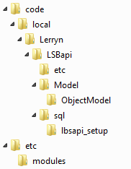

The files including the directory structure are:

code\local\lerryn\LBSapi\etc\api.xml
code\local\lerryn\LBSapi\etc\config.xml
code\local\lerryn\LBSapi\Model\Observer.php
code\local\lerryn\LBSapi\Model\ObjectModel\Api.php
code\local\lerryn\LBSapi\sql\lbsapi_setup\install-0.1.11.php
etc\modules\Lerryn_LBSapi.xml

The API needs to be installed in the base\app folder in the Magento installation. Here is the directory structure for the Magento base directory:

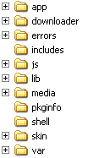

The files can be downloaded in either a Windows zip or Unix tarball format which contains the 6 files and the necessary directory structure from
www.pluginsforconnectedbusiness.com/plugins/eshopconnect/download/LerrynMagentoAPI.zip or www.pluginsforconnectedbusiness.com/plugins/eshopconnect/download/LerrynMagentoAPI.tar

If the downloaded .zip or .tar file is placed in the ‘app’ folder and extracted ‘into the current directory’ the files will be placed in the correct folders. When installed the directory structure will look like this:

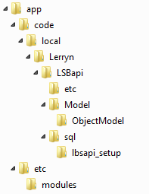

Following installation of the API files, you may need to either re-boot your Magento server or force a refresh of the registered API modules as follows :-

- Login to your Magento Admin screen.
- Navigate to System (across top) → configuration
- Click Advanced (near bottom of left hand side) → Advanced
- Expand ‘Disable Modules Output'
- Check for a Lerryn_LBSapi entry above the standard Magento entries
- If there is no Lerryn_LBSapi entry, click ‘Save Config’ (top right)
- Wait a few seconds
- Look for ‘The configuration has been saved’ message
- Make sure the Lerryn_LBSapi entry is now showing

This API extension has been tested on Magento versions 1.3, 1.4.2, 1.5.0.1, 1.6.01, 1.7.01, 1.8.0.0, 1.11.2 and 1.13.0.2. There are no differences in the installation for any version, regardless of the operating system.

Once the API extension is installed and registered, you need to create an API login for eShopCONNECT to use as follows :-

First step is to create an API Role
- Login to your Magento Admin screen (if not already logged in)
- Navigate to System (across top) → Web Services → Roles
- Create a new Role and give it a Role Name such as Web-API
- Click on Role Resources and select All in the Resource Access list box
- Click Save Role

Next step is to create the API User
- When the role has saved, select System → Web Services → Users
- Create a new User and give it a User Name such as eShopCONNECT, plus first and last name plus email address.
- The API Key is the password that will be used by the API User – we recommend that it contains a mixture of at least 10 upper and lower case letters and numbers to make it secure.
- Make sure the account is marked as active, then click on User Role and select the User Role created above
- Click Save User

