class04.R

emilyhendrickson

2024-10-11

# Practice for class  
  
x <- 1:500  
plot(x)

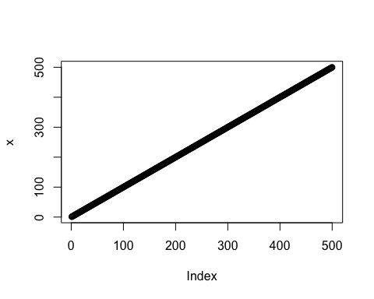

plot(x, sin(x), type = "l", col="red")

