1. Retrieve the name and address of each employee that works in the Research department.

SELECT fname, lname, ssn
FROM employee
WHERE dno = '5';

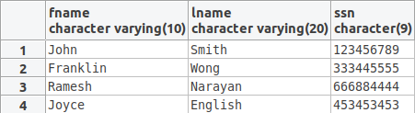

2. Retrieve the name and SSN of each employee that either works in department 4 or has a salary lower
or equal to $30,000. You can use only one condition term in any WHERE clause; i.e., don't use AND/OR Boolean operations.

SELECT fname, lname, ssn
FROM employee
WHERE dno = '4'
UNION
SELECT fname, lname, ssn
FROM employee
WHERE salary <= '30000';
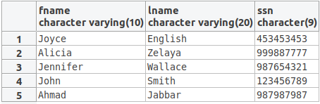

3. List the name and SSN of each employee that works on at least one of the projects 1, 2, and 3. You
can use only one condition term in any WHERE clause.

SELECT ssn, fname, lname
FROM employee JOIN works_on ON ssn=essn
WHERE pno='1'
UNION
SELECT ssn, fname, lname
FROM employee JOIN works_on ON ssn=essn
WHERE pno='2'
UNION
SELECT ssn, fname, lname
FROM employee JOIN works_on ON ssn=essn
WHERE pno='3';

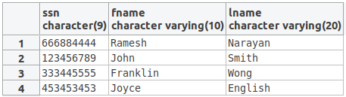

4. Retrieve the names of all employees of the Research department who work more than 10 hours per
week on the ProductX project.

SELECT fname, lname
FROM employee, works_on, project
WHERE dno = '5'
AND ssn = essn AND pno = pnumber AND pname = 'ProductX' AND hours > '10';

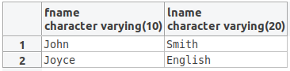

5. Retrieve the names of all employees who work on all projects [every project] located in either
Bellaire or Sugarland. That is, if p1, p2, and p3 are in Bellaire; and p4 and p5 are located in Sugarland;
then I want an employee who works on p1, p2, p3, p4, and p5.

SELECT DISTINCT fname, lname
FROM ((employee JOIN works_on ON ssn=essn) JOIN project ON pnumber=pno)
WHERE plocation='Bellaire' OR plocation='Sugarland';SELECT DISTINCT fname, lname
FROM ((employee JOIN works_on ON ssn=essn) JOIN project ON pnumber=pno)
WHERE plocation='Bellaire' OR plocation='Sugarland';

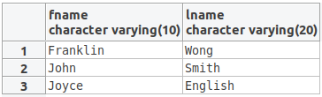

6. Find the names of all employees who work on at least one project located in Houston but whose
department has no location in Houston.

SELECT fname, lname
FROM employee
WHERE EXISTS (SELECT *
FROM works_on, project
WHERE ssn=essn AND pno=pnumber AND plocation='Houston')
AND NOT EXISTS (SELECT *
FROM dept_locations
WHERE dno=dnumber AND dlocation='Houston');

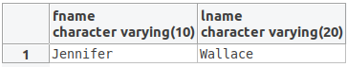

7. For each department whose average employee salary is more than $30,000, retrieve the department
name and the number of male employees working for that department.

SELECT dname, COUNT(*)
FROM department JOIN employee ON dnumber=dno
WHERE sex='M'
GROUP BY dname HAVING AVG(salary) > '3000';

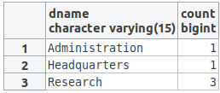

8. Retrieve the names of all employees who work in the department that has the employee with the
highest salary among all employees.

SELECT fname,lname
FROM employee
WHERE dno=(SELECT dno
FROM employee
WHERE salary=(SELECT MAX(SALARY)
FROM employee));

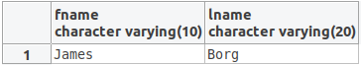

9. [9A] Create a View ProjectInfo that has the project name, controlling department name, number of
employees, and total hours worked per week on the project for each project with more than one
employee working on it. [9B] Show the content of this view.

9a.
CREATE VIEW ProjectInfo (project_name, department_name, number_of_employees, total_num_hours)
AS
SELECT pname, dname, COUNT(*), SUM(hours)
FROM project, department, works_on
WHERE pnumber=pno AND dnumber=dnum
GROUP BY pname, dname HAVING COUNT(*)>1;
9b.
SELECT * FROM ProjectInfo;

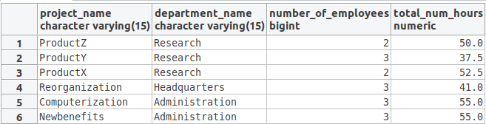

10. [10A] Create a View DepartmentInfo that has the department name, manager name for each
department. [10B] Show the content of this view.

10a.
CREATE VIEW DepartmentInfo (department_name, mgr_fname, mgr_lname)
AS
SELECT dname, fname, lname
FROM DEPARTMENT, EMPLOYEE
WHERE DEPARTMENT.Mgr_ssn = EMPLOYEE.Ssn
GROUP BY dname, fname, lname;
10b.
SELECT * FROM DepartmentInfo;

