chem313_LCMSlab

Emily McLaughlin Sta. Maria

11/20/2020

X <- lm(calibration$signal~calibration$conc)  
plot(calibration$signal~calibration$conc,  
 xlab="[Levoglucosan] (ug/mL)",  
 ylab="Peak Area",  
 main="Calibration Curve for Levoglucosan")  
abline(X)

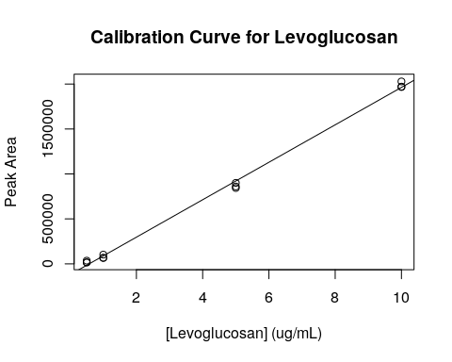

summary(X)

##   
## Call:  
## lm(formula = calibration$signal ~ calibration$conc)  
##   
## Residuals:  
## Min 1Q Median 3Q Max   
## -78140 -21718 5998 31208 65807   
##   
## Coefficients:  
## Estimate Std. Error t value Pr(>|t|)   
## (Intercept) -119530 19252 -6.209 1e-04 ***  
## calibration$conc 208247 3427 60.768 3.54e-14 ***  
## ---  
## Signif. codes: 0 '***' 0.001 '**' 0.01 '*' 0.05 '.' 0.1 ' ' 1  
##   
## Residual standard error: 45280 on 10 degrees of freedom  
## Multiple R-squared: 0.9973, Adjusted R-squared: 0.997   
## F-statistic: 3693 on 1 and 10 DF, p-value: 3.54e-14

## sorting by coast and year - West  
  
lev_conc_solution <- (data$signal+119530)/208247 #x = (y - b)/m  
  
lev_conc <- lev_conc_solution*4*70/24 ##unit conversion   
  
error <- sqrt((3427/208247)^2 + (19252/119530)^2) * lev_conc  
  
graph_data <- data.frame(lev_conc, error, data$coast, data$year)  
  
West_lev <- graph_data %>%  
 filter(data.coast=="W")   
  
West_lev_1750 <- West_lev %>%   
 filter(data.year==1750)  
West_lev_1950 <- West_lev %>%   
 filter(data.year==1950)  
West_lev_2020 <- West_lev %>%   
 filter(data.year==2020)  
  
West_lev_1750

## lev_conc error data.coast data.year  
## 1 47.86775 7.749917 W 1750  
## 2 48.93437 7.922607 W 1750  
## 3 50.54213 8.182906 W 1750

W_1750 <- mean(West_lev_1750$lev_conc)  
W_1950 <- mean(West_lev_1950$lev_conc)  
W_2020 <- mean(West_lev_2020$lev_conc)  
  
W_errors_sq_17 <- (West_lev_1750$error)^2  
W_errors_sum_17 <- sum(W_errors_sq_17)  
W_errors_17 <- (sqrt(W_errors_sum_17)/sum(West_lev_1750$lev_conc))*W_1750  
  
W_errors_sq_19 <- (West_lev_1950$error)^2  
W_errors_sum_19 <- sum(W_errors_sq_19)  
W_errors_19 <- (sqrt(W_errors_sum_19)/sum(West_lev_1950$lev_conc))*W_1950  
  
W_errors_sq_20 <- (West_lev_2020$error)^2  
W_errors_sum_20 <- sum(W_errors_sq_20)  
W_errors_20 <- (sqrt(W_errors_sum_20)/sum(West_lev_2020$lev_conc))*W_2020  
  
  
west_averages <- c(W_1750, W_1950, W_2020)  
west_errors <- c(W_errors_17, W_errors_19, W_errors_20)

## sorting by coast and year - West  
  
East_lev <- graph_data %>%  
 filter(data$coast=="E")   
  
East_lev_1750 <- East_lev %>%   
 filter(data.year==1750)  
East_lev_1950 <- East_lev %>%   
 filter(data.year==1950)  
East_lev_2020 <- East_lev %>%   
 filter(data.year==2020)  
  
E_1750 <- mean(East_lev_1750$lev_conc)  
E_1950 <- mean(East_lev_1950$lev_conc)  
E_2020 <- mean(East_lev_2020$lev_conc)  
  
east_averages <- c(E_1750, E_1950, E_2020)  
  
E_errors_sq_17 <- (East_lev_1750$error)^2  
E_errors_sum_17 <- sum(E_errors_sq_17)  
E_errors_17 <- (sqrt(E_errors_sum_17)/sum(East_lev_1750$lev_conc))*E_1750  
  
E_errors_sq_19 <- (East_lev_1950$error)^2  
E_errors_sum_19 <- sum(E_errors_sq_19)  
E_errors_19 <- (sqrt(E_errors_sum_19)/sum(East_lev_1950$lev_conc))*E_1950  
  
E_errors_sq_20 <- (East_lev_2020$error)^2  
E_errors_sum_20 <- sum(E_errors_sq_20)  
E_errors_20 <- (sqrt(E_errors_sum_20)/sum(East_lev_2020$lev_conc))*E_2020  
  
east_errors <- c(E_errors_17, E_errors_19, E_errors_20)  
  
west_averages <- c(W_1750, W_1950, W_2020)  
west_errors <- c(W_errors_17, W_errors_19, W_errors_20)

average_conc <- c(E_1750, E_1950, E_2020, W_1750, W_1950, W_2020)  
average_errors <- c(E_errors_17, E_errors_19, E_errors_20, W_errors_17, W_errors_19, W_errors_20)  
average_coast <- c("E", "E", "E", "W", "W", "W")  
average_year <- c("1750", "1950", "2020", "1750", "1950", "2020")  
  
graph_data_averages <- data.frame(average_conc, average_errors, average_coast, average_year)  
  
ggplot(data=graph_data_averages, aes(x=average_year, y=average_conc, fill=average_coast)) +  
 geom_bar(stat="identity", position=position_dodge()) +  
 geom_errorbar(aes(ymin=average_conc-average_errors, ymax=average_conc+average_errors), width=0.2, position=position_dodge(0.9)) +  
 xlab("Year") +  
 ylab("Concentration (ug/m^3)") +  
 ggtitle("Levoglucosan Levels") +  
 scale_fill_discrete(name="US Coast", labels=c("East", "West")) +  
 theme(plot.title = element_text(hjust = 0.5))

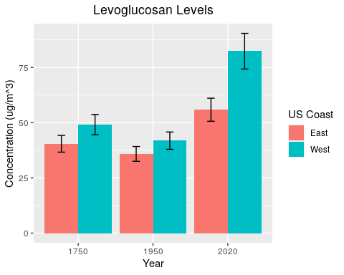

#statistics  
  
var.test(East_lev_2020$lev_conc, West_lev_2020$lev_conc)

##   
## F test to compare two variances  
##   
## data: East_lev_2020$lev_conc and West_lev_2020$lev_conc  
## F = 0.00037247, num df = 2, denom df = 2, p-value = 0.0007447  
## alternative hypothesis: true ratio of variances is not equal to 1  
## 95 percent confidence interval:  
## 9.550556e-06 1.452640e-02  
## sample estimates:  
## ratio of variances   
## 0.0003724717

t.test(West_lev_2020$lev_conc, East_lev_2020$lev_conc, mu=0, paired=FALSE, var.equal=FALSE)

##   
## Welch Two Sample t-test  
##   
## data: West_lev_2020$lev_conc and East_lev_2020$lev_conc  
## t = 1.445, df = 2.0015, p-value = 0.2852  
## alternative hypothesis: true difference in means is not equal to 0  
## 95 percent confidence interval:  
## -52.36633 105.38039  
## sample estimates:  
## mean of x mean of y   
## 82.36755 55.86052