

Bailey Arman

arman013@umn.edu

Abstract

How can the University of Minnesota’s College of Liberal Arts’ web help team synthesize the current Drupal training guide, pattern library, and style guide to create a cohesive style guide that meets the needs of disabled and abled users?

Recommendation report

CLA’s Style Guide

LETTER OF TRANSMITTAL

December 19th, 2018

Professor Daniel Card

Nolte Center 221

315 Pillsbury Dr SE

Minneapolis, Minnesota, 55455

Professor Card,

To fulfill the final assignment requirement of the course WRIT3562V, I submit the attached recommendation report.

This report compiles research on how websites can be made more accessible to visually impaired users, which includes those that are legally blind, losing their vision, and are color blind. These research findings are then compared to the University of Minnesota’s current policy regarding technology and visually impaired users. Taking into account both the research and the resources currently offered by the University of Minnesota, a variety of remedies will be recommended. I hope you find this report satisfactory.

Sincerest regards,

Bailey Arman

WRIT3562V, fall 2018

Nolte Center 229

315 Pillsbury Dr SE

Minneapolis, Minnesota, 55455

TABLE OF CONTENTS

* Letter of Transmittal 1
* Table of Contents 2
* Introduction 3
* Background 3
* Criteria 9
* Options 10
* Conclusion 13
* Recommendation 13
* References 15
* Glossary 16

**INTRODUCTION:** With 35,433 students enrolled in 2018, The University of Minnesota has one of the highest enrollments of colleges worldwide. No two students are identical, which means our students have a diverse range of abilities. How can the University of Minnesota better serve our blind and low visibility population when it comes to electronic media, such as the University’s website? While I am not blind or low vision myself, part of my job is to maintain the College of Liberal Art’s website, and I want to be sure that any information relevant to a student’s university experience is actually accessible to that student.

**BACKGROUND:** In name I work for a marketing agency called CLAgency, but half of the work that I do is actually in tandem with the Office of Information Technology (OIT). The work I do for them includes web development, responding to tickets, and maintaining the College of Liberal Arts’ (CLA) website. If ever an employee of a CLA department would like to make edits or gain access to CLA’s website, they must first be trained in by me. After this training session, they are then released to the world and allowed to independently make edits. If they have any further questions, they can either contact the web help team (which I am a part of) or reference the online guides, plural. Unfortunately, these guides cause quite a few problems, but with enough effort, these guides can be part of the solution.

CLA has three guides, a pattern library, style guide, and Drupal resource (Drupal is the software the UMN site is hosted on, and the web training employees receive instructs them on how the software works), any three of which may have the answer that the worker seeks. The pattern library mainly covers UMN and CLA brand guidelines, the style guide covers text formatting, grammar, and tone, while the Drupal resource answers FAQs about using Drupal. My task is to cohesively synthesize all three of these guides into one resource that effectively and efficiently conveys web development information to workers who have little experience in the topic.

I would have been assigned to this task no matter what, so where do visually impaired users come in? How do they fit into the context of web resources? As previously mentioned, I want to ensure that every student has access to what they need, and often it does not occur to sighted workers (or hearing workers, or able-bodied users, etc.) that visually-impaired folk use their websites![1] Beyond that sentiment, it is also just University policy that web resources are accessible to all users. Specifically, “web site owners or their designee shall be responsible for monitoring Web resources for compliance with WCAG 2.1 AA[2]. Monitoring shall include an automated scan using the [*Functional Accessibility Evaluator (FAE)*](https://fae.illinois.edu/) on a bi-annual (twice yearly) basis and results submitted to the Disability Resource Center (DRC)” (University Policy Program, 2018). Beyond even University policy, the Americans with Disabilities Act (ADA) and sections 504 and 508 of the Rehabilitation Act of 1973 require, by federal law, that those with disabilities have equal opportunity to benefit from all programs, services, and activities offered by state and lo[cal](https://accessibility.umn.edu/policy/civil-rights-laws-helpful-guidelines) institutions, which, as a land grant and public institution, includes the University of Minnesota Twin Cities. Section 504 explicitly states that “no qualified individual with a disability in the United States shall be excluded from, denied the benefits of, or be subjected to discrimination under any program or activity that […] receives Federal financial assistance” (Congress, 1973). The University is legally required to be accessible, and the University explicitly states that those in the web development department are responsible for providing “consulting services to units making changes to comply with this policy” (University Policy Program, 2018), while web developers must “follow established University standards when creating and revising University web pages”(University Policy Program, 2018). So, while it is ultimately up to the departments to maintain their individual sites with WCAG accessibility standards, it is the task of web development to provide services and information that allow those departments to create accessible sites.

As previously established, the OIT is currently overhauling three CLA resources: the pattern library, style guide, and Drupal resource. It is our duty to create guides that are both more accessible and promote accessibility in a better way. The next section of this essay will include a mock-up of a new guide, for your perusal, with brief notes on accessibility.

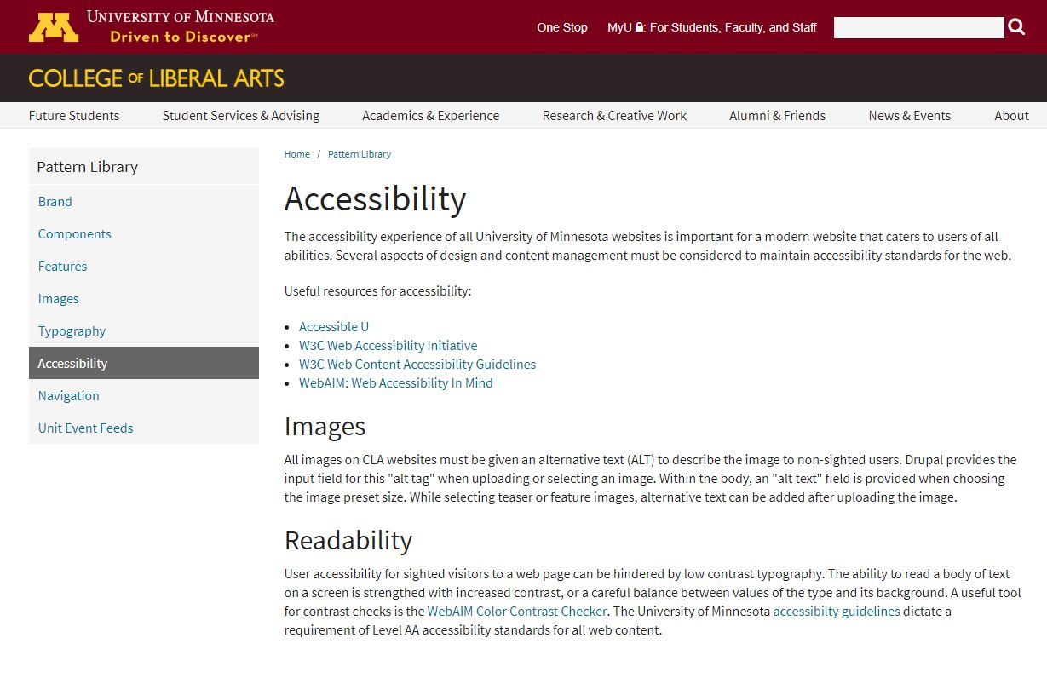

Figure 1. Pattern Library's accessibility section

While I can ensure that in live training sessions I explicitly mention why the website should be accessible and what tactics we use to make it so, this is more difficult in the style guide. Currently, neither the Drupal training guide nor the style guide have an accessibility statement. The pattern library does (see figure 1), and while informative, it is sparse. My team and I hope to have a more comprehensive accessibility statement, while also interspersing accessibility standards within the rest of the style guide.

Before we move on, though, a brief note on the terms “accessible” and “visually impaired.” University policy defines the term “accessible” as follows:

*“A person with a disability is afforded the opportunity to acquire the same information, engage in the same interactions, and enjoy the same services as a person without a disability in an equally effective and equally integrated manner, with substantially equivalent ease of use. The person with a disability must be able to obtain the information as fully, equally and independently as a person without a disability. Although this might not result in identical ease of use compared to that of persons without disabilities, it still must ensure equal opportunity to the educational benefits and opportunities afforded by the technology and equal treatment in the use of such technology” (University Policy Program, 2018).*

The Disability Resource Center defines a disability as “a physical or mental impairment that substantially limits one or more major life activities such as concentrating, sleeping, seeing, hearing, walking, learning or self-care” (Disability Resource Center, 2018) and has this to say about “blind and low vision” students in particular:

*“Few individuals are totally blind; many individuals have some useful vision that can be utilized through the use of adaptive devices. Individuals are considered to be legally blind when they meet specific criterion for their vision loss. Someone has low vision when they have decreased visual acuity or visual field that cannot be corrected with ordinary eyeglasses, contact lenses, medical or surgical procedures.*

*Visual impairments may occur because of birth defects, inherited diseases, injuries, diabetes, glaucoma, cataracts, macular degeneration, and other conditions. Some individuals may use Braille, large print, various assistive technologies, or a combination of these for communication purposes” (Disability Resource Center, 2018).*

Thus far it may seem like the terms “visually-impaired” and “blind” have been used synonymously and interchangeably, but this is not the case. Visually-impaired is a blanket term for any disability relating to vision. The proposed solution have not only blind users in mind, but also benefit other visually-impaired users as well. Low vision, a condition under the term “visually-impaired,” generally means a decreased ability to see unable to be fixed by glasses, although most organizations define this term slightly differently. Visually-impaired also includes various forms of color-blindness.

Other external resources that informed our decision-making process about the future of these resources include: Bigham’s article “A Comparative Analysis of Blind and Sighted Browsing Behavior,” Carter & Markel’s “Writing and Speaking in the Technology Professions: A Practical Guide,” Lazar & Jonathan’s “What Frustrates Screen Reader Users on the Web,” Power et. al.’s Guidelines are Only Half of the Story: Accessibility Problems Encountered by Blind Users on the Web,” and Schmetzke’s “Web Accessibility at University Libraries and Library Schools.”

**CRITERIA:** The previously discussed research and an interview with CLA’s head web developer, Simon Whitney[3], provided input for the development of the following criteria. The criteria have no particular rank, and though this report has focused almost entirely on accessibility, each criterion is equally important.

1. Intuitive design – How easy is it for users to find what they are looking for? Does the content under headings make sense under their heading? Is it easy to predict what content is beneath the heading?
2. Layman’s ability to use the style guide – Can those that are not experts in web development understand the style guide? Do amateurs benefit from the style guide as much as those that may have some background in website design?
3. Efficiency – How quickly can users find what they are looking for? Can they quickly complete their task without many or any errors?
4. Accessibility – Is the style guide easy and intuitive for visually-impaired users as much as it is for sighted users?

It should be noted that the principles and practices that make a website more accessible for visually impaired users also, in general, make the site easier for sighted users to use as well.

**OPTIONS:** As stated in the Background section of this report, the College of Liberal Arts currently have three different guides that, if all goes as planned, will be merged into one as a result of this report. These guides, the Drupal training guide, CLA style guide, and CLA pattern library, all have different layouts and purpose. Before we reveal the proposed style guide, let’s evaluate the current versions.

***DRUPAL TRAINING GUIDE***

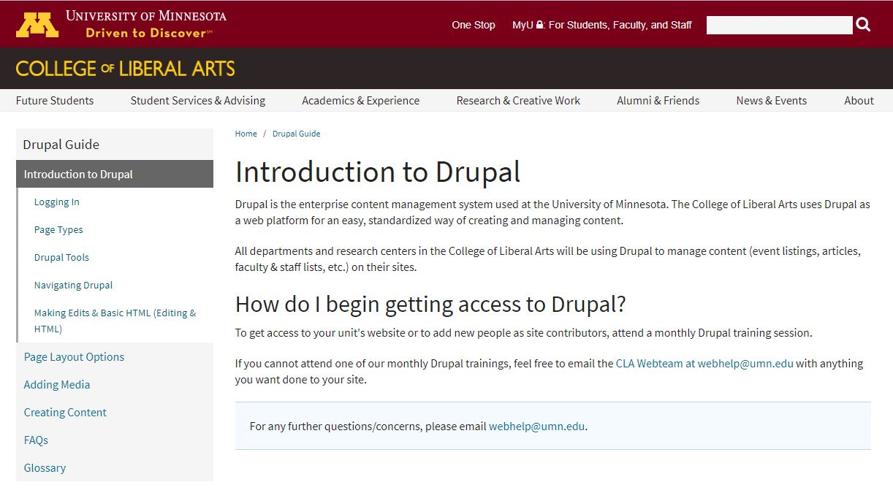

Figure 2. Drupal Guide Introduction page

The Drupal Guide is a resource for those that make edits to CLA’s website. It serves a variety of purposes: to give college employees the independence to edit the website without contacting the web team; to ensure unity across department sites; to be a resource for those that have just completed Drupal training and are just beginning to edit the site.

The Drupal section does cover alt text, but not in detail. The most concerning issue is the fact that the Drupal guide isn’t even finished, and has been left unfinished for at least one full year. Along with covering accessibility in greater detail, unfinished sections should be filled in.

***CLA STYLE GUIDE***

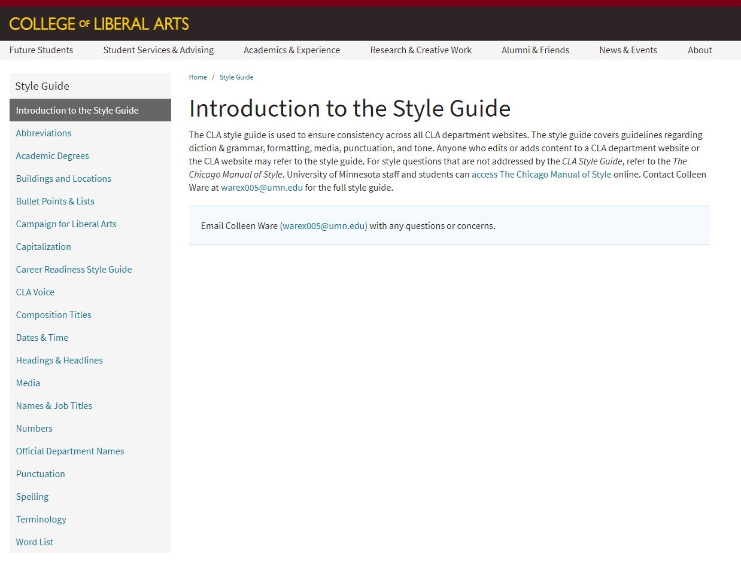

Figure 3. CLA's Style Guide

CLA’s style guide was created mainly as a resource for a marketing agency, CLAgency, which serves the College of Liberal Arts, and as such does not fit the needs of the majority of CLA’s employees. The style guide requires condensing of material and decisions about what information should and should not continue be included. If CLAgency would like to retain their style guide, a new page should be made to serve that purpose. The style guide contains no mention of accessibility.

***CLA PATTERN LIBRARY***

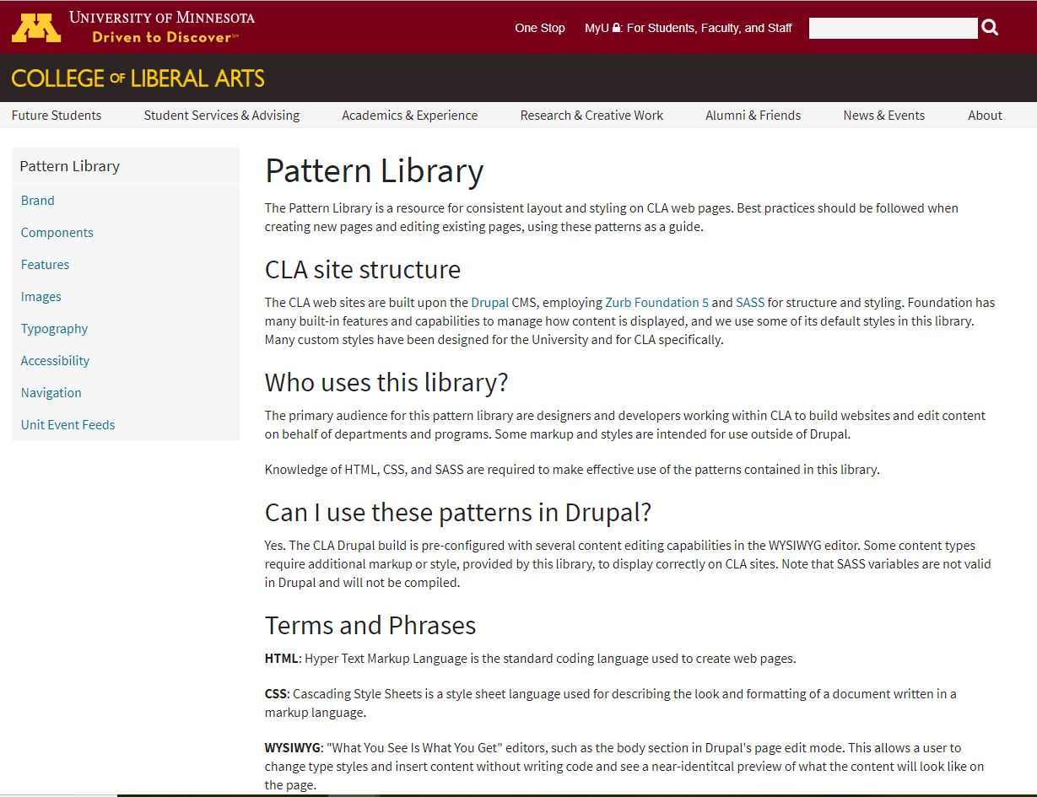

Figure 4. CLA's Pattern Library

The pattern library’s main purpose should be to provide UMN branded design elements that can be used across sites, but in reality it does this in addition to explaining how to use and format them in Drupal. Basically, the pattern library should be a subsection of the Drupal training guide.

Of all the resources, the pattern library best accomplishes educating the audience about online accessibility. In figure 4, one can observe by viewing the sidebar that accessibility has its own section.

**CONCLUSION:** Based on the research and the current University of Minnesota policy regarding the accessibility of technology, it is evident that the University of Minnesota policy is the issue at hand, but rather the enforcement of this policy. It is doubtful that those editing the site are maliciously barring access to those that are disabled, but are rather either unaware of the policy or of how to make their sites accessible. Furthermore, the three CLA guides are primed for improvement.

**RECOMMENDATION:** Based on the conclusion, three recommendations are proposed: an audit, revised training notes, and an overhaul of the Drupal resource.

The audit is fairly straightforward. Each and every page on the College of Liberal Art’s site will be reviewed for accessibility standards. A tool to easily conduct this audit is the [Web Accessibility Checker](https://achecker.ca/checker/index.php), which will analyze a page for accessibility issues. If a specific issue consistently crops up in a department’s site, the chair or the staff in charge of editing the site should be approached and set on the correct course. In addition, we can also use this audit as an opportunity to look for style and formatting issues, such as blurry photos on landing pages or a repeated misuse of commas and colons. The audit may take a considerable amount of time, but it is a long time coming and worth investing into.

The next order of business are the Drupal training notes. Because I have experience training staff in on web editing, I know what to say about accessibility and when during the training I should say it. However, I am a student worker, and at some point I will graduate, and someone will replace me. Relying on relaying the information verbally, from one worker to another over the years, is a poor strategy, because there will always be information lost or altered in the various iterations or verbal relay. Instead, I propose to edit the current training notes, which are already quite bare as they currently exist, with a more comprehensive section on accessibility. In addition, I will bolster the other sections as well, such as the navigation, images, and formatting content sections.

Finally, my colleague Emily Raper and I have proposed a synthesis of the style guide, pattern library, and Drupal resource, pulling elements of each into the final product. For example, the pattern library and Drupal training guide both use drop down menus, but the style guide does not, and could benefit from that. As is currently the case in the pattern library, accessibility will have it’s own page. Following the implementation of the proposed resource, usability testing would be conducted on the resource, and revisions would be implemented as need be.

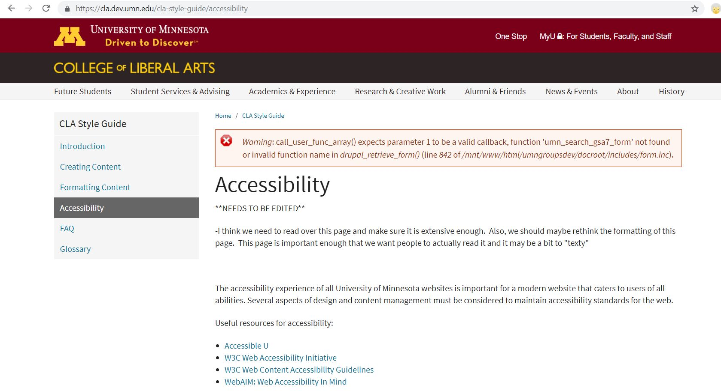

Figure 5. Mock-up of accessibility page on synthesized guide

**REFERENCES:**

Bigham, J. et. al. (2007). WebinSitu: A comparative analysis of blind and sighted browsing behavior. *Special Interest Group on Accessible Computing, 9*. Pp 51-58

Carter, J., Markel, M. (2015). Web accessibility for people with disabilities: An introduction for web developers. *Writing and Speaking in the Technology Professions: A Practical Guide*. Pp 484 – 492

Congress (1973). *The rehabilitation act of 1973.* Washington, D.C: U.S. G.P.O.

Disability Resource Center. (2018). Information about disabilities. Retrieved Dec 15th, 2018, from <https://diversity.umn.edu/disability/informationaboutdisabilities>

Lazar, Jonathan. et. al. (2007). What frustrates screen reader users on the web: A study of 100 blind users. *International Journal of Human-Computer Interaction, 22*(3). Pp. 247-269

Power, C. et. al. (2012). Guidelines are only half of the story: Accessibility problems encountered by blind users on the web. *ACM SIGCHI Conference on Human Factors in Computing Systems*. Pp 433-442

Schmetzke, A. (2001). Web accessibility at university libraries and library schools. *Library Hi Tech, 19*(1). Pp. 35-49

University Policy Program. (2018). *Accessibility of information technology.* Minneapolis, MN: U.S.

**GLOSSARY:**

**A**

accessible: A person with a disability is afforded the opportunity to acquire the same information, engage in the same interactions, and enjoy the same services as a person without a disability in an equally effective and equally integrated manner, with substantially equivalent ease of use. The person with a disability must be able to obtain the information as fully, equally and independently as a person without a disability. Although this might not result in identical ease of use compared to that of persons without disabilities, it still must ensure equal opportunity to the educational benefits and opportunities afforded by the technology and equal treatment in the use of such technology (University Policy Program, 2018).

**C**

CLA: This acronym stands for College of Liberal Arts

**D**

Disability Resource Center (DRC): An on campus resource working with students, faculty, staff, and guests at the University of Minnesota to eliminate or minimize barriers to disabled folks at the University.

Drupal: a free and open source content-management framework. The CLA site is hosted on Drupal.

**O**

Office of Information Technology (OIT): The University of Minnesota’s central IT unit. OIT provides technology support to students, staff, faculty, and administration at the University

**P**

pattern-library: a collection of design elements (for example brands, logos, colors, etc.) that appear multiple times on a site.

**S**

screen-reader: assistive technology that reads words out loud. Blind or visually impaired folk use this software to access the internet, computers, and cell phones.

style guide: a set of standards for the writing and design of documents within a specific publication, organization, or field.

**U**

UMN: This acronym stands for the University of Minnesota

**V**

visually-impaired: A blanket term for disabilities related to vison

1. And yes, blind people do use the internet. To do so they utilize software called “screen readers,” which basically read out loud the words that are on the screen of either the user’s phone or computer. Additionally, they may purchase a braille computer display, which allows them to read or type silently.
2. WCAG stands for “Web Content Accessibility Guidelines,” and 2.1AA is the most updated version, as recently as August 2018. WCAG is internationally recognized as a standard for accessibility.
3. Mr. Whitney can be reached by email at simonw@umn.edu