Extensions on a Dynamical Systems Model of Reward and Executive Circuitry in Obsessive-Compulsive Disorder

Emily Davies

# Statement of the Research Problem

Despite the prevalence and debilitating character of OCD, the neural circuitry underlying it is not fully understood. Biologically informed mathematical models can be used to understand dynamics underpinning the disorder, but current models are limited by simplifying assumptions.

# Background Information

Obsessive-compulsive disorder (OCD) is a prevalent psychiatric disorder that affects 1-3% of people. The defining symptoms are obsessions— intrusive thoughts and fears that cause intense anxiety— and compulsions— repetitive actions performed to alleviate this anxiety.1

The neurobiological mechanisms responsible for this disorder are still being investigated.

Because OCD is a heterogeneous disorder with a variety of factors that contribute to its development, it is difficult to label a single brain circuit or abnormality responsible.1 Advances in structural and functional brain imaging technology, however, have highlighted some specific neural circuits as contributors to the characteristic symptoms of OCD. For example, brain scans of unaffected and affected individuals have associated cortical regions, specifically the orbitofrontal cortex and the anterior cingulate cortex with obsessive-compulsive symptoms.3 The orbitofrontal cortex is associated with emotion and fear response as well as reward signaling, and the anterior cingulate cortex is linked to motivation and action.2 However, psychiatric disorders can rarely be ascribed to abnormalities in a single section of the brain, and are often informed by complex interactions between different pathways and networks of neurons and areas.

In order to investigate these interactions, researchers can construct mathematical models to visualize how changes in connectivity and interactions can lead to varied dynamics. In “A mathematical model of reward and executive circuitry in obsessive compulsive disorder”, published in the *Journal of Theoretical Biology*, . Rǎdulescu and Marra propose a model to describe the dynamics of several brain regions thought to be involved in OCD symptoms.2

# Planned Work

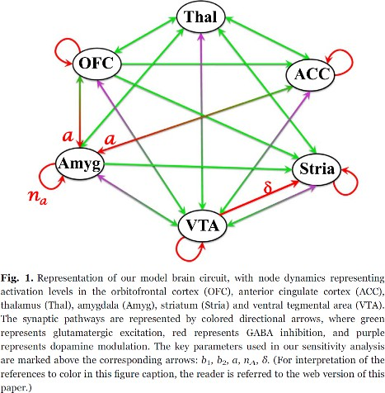For this project, I plan to expand upon the model proposed by Rǎdulescu and Marra in “A mathematical model of reward and executive circuitry in obsessive compulsive disorder”, published in the *Journal of Theoretical Biology*. This model was able to produce different steady state dynamics based on strength of connections between brain regions, corresponding to clinically significant subtypes of OCD.

The figure on the left is from the aforementioned paper and describes the connectivity scheme, informed by neurobiological data, that Rǎdulescu and Marra devised as a basis for their model. The model takes into account interactions between the orbitofrontal cortex and

anterior cingulate cortex (cortical regions), the striatum and thalamus (CTSC reward pathway), the amygdala and hippocampus (limbic areas) and other related dopamine pathways.

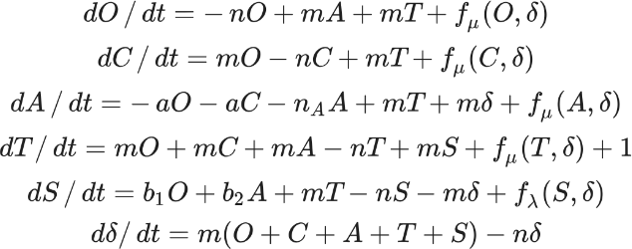The equations for this model were defined by Rǎdulescu and Marra as pictured where O represented activity of the orbitofrontal cortex, C the cingulate cortex, A the amygdala, T the thalamus, S the ventral striatum and nucleus accumbens, and δ dopamine modulation controlled by a sigmoidal function. The

relationships between the nodes were otherwise defined linearly. I plan to alter that linearity to better reflect the biological trends of network connections.2

First, I will research accepted modes of representing neural circuits mathematically to determine whether the model can be adjusted to account for nonlinearity. Then I will use computational methods to replicate Rǎdulescu and Marra’s parameter adjustments and evaluate the resulting dynamics of the system.

# Timeline

*Week 1: April 18 - April 24* – Locate the datasets/previous work used by Rǎdulescu and Marra to construct their model, and identify if/where relationships between nodes or other aspects were simplified. Also research conventions of representing biological neural networks and make educated guesses about ways the model can be modified to potentially better reflect reality. Reproduce original results.

*Week 2: April 25 - May 1* – Implement modified model computationally and evaluate results. Adjust if needed. If no interesting results are observed, consider other modifications, such as parameter adjustments. Work on objectives and background section of presentation

*Week 3: May 2 - May 8* – Finish implementing model if not finished, and perform analysis on results. Work on model and results section of presentation.

*Week 4: May 9 – May 15* – Work on Discussion section of presentation and prepare presentation.

# References

1. Brock, H., Rizvi, A., & Hany, M. (2024). Obsessive-Compulsive Disorder. In *StatPearls*. StatPearls Publishing.
2. Rǎdulescu, A., & Marra, R. (2017). A mathematical model of reward and executive circuitry in obsessive compulsive disorder. *Journal of theoretical biology*, *414*, 165–175. https://doi.org/10.1016/j.jtbi.2016.11.025
3. Thorsen, A. L., Hagland, P., Radua, J., Mataix-Cols, D., Kvale, G., Hansen, B., & van den Heuvel, O.

A. (2018). Emotional Processing in Obsessive-Compulsive Disorder: A Systematic Review and Meta- analysis of 25 Functional Neuroimaging Studies. *Biological psychiatry. Cognitive neuroscience and neuroimaging*, *3*(6), 563–571. https://doi.org/10.1016/j.bpsc.2018.01.009