Above-ground biomass map for Haiti from 2019 L-band backscatter

Emily Sturdivant, JL, CR, SB, RB, RL, AG

7/16/2021

## Abstract

The island of Hispaniola has a complex forest dynamic that to date lacks reliable estimates of above-ground biomass (AGB). Such estimates are important to understanding dynamics of forest loss and recovery in the evolving landscape mosaic. Here, we develop a map of AGB in 2019 for Haiti and the Dominican Republic at 25 meter resolution. The map is created by calibrating the 2019 ALOS-2 PALSAR-2 mosaic from JAXA to in situ AGB at 36 sites in Haiti, with the following steps: a) inventory trees at 36 plots in Haiti in fall 2019; b) calculate AGB per hectare for each plot using the pan-tropical allometric model developed by Chave et al. (2014; Eq. 4); c) calibrate plot mean backscatter values from the 2019 L-band mosaic (25 m resolution) to observed AGB per ha using an OLS regression model (n=36) with repeated k-fold cross-validation; d) apply the resulting linear model (validation RMSE=19.8 ± 6.9 Mg/ha) to the backscatter mosaic. The resulting AGB map has a mean value of 40.5 ± 29.5 Mg/ha (median=33.9), with about 96% of the values falling below 100 Mg/ha.

summary(cars)

## speed dist   
## Min. : 4.0 Min. : 2.00   
## 1st Qu.:12.0 1st Qu.: 26.00   
## Median :15.0 Median : 36.00   
## Mean :15.4 Mean : 42.98   
## 3rd Qu.:19.0 3rd Qu.: 56.00   
## Max. :25.0 Max. :120.00

## Including Plots

You can also embed plots, for example:

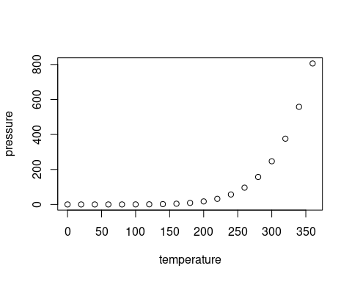

Note that the echo = FALSE parameter was added to the code chunk to prevent printing of the R code that generated the plot.