Carbon Report for Indonesia

### 1. Total aboveground carbon

The region has an area of 189,531,752 ha, and stored 20,291.5 million metric tons of aboveground carbon (MtC) ca. 2003, with an average carbon density of 107.1 tons of carbon per hectare (tC/ha). As of 2018, the region stored 20,499.4 MtC with an average carbon density of 108.2 tC/ha.

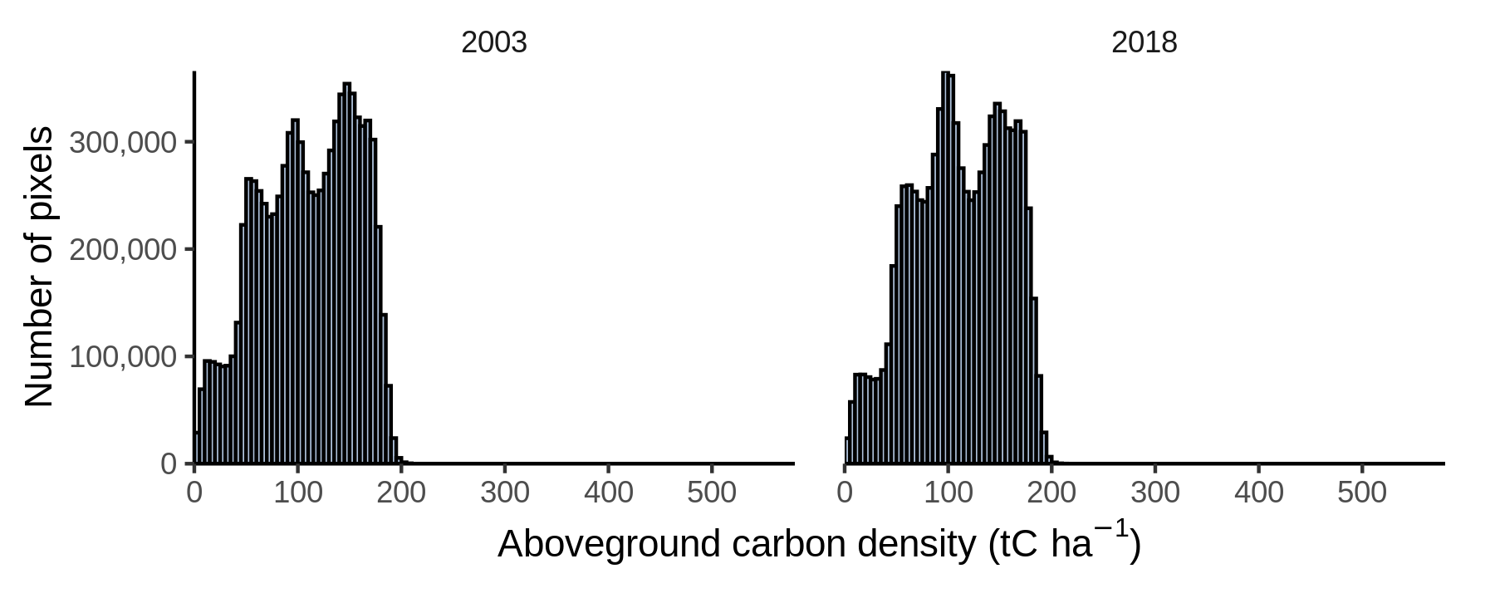

Figure 1: Distribution of aboveground carbon density ca. 2003 (left) and 2018 (right).

### 2. Annual losses and gains (2003-2018)

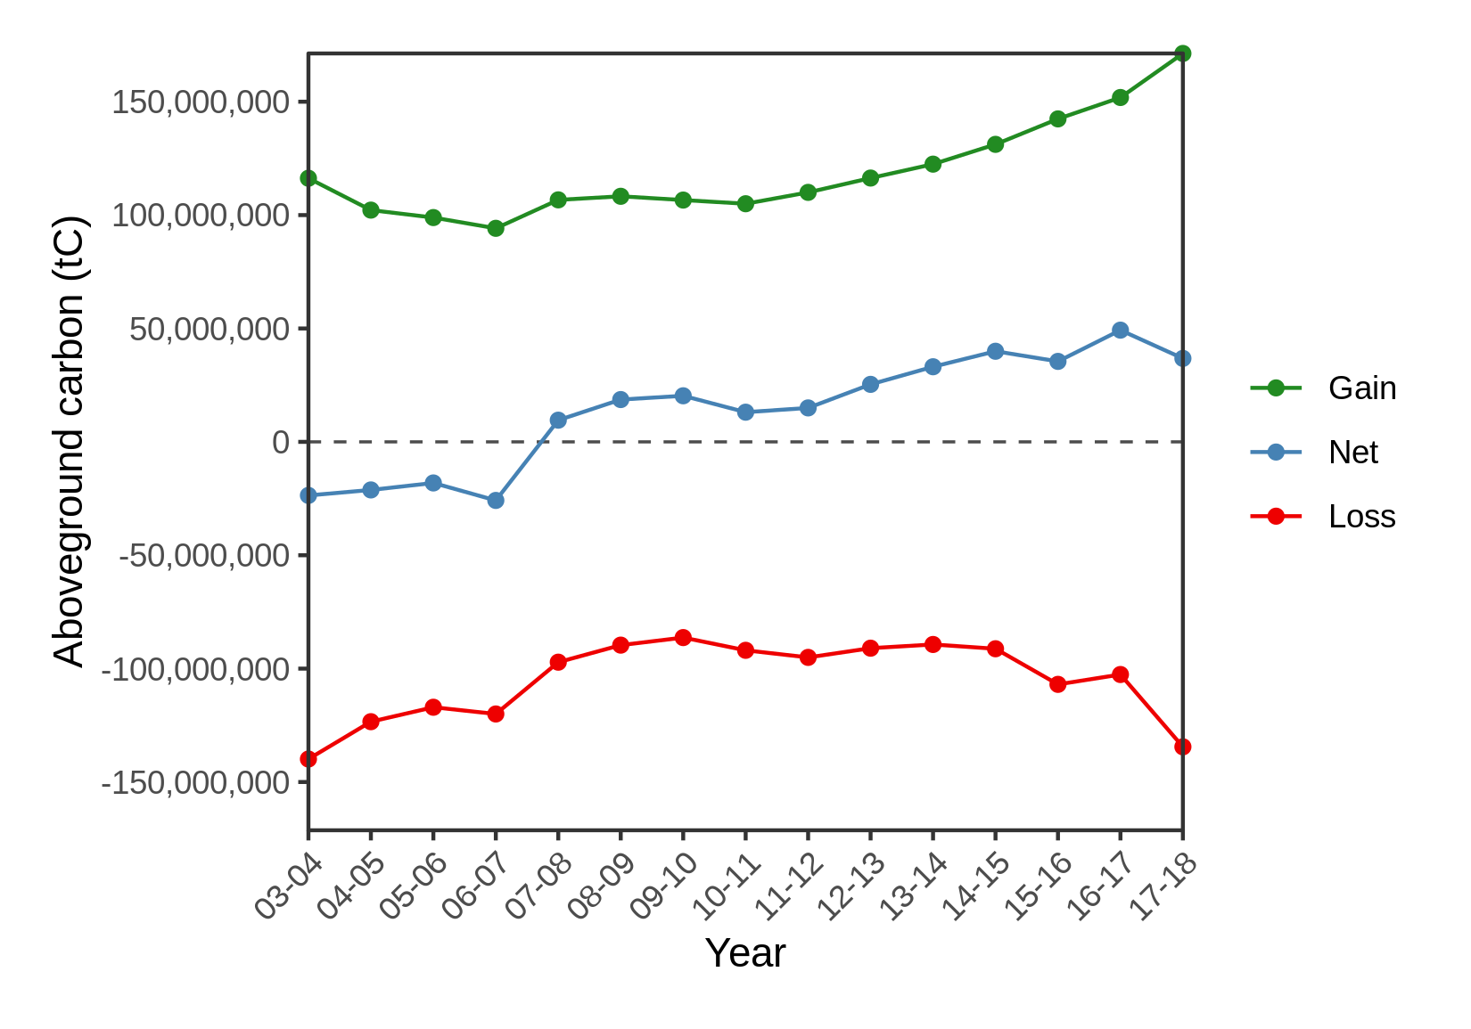

Figure 2: Annual gain, loss, and net change in aboveground carbon storage.

### 3. Greatest rates of carbon gain and loss (2003-2018)

Table 1: Maximum rates of gain and loss in aboveground carbon at three different scales (ca. 2.5, 25, and 250 sq. km).

| **Scale (sq. km)** | **Gain (tons C ha-1 yr-1)** | **Loss (tons C ha-1 yr-1)** |
| --- | --- | --- |
| ~2.5 | 13.8 | -15.2 |
| ~25 | 9.6 | -9.5 |
| ~250 | 4.7 | -5.6 |

### 4. Greatest gain and loss of carbon (2003-2018)

Table 2: Greatest total gain and loss in aboveground carbon at three different scales (ca. 2.5, 25, and 250 sq. km).

| **Scale (sq. km)** | **Gain (1x103 tons C)** | **Loss (1x103 tons C)** |
| --- | --- | --- |
| ~2.5 | 26.3 | -27.8 |
| ~25 | 244.1 | -295.0 |
| ~250 | 1,501.1 | -1,641.7 |

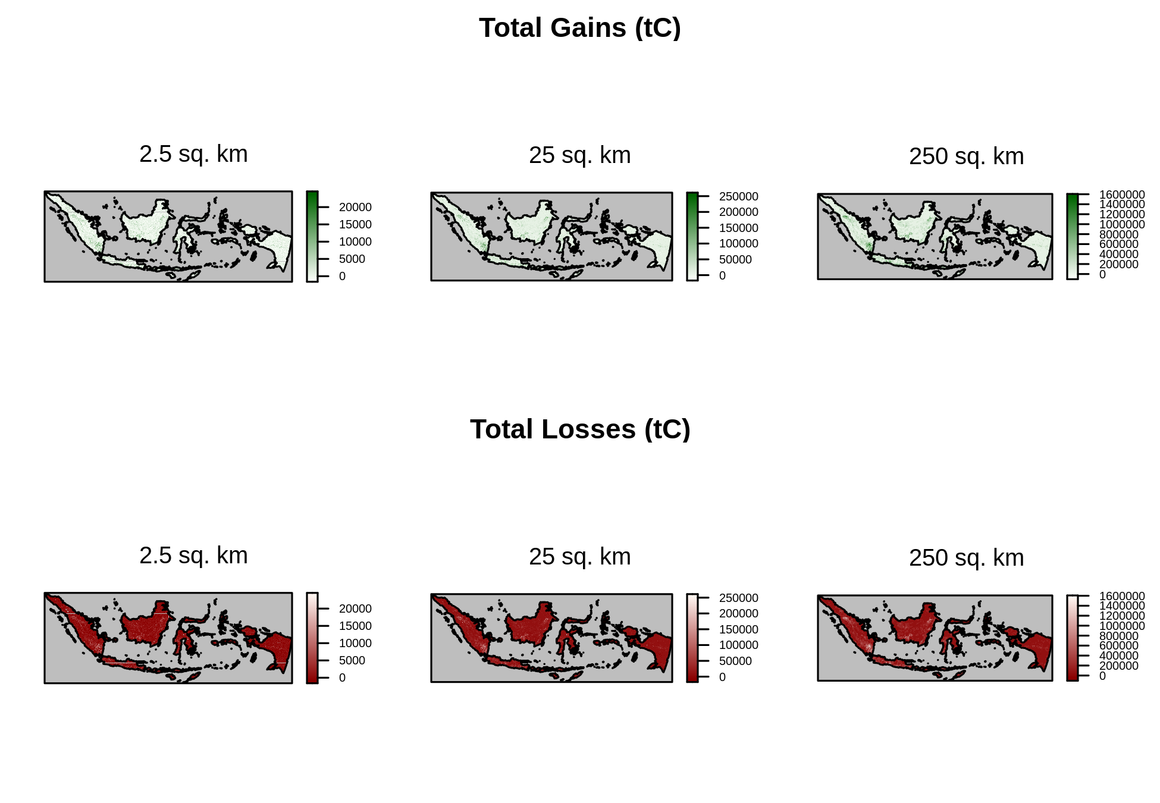

Figure 3: Gains and losses in aboveground carbon aggregated to three different scales (ca. 2.5, 25, and 250 sq. km).