Object-Orientated Programming

Box Jump Game

Submitted By: Emily Switzer (T00208234)

Computing with Software Development

Date Submitted: 28/11/2019

# **Class Diagram for BoxJump:**

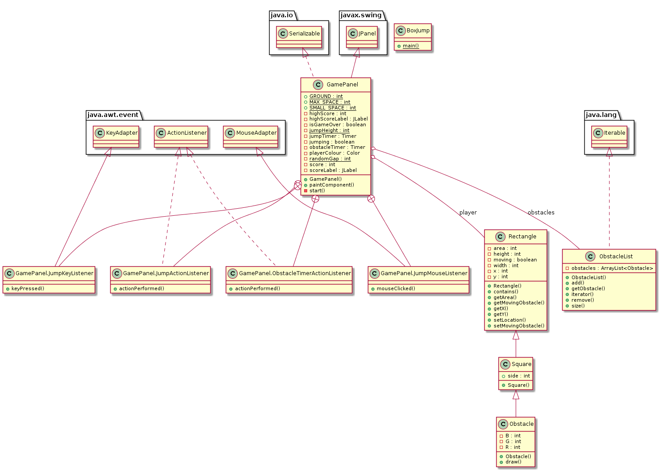

**Javadoc for GamePanel:** located in Javadoc folder

**Github Link:** <https://github.com/emilyswitzer/BoxJumpGame>

**Git Logs:** I had to restart my project last minute and so lost my commits and logs for my project.