
University of Technology Bahrain
Salmabad, Kingdom of Bahrain
COLLEGE OF ENGINEERING

_√ 1st Tri, _ 2nd Tri, _√_ 3rd Tri, Summer, SY 2024-2025
CENG622-CSCI613-Data Communications and Networking 2

In-course Open-ended Design Project

STUDENT NAME | Ananya Iyer | STUDENT NO. | BH23500036
STUDENT NAME | Emaan Mohammed Habib Munshi | STUDENT NO. | BH23500045
COURSE NAME | Data Communications and Networking 2 | COURSE CODE | CSIT723- IF
INSTRUCTOR NAME | Dr. Marwa Hassan Issa | SUBMISSION DATE | 1/4/2026

TABLE OF CONTENTS

S. No | Title | Page No.
1 | Detailed Specification of the Project | 3
1.1 | Introduction | 3
1.2 | Purpose of the Project | 4-5
2 | Classless Subnetting Design | 5
2.1 | Network Requirements | 5-6
2.2 | Classless Subnetting Calculations | 6
2.3 | Subnetting Scheme & IP Addressing | 6-8
3 | Router & Switch Configuration Commands and Simulation | 8
3.1 | Simulation Scenario Description | 8-10
3.2 | Device Configurations | 10-28
3.3 | Explanation of Configuration Commands | 28-31
3.4 | Configuration Testing and Verification | 31-37
4 | Conclusion | 37-38
5 | References | 38-39

1. Detailed Specification of the Project
1.1 Introduction
In today's increasingly interconnected world, the ability to design, implement, and manage complex enterprise networks is a critical competency for modern organizations. As businesses expand across geographically distributed locations, the demand for secure, reliable, and scalable network infrastructure grows proportionally. This project responds to that demand by presenting the end-to-end design and implementation of a comprehensive corporate network topology developed using Cisco Packet Tracer, a widely adopted network simulation platform used across the Cisco Networking Academy program.

The network presented in this report connects two geographically separated sites, a Central Headquarters (HQ) and a Remote Branch Office, through a fully encrypted IPSec VPN tunnel established across two external Internet Service Providers (ISP1 and ISP2). The design adopts a layered architectural approach consistent with the Cisco hierarchical network model, separating internal corporate traffic, internet-bound traffic, and publicly accessible services into distinct and secure network zones. A dedicated Demilitarized Zone (DMZ) hosts shared organizational services including DNS, HTTP, Email, NTP, Syslog, and IoT servers, while a mobile 4G network segment accommodates executive-level wireless connectivity through a simulated cellular infrastructure.

The topology demonstrates the practical application of advanced networking concepts covered throughout the Data Communications and Networking 2 course. These include classless subnetting using VLSM, dynamic routing through OSPF, deployed within both the HQ and Branch internal networks, and BGP, which is configured on the ISP-facing border routers to manage inter-autonomous system routing across the two external Internet Service Providers. The topology further implements inter-protocol operation across autonomous systems such as VLAN segmentation, HSRP gateway redundancy, Layer 3 EtherChannel link aggregation, site-to-site IPSec VPN and more. Each technology has been deliberately selected and positioned within the topology to reflect real-world enterprise network design principles rather than theoretical implementation alone.

The project demonstrates that even within the constraints of a simulation environment, it is entirely possible to construct a fully functional, secure, and professionally designed network that mirrors the complexity and standards expected in industry deployments. The design reflects not only technical proficiency but also a thorough understanding of how individual networking components interact as part of a cohesive, redundant, and resilient system.

The remainder of this report is structured as follows: Part 2 details the classless subnetting design including network, broadcast, and usable host addresses for all subnets. Part 3 covers the simulation scenario, interface IP configurations, and router and switch command explanations. Part 4 presents the conclusions drawn from the design and implementation process, followed by references in Part 5.
1.2 Purpose of the Project
The primary aim of this project is to design and simulate a fully functional multi-site enterprise network incorporating advanced routing, switching, security, and network management technologies. The goals of the project include the following:

Network Design and Addressing
- Design a classless subnetting scheme using CIDR and VLSM in both sites to efficiently allocate IP addresses across all departments
- Implement VLAN segmentation to provide logical isolation between departments, improving security and traffic management
- Configure inter-VLAN routing using Layer 3 multilayer switches to enable controlled communication between network segments

Routing and Connectivity
- Deploy OSPF as the interior dynamic routing protocol within both the HQ and Branch sites
- Implement BGP on ISP-facing border routers to simulate real-world inter-autonomous system routing across two external providers
- Establish a site-to-site IPSec VPN tunnel between HQ and Branch VPN routers to secure all cross-site traffic

Security and Access Control
- Define extended ACLs to control traffic permitted through the VPN tunnel and traffic subject to NAT
- Configure NAT/PAT on border routers to enable internal hosts to access the internet via public IP addresses

Redundancy and High Availability
- Implement HSRP on multilayer switches to provide gateway redundancy and eliminate single points of failure
- Configure Layer 3 EtherChannel between multilayer switches on each site to provide link redundancy and increased bandwidth

Services and Management
- Deploy a centralized DHCP server with IP helper-addresses to dynamically assign IP configurations to all end devices
- Configure SSH on all routers and Layer 3 switches for secure remote management

Testing and Verification
- Validate all implemented technologies through ping tests, routing table inspection, VPN session confirmation, DHCP binding verification, and ACL behavior testing

2. Classless Subnetting Design
This section details the subnetting logic, structure, and addressing strategy applied across all network segments.
The HQ network is subnetted from the 192.168.170.0/24 block using /27 masks, yielding 32 addresses and 30 usable hosts per subnet, sufficient for each HQ department. The Branch network is subnetted from the 192.168.171.0/24 block using /28 masks, yielding 16 addresses and 14 usable hosts per subnet. Internal backbone links at both sites are addressed from the 172.16.0.0/16 block using /30 subnets, providing exactly two usable addresses per point-to-point link. The DMZ server network is allocated the 90.64.110.0/24 block, providing ample address space for all centralized servers. Public-facing ISP links use publicly routable /30 address blocks from the 195.137.21.0 and 195.137.22.0 ranges, with the ISP1 to ISP2 serial backbone link addressed as 12.12.12.0/30. All subnets have been allocated using Variable Length Subnet Masking (VLSM) to efficiently distribute the available address space in accordance with each segment's specific requirements.

2.1 Network Requirements
Departmental Needs
The network serves two geographically separated sites, i.e., Headquarters (HQ) and Branch, each hosting multiple departments that require logical isolation through dedicated VLANs and subnets. The HQ site accommodates six departments, while the Branch site similarly hosts six departments. Additionally, a shared DMZ hosts all centralized servers, and a mobile 4G segment provides wireless connectivity for executive devices.

Technical Requirements
- Each department must reside in its own VLAN and subnet
- HQ departments require /27 subnets (30 usable hosts each)
- Branch departments require /28 subnets (14 usable hosts each)
- The DMZ server network uses a /24 subnet (90.64.110.0/24)
- All point-to-point backbone links use /30 subnets (2 usable hosts)
- Public-facing ISP links use publicly routable /30 address blocks
- Layer 3 EtherChannel links between multilayer switches use /30 subnets
- DHCP must be centralized on the HQ and Branch routers with ip helper-address forwarding
- All end devices must receive IP configuration dynamically via DHCP

2.2 Classless Subnetting Calculations
The following example illustrates the subnetting calculation for the HQ SOC department (VLAN 10):

Parameter | Value
Base Network | 192.168.170.0/24
Subnet Mask | 255.255.255.224 (/27)
Block Size | 256 − 224 = 32
Network Address | 192.168.170.0
First Usable Host | 192.168.170.1
Last Usable Host | 192.168.170.30
Broadcast Address | 192.168.170.31
Total Usable Hosts | 30

The same methodology is applied to derive all other subnet allocations across the HQ, Branch, backbone, and ISP-facing networks as detailed in Section 2.3.

2.3 Subnetting Scheme & IP Addressing

HQ Departments: 192.168.170.0/24 (Subnetted into /27)

VLAN | Department | Network Address | Host Range | Broadcast | Gateway (SVI)
10 | SOC | 192.168.170.0/27 | 192.168.170.1 – .30 | 192.168.170.31 | 192.168.170.1
20 | IT | 192.168.170.32/27 | 192.168.170.33 – .62 | 192.168.170.63 | 192.168.170.33
30 | Engineering | 192.168.170.64/27 | 192.168.170.65 – .94 | 192.168.170.95 | 192.168.170.65
40 | Operations | 192.168.170.96/27 | 192.168.170.97 – .126 | 192.168.170.127 | 192.168.170.97
50 | Customer Service | 192.168.170.128/27 | 192.168.170.129 – .158 | 192.168.170.159 | 192.168.170.129
60 | Accounting | 192.168.170.160/27 | 192.168.170.161 – .190 | 192.168.170.191 | 192.168.170.161

Branch Departments: 192.168.171.0/24 (Subnetted into /28)

VLAN | Department | Network Address | Host Range | Broadcast | Gateway (SVI)
80 | NetOps | 192.168.171.0/28 | 192.168.171.1 – .14 | 192.168.171.15 | 192.168.171.1
90 | R&D | 192.168.171.16/28 | 192.168.171.17 – .30 | 192.168.171.31 | 192.168.171.18
100 | HR | 192.168.171.32/28 | 192.168.171.33 – .46 | 192.168.171.47 | 192.168.171.33
110 | Marketing | 192.168.171.48/28 | 192.168.171.49 – .62 | 192.168.171.63 | 192.168.171.50
120 | PMO | 192.168.171.64/28 | 192.168.171.65 – .78 | 192.168.171.79 | 192.168.171.65
130 | Corporate Finance | 192.168.171.80/28 | 192.168.171.81 – .94 | 192.168.171.95 | 192.168.171.81

DMZ Server Network
VLAN | Network | Purpose | Host Range
70 | 90.64.110.0/24 | DMZ- All organizational servers | 90.64.110.1 – 90.64.110.254

HQ Backbone Point-to-Point Links: 172.16.0.0/16

Link | Network | Device A IP | Device B IP
VPN-HQ ↔ HQ-Multilayer-SW1 | 172.16.0.0/30 | 172.16.0.2 (VPN-HQ Gig0/1) | 172.16.0.1 (SW1 Fa0/10)
VPN-HQ ↔ HQ-Multilayer-SW2 | 172.16.0.4/30 | 172.16.0.6 (VPN-HQ Gig0/2) | 172.16.0.5 (SW2 Fa0/10)
HQ-Router ↔ HQ-Multilayer-SW1 | 172.16.0.8/30 | 172.16.0.10 (HQ-Router Gig0/0) | 172.16.0.9 (SW1 Fa0/9)
HQ-Router ↔ HQ-Multilayer-SW2 | 172.16.0.12/30 | 172.16.0.13 (HQ-Router Gig0/1) | 172.16.0.14 (SW2 Fa0/9)
SW1 ↔ SW2 (EtherChannel) | 172.16.0.16/30 | 172.16.0.17 (SW1 Port-channel 1) | 172.16.0.18 (SW2 Port-channel 1)

Branch Backbone Point-to-Point Links: 172.16.1.0/16

Link | Network | Device A IP | Device B IP
VPN-Branch ↔ BR-Multilayer-SW1 | 172.16.1.0/30 | 172.16.1.2 (VPN-Br Gig0/1) | 172.16.1.1 (SW1 Fa0/10)
VPN-Branch ↔ BR-Multilayer-SW2 | 172.16.1.4/30 | 172.16.1.6 (VPN-Br Gig0/2) | 172.16.1.5 (SW2 Fa0/10)
BR-Router ↔ BR-Multilayer-SW1 | 172.16.1.8/30 | 172.16.1.10 (BR-Router Gig0/0) | 172.16.1.9 (SW1 Fa0/9)
BR-Router ↔ BR-Multilayer-SW2 | 172.16.1.12/30 | 172.16.1.13 (BR-Router Gig0/1) | 172.16.1.14 (SW2 Fa0/9)
SW1 ↔ SW2 (EtherChannel) | 172.16.1.16/30 | 172.16.1.17 (SW1 Port-channel 1) | 172.16.1.18 (SW2 Port-channel 1)

Public / ISP-Facing Links

Link | Network | IP Address A | IP Address B
VPN-HQ ↔ ISP1 | 195.137.21.0/30 | 195.137.21.2 (VPN-HQ Gig0/0) | 195.137.21.1 (ISP1 Gig0/1)
VPN-Branch ↔ ISP2 | 195.137.22.0/30 | 195.137.22.2 (VPN-Br Gig0/0) | 195.137.22.1 (ISP2 Gig0/0)
ISP1 ↔ ISP2 (Serial) | 12.12.12.0/30 | 12.12.12.1 (ISP1 Se0/3/0) | 12.12.12.2 (ISP2 Se0/3/0)

3. Router & Switch Configuration Commands and Simulation
3.1 Simulation Scenario Description
The network design follows the Cisco three-tier hierarchical model, which comprises the Access, Distribution, and Core layers. This hierarchical structure ensures scalability, manageability, and fault tolerance across the entire enterprise topology.
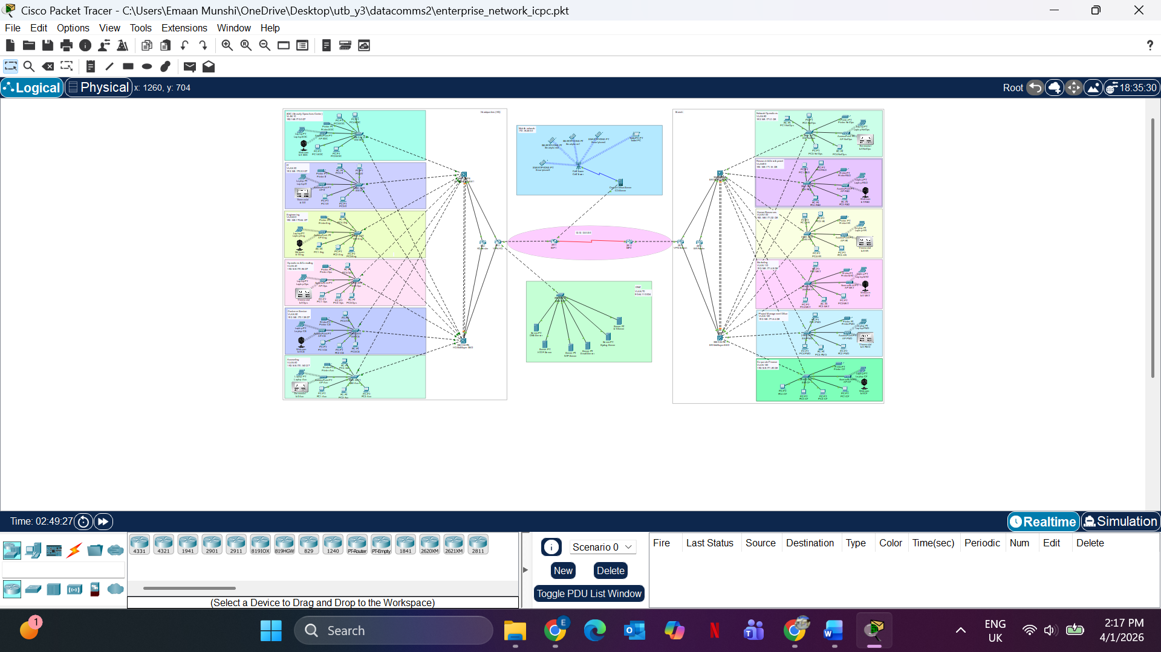
Fig 1. Enterprise Network Topology

A. Core Layer
The Core Layer forms the backbone of the enterprise network and is responsible for high-speed forwarding of traffic between the distribution layer and external networks. At the HQ site, this layer consists of HQ-Router and VPN-HQ. At the Branch site, it consists of BR-Router and VPN-Branch. The two ISP routers (ISP1 and ISP2) form the public internet core connecting the two sites. Key technologies at this layer include OSPF for internal dynamic routing, BGP for inter-ISP routing, static default routes on VPN routers pointing toward their respective ISPs, and IPSec VPN for secure cross-site traffic.

B. Distribution Layer
The Distribution Layer is implemented using two Layer 3 multilayer switches at each site, i.e., HQ-Multilayer-SW1 and HQ-Multilayer-SW2 at the HQ, and BR-Multilayer-SW1 and BR-Multilayer-SW2 at the Branch. These switches perform inter-VLAN routing via Switch Virtual Interfaces (SVIs), aggregate uplinks from all access layer switches via 802.1Q trunk ports and connect to the core routers via routed Layer 3 interfaces. HSRP is configured between the two multilayer switches at each site to provide gateway redundancy for all VLANs. A Layer 3 EtherChannel (Port-Channel 1) is configured between the two multilayer switches at each site to provide a redundant, high-bandwidth logical uplink.

C. Access Layer
The Access Layer consists of Cisco 2960 Layer 2 switches, one per department at each site. Each access switch is responsible for connecting end devices such as PCs, laptops, printers, access points, and IoT devices to the network. All access/departmental switch ports facing end devices are configured as access ports assigned to the appropriate VLAN. Uplink ports facing the multilayer switches are configured as 802.1Q trunk ports. Each access switch connects to both HQ multilayer switches via dual uplinks to ensure redundancy, with STP managing the forwarding topology.

D. DMZ and Mobile Segment
A dedicated DMZ switch (DMZ-SW) connects all organizational servers within VLAN 70 on the 90.64.110.0/24 network. This segment is intentionally isolated from internal VLANs and is reachable only through controlled routing and ACL-enforced access policies defined on VPN-HQ. The mobile 4G segment is integrated through a cellular infrastructure and connects to the HQ core through the VPN-HQ router.

E. Key Design Features Summary
- Inter-VLAN routing via SVI-based Layer 3 switching on multilayer switches
- HSRP for gateway redundancy; virtual IP shared between both multilayer switches per VLAN
- Layer 3 EtherChannel between multilayer switches for link aggregation
- Dual uplinks from every access switch to both multilayer switches
- OSPF single-area routing within HQ and Branch domains
- BGP inter-AS routing between ISP1 (AS 65000) and ISP2 (AS 65001)
- Site-to-site IPSec VPN between VPN-HQ (195.137.21.2) and VPN-Branch (195.137.22.2)
- NAT/PAT on VPN routers for internet access from private networks
- Centralized DHCP on HQ-Router and BR-Router with ip helper-address on all SVIs
- DMZ hosting DNS, HTTP, Email, NTP, Syslog, IoT servers on 90.64.110.0/24

3.2 Device Configurations

A. Basic Router and Switch Setup
All routers and switches were configured with a hostname, encrypted enable password, console and VTY line authentication, and a login banner.

HQ-Router
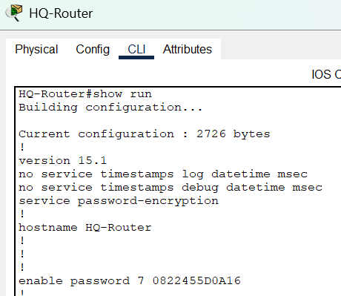
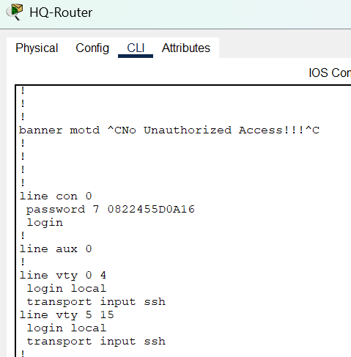

B. Interface IP Addressing
Each routed interface is assigned an IP address as per the addressing scheme defined in Section 2.3. The following screenshots show the interface IP configurations on the core routers and multilayer switches.

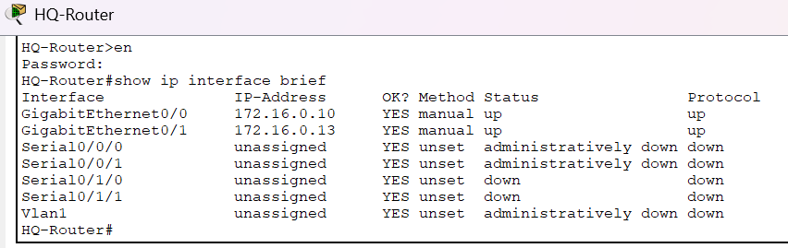

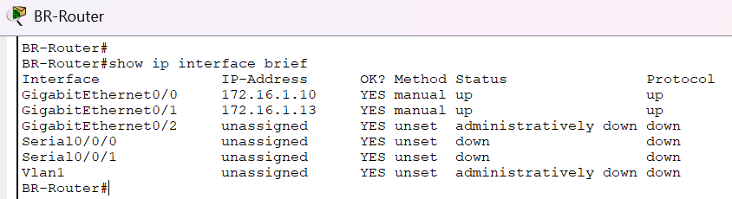
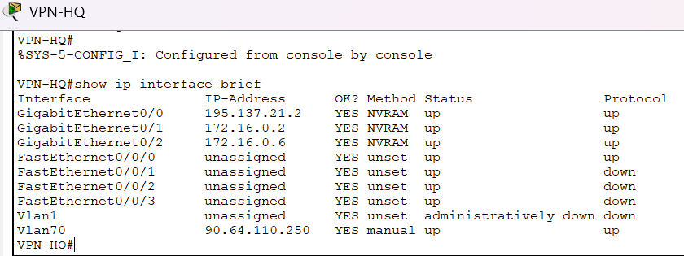

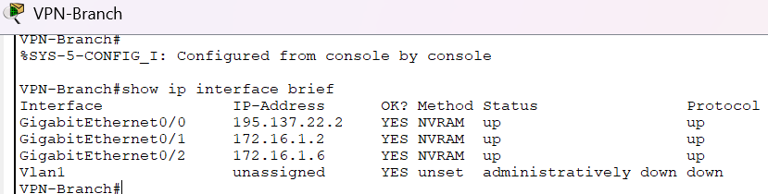

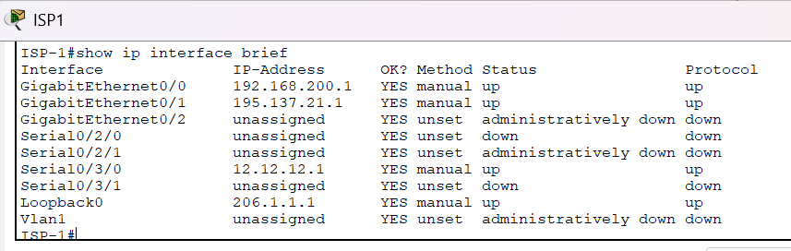

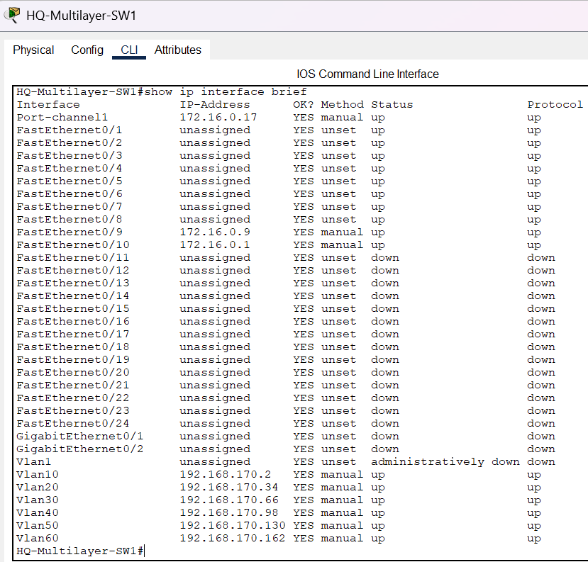
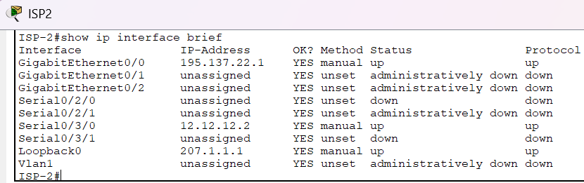

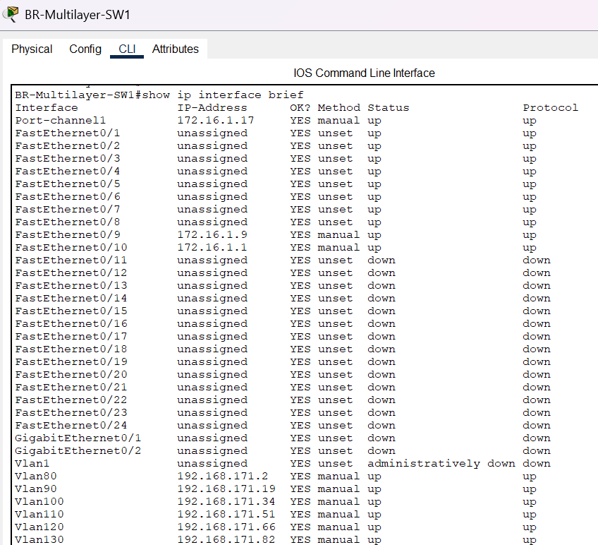

C. VLAN Configuration and Inter-VLAN Routing
VLANs were created on all multilayer switches and access switches. Each VLAN corresponds to a single department and is assigned a dedicated subnet. Trunk ports were configured on all uplinks between access switches and multilayer switches using 802.1Q encapsulation. On multilayer switches, switchport trunk encapsulation dot1q was applied before enabling trunk mode, as these are Layer 3 capable devices. Switch Virtual Interfaces (SVIs) were created on each multilayer switch for every VLAN, with ip routing enabled to perform inter-VLAN routing. DHCP ip helper-address was applied to each SVI pointing to the respective site router.

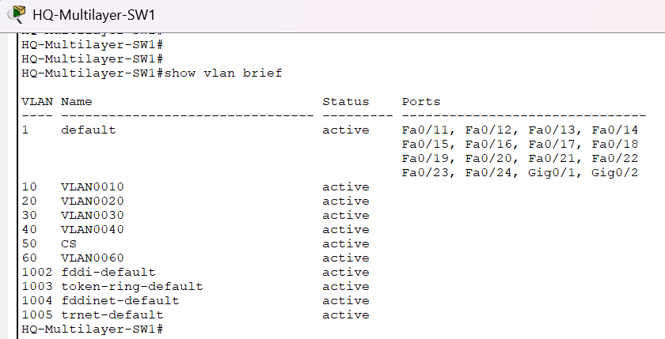
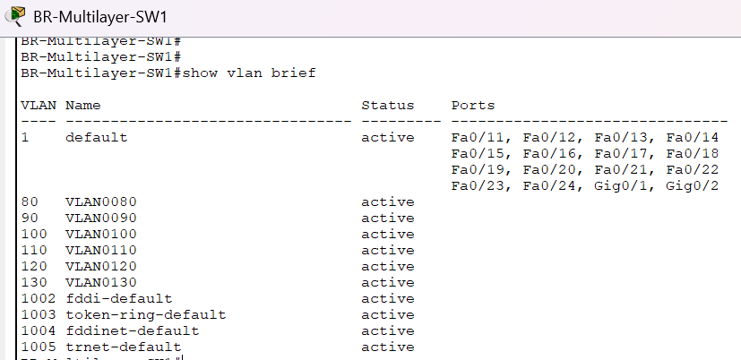

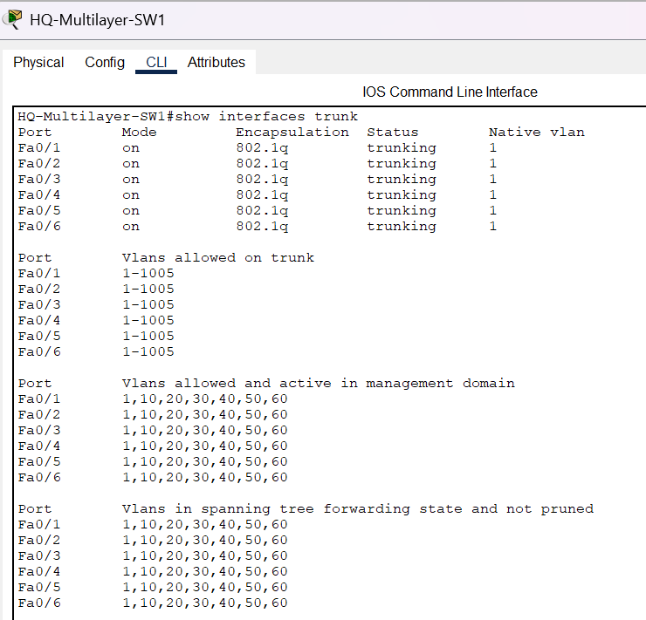

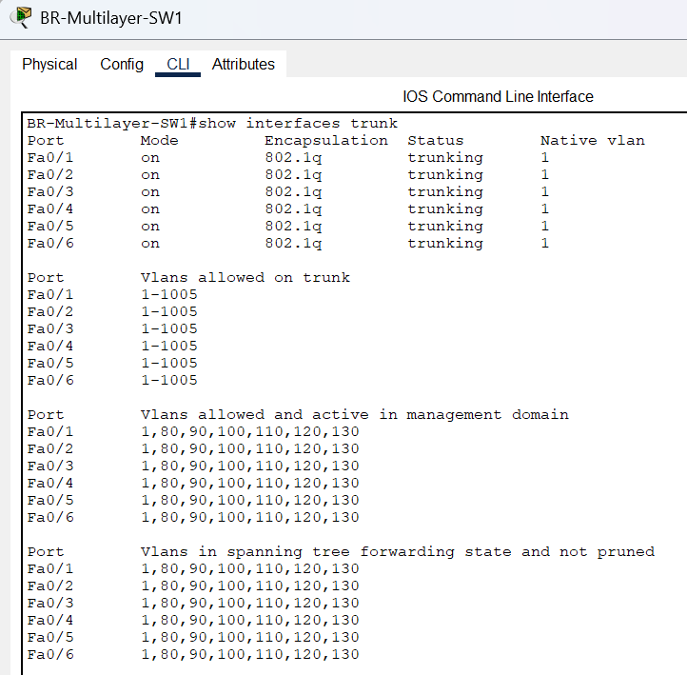

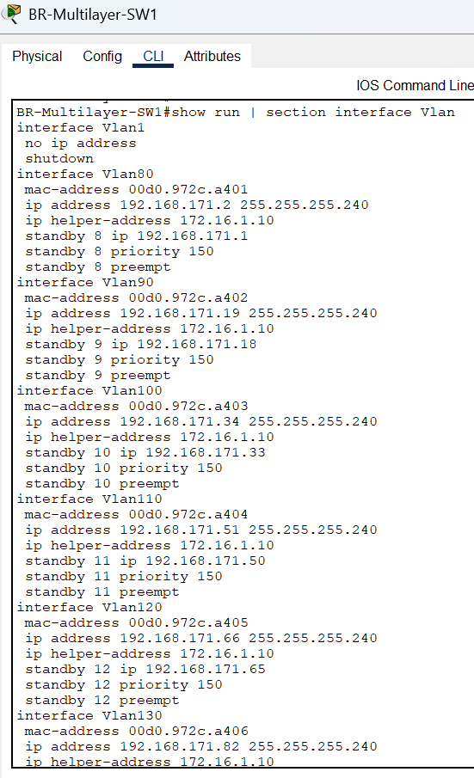
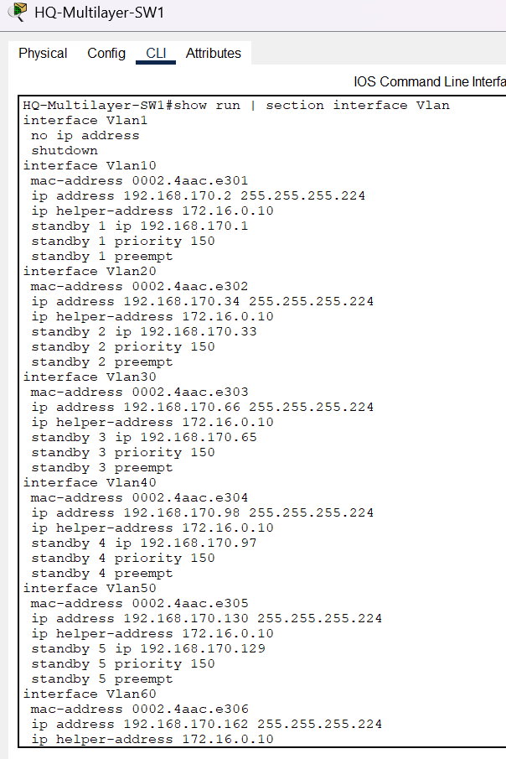

D. Layer 3 EtherChannel Configuration
A Layer 3 EtherChannel (Port-Channel 1) was configured between the two multilayer switches at each site using LACP active mode. The physical member interfaces (Fa0/7 and Fa0/8) were converted to routed ports using no switchport and added to the channel group. The Port-Channel 1 interface was then assigned a /30 IP address to enable Layer 3 routing between the two switches. This provides both link redundancy and increased inter-switch bandwidth.

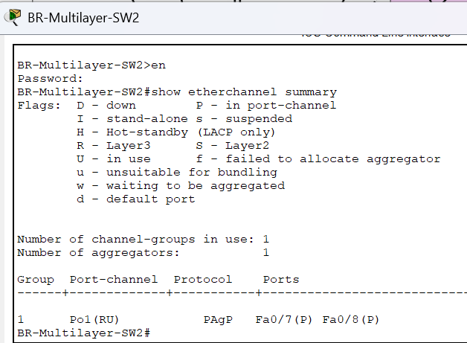
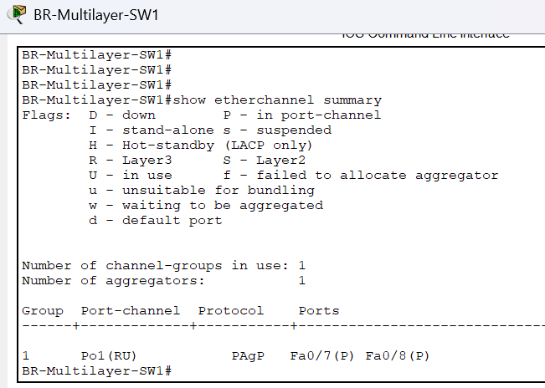

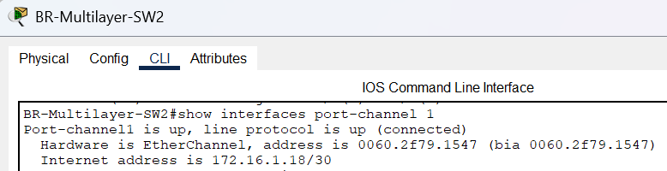
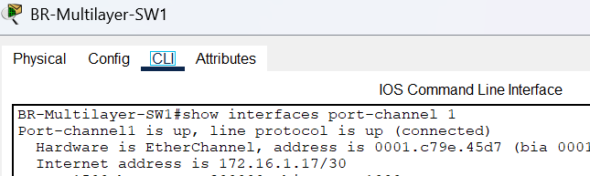

E. OSPF Routing Configuration
OSPF process 10 was configured in single Area 0 on all routers and multilayer switches within both the HQ and Branch sites. Each device was assigned a unique router-id to prevent OSPF identity conflicts. The GigabitEthernet0/0 interface on both VPN routers was configured as a passive-interface to prevent OSPF hellos from being sent toward the ISP.
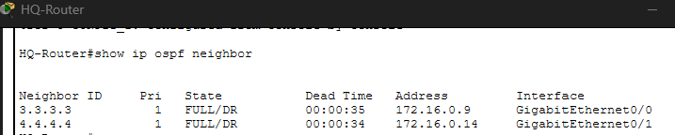

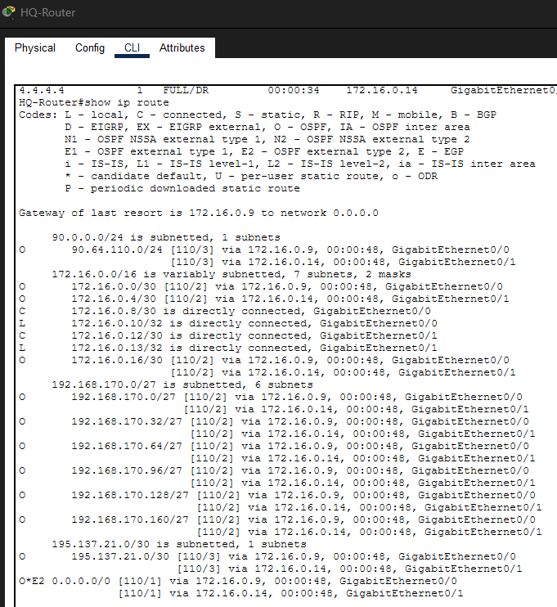

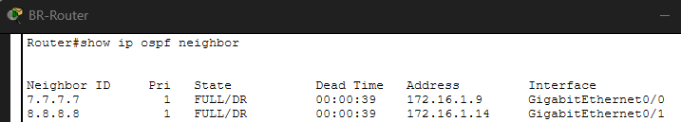
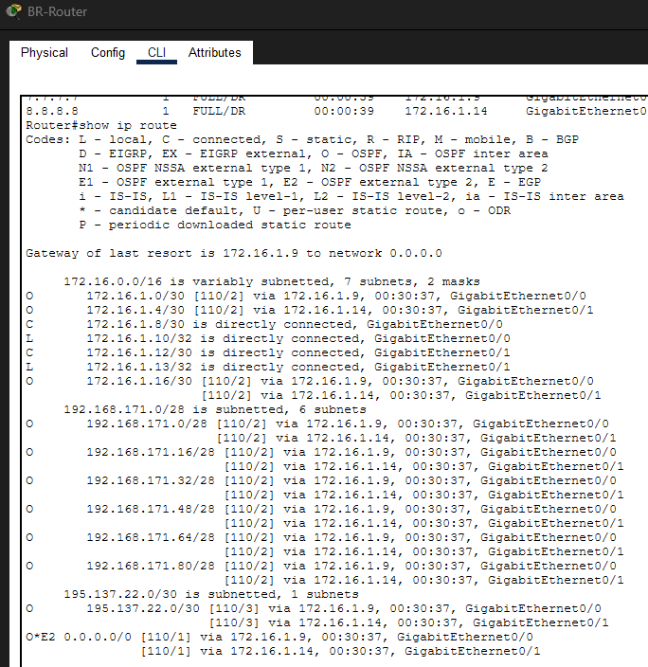

F. BGP Configuration
BGP was configured exclusively between the two ISP routers to simulate real-world inter-autonomous system routing. ISP1 operates in AS 65000 and ISP2 operates in AS 65001. Each ISP router was configured with the neighbor statement pointing to the other ISP's serial interface IP address. Each ISP advertised its loopback network into BGP using the network command. Static routes on each ISP router handle reachability to the VPN routers and the DMZ network.

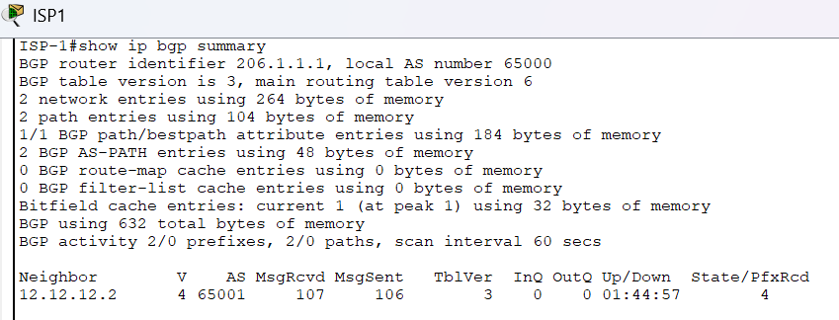

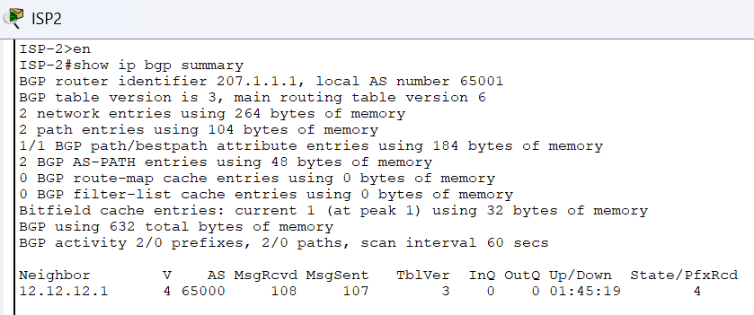

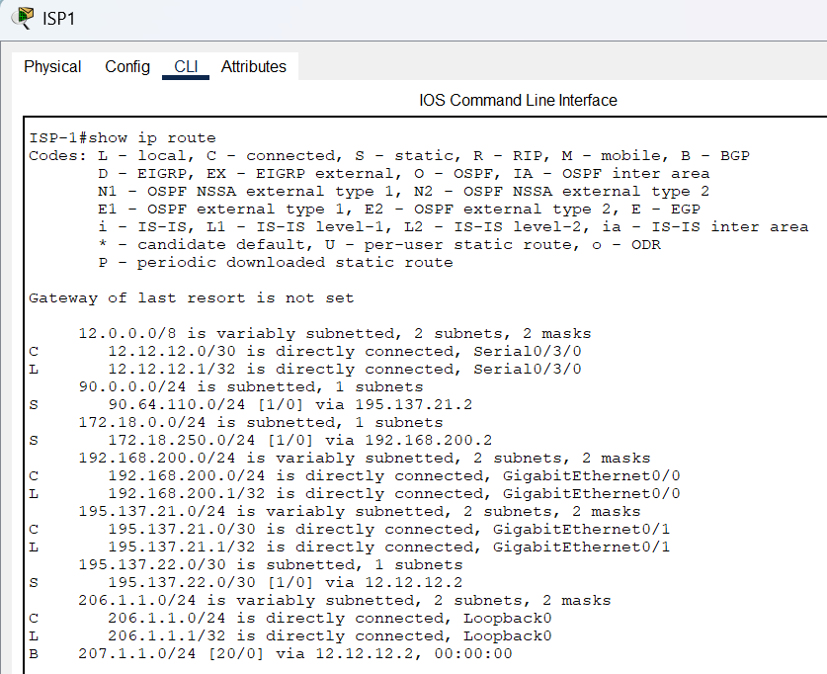

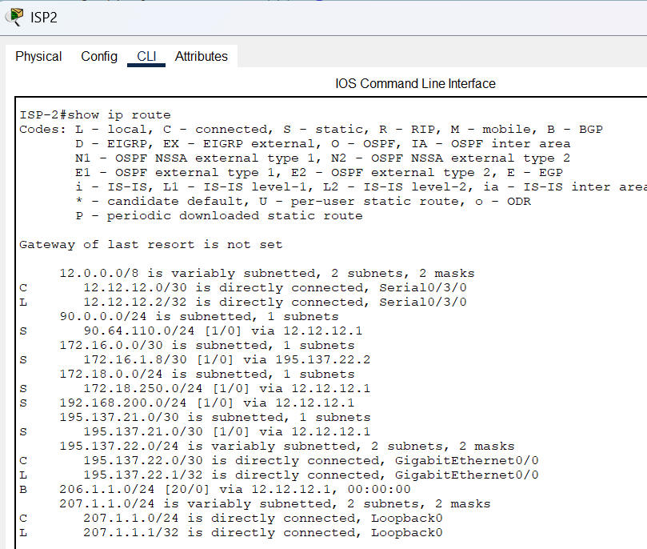

G. NAT and PAT Configuration
Network Address Translation (PAT/overload) was configured on both VPN-HQ and VPN-Branch to allow internal private hosts to access the internet. The outside interface (GigabitEthernet0/0) was marked as ip nat outside, and both inside interfaces (GigabitEthernet0/1 and GigabitEthernet0/2) were marked as ip nat inside. ACL 105 was defined to specify which traffic should be NATted. Critically, traffic destined for the other site (HQ to Branch or Branch to HQ) is explicitly denied in ACL 105, ensuring that cross-site traffic bypasses NAT and is instead handled by the IPSec VPN tunnel.

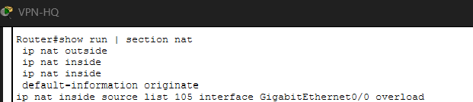
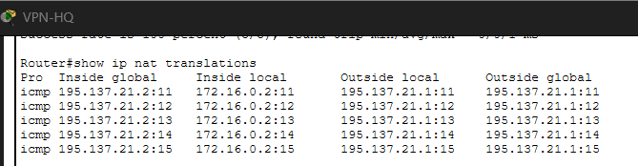

H. Access Control List Configuration
Two ACLs were configured on each VPN router serving distinct purposes. ACL 105 is the NAT ACL that defines interesting traffic for PAT. It first denies cross-site traffic (HQ-to-Branch or Branch-to-HQ) from being NATted, then permits all other internal and backbone traffic for NAT. ACL 100 is the VPN crypto ACL that defines interesting traffic for the IPSec tunnel. It permits IP traffic from the HQ internal networks to the Branch internal networks. Only packets matching ACL 100 are encrypted and sent through the VPN tunnel.

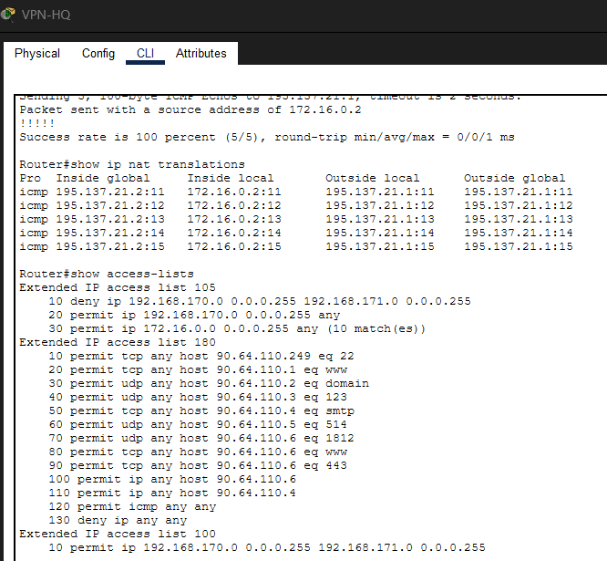
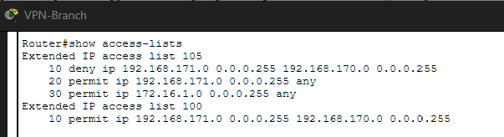

I. Site-to-Site IPSec VPN Configuration
A secure VPN tunnel is established between VPN-HQ (public IP 195.137.21.2) and VPN-Branch (public IP 195.137.22.2) to securely transmit cross-site corporate traffic over the public ISP infrastructure.

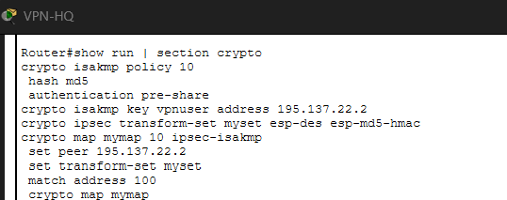

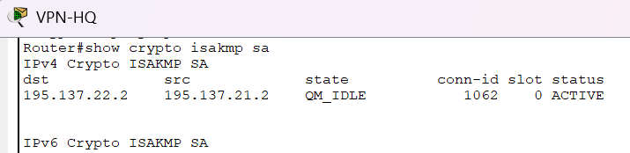

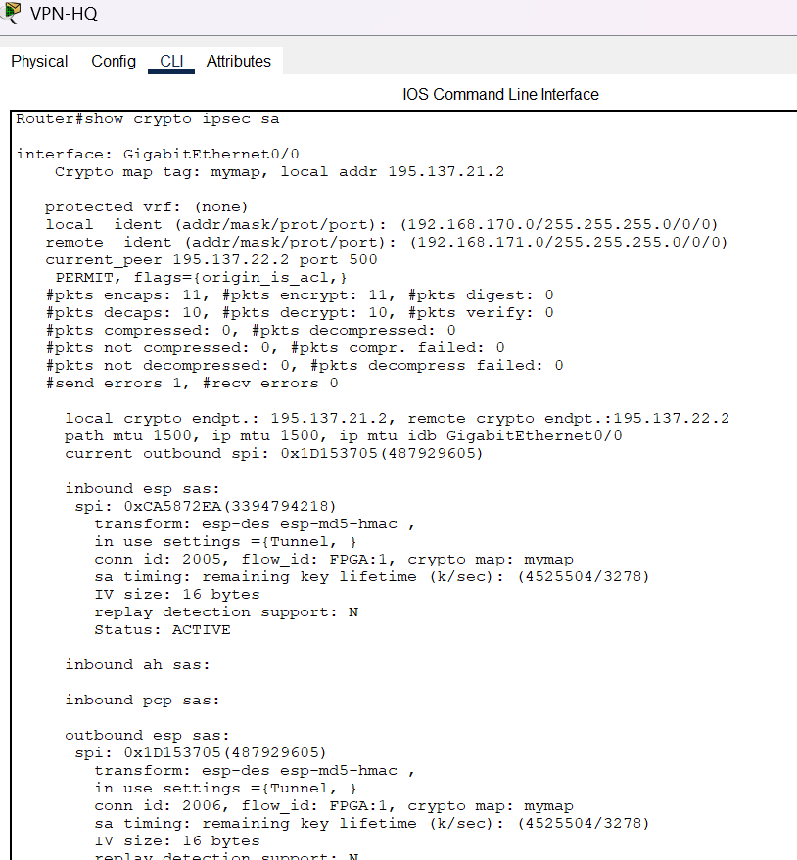

J. DHCP Configuration
Centralized DHCP was configured on HQ-Router for all six HQ VLANs and on BR-Router for all six Branch VLANs. Each DHCP pool defines the network, default-router (matching the SVI gateway IP), and DNS server (90.64.110.2). Excluded address ranges at the beginning of each subnet reserve addresses for network infrastructure. Since the DHCP server resides on a different subnet than the clients, ip helper-address was configured on every SVI of the multilayer switches, pointing to the respective router's interface IP. DHCP relay forwards client DHCP Discover broadcasts as unicast to the DHCP server.

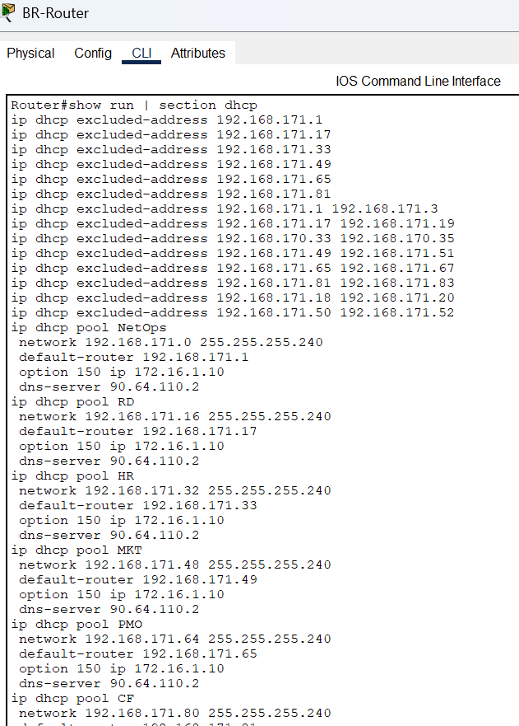
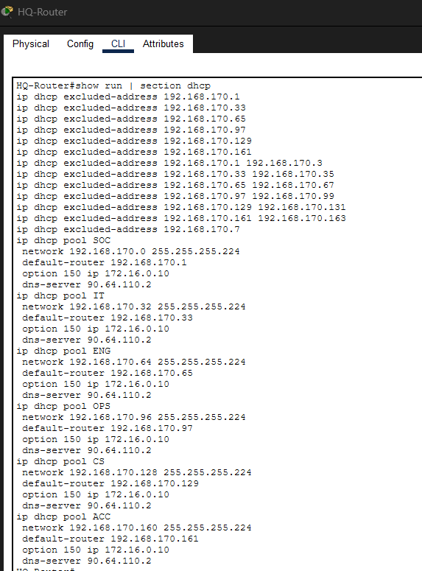

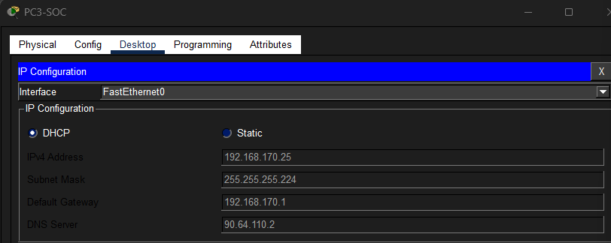

K. HSRP Gateway Redundancy
HSRP was configured on both multilayer switches at each site to provide first-hop redundancy for all VLAN gateways. For each VLAN, both switches share a virtual IP address that end devices use as their default gateway. HQ-Multilayer-SW1 is configured with HSRP priority 150 and preempt, making it the active gateway. HQ-Multilayer-SW2 uses the default priority of 100 and acts as the standby. If the active switch fails, the standby automatically assumes ownership of the virtual IP without any reconfiguration on end devices.
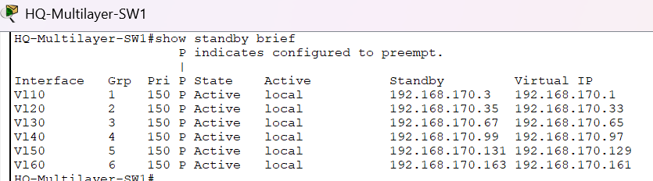

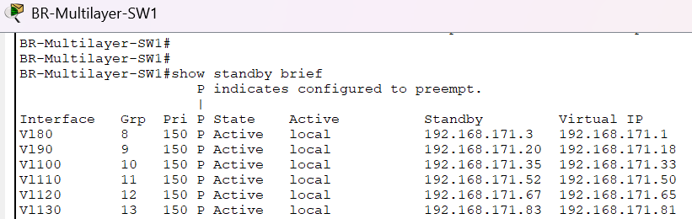

3.3 Explanation of Configuration Commands

Basic Commands
Command | Explanation
hostname <name> | Assigns an identifying name to the device for management purposes
enable secret <password> | Sets an encrypted privileged EXEC mode password using MD5 hashing
service password-encryption | Encrypts all plaintext passwords stored in the running configuration
banner motd #<message># | Displays a warning message to users before login
line con 0 | Enters console line configuration

Interface Commands
Command | Explanation
interface <type> <number> | Enters interface configuration mode for the specified interface
ip address <IP> <mask> | Assigns an IPv4 address and subnet mask to the interface
no shutdown | Activates the interface (interfaces are administratively down by default on routers)
description <text> | Adds a human-readable label to the interface for documentation
duplex auto / speed auto | Allows automatic negotiation of duplex and speed settings
switchport trunk encapsulation dot1q | Specifies 802.1Q as the VLAN trunking protocol (required on multilayer switches)
switchport mode trunk | Configures the port as a trunk, allowing multiple VLANs to pass
switchport mode access | Configures the port as an access port for a single VLAN
switchport access vlan <id> | Assigns an access port to a specific VLAN
no switchport | Converts a switch port into a routed Layer 3 port
channel-group 1 mode active | Adds the interface to EtherChannel group 1 using LACP active mode
ip nat inside / outside | Marks an interface as inside (private) or outside (public) for NAT
crypto map mymap | Applies the IPSec crypto map to the interface for VPN processing

Routing Commands
Command | Explanation
ip routing | Enables Layer 3 IP routing on a multilayer switch
router ospf 10 | Enters OSPF configuration mode with process ID 10
router-id <x.x.x.x> | Manually sets the OSPF router ID to prevent auto-selection conflicts
network 0.0.0.0 255.255.255.255 area 0 | Advertises all directly connected interfaces into OSPF Area 0
passive-interface <interface> | Prevents OSPF hello packets from being sent on the specified interface
default-information originate | Redistributes the static default route into OSPF for propagation
ip route 0.0.0.0 0.0.0.0 <next-hop> | Configures a static default route pointing to the next-hop device
router bgp <AS> | Enters BGP configuration mode for the specified autonomous system
neighbor <IP> remote-as <AS> | Defines a BGP peer and its autonomous system number
network <network> mask <mask> | Advertises a specific network into BGP
no synchronization | Disables the BGP synchronization rule (standard in iBGP environments)

DHCP Commands
Command | Explanation
ip dhcp excluded-address <start> <end> | Reserves a range of addresses that DHCP will not assign to clients
ip dhcp pool <name> | Creates a named DHCP pool and enters DHCP pool configuration mode
network <network> <mask> | Defines the subnet from which addresses will be assigned
default-router <IP> | Specifies the default gateway to be sent to DHCP clients
dns-server <IP> | Specifies the DNS server address to be sent to DHCP clients
option 150 ip <IP> | Specifies the TFTP/VoIP server address (option 150 for IP phones)
ip helper-address <IP> | Configures DHCP relay on an SVI to forward broadcast DHCP requests to the server

NAT and ACL Commands
Command | Explanation
ip nat inside source list 105 interface Gi0/0 overload | Enables PAT using ACL 105 to define interesting traffic, translating to the outside interface IP
access-list 105 deny ip <src> <dst> | Denies matching traffic from being NATted (used to exclude VPN traffic)
access-list 105 permit ip <src> any | Permits matching traffic to be NATted to the public IP
access-list 100 permit ip <src> <dst> | Defines the interesting traffic for IPSec VPN encryption

VPN Commands
Command | Explanation
crypto isakmp policy 10 | Creates an ISAKMP (IKE Phase 1) policy with priority 10
hash md5 | Specifies MD5 as the integrity hashing algorithm for IKE
authentication pre-share | Uses a pre-shared key for IKE peer authentication
crypto isakmp key <key> address <IP> | Defines the pre-shared key and the remote peer IP address
crypto ipsec transform-set myset esp-des esp-md5-hmac | Defines Phase 2 encryption (ESP-DES) and integrity (MD5-HMAC)
crypto map mymap 10 ipsec-isakmp | Creates a crypto map entry referencing the transform set and peer
set peer <IP> | Specifies the remote VPN peer IP address within the crypto map
set transform-set myset | Associates the transform set with the crypto map entry
match address 100 | References ACL 100 to define traffic to be encrypted

HSRP Commands
Command | Explanation
standby <group> ip <virtual-IP> | Defines the HSRP group and the shared virtual gateway IP address
standby <group> priority <value> | Sets the HSRP priority; higher value wins the Active role (default 100)
standby <group> preempt | Allows the higher-priority switch to reclaim Active role after recovering from failure

3.4 Configuration Testing and Verification
3.4.1 End-to-End Connectivity Testing
Ping tests were conducted from end devices across multiple VLANs and across sites to verify full network connectivity. The following tests confirm that inter-VLAN routing, OSPF, NAT, and the IPSec VPN are all functioning correctly.

HQ PC (SOC VLAN 10) to HQ PC (IT VLAN 20): Inter-VLAN test
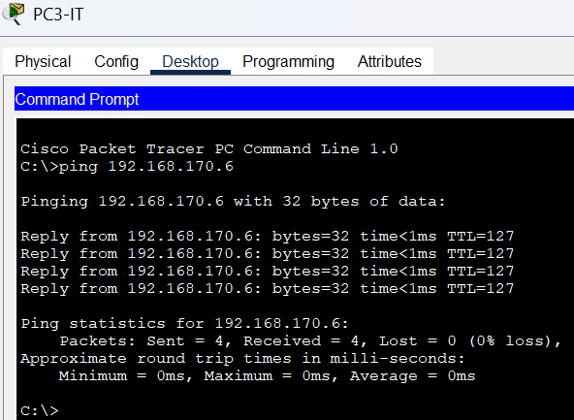
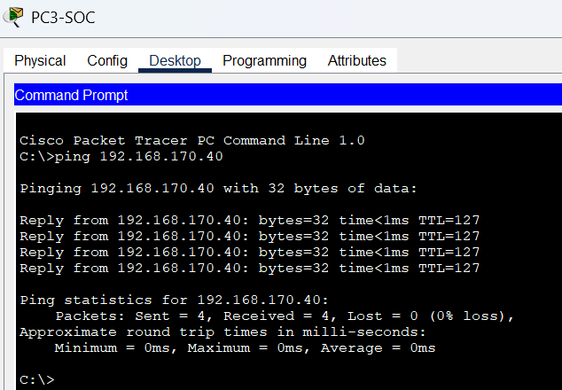

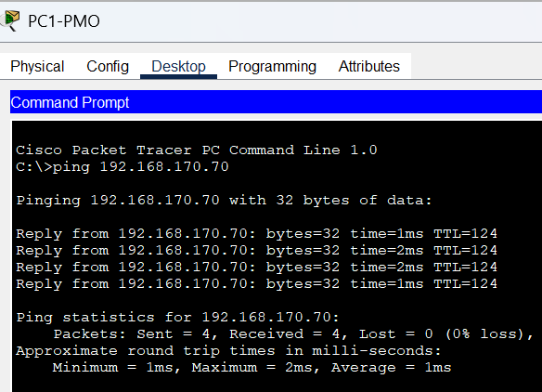
HQ PC to Branch PC: Cross-site VPN test
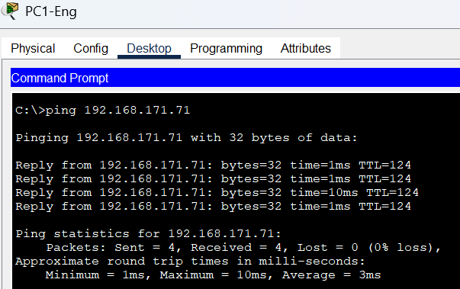

NAT/routing test

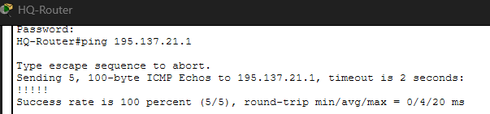

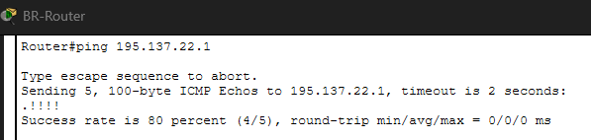

HQ-Router to VPN-HQ (172.16.0.2): Backbone Connectivity

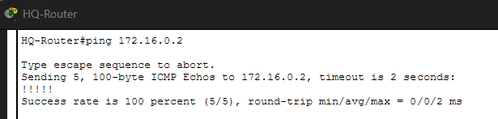

3.4.2 Routing Table Verification
The routing tables of key devices were inspected to confirm that OSPF adjacencies are fully established, that the default route is correctly propagated via OSPF, and that all VLAN subnets are reachable.

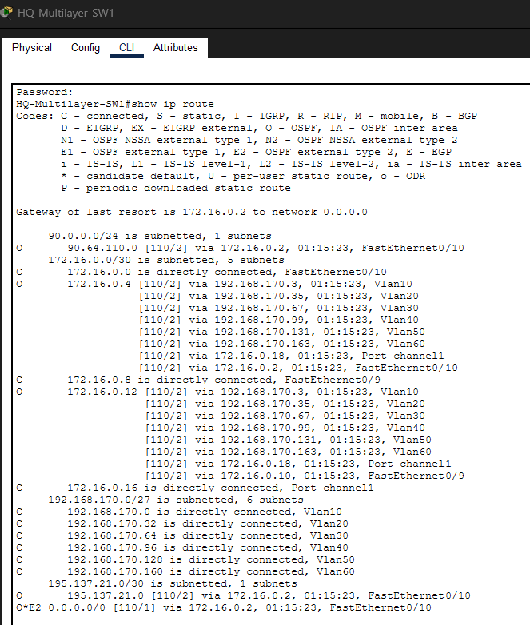

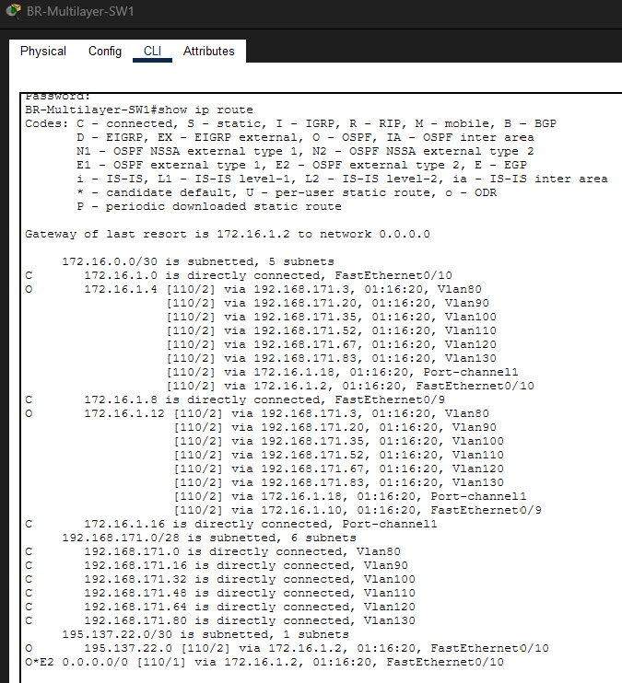

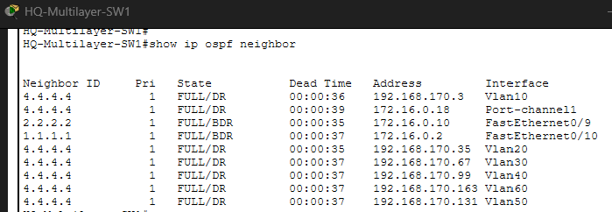

3.4.3 VPN Session Verification
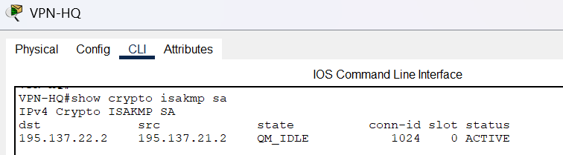
The IPSec VPN tunnel state was verified to confirm that Phase 1 (ISAKMP) and Phase 2 (IPSec) security associations are established and actively encrypting and decrypting traffic.

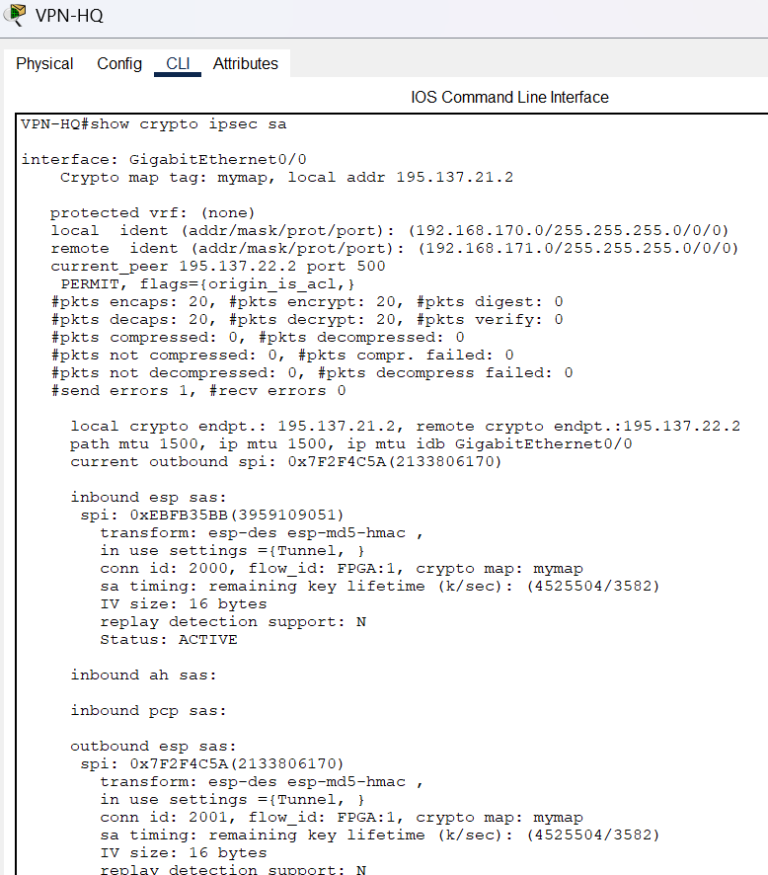

3.4.4 DHCP Verification
DHCP assignment was verified by setting end devices to DHCP mode and confirming successful address acquisition from the correct pool.

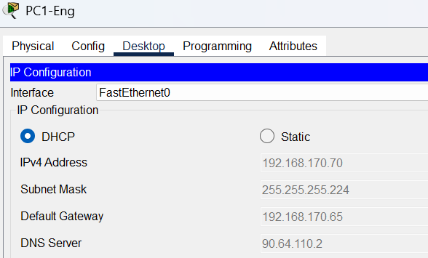

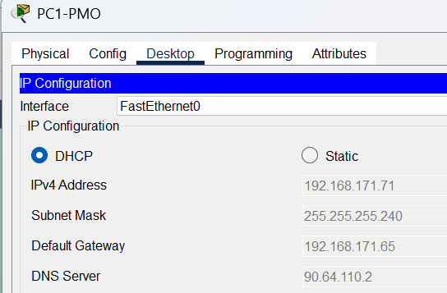

3.4.5 NAT Verification
NAT translations were verified to confirm that internet-bound traffic from internal hosts is being correctly translated to the public IP of the VPN router.

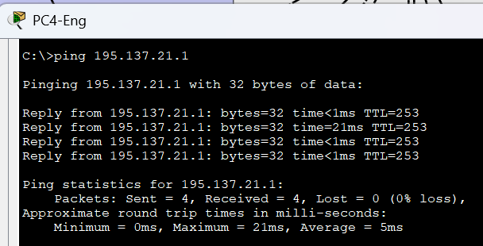
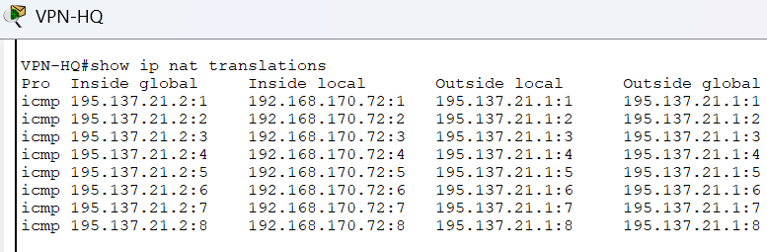

4. Conclusion
Overall, the project successfully demonstrates the design, implementation, and functionality of a complete enterprise-grade network topology spanning two geographically separated sites. The network was constructed entirely within Cisco Packet Tracer and reflects real-world architectural principles, showcasing the practical application of advanced networking technologies covered throughout the Data Communications and Networking 2 course.

The three-tier hierarchical model, comprising Access, Distribution, and Core layers, provided a structured and scalable foundation for the entire design. VLAN segmentation logically isolated each department's traffic, while inter-VLAN routing through Layer 3 SVIs on the multilayer switches enabled controlled communication across segments. HSRP eliminated single points of failure at the gateway level, and Layer 3 EtherChannel provided both redundancy and increased bandwidth between the multilayer switches.

OSPF single-area routing within each site ensured dynamic and efficient route propagation without manual intervention. BGP between the two ISP routers accurately simulated real-world inter-autonomous system routing across the public internet. The site-to-site IPSec VPN provided a secure, encrypted communication channel between the HQ and Branch, ensuring that sensitive corporate traffic traversing the public ISP infrastructure is protected from interception. NAT and PAT on the VPN routers allowed internal hosts to access the internet while preserving the security of the private address space.

DHCP relay through “ip helper-address” on all SVIs enabled centralized dynamic IP address assignment across all VLANs without deploying individual DHCP servers per segment. The DMZ provided a controlled zone for hosting publicly accessible organizational services, isolated from the internal corporate network through routing and ACL enforcement.

Throughout the implementation process, several challenges were encountered and resolved. These included the need to explicitly configure switchport trunk encapsulation dot1q on multilayer switches before enabling trunk mode, the importance of the correct ordering of NAT ACL deny and permit statements to prevent cross-site traffic from undergoing NAT before VPN processing, and the debugging of OSPF default route propagation requiring default-information originate on the VPN routers. Each challenge deepened the understanding of how individual networking components interact within a complex, multi-technology enterprise network.

Looking ahead, several enhancements could further strengthen the design: IPv6 dual-stack implementation would future-proof the addressing scheme; RADIUS/TACACS+ centralized AAA could be extended to all device management access; firewall appliances could replace ACL-only security at the DMZ boundary; and network automation tools could streamline configuration management and reduce human error.

5. References

[1] Cisco Systems. (2024). Cisco Packet Tracer. Cisco Networking Academy. https://www.netacad.com/courses/packet-tracer

[2] Cisco Systems. (2024). OSPF configuration guide. Cisco IOS Documentation. https://www.cisco.com/c/en/us/td/docs/ios-xml/ios/iproute_ospf/configuration/xe-16/iro-xe-16-book.html

[3] Cisco Systems. (2024). BGP configuration guide. Cisco IOS Documentation. https://www.cisco.com/c/en/us/td/docs/ios-xml/ios/iproute_bgp/configuration/xe-16/irg-xe-16-book.html

[4] Cisco Systems. (2024). RIPv2 configuration guide. Cisco IOS Documentation. https://www.cisco.com/c/en/us/td/docs/ios-xml/ios/iproute_rip/configuration/xe-16/irr-xe-16-book.html

[5] Cisco Systems. (2024). HSRP configuration guide. Cisco IOS Documentation. https://www.cisco.com/c/en/us/td/docs/ios-xml/ios/ipapp_fhrp/configuration/xe-16/fhp-xe-16-book.html

[6] Cisco Systems. (2024). NAT configuration guide. Cisco IOS Documentation. https://www.cisco.com/c/en/us/td/docs/ios-xml/ios/ipaddr_nat/configuration/xe-16/nat-xe-16-book.html

