The Design Journal of Game Kitty Buddy Go!

Xiaojie Wu - November 27, 2019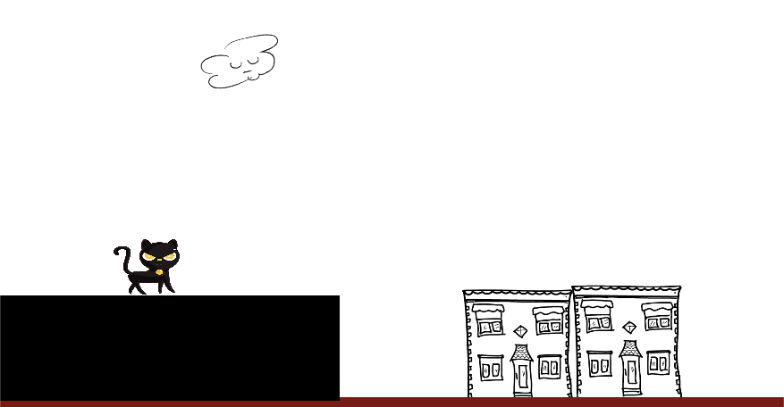

# Introduction

Everyone plays games more or less. But not every game is so interesting and attractive. Before taking this course, I tried to take class CART215 but did not get it. What attracts me to this course is that I can experience the overall process of designing a game by myself in three months. I can learn about the different types and features of games. This deepened my understanding of the field of game design. This is creative and challenging for entertainment purposes or even more.

My original idea for the design of this game came from the processing course in the first semester. I have always wanted to make the gameplay experience interesting and vivid for the player. Voice-activated games are one type, and the other is motion-controlled games using sensors to capture body gestures. It was impressive that I watched a movie called “Her” a few years ago. It is one of my favorites. It is a sci-fiction and futurist kind of type. There was a moment that the main character was playing the game at home. The whole room was being projected like a VR game without glasses. He sat down on the sofa relaxing. and he showed up his hands to do a running gesture driving the little monster in the game run/stop/come close and talk. It is inspired in a way that how naturally the gameplay can be. There are also already brainwave controlled games. There have been so many new ways to get involved in a game by now.

In this game, I use breathing as gameplay to evoke players to re-experience what they do naturally every day but ignore. I hope players enjoying a fresh and enjoyable gaming experience through breathing. The innovation of this game is that it is click-free all the way, from start to the end. It can be played quietly in public places. Of course, and you can also play it at home. In the levels, players are required to complete the game by controlling the rhythm of their breathing. Obstacles are on the ground, and in the sky. This breathing concept on project update3 was inspired by a game about breathing tests for kids with asthma from the instructor.

The first project update, I set a storyline of a brave little black cat’s adventure journey through the whole city from east to west to reach his girlfriend's home. Based on this storyline, I designed many obstacles. For example, I imagine a kitten going through a big city to go through many dangers. There are unclosed sewer covers, cars, pedestrians, telephone poles, barricades, or even a big dog. Extra points will be attributed by collecting squirrels, abandoned food and birds flying in the air. My idea was that the game should have a bonus point reducing&increasing mechanism, the game should have obstacles to reduce the health and life of a character, and there should be a bonus mechanism to increase health and life. I also designed the UI and three levels to increase the difficulty by increasing speed and adding more obstacles. Considering that the blowing mechanism is prone to fainting, I made a time limit of two minutes. I was trying to reduce the time of blowing the mic to avoid the negative feeling from players. I felt good about this design at that moment. What surprised me was that the game design got only B at this stage. I was thinking about why.

Based on feedback from my first project update, I knew that I need to find similar games for comparison. I have checked out the chicken scream game. The fun part of this game is the gameplay design. There are two kinds of action: walking and jumping. The chicken moves when the player makes a sound. A slight sound drives the chicken to walk, and a high volume sound drives the chicken to jump. There is also a game called flappy bird that impressed me. It is an endless runner game, which is quite simple and interesting. The players control the bird's flight by simply tapping the screen to avoid obstacles. And the obstacles are all pipes placed in a vertical way up and down. It is about the precise control of height by tapping. This design makes players focus on control the bird other than distracted by other types of elements. what is necessary for this game is the score since it is an endless runner game. That means the designer is supposed to give feedback to the player and tell them how far they have gone. These two games made me reflect on my game, and I realized that in my first version of the cat game, the design of obstacles and points was a distraction, not a good design. The first gameplay mechanism is not clear and strong.

The main purpose of my game is entertainment in a new way, not a competition(no need a score), and I need to focus on making it different from other games. I should focus on what a player would experience while playing this game. So in project update2, I immersed myself in the story. If I were a cat, how would I cross the city? A metropolis is designed by human beings, the path taken by a cat such as a rooftop is different from that designed for humans. So I unified all obstacles into blocks and further mapped them into the rooftop of buildings in Montreal. The game should be designed around my theme. I should only add the necessary elements close to the storyline. Also, I got feedback on my first update presentation. it is that blowing for a long time makes people dizzy. I need to change my gameplay mechanism not by reducing the time, but by allowing a jump to the highest point with slight airflow(puff). The player’s experience has improved. By the time of the second update, my definition of the target player had gradually become clear. The players I targeted were children and women, as well as casual game enthusiasts. From this basic point, I reduced the level of difficulty of the game by making the mechanics of the entire game simple and easy to understand. These ideas are all target player related.

According to the characteristics of the sound control game, when the player fails, to get another life, they need to keep making a sound to make the kitten reach the top of the screen, where the start and replay buttons get triggered allowing the player keeps playing. To make the game interesting, I added a underground city level in update3. This level has two obstacles up and down. The jumping space is limited and short and rhythmic breathing cooperation is required to pass. The design of this level is to match the characteristics of the voice-activated game. At the beginning of the game, this fun training method is used to inform the player how to control the character. Another idea is that the design without manual control throughout the process will make the player better immersed in the game and enjoy the rhythm adjustment of breathing. I ended up with the 275-second limitation of playtime according to the time of holding children’s attention. I did not make the game very easy to pass, I think keep player’s passion on this game is important. A proper level of difficulty would help.

My overall evaluation of this game is progressive. I think that the third update of this game has reached the goal I set for this game. I have got feedback from five test players, one teen, and four 20+ player testers. some said it is novel and interesting. Some said it was sometimes little hard to control the height of jump. Some said it is sensitive to control the jump. Some said the way that cat fly is a little wired. Some said it is fun game to play. Some said it is a little difficult to pass the underground level. I have adjusted my game base on the feedback. I wanted to release this small game to google play at the beginning of this semester. I gradually realized that I need to do a lot more to achieve this goal, including optimizing the levels, controlling the jumping height supper precisely through the breath, and adding new mechanisms, such as kitty can flip around according to changes in airflow for the next level to get a landing point which helps the kitten pass the obstacles.

In the final presentation class, a word from the guest impressed me. Where a game should start. It should start with what kind of experience the game wants to bring to the player, and start designing around this rule. From the one-sentence theme, description to slowly refinement, setting the game type, designing the levels, and then player test, feedback, and re-modification, and finally, marketing, every step is important. There is no such thing as correct or incorrect design in games. The design fits only for the main purpose and characteristics of this particular game.

At the beginning of this game, a lot of things were not so clear. The feedback from peers and pros are really helpful. I enjoyed this course and finally understand how to design a game for real. Learning new things is a enjoyable process.

**Diagram Update 1**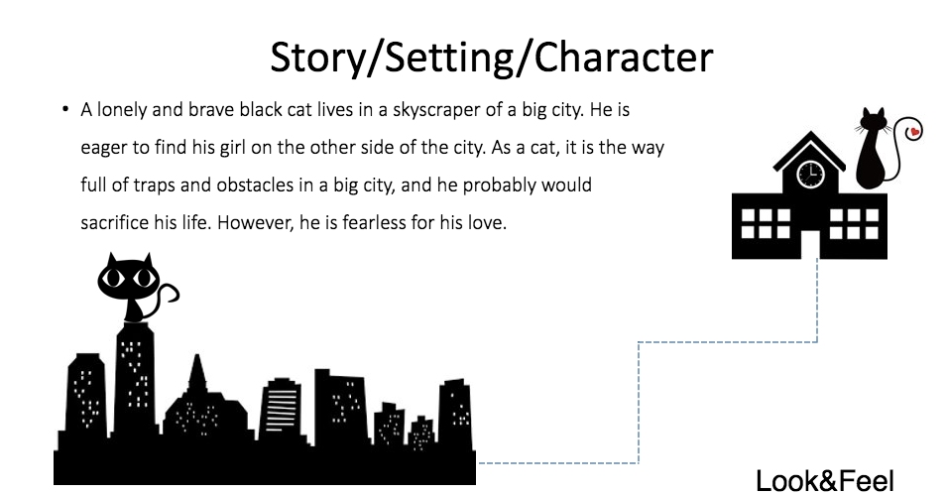

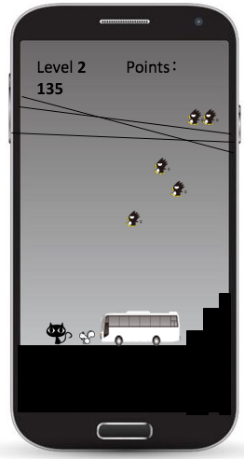

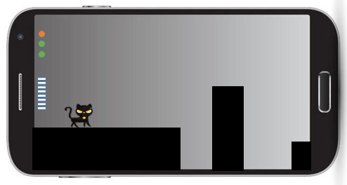

**Diagram Update 2**

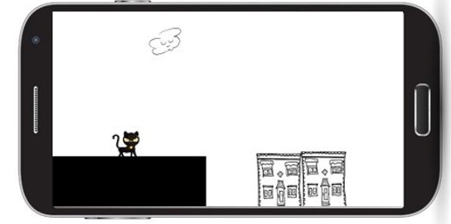

**Diagram Update 3**