Howard University
College of Engineering and Architecture
Department of Electrical Engineering & Computer Science

Large Scale Programming
Fall 2024

Midterm Exam – Part I
October 17, 2024

NAME: Emily Jones
ID: 03002783

Part I: 50 pts. (essay questions)

Instructions:
- Submit completed exam to your github repository under package org.howard.edu.lsp.midterm

Verify that the commit(s) completed successfully

- OPEN BOOK, OPEN NOTES. THERE IS NO COLLABORATION ON THIS EXAM
- Site any and ALL references for anything obtained off the internet.

Question 1. (10 pts.)

You are reviewing the following class in a Fitness Tracking System. The class is intended to manage various aspects of a user’s fitness activities.

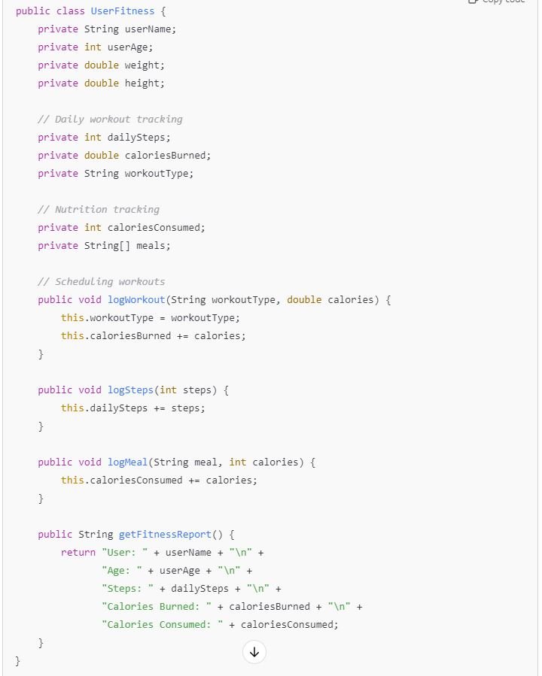

Tasks:
- Analyze the UserFitness class. Explain why this class has low cohesion. (5 pts.)
The UserFitness class has low cohesion because it handles multiple responsibilities that are not directly related.
This class tries to manage user personal information --- User information (userName, userAge, weight, height), workout routines, and nutritional tracking. Combining all these aspects into a single class violates the Single Responsibility Principle, making it harder to maintain. Changing one aspect might unintentionally affect other unrelated functionalities.

- Describe, in general, how you would split the UserFitness class into more cohesive classes. Your answer should not be a complete design. (5 pts.)
To improve cohesion, the class should be split into more specialized classes, each handling a specific concern.
For instance, there should be a UserProfile class, WorkoutTracker class, NutritionTracker class, and FitnessReport class each with their own responsibilities.
By creating separate classes for each responsibility, the design would become more maintainable. Each class would focus on a single aspect of fitness tracking, improving cohesion.

Question 2. (5 pts.)
Given the following, answer the below questions.

A university manages its students using a program that has a class Student with subclasses FirstYear, SecondYear, and ThirdYear for year-specific state and behaviors. The program has a List that contains all Students.

Should Student be a class, an abstract class or an interface? Explain your answer
Student should be an abstract class rather than a regular class or an interface. This is because the Student class likely contains common attributes such as name, ID and methods such as getName(), getID(), that are shared by all students regardless of their year.
Using an abstract class allows the definition of common properties and methods for all students, while enabling specific subclass -- FirstYear, SecondYear, and ThirdYear to provide unique behaviors or states.
An interface would only define method signatures, but students may share common implementation that should be inherited.

- At the end of each year, the third-year students graduate and must be removed. This is done by passing the list to the following method:

void removeThirdYears(List<Students> students) {
for (Student student : students) {
try {
ThirdYear = (ThirdYear) student;
students.remove(thirdyear);
}
}
}

Why is the above method flawed? Hint: Another Arthur Riel heuristic (5 pts.)
The above method is flaws because it modifies the list during iteration, which is a violation of Arthur Riel’s heuristic that states to avoid modifying a collection while iterating over it.
Removing elements from a list inside a for loop can lead to unexpected behavior, such as a ConcurrentModificationException in Java.

Question 3. (5 pts.)
Given the following, answer the below questions.

public class BankAccount {
public String accountHolderName;
public String accountNumber;
public double balance;
public double interestRate;

public BankAccount(
String accountHolderName,
String accountNumber,
double initialDeposit,
double interestRate) {
this.accountHolderName = accountHolderName;
this.accountNumber = accountNumber;
this.balance = initialDeposit;
this.interestRate = interestRate;
}

// Exposed implementation for adding interest
public void addInterest() {
double interest = balance * (interestRate / 100);
balance += interest;
}

// Exposed implementation for deposits
public void deposit(double amount) {
balance += amount;
}

// Exposed implementation for withdrawals
public void withdraw(double amount) {
balance -= amount;
}
}

- Is BankAccount well-encapsulated? Why or why not? If so, describe what changes you would make to the class. Otherwise, state nothing. (5 pts.)
No, the BankAccount is not well-encapsulated because the member variables are declared public, allowing direct access and modification from outside the class. This violates the principle of encapsulation, which aims to restrict direct access to the internal state of objects.
The changes I would make to the class would be to make member variables private, this would ensure that the internal state is protected and can only be accessed through methods.

Question 4. (10 pts.)
Given the following, answer the below questions.

Given:
A car manufacturer uses Java software to track current vehicles being built. The UML diagram below shows an excerpt of the current software structure. You should assume the presence of other appropriate fields and methods

Car
getTrimLevel()
Engine
accelerate()
getFuelLevel()
Base
Sports
Luxury
Electric
Petrol

Each car can be built to one of three trim levels: Base, Luxury or Sport. They can also be configured with an electric or petrol engine. At various points in the manufacturing process the customer can choose to change the trim level.

Task:
- Explain in detail why the current structure does not support this. (5 pts.)
In the current structure, Base, Luxury and Sport are subclasses of Car, meaning each Car object is locked into its specific trim level when instantiated.
Java does not allow changing the class of an object after it is created, making it impossible to change the trim level.

Same for the engine types, they are tightly coupled to their specific subclasses, limiting flexibility.

- Describe how to refactor the structure to allow trim-level change for a car to dynamically change. Hint: How would you modify Car to use composition to solve the problem? (5 pts.)
To allow dynamic changes to trim levels and engine types, the design should be changed to use composition instead of inheritance.

Question 5. (5 pts.)
Suppose you are about to code a particular class and find that you have written another class with nearly the functionality that you now are developing. This means that the two classes in large parts contain the same code, but in smaller parts have different code. Explain in detail why this may be a problem and how to solve it. Give your answer in terms of Arthur Riel’s design heuristics.

When two classes contain similar code but differ in smaller parts, this leads to code duplication which violates Arthur Reil’s heuristic of avoiding duplication of code.
When you have duplicated code, it makes maintenance difficult, as changes must be made in multiple places.
To solve this, you could use inheritance or composition to factor out the common functionality into a shared superclass or helper class, reducing redundancy and improving maintainability.

Question 6. (5 pts.)
Suppose we need to store instances of the classes Car and BankAccount in a database. To obtain low coupling it may seem as if the functionality to save an instance should be in precisely those classes, since they have the information that shall be saved. Why is it unwise to place the database calls there?

Placing database calls directly inside classes like Car and BankAccount results in high coupling between the business logic and persistence layer, violating the principle of "low coupling" (Arthur Riel's heuristic).
This ties the class to a specific database structure, making it harder to modify or replace the persistence logic. Instead, use a Data Access Object (DAO) or repository pattern to handle database operations, keeping business logic separate from persistence concerns.

Question 7. (5 pts.)
Given a set of requirements, what conditions must be met to make it appropriate to create a new class hierarchy using inheritance? Neither superclass nor subclass exist before, the question is about designing a new class hierarchy.

A new class hierarchy using inheritance is appropriate when:
- The subclasses can share common behavior from the superclass.
- There is a "is-a" relationship between the subclass and superclass (i.e., subclasses are specialized versions of the superclass).
- The subclass will extend or override certain functionalities, not just replicate them. Inheritance is useful for organizing related classes under a common abstract type, promoting reuse and clarity.

Question 8. (2.5 pts.)
Describe the difference between inheritance and composition why would you choose one over the other.

Inheritance is when one class derives from another, inheriting its behavior.
Composition is when a class contains objects of other classes to achieve functionality. Choose inheritance when there is a clear "is-a" relationship and choose composition when the relationship is "has-a" (the class contains instances of other classes).
Composition is preferred for flexibility, as it allows objects to be composed of different behaviors dynamically, while inheritance is more rigid.

Question 9. (2.5 pts.)
Explain the meaning of cohesion and describe whether low or high cohesion is better.

Cohesion refers to how closely related and focused the responsibilities of a class or module are.
High cohesion means that a class performs one focused task, while low cohesion indicates that it handles unrelated tasks.
High cohesion is better because it makes the class easier to understand, maintain, and extend, while low cohesion leads to confusion and makes the class harder to work with.

