Emily Robideau

11-1-18

Problem 8

1. 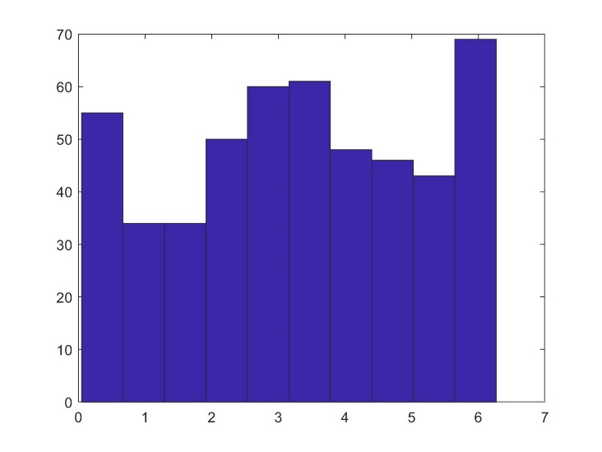MSD = 6230
2. 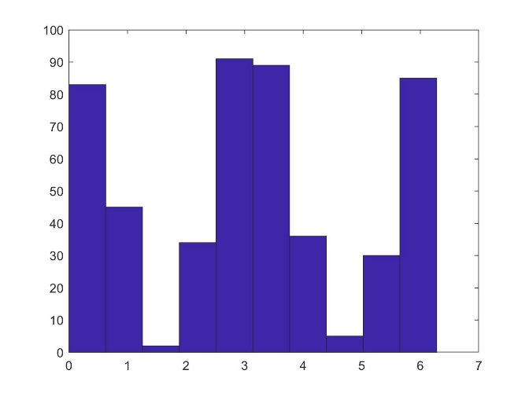MSD = 8100
3. 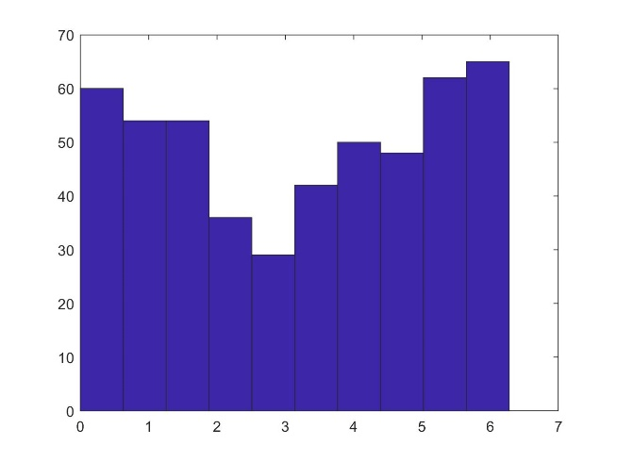MSD = 304.5

The difference between these results and the ones produced by part a are that the mean squared displacement is much smaller. The angles are also slightly more skewed out to the smaller and larger angles than to the middle ones in the part c graph than in the part a graph. The spread of angles in the graph here is also slightly more even than in the part a graph.

1. 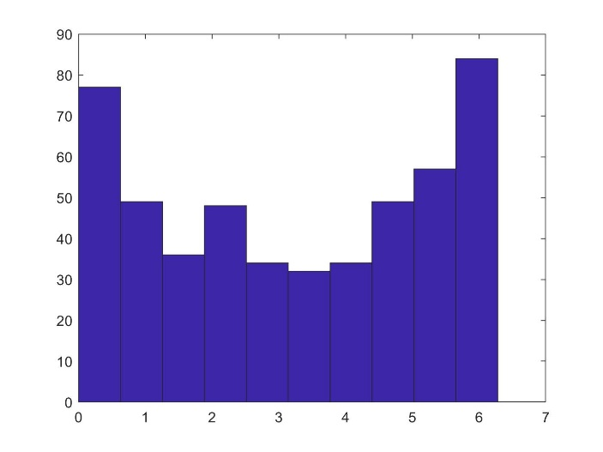MSD = 169.6

Here, the mean squared displacement is also much smaller than in part b, and again, the angles are skewed out more to the outskirts of the distribution than in the graph of part b. The distribution of angles in this graph is also slightly more even than in the part b graph.