Emily Robideau

11-15-18

**Problem Set 9**

2a. σ0 = 0.0178

2b. 3

3a. M = 1443.5

3b. 78.6951

4c. -0.7259

5d. 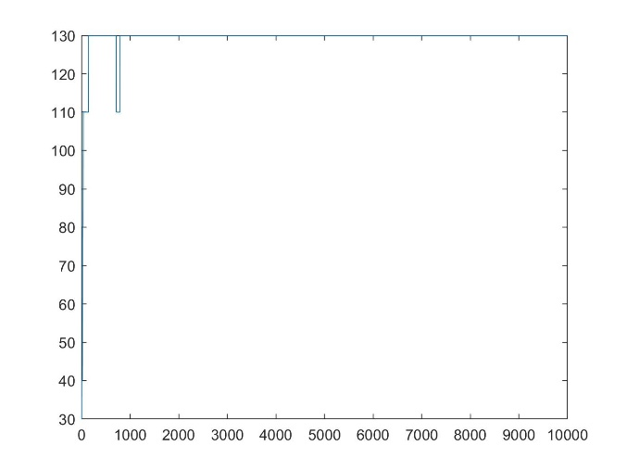

5e. 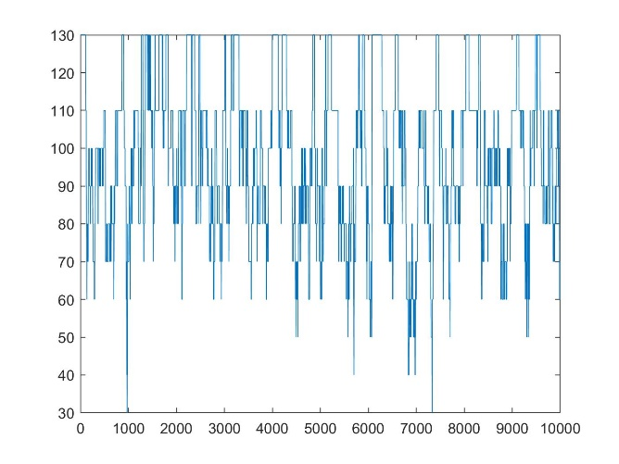

5f. 