Programming principles Team 54 project

## Description of project:

The software provides users with a centralized platform for managing their reading materials, library, and book-related experiences. By utilizing an object-oriented design, it aims to give readers an organized way to track their books and connect with others. The software allows users to store details about each book, share reviews, and customize their libraries.

## Participation of team members:

| **Team Members** | **Participation Percentage** | **Description** |
| --- | --- | --- |
| Emin Dabakhov | 40% | Created data model classes (Book Review ProfileBook). Created databases with CRUD operations for General Personal and Account databases. Converted brodsky.csv into General database. Created UI components for rendering Databases. Added Localization support. Created a logic for login and registration. Handled potential exceptions. |
| Ayla Ismayilzada | 30% | Created Sorting (General and Personal) for Author and Title, and a search filter (Author and Title), also created Reviews View and Ratings, wrote ReadMe |
| Gulay Mehraliyeva | 20% | Added styles to Login page, Register page, Edit profile book page, GeneralDB page, PersonalDB page. Translated words from English to Azerbaijani. |
| Elgun Rzazada | 10% | Created UML diagram. Cleaned code from unused comments and wrote descriptions for classes. |

## Links:

Github repository

<https://github.com/ADA-SITE-CSCI-1202/team-project-team-54>

Video presentation:

## Screenshots:

Login page:

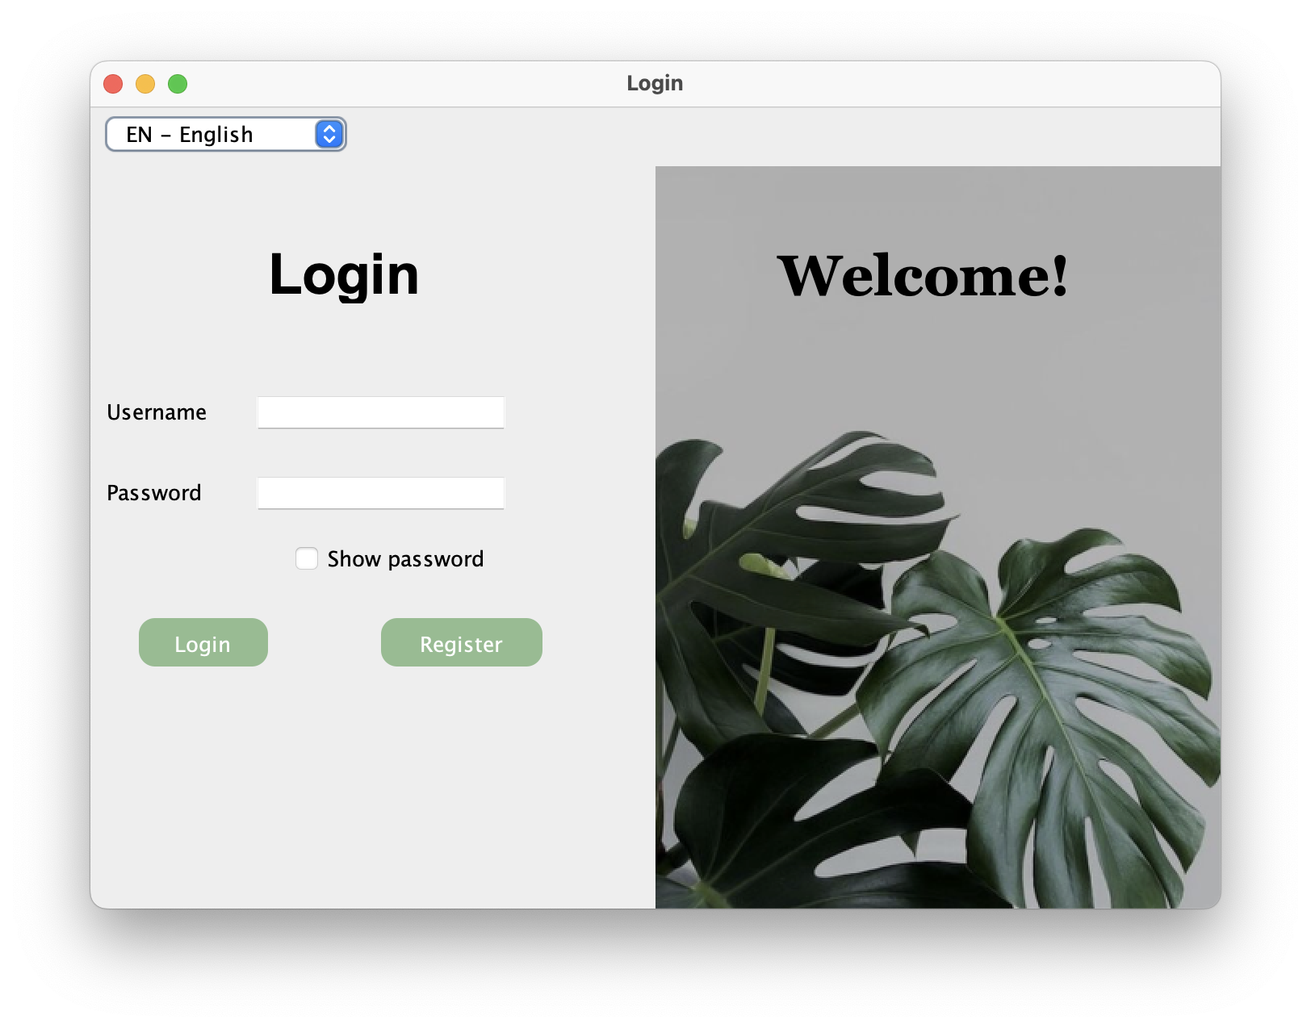Register page:

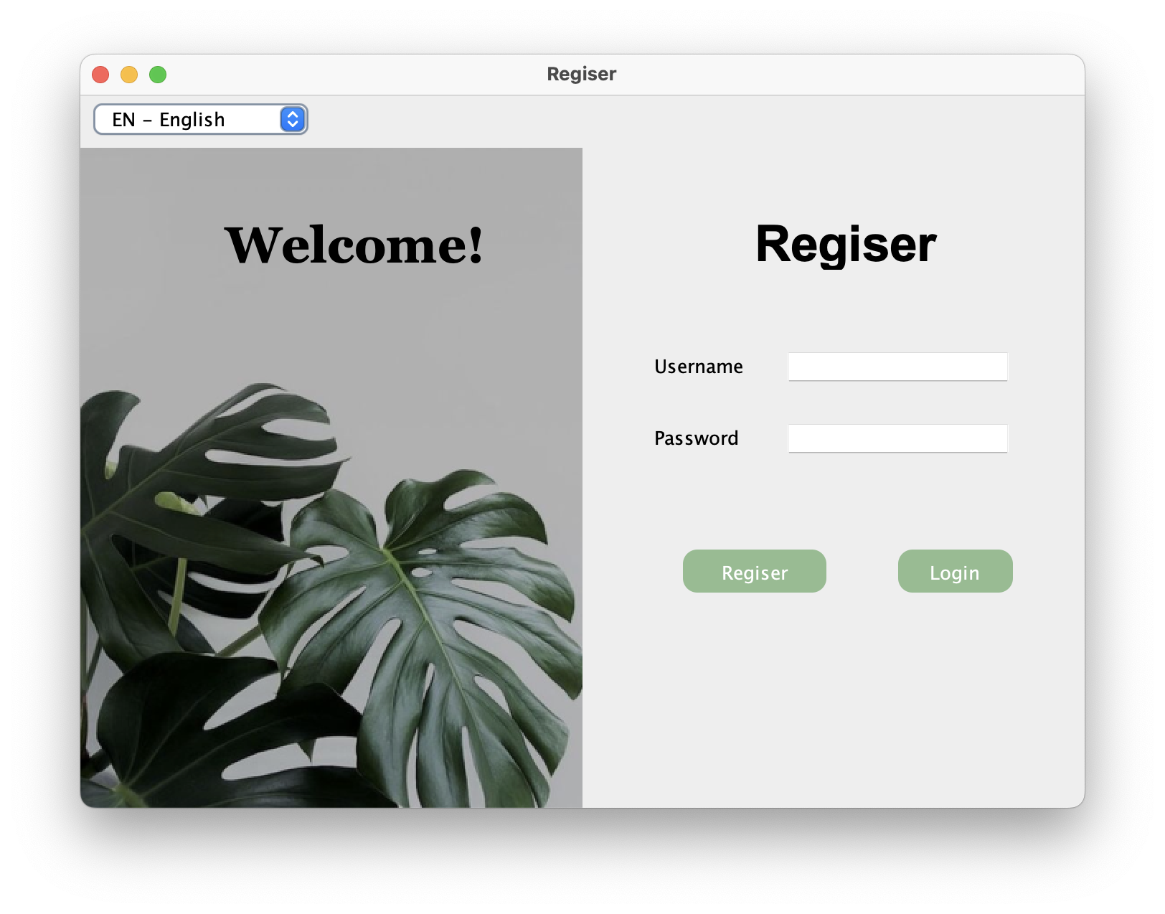General Database Page:

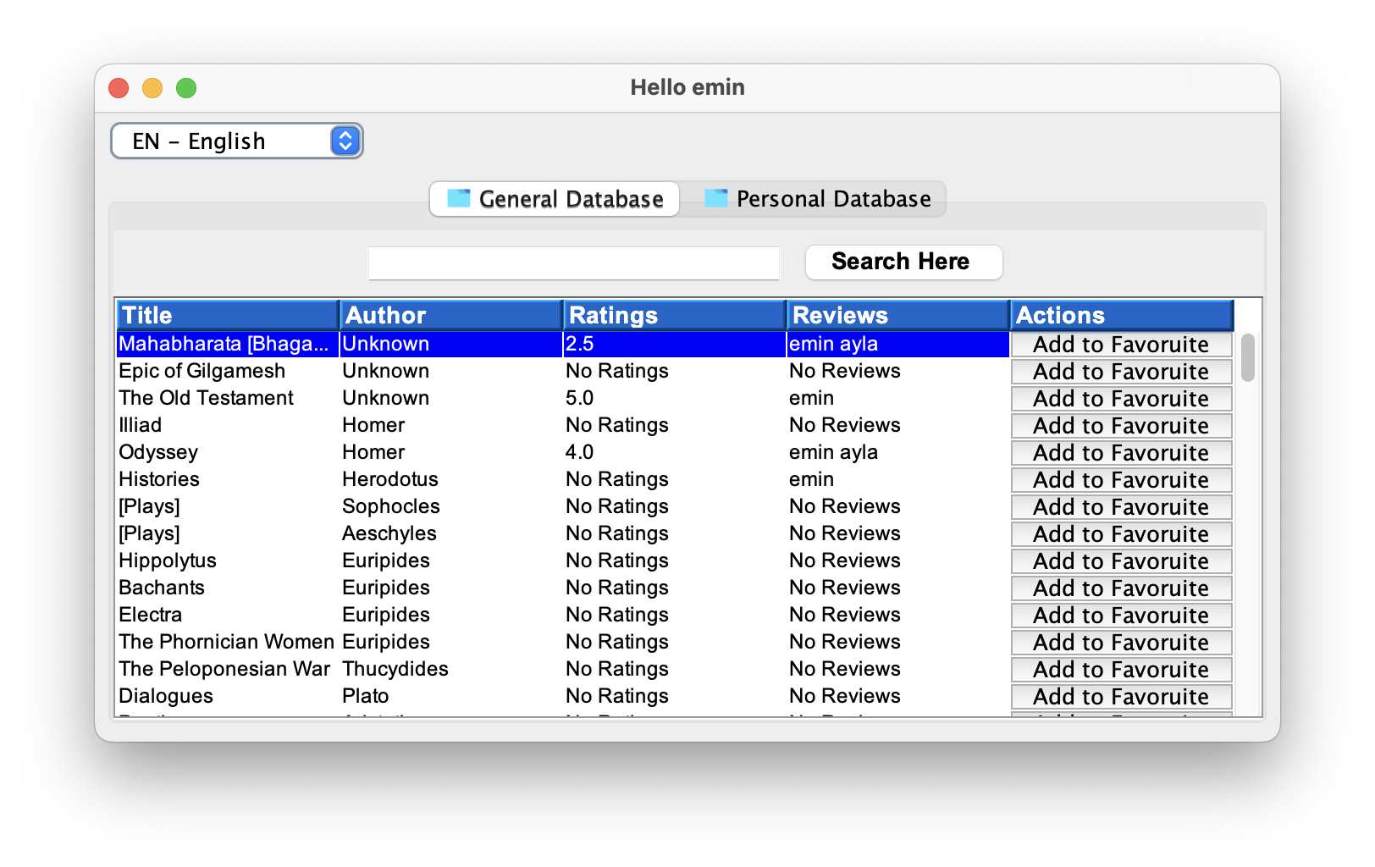Personal Database Page:

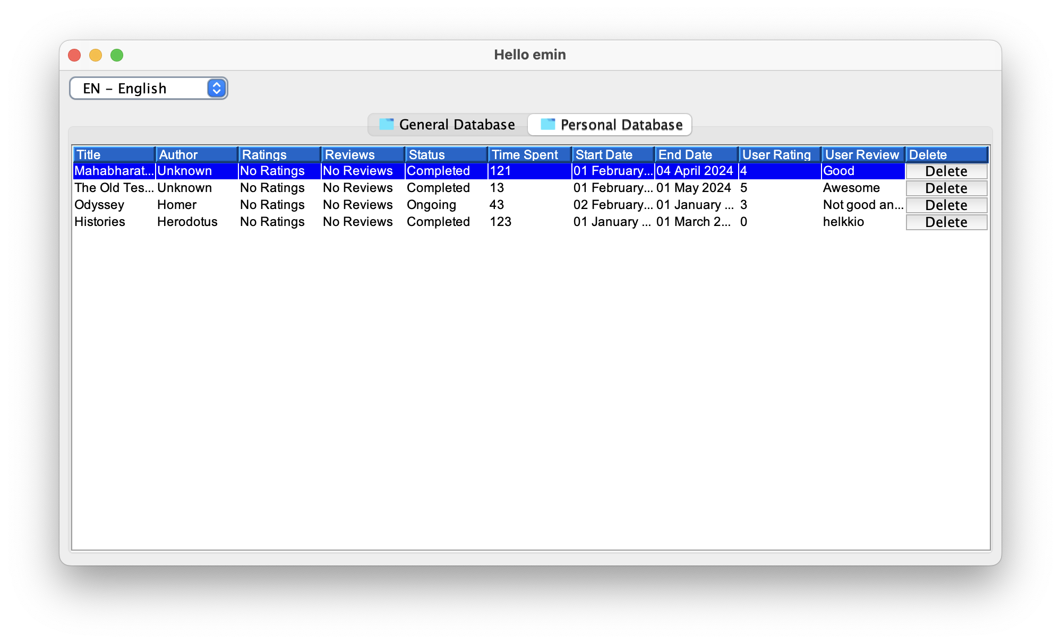Account Database Page: 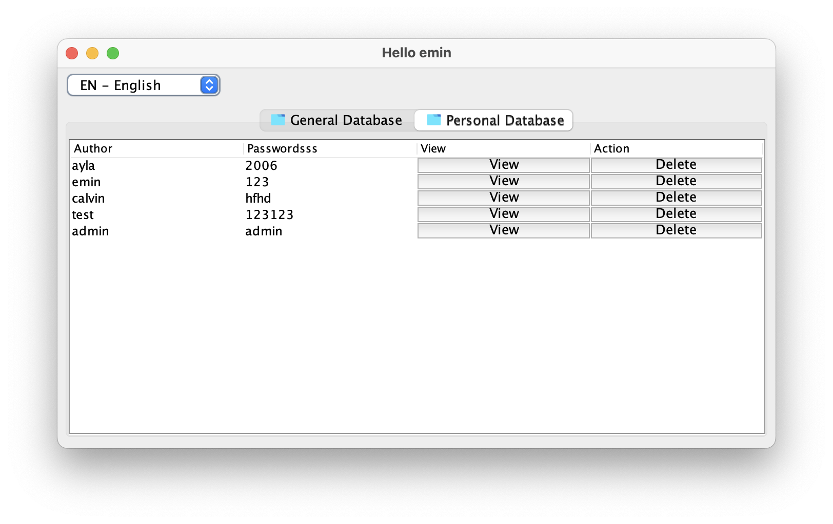

New ProfileBook Pa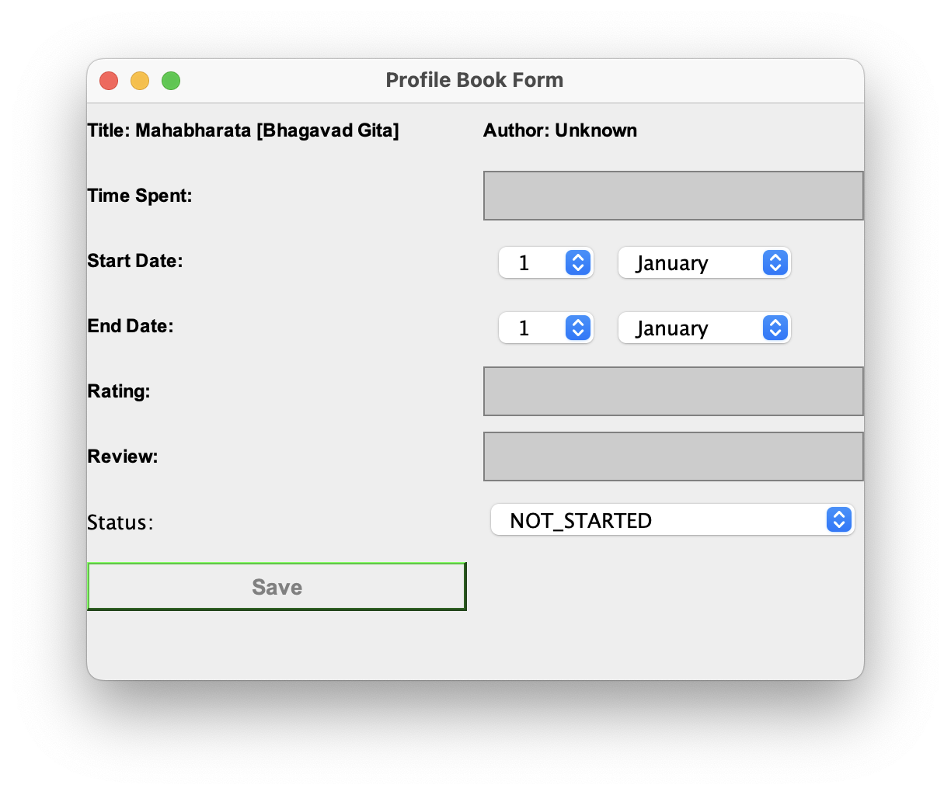Reviews Page:

