

MIDDLE EAST TECHNICAL UNIVERSITY

ELECTRICAL & ELECTRONICS ENGINEERING

*EE464 – STATIC POWER CONVERSION II*

*TERM PROJECT COMPLETE DESIGN REPORT*

Emin ÜN 2167476

Emre KARABAKLA 2540706

Görkem GÜLLETUTAN 2166544

Table of Content

Introduction 3

Topology Selection 3

Circuit Analysis, Magnetic Design and Simulation Results 5

Power Losses and Thermal Analysis 11

Component Selection 13

PCB Design 15

Cost Analysis 17

Conclusion 19

Appendix 19

Box Design for the Project 23

References 24

# 

# Introduction

A power supply is needed everywhere. Almost all electronic systems need a constant voltage supply. And a DC-DC converter is a circuit device to provide the DC power from a source to a load. In today's world, these converters are used to provide constant DC voltage or current to the circuits. For example, in electric cars, there are high voltage batteries, but the inner electronic circuits are powered with low voltage. Therefore, there are low voltage batteries that are charged by the high voltage battery. In this project, PL Electronics introduces a flyback converter (Buck-Boost) which is utilized to charge a 12 V battery from a 400 V high voltage battery. In the first part of this report, the topology of the converter will be discussed with the comparison of different topologies. The reason for the topology selection will be given in this part. In the second part, the circuit design and simulation results will be provided with the selected components. In the third part, the PCB design and cost analysis of the project will be provided. To conclude, our engineering skills in circuit design, simulations, and our project management skills will improve. Additionally, this project will give us an opportunity to implement the theoretical knowledge of us on EE464 lecture.

# Topology Selection

As mentioned in the 'Introduction' section, the high voltage needs to be converted to low voltage to charge the low voltage battery. To achieve the conversion, there are lots of DC-DC converter topologies that can be used. In this project, PL Electronics decided to use quasi resonant flyback converter topology which is an isolated DC-DC converter that works as a buck - boost converter. The reason for this topology selection is the advantages of the flyback converter. These advantages are specified below:

* The primary side of the flyback converter is isolated from the output.
* The converter has the ability to operate on a wide range of input voltages.
* The converter uses very few components compared to other switching mode power supplies.
* There is no need for an additional inductor.
* Voltage rating for the components in the secondary side is low.

Quasi resonant flyback converter is a variant of flyback converter wherein it makes use of the parasitic elements to partially resemble a resonance action. Its basic operation is the same with a normal flyback converter. It stores energy in the primary during the switch on cycle and transfers the stored energy during the switch off cycle. It is designed for DCM operation. During the dead time period, there is no more energy. This results in a natural oscillation like a second order system. Magnetizing inductance in the circuit diagrams is used to store energy that is to be transferred to the load. The advantages of the quasi resonant flyback converter compared to the flyback converter are specified below;

* Lower switching losses when switching on the lowest valley point.
* EMI will be better since it can behave as partial resonance.
* The partial resonance action will be performed by parasitic elements thus no more added parts counts.
* Wider input range.
* Better transient response.
* Easier to compensate.

To implement the quasi resonant flyback converter, an integrated circuit component called LT8316, which is produced by Analog Devices, is used. This component is an IC that has a controller for duty cycle. The duty cycle is used to control the MOSFET which is the main control element of the flyback converter. Also, it is needed to design a transformer for the flyback converter. PL Electronic decided to design a suitable transformer itself by winding an E core with suitable cables.

Because of the pandemic conditions, we have no chance to work on the designed circuit physically in the laboratory. Therefore, we decided to design our circuit in an LTSpice to implement the real-life values of the components. In the following parts of the report, the simulation results for the LTSpice design will be given.

In short, PL Electronics chose a flyback converter with an integrated controller and a self-designed transformer. In the following section, the circuit will be examined in detail and the simulation results will be shown.

# Circuit Analysis, Magnetic Design and Simulation Results

In this part of the report, analytical calculations, magnetic design, and simulation results will be demonstrated. After analytical calculations for the flyback converter, we will show the magnetic design according to analytical calculations. Lastly, we will provide the simulation results according to analytical calculation and magnetic design. We used LTSpice to simulate the circuit with the selected controller (LT 8316) and components.

In the flyback converter, the relation between output voltage and input voltage is:

As we will examine in magnetic design part, we found turn ratio secondary to primary 3/36, iteratively. Putting this turn ratio, output voltage and input voltage at boundaries (220 V and 400 V), we obtained following duty ratios:

Output capacitor is found by Equation 3 to be suitable for the project ripple specification (max peak to peak ripple is 4%). For this calculation, the worst case (D is maximum) took into consideration. Also, ripple depends on switching frequency which we take 100 kHz because the controller LT8316 operates at 100 kHz with 220 V - 400 V input range.

After these analytical calculations, we have done magnetic design. Since, the controller samples the output voltage from the isolated flyback waveform appearing across a third winding on the transformer, a transformer with three windings has been designed. To decide the primary to secondary turn ratio, we did some iterative calculations on Matlab.

The transformer primary and secondary side inductances for the flyback converter to operate in the worst case is found by Equation 4.

Also, peak current in the secondary and primary side is found:

After these calculations, we decided which core we will use. As a result of iterative calculations, we have decided to use 0P44721EC core. This core length is sufficient to get desired primary and secondary inductances. The properties of the selected core is shown table below.

Table-1 The properties of the selected core

|  |  |  |
| --- | --- | --- |
| Core | Effective Cross-Sectional Area (Ae) (mm2) | Maximum Magnetic Flux Density (T) |
| 0F43517EC | 84.3 | 0.3 |

With the chosen core, the minimum number of turns for the transformer primary side to avoid the core saturation is found:

Required air gap to obtain calculated inductances with the selected core is found:

Also, skin depth in mm is found:

We have selected the current density in the cables .

The required AWG diameter for primary side is found:

The required AWG diameter for secondary side is found:

Also, for the tertiary side we have selected AWG 40 because the current on that side is very small. (around 50 mA)

In the table below, the properties of the selected AWG cables can be seen.

Table-2 The properties of the selected AWG cables

|  |  |  |  |  |
| --- | --- | --- | --- | --- |
| Transformer Side | Required min diameter (mm) | Selected AWG | Diameter (mm) | Cross section area |
| Primary | 0.52 | AWG 20 | 0.8128 | 0.518 |
| Secondary | 2.52 | AWG 10 | 2.58 | 5.26 |
| Tertiary | - | AWG 40 | 0.0799 | 0.00501 |

To calculate fill factor, size of selected core and cables are needed.

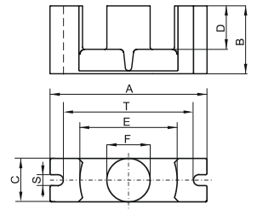

Figure 1: Dimensions of selected core

In the figure above; D, E and F are 12.3, 22.75 and 9.5, respectively. Therefore window area as found:

To calculate fill factor, we have found cable area:

Also, the length of each cable can be seen in the Table below.

Before calculating the length of the each AWG cable, we should calculate circumstance of the 1 turn.

Table-3 The length of each AWG cable

|  |  |  |  |
| --- | --- | --- | --- |
| Transformer Side | Turn Number | Selected AWG | Length (mm) |
| Primary | 36 | AWG 20 | 1172 |
| Secondary | 3 | AWG 10 | 97.62 |
| Tertiary | 3 | AWG 40 | 97.62 |

Effective areas for AWG cables are found:

AC resistances of the AWG cables are found by the equation below, where p is resistivity and it is around

AC resistances:

Then we simulate the circuit according to values we have found analytically and our magnetic design. In the figure below, overall circuit design can be seen.

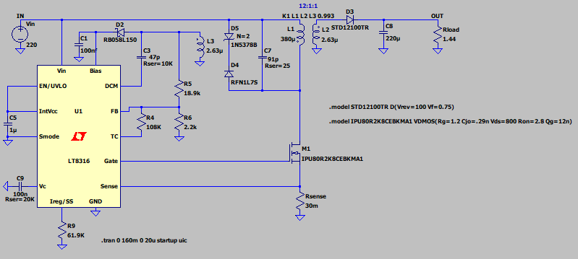

Figure 2: The overall circuit design

Feedback resistors and for the controller are found:

Since it is recommended to keep between 1kΩ and 10kΩ in order to preserve the resistor divider’s dynamic response, we chose =2k Ohm and =18.9k Ohm.

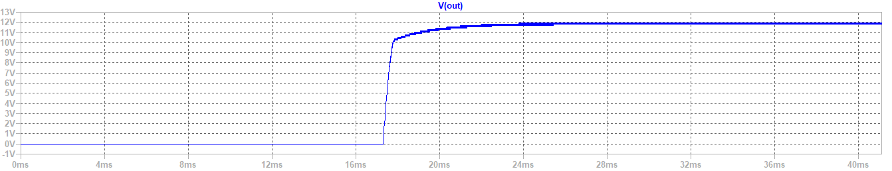

Figure 3: Output Voltage Waveform for 220 V input

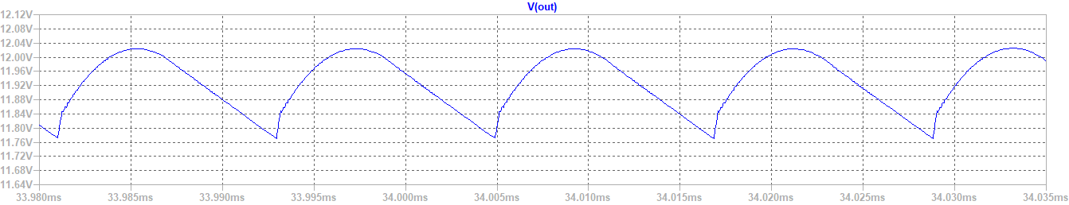

Figure 4: Output voltage ripple for 220 V input

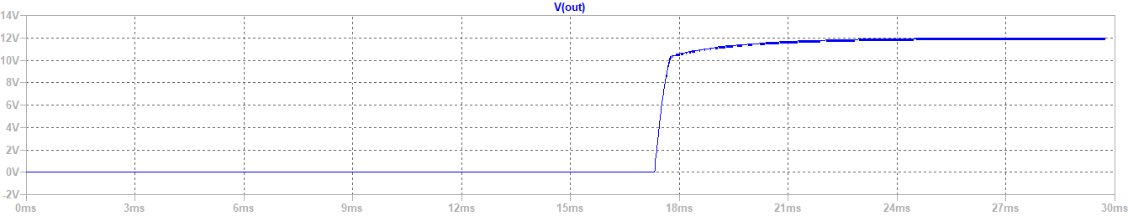

Figure 5: Output Voltage Waveform for 400 V input

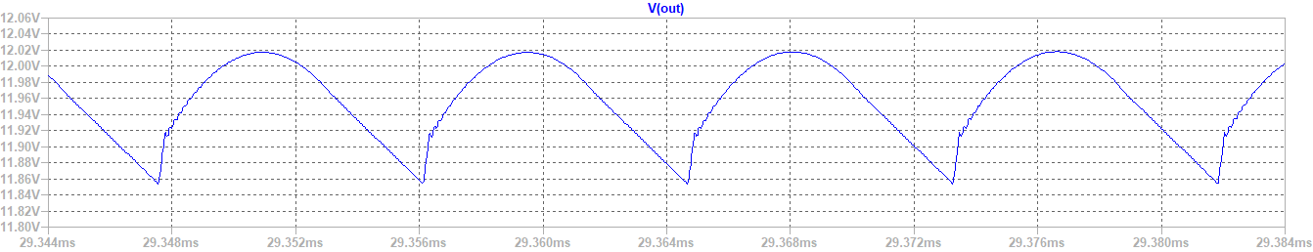

Figure 6: Output voltage ripple for 400 V input

As seen in the figures above, output voltage is 12 V for input voltage is 220 V and 400 V. It is not affected by varying input voltage between 220 V and 400 V.

# Power Losses and Thermal Analysis

Power loss calculations and thermal analysis for the MOSFET are given below:

Power loss calculations and thermal analysis for the diode are given below:

Power loss calculations for the core are given below:

These calculations are for the room temperature. Therefore, we need to add a temperature dependence for the core loss calculation. The equation becomes:

Then,

Thermal simulation is given below:

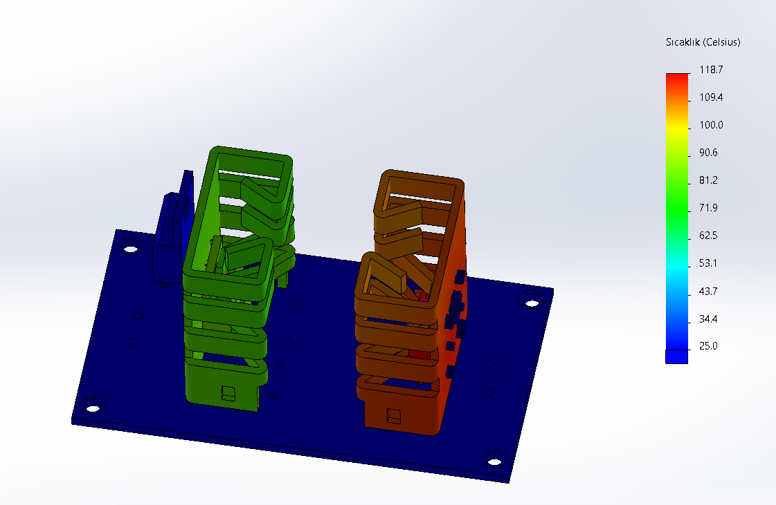

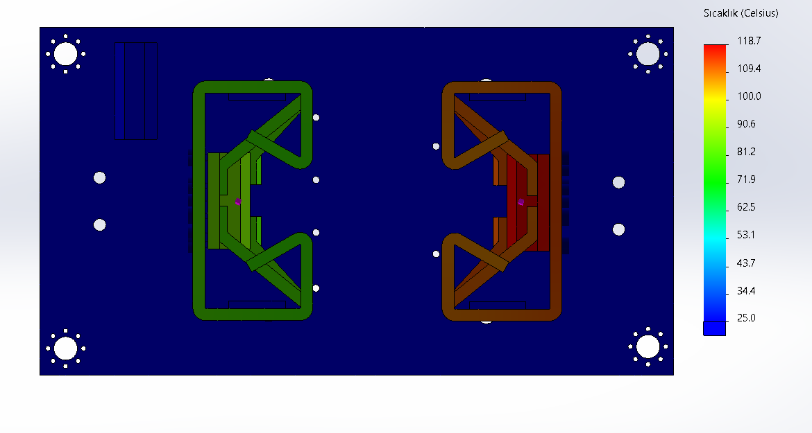

Figure 7: Thermal Simulation for heatsinks and semiconductors

# Component Selection

Table-4

|  |  |  |  |
| --- | --- | --- | --- |
|  | **Component** | **Manufacturer** | **Digi-Key Part Number** |
| Mosfet | SIHB24N80AE-GE3 | Vishay Siliconix | 742-SIHB24N80AE-GE3-ND |
| Diode | STD12100TR | SMC Diode Solutions | STD12100TRSMC-ND - Tape & Reel (TR) |
| Output Capacitor | EEU-FK1E271B | Panasonic Electronic Components | EEU-FK1E271B-ND - Tape & Box (TB) |
| Transformer Core | [0F43517EC](https://www.digipart.com/rfq?distr=Semisource&mfr=&mpn=0P44721EC) | Magnetics. |  |
| RFB1 | WR04X202 JTL | Walsin Technology Corporation | 1292-WR04X202JTLTR-ND - Tape & Reel (TR) |
| RFB2 | MCT06030C1892DP500 | Vishay Byschlag/Draloric/BC Components | MCT06030C1892DP500-ND - Tape & Reel (TR) |
| RTC | CR205402F | Meritek | 2997-CR205402FTR-ND - Tape & Reel (TR) |
| Rsense | WK73S2HTTE29L4F | KOA Speer Electronics, Inc. | 2019-WK73S2HTTE29L4FTR-ND - Tape & Reel (TR) |
| R_l_reg | WR04X6192FTL | Walsin Technology Corporation | 1292-WR04X6192FTLTR-ND - Tape & Reel (TR) |
| R_load | WR04W1R43FTL | Walsin Technology Corporation | 1292-WR04W1R43FTLTR-ND - Tape & Reel (TR) |
| R_ser(C7) | CR2025R0F | Meritek | 2997-CR2025R0FTR-ND - Tape & Reel (TR) |
| R_ser(C9) | WR04X203 JTL | Walsin Technology Corporation | 1292-WR04X203JTLTR-ND - Tape & Reel (TR) |
| C7 | GRM0335C1H910JA01D | Murata Electronics | GRM0335C1H910JA01D-ND - Tape & Reel (TR) |
| R_ser(C3) | CR20103J | Meritek | 2997-CR20103JTR-ND - Tape & Reel (TR) |
| C3 | GMC04CG470J16NT | CAL-CHIP ELECTRONICS, INC. | 2571-GMC04CG470J16NTTR-ND - Tape & Reel (TR) |
| C1 | CL10A475KQ8NNNL | Samsung Electro-Mechanics | CL10A475KQ8NNNL-ND - Tape & Reel (TR) |
| C5 | CL05A105KQ5NNND | Samsung Electro-Mechanics | CL05A105KQ5NNND-ND - Tape & Reel (TR) |
| C8 | EDK227M025S9MAA | KEMET | EDK227M025S9MAA-ND |
| C9 | CL05A104KA5NNND | Samsung Electro-Mechanics | CL05A104KA5NNND-ND - Tape & Reel (TR) |
| D2 | BAT54WSTR | SMC Diode Solutions | BAT54WSTRSMC-ND |
| R-Pot | 3314G-1-103G | Bourns Inc. | 3314G-1-103G-ND |
| D5 | SMBJ5386B-TP | Micro Commercial Co | SMBJ5386B-TPMSTR-ND |
| D4 | M7L | Diotec Semiconductor | 2796-M7LTR-ND |

# 

Table-5

|  |  |  |  |
| --- | --- | --- | --- |
| **Voltage Protection circuit** |  |  |  |
| Mosfet | IXTA10P50P | IXYS | IXTA10P50P-ND |
| PNP Transistor | PBHV9050ZF | Nexperia USA Inc. | PBHV9050ZF-ND |
| Zener | BZT52-C51X | Nexperia USA Inc. | 2156-BZT52-C51X-NEX-ND |
| C1 | MC12KTB501104 | Viking Tech | 2577-MC12KTB501104TR-ND |

# PCB Design

PL Electronics decided to design a 2-layer PCB for quasi resonant flyback circuit.

Schematic for the PCB design and 3D view for the PCB design is given below;

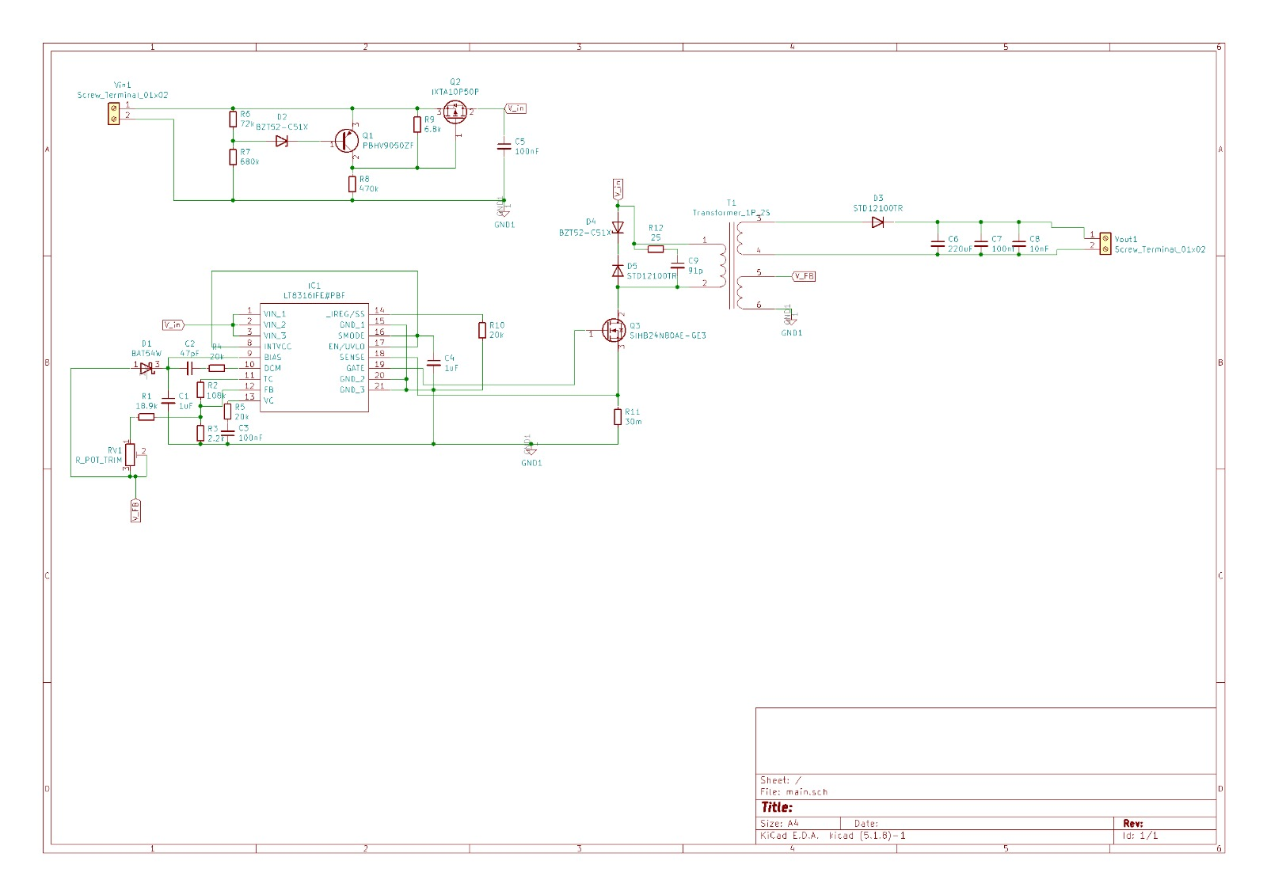

Figure 8: Schematic of the PCB Design

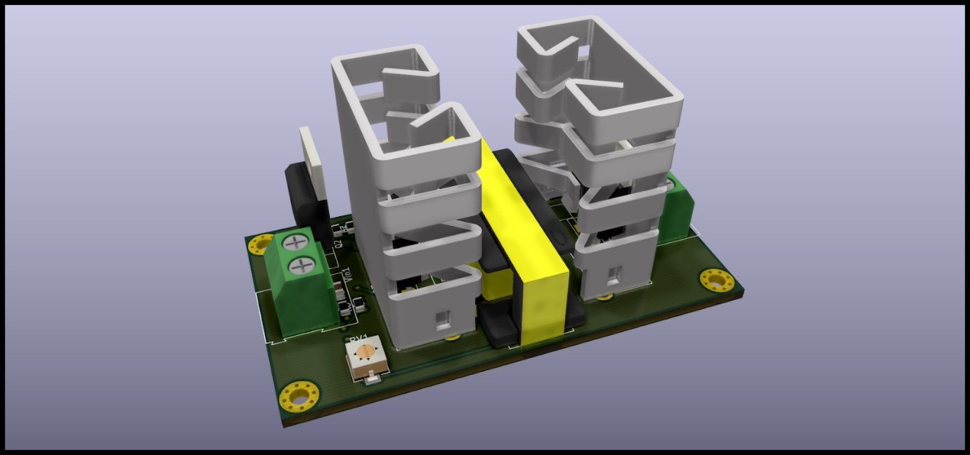

Figure 9: General View of the PCB Design

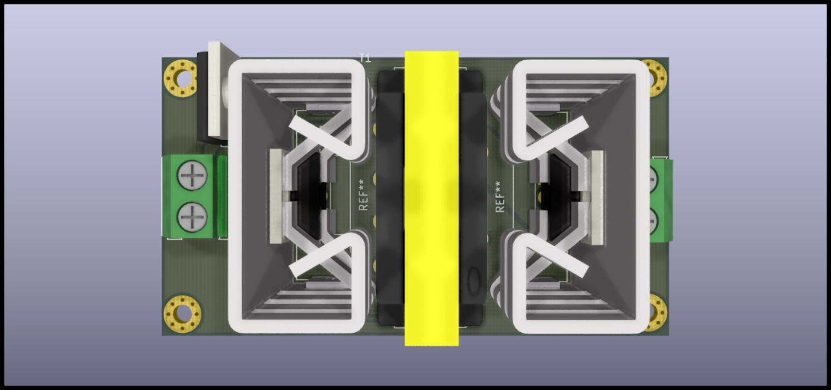

Figure 10: Top View of the PCB Design

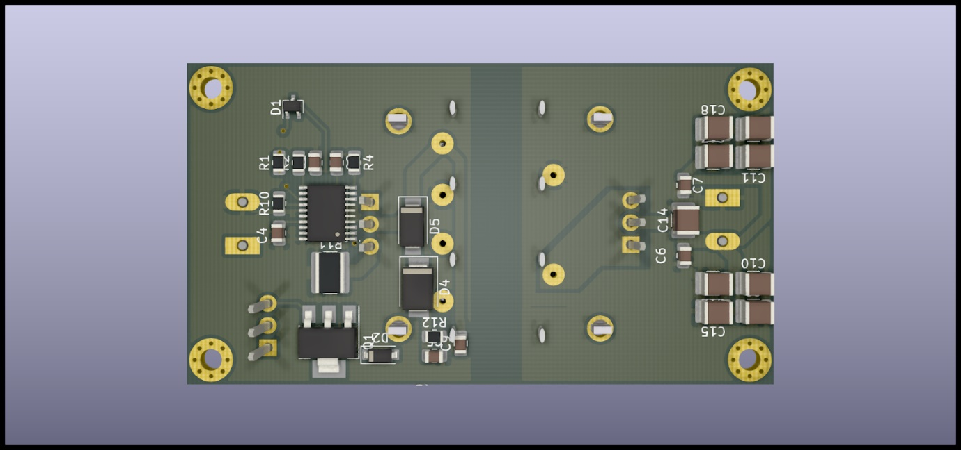

Figure 11: Bottom View of the PCB Design

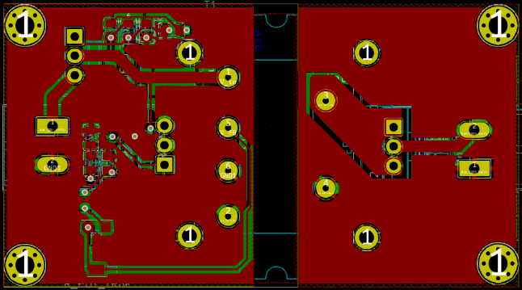 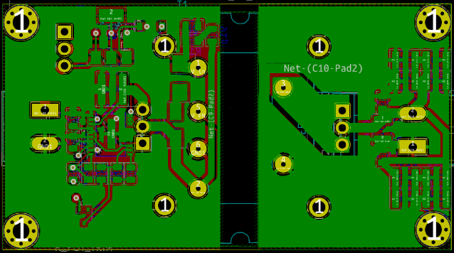

Figure 12: Layers of the PCB Design

# Cost Analysis

Table-6

|  |  |
| --- | --- |
| **Component** | **Cost** |
| Mosfet | $3,39000 |
| Diode | $0,20000 |
| Output Capacitor | $0,12606 |
| Transformer Core | $1,00000 |
| RFB1 | $0,00084 |
| RFB2 | $0,02160 |
| RTC | $0,14000 |
| Rsense | $0,12420 |
| R_l_reg | $0,00083 |
| R_load | $0,00105 |
| R_ser(C7) | $0,00240 |
| R_ser(C9) | $0,00084 |
| C7 | $0,00264 |
| R_ser(C3) | $0,00240 |
| C3 | $0,00170 |
| C1 | $0,00511 |
| C5 | $0,00220 |
| C8 | $0,14887 |
| C9 | $0,01250 |
| D2 | $0,02055 |
| R-Pot | $0,93000 |
| D5 | $0,65000 |
| D4 | $0,01460 |
| Voltage Protection circuit |  |
| Mosfet | $5,93000 |
| PNP Transistor | $0,16198 |
| Zener | $0,03246 |
| C1 | $0,00125 |
| Total Cost | **$12,92408** |

# Conclusion

To conclude, PL Electronics have designed a quasi resonant flyback circuit, which is utilized to charge 12 V battery from a 400 V high voltage battery. These types of circuits and converters are used everywhere that needs a constant DC voltage such as electric cars. Therefore, the purpose of the project is to follow up the latest technologies on the power electronics.

In the first part of this report, the topology of the converter is discussed with the comparison of different topologies. The reason for the topology selection is given in this part. In the second part, the circuit design and simulation results are provided with the selected components. In the third part, the PCB design and cost analysis of the project is provided.

This project helps us improve our engineering skills in circuit design, simulations, and our project management skills. Additionally, this project gave us an opportunity to implement the theoretical knowledge of us on EE464 lecture.

# Appendix

Our MATLAB Code for magnetic design and some components::

%%Flyback Converter

%Circuit Parameters

Vin_min=220;

Vin_max=400;

Vout=12;

Pout=100;

R_Load=Vout^2/Pout;

I_out_avg=Pout/Vout;

V_sw_on=0.2;%Mosfet on voltage

V_diode_on=0.8;%Diode forward voltage drop

%Limitations

Vout_ripple=4/100;% output ripple

D_max=0.40;

B_sat=0.3;

Kcu=0.4;%Winding factor

Fs=100e3;%37-50kHz

Skin_depth=75/sqrt(Fs);%Skin depth in mm

KRF=0.6;%Input current ripple factor

Current_Density=4;%Current Density A/mm^2

K_margin=1.25;

u_r=1500;

u_0=4*pi*1e-7;

%Equations

n=ceil((Vin_min-V_sw_on)/(Vout+V_diode_on)*D_max/(1-D_max)); %N1/N2

D_min=1/((Vin_max-V_sw_on)/((Vout+V_diode_on)*n)+1);

D_IL=2*I_out_avg/((1-D_max)*n);

Lm=Vin_min*D_max/(Fs*D_IL);

%Lm=(Vin_min*D_max)^2/(2*Pout*Fs*KRF);

I_sw_max=Pout/(Vin_min*D_max)+D_IL/2;

Vds_max=Vin_max/(1-D_min);

C_out=I_out_avg*D_max/(Vout_ripple*Vout*Fs);

I_Diode=I_out_avg;

%Transformer Design E-core with gap

N1_min=@(Ae)Lm*I_sw_max*1e6/(B_sat*Ae); %Function to calculate Primary turn input is area of core Ae in mm^2

d_air_gap=@(Ae)u_0*N1_selected^2*Ae*1e-4/Lm; %required air gap in mm;

Ae=84.3;%pi*7.68^2;%mm^2

N1_selected=ceil(N1_min(Ae));

N2_calc=round(N1_selected/n);

d_air_gap_calc=d_air_gap(Ae);

N1_wire_len=N1_selected*2*pi*sqrt(Ae/pi);

N2_wire_len=N1_selected/n*2*pi*sqrt(Ae/pi);

N3_wire_len=N2_wire_len;

wire_area_N1=N1_selected*I_sw_max/Current_Density; %mm^2

wire_area_N2=N2_calc*I_out_avg/Current_Density;%mm^2

wire_area_N3=N2_calc*100e-3/Current_Density;%mm^2

Total_wire_area=wire_area_N1+wire_area_N2+wire_area_N3;

winding_window_area=Total_wire_area/Kcu; %mm^2

winding_window_height=sqrt(Total_wire_area);

Transformer_Volume=winding_window_height*winding_window_area*6; %mm^3;

%AWG Area in mm^2 List 1-40

AWG_Area=[42.4 33.6 26.7 21.2 16.8 13.3 10.5 8.37 6.63 5.26 4.17 3.31 2.62 2.08 1.165 1.31 1.04 0.823 0.653 0.518 0.41 0.326 0.258 0.205 0.162 0.129 0.102 0.081 0.0642 0.0509 0.0404 0.032 0.0254 0.0201 0.016 0.0127 0.01 0.00797 0.00632 0.00501];

[minValue,N1_AWG] =min(abs(AWG_Area-I_sw_max/Current_Density));

[minValue2,N2_AWG] =min(abs(AWG_Area-I_out_avg/Current_Density));

N3_AWG=length(AWG_Area);

% Result Section

fprintf("Mosfet V_DS(on)=%0.2fV I_DS(on)=%0.2f\n",Vds_max*K_margin,I_sw_max*K_margin);

fprintf("Diode V_D(reverse)=%0.2fV I_D(on)=%0.2fA\n",2*Vds_max*K_margin/n,I_out_avg*K_margin);

fprintf("Output Capacitance=%0.2fuF\n",C_out*1e6*K_margin);

fprintf("Transformer N1 Turns=%d Cable=AWG%d Length=%0.2fm\n",N1_selected,N1_AWG,N1_wire_len*K_margin*1e-3);

fprintf("Transformer N2 Turns=%d Cable=AWG%d Length=%0.2fm\n",N2_calc,N2_AWG,N2_wire_len*K_margin*1e-3);

fprintf("Transformer N3 Turns=%d Cable=AWG%d Length=%0.2fm\n",N2_calc,N3_AWG,N3_wire_len*K_margin*1e-3);

fprintf("Transformer Winding window area=%0.2fmm^2 Air gap=%0.2fmm, Ae=%0.2fmm^2 Estimated Volume=%0.2fmm^3\n",winding_window_area,d_air_gap_calc,Ae,Transformer_Volume);

fprintf("Transformer Lm=%0.2fmH Fs=%dkHz\n",Lm*1e3,Fs);

>> Selection_Script_v2

Mosfet V_DS(on)=692.10V I_DS(on)=2.87

Diode V_D(reverse)=115.35V I_D(on)=10.42A

Output Capacitance=86.81uF

Transformer N1 Turns=35 Cable=AWG20 Length=1.42m

Transformer N2 Turns=3 Cable=AWG14 Length=0.12m

Transformer N3 Turns=3 Cable=AWG40 Length=0.12m

Transformer Winding window area=65.99mm^2 Air gap=0.07mm, Ae=84.30mm^2 Estimated Volume=2034.16mm^3

Transformer Lm=0.38mH Fs=100000kHz

## Box Design for the Project

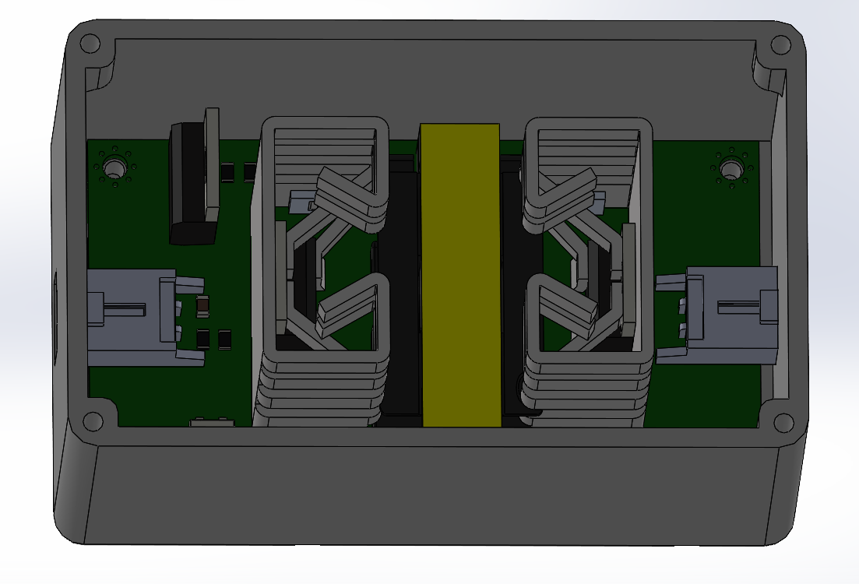

Figure 13: The Project in the Designed Box

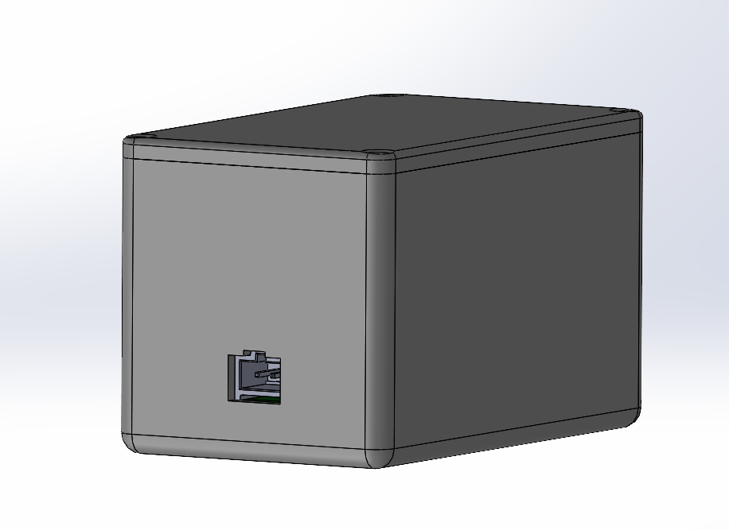

Figure 14: The Outside View of the Designed Box

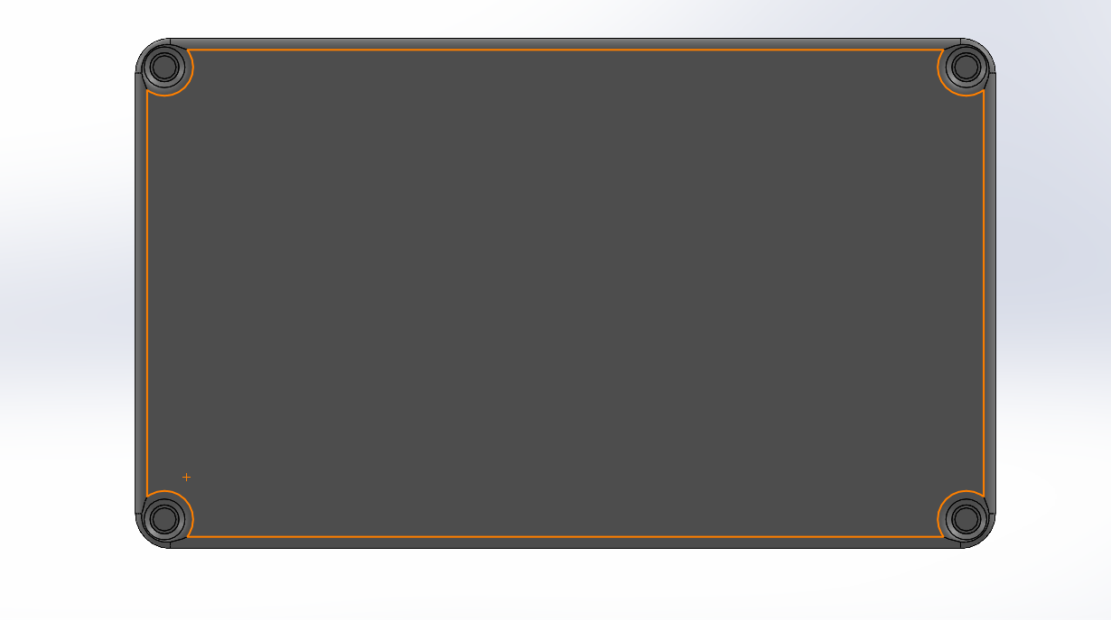

Figure 15: The Bottom View of the Designed Box

# References

<http://electronicsbeliever.com/how-quasi-resonant-flyback-works-detailed-operation/>

<https://www.analog.com/media/en/technical-documentation/data-sheets/lt8316.pdf>