**Installation**

The following installations are for Linux servers.

**Step 1:**

Node Exporter installation can be performed by following the steps in the link below.

<https://devopscube.com/monitor-linux-servers-prometheus-node-exporter/>

While following the steps in the link above. Under the title of “**Create a Custom Node Exporter Service**” below content will be added. **\*location_of_directory\*** must point the file where **\*.prom** files to be saved. Thus, Node Exporter will display the files contents at ‘**\*node_exporter_ip*:9100/metrics**’

**[Unit]**  
Description=Node Exporter  
After=network.target  
  
**[Service]**  
User=node_exporter  
Group=node_exporter  
Type=simple  
ExecStart=/usr/local/bin/node_exporter --collector.textfile.directory="/*location_of_directory*"  
  
**[Install]**  
WantedBy=multi-user.target

**Step 2:**

Prometheus installation can be performed by following the steps in the link below.

<https://devopscube.com/install-configure-prometheus-linux/>

While following the steps in the link above. Under the title of “**Setup Prometheus Configuration**” below content will be added. In the section of **\*node_exporter_ip\*** must be entered the IP address where Node Exporter installed. When the Prometheus is activated, it starts to collect and store the metrics in real time.

**global**:  
 **scrape_interval**: 10s  
  
**scrape_configs**:  
 - **job_name**: 'prometheus'  
 **scrape_interval**: 5s  
 **static_configs**:  
 - **targets**: ['localhost:9090']  
  
 - **job_name**: 'node_exporter_metrics'  
 **scrape_interval**: 5s  
 **static_configs**:  
 - **targets**: ['*node_exporter_ip*:9100']

**Step 3:**

Grafana installation can be performed by following the steps in the link below.

<https://devopscube.com/integrate-visualize-prometheus-grafana/>

By following the steps below, you can add prepared dashboard and you can edit the dashboard as you like. For every query you should edit **\*localhost\*** with Node Exporter’s IP and **\*node_name\*** with the node name that you named via **get_of_metrics** script.

Note: node_name is host_name which is required by the get_of_metrics script.

**instance=\"*localhost*:9100\"” and “node_name=\"*node_name*\"**

The JSON file is at sample-dashboard.json

**Step 1:**

This way you can access the importing the JSON

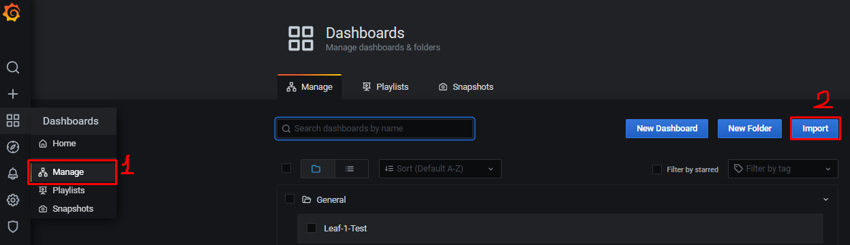

**Step 2:**

After copying the JSON file into the box or uploading the JSON file, the dashboard installation will be done when press the "Load" button.

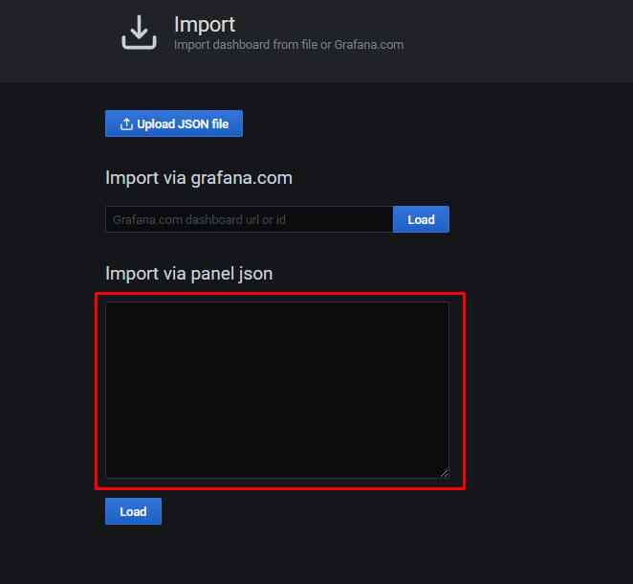

**Step 4:**

Installing the get_of_metrics.py script as a service.

**Step 1:**

Copy the get_of_metrics.dep file to server which will run the script constantly. So, we can install the debian package using the dpkg or apt package management tool.

**Step 2:**

**sudo apt install ./get_of_metrics.deb**

or

**sudo dpkg -i ./get_of_metrics.deb**

**Step 3:**

While installation it asks to enter the parameter to connect remote machine each step you should enter alias name, host ip/name, username and password. When you are done, it will ask you to enter directory path which is already created. Then, you can give delay time if not want to enter just press enter to skip. The default delay time is 5 seconds. In the end you will end up such service file. If you make any error you can restart the process or cancel, it will show you this service file content and waits your answer to continue.

**[Unit]  
Description=get_of_metrics service. You can check with [sudo systemctl status get_of_metrics] every 10 minutes, if the hosts are still connected. If not please check the error logs at /var/log/get_of_metrics.**

**After=network.target  
[Service]  
Type=simple  
Restart=always  
RestartSec=60  
ExecStart=/usr/bin/python3 /usr/bin/get_of_metrics.py -a *host_name1* *host_name2* ... -i *host_ip1* *host_ip2* ... -u *user_name1* -u *user_name2* ... -p *user_password1* *user_password2* ... -d *directory_path* -t *time(seconds)*  
  
[Install]  
WantedBy=multi-user.target**