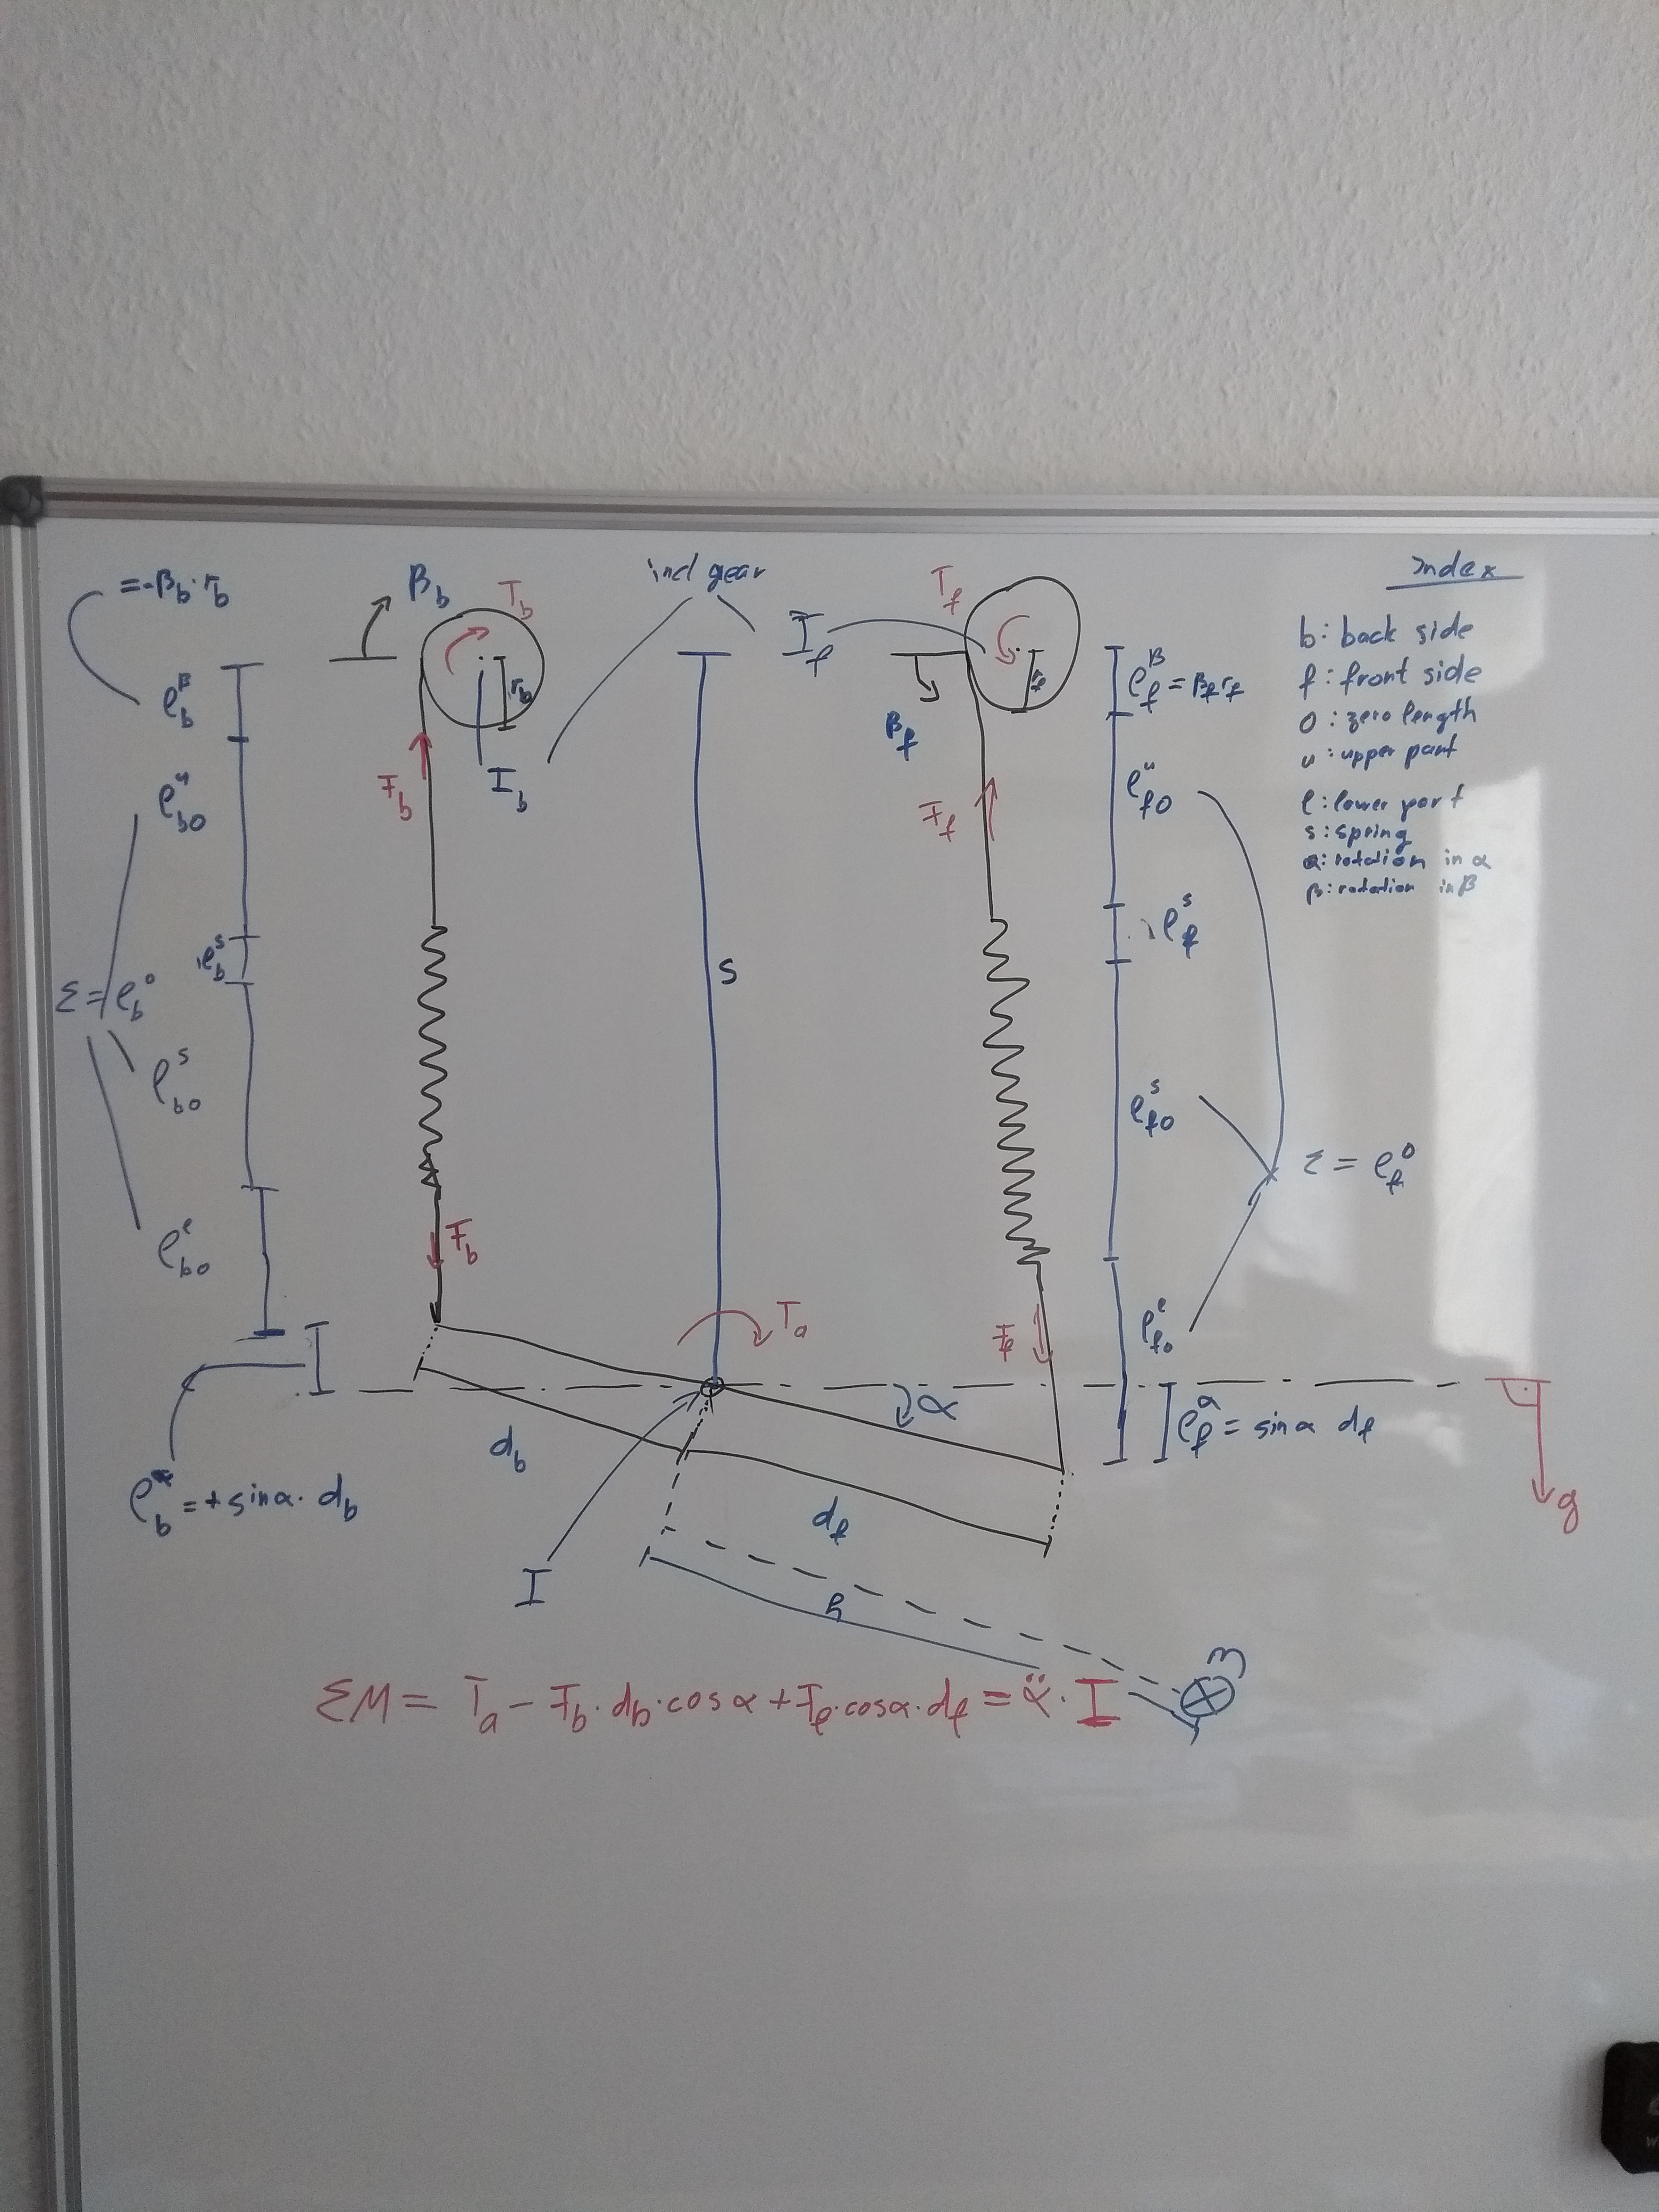

|  |  |  |  |  |  |  |
| --- | --- | --- | --- | --- | --- | --- |
| Back Side | | | | Front Side | | |
| Length of Rope + Spring | | | | | | |
|  |  | | |  | |  |
|  |  | | |  | |  |
|  |  | | |  | |  |
|  |  | | |  | |  |
| Condition - | | | | | | |
|  | |  | | | | |
|  | |  | | | | |
|  | |  | | | | |
| Gear Ratio (direction already considered to be opposing) | | | | | | |
|  | |  | | |  | |
| Kinetic Energy | | | | | | |
|  | |  | | | | |
| Potential Energy | | | | | | |
|  | |  | | | | |
|  | |  | | | | |
| Euler Lagrange Equation | | | | | | |
|  | | | | | | |
|  | | | | | | |
|  | | |  | | | |

: external Torque applied to foot (result from external forces); : Torques applied by motor/gear

Assumptions:

* Angle of rope is so small that effect can be neglected (angle between rope in zero and non-zero position)
* Mass of spring + rope neglectable
* Zero position “orthorgonal” to gravity; else include extra angle in Potential energy

|  |  |
| --- | --- |
|  |  |
|  |  |
|  |  |
|  |  |
|  |  |
|  |  |
|  |  |
|  |  |
|  |  |
|  |  |

|  |  |  |
| --- | --- | --- |
| Equations of Motion | | |
|  |  | (1) |
|  |  | (2) |
|  |  | (3) |

|  |  |  |  |  |
| --- | --- | --- | --- | --- |
| (2)🡪 |  |  | | (4) |
| (3)+(4)🡪 |  |  | | (5) |
| (5)🡪 |  | |  | (6) |
| (6)🡪 |  |  | | (7) |
| (1)+(7)🡪 |  | Final equation to find | |  |