GA4 eCommerce Funnel Analysis (BigQuery & Looker Studio)
Overview
This project analyzes an end-to-end eCommerce user funnel using Google Analytics 4 (GA4) data in BigQuery.
- Session-level user journeys are reconstructed using SQL window functions to identify funnel drop-offs, conversion friction, and time-to-purchase behavior.
- Insights are visualized in Looker Studio dashboards designed for product and business decision-making.
Problem Statement
Understanding where and why users drop off in the conversion funnel is critical for improving eCommerce performance.
This project focuses on:
- Identifying the largest drop-off points between key funnel steps
- Measuring time to purchase across device segments (Mobile vs. Desktop)
- Translating event-level data into actionable product insights
Dataset
- Google Analytics 4 Obfuscated Sample Dataset
- Source: BigQuery Public Datasets
- Event-based schema (events_* tables)
Methodology
- Reconstructed session-level user journeys from GA4 events
- Applied SQL window functions (LEAD, LAG) to analyze event transitions
- Built funnel conversion metrics and drop-off rates
- Calculated time-to-purchase by device segment
- Modeled all outputs as BigQuery views for reproducibility
Key Insights
- ~30% of users drop off between View Item → Add to Cart, indicating early funnel friction
- Desktop users take longer to convert than mobile users, suggesting higher decision complexity
- Conversion challenges occur before checkout, not during payment
Tools & Stack
- Google BigQuery (SQL)
- GA4 event schema
- Looker Studio
Outputs
- BigQuery Views:
- funnel_summary: Session-level funnel metrics and conversion rates
- funnel_data_for_viz: UNPIVOT-ed funnel data optimized for funnel visualization in Looker Studio
- device_time_to_purchase: Time-to-purchase metrics segmented by device type
- event_transitions: Event-to-event transitions and average latency between user actions
- Looker Studio dashboards
Repository Structure
ga4-funnel-analysis-bigquery/
├── README.md
├── sql/
│ ├── 01_funnel_summary.sql
│ ├── 02_ funnel_data_for_viz.sql
│ └── 03_ time_to_purchase.sql
│ └── 04_event_transitions.sql
├── looker/
│ ├── dashboard_overview.png
│ └── dashboard_event_level_transitions.png
Technical Details
BigQuery Data Modeling
- event_transitions
Uses LEAD() to calculate average time between sequential GA4 events.
- funnel_summary
Computes session counts and conversion percentages for each funnel step.
- device_time_to_purchase
Calculates average and median time-to-purchase segmented by device type.
Funnel Visualization Modeling
To support funnel charts in Looker Studio, the `funnel_summary` view is transformed into a long format using `UNPIVOT`.
- The resulting `funnel_data_for_viz` view converts funnel step columns into rows, enabling:
- - Proper funnel chart rendering
- - Flexible step ordering
- - Cleaner visualization logic in Looker Studio
All tables are implemented as views to ensure reproducibility using the public dataset.
Visualization (Looker Studio)
- Funnel chart showing user progression and drop-offs
- Scorecards for conversion rates
- Bar charts comparing time-to-purchase by device
- Event transition table highlighting latency between user actions
Screenshots of the dashboard's main pages:
- Image 1: Main Dashboard Overview
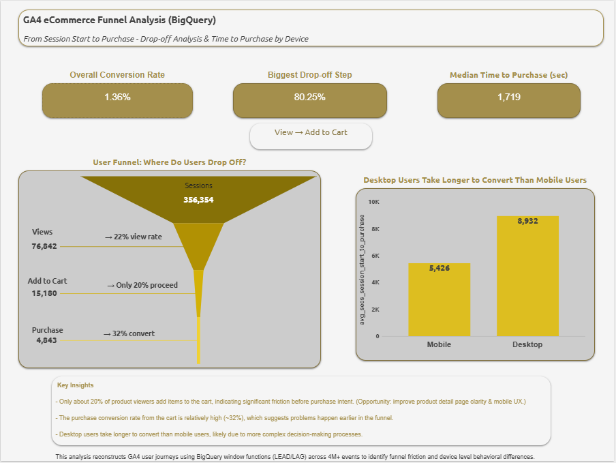
- Image 2: Detailed Event Level Transitions
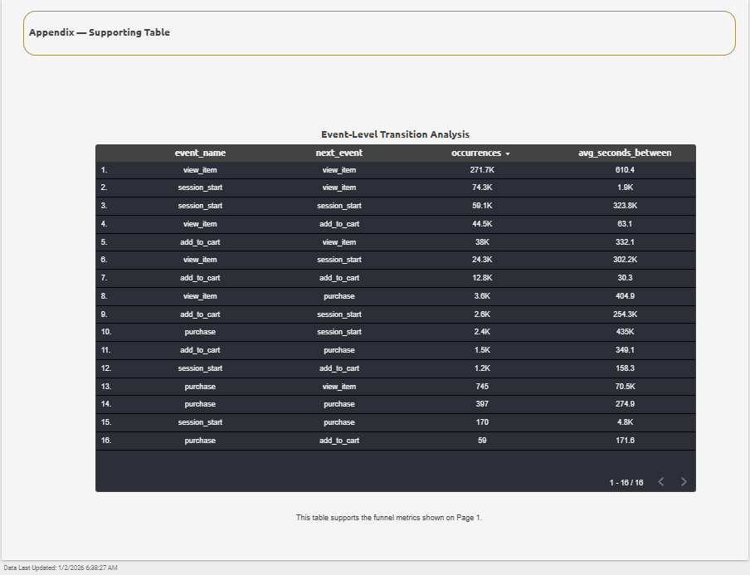
How to Reproduce
- Open BigQuery
- Access the GA4 public dataset
- Run SQL scripts in the /sql folder
- Connect the resulting views to Looker Studio
What I Would Do Next
- Analyze funnel drop-offs by product category
- Add cohort analysis for returning vs. new users
- Validate UX hypotheses through A/B testing
License
This project is licensed under the MIT License.
Contact
Emine Erdogan
- GitHub: @emineerdogane
- LinkedIn: https://www.linkedin.com/in/emine-erdogan/

