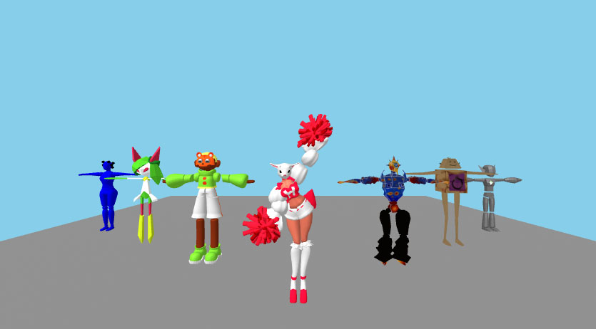

“teach me to dance”
INITIATION TO 3D ANIMATION & SCENOGRAPHY WEB VR/AR

March 25-26-27 _ erasmus program workshop _ENSAAMA, Paris

In a 3-day workshop, discover the possibilities of :
- 3D animation with Blender and
- Web Virtual Reality/ Augmented Reality

Choose one character, animate it and share it, Create a choreography with animated characters
Test in VR with an Oculus headset or in AR with your smartphone.

Students : 2x15 students  Student Prerequisites :  - english level B (language of teaching)  - basics knowledges in :  - code editing  - basics knowledges in HTML/CSS  - basics knowledges in animation or motion design | Softwares : blender, vscode, web browser  Hardware : oculus quest 2/3, smartphones

