WORKSHOP ABAROMA _ 19-20-21 march 2025
INITIATION TO BLENDER ANIMATION AND SCENOGRAPHY IN WEB VR/AR
SHORT PRESENTATION OF THE ENSAAMA ART SCHOOL AND THE NUMERIC DEPARTMENT

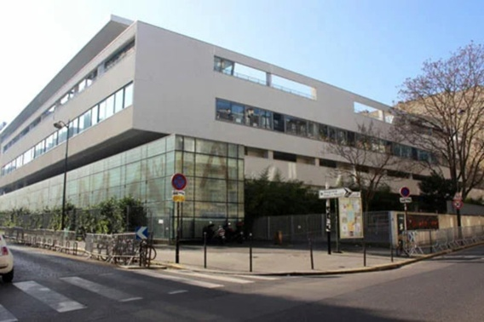 | 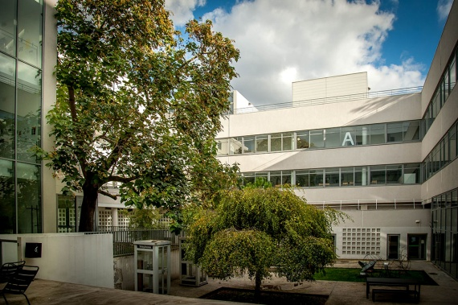 | 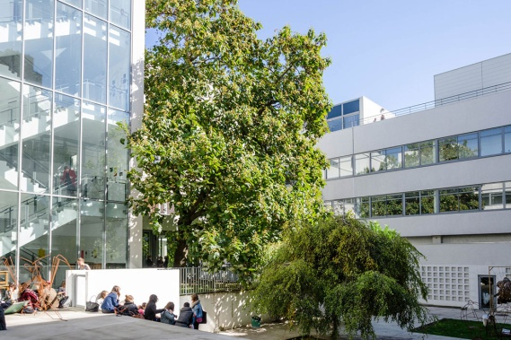

ENSAAMA (public school, 900 students, diplomas Licence/Master, erasmus partnership)
  - https://ensaama.net/site/
  - https://ensaama.net/site/home/formations/dnmade/numerique-expriences-narratives-et-interactives
  - https://ensaama.net/site/home/formations/dsaa/design-numerique
  - https://ensaama.net/site/home/international/genralit-s
  - https://ensaama.net/site/home/international/incoming-students

Positioning the Numeric Department
Difference between Digital and Numeric Design : the paradigms of the Numeric Department

- The premise is that our reality today is as much a physical world as a numeric one
- Numeric is considered as a medium and not a (digital ) media, informational material to be shaped into representations.
  - That’s why prefer “Numeric Design” as “Digital Design”, even if it is not good English

- The position is delicate in a reality in which most digital technologies are used for the benefit of economic liberalism, population control, in commercials, security and military applications.
- The students' projects are designed to denounce these negative virtualities, and even more so to highlight the positive virtualities of the informational medium. This leads to constant critical questioning of the definition and nature of new technologies, as well as the positioning of the Department.

- The approach is therefore more artistic, experimental and critical than design (as applied to industry).
- We borrow from design the notion of the user scenario, but we're closer to the arts and crafts, firstly because creativity comes from the material and the techniques for shaping it, and secondly because we produce the artwork (and not images of what the project should be).An heavy technical training is a prerequisite for the design of digital representations.

- Representations based on 3 types of images:
- captured images (photo, video, 3D scan, etc.)
- created images (3D modeling, rig, animation),
- calculated images (generative design, interactivity).

- The training program is based on 3 strong technological poles (using mostly free softwares except Adobe when it doesn’t exist better alternatives)
- technologies of static and moving images (retouching, post-production, …)
- 3D technologies (modeling, rig, animation with Blender and scan3D and 3D printing)
- programming (generative design, AR-VR, interactivity)

- It's exciting and exhausting too, because it's all happening so fast. The issue of AI is a new big topic !

