Team 10 Documentation

Project Title

Table of Contents

Introduction 1

Materials 1

Instructions 1

Conclusion 1

References 2

# Introduction

Security comes before convenience. Fancy cutting edge home automation devices are no use if they are robbed by illegal break in. Our project starts there. We aim to implement automated home security system which enables consumers to lock and unlock the door by specified keys, turns on the alarm when illegal attempts are detected, locks the door automatically when they forget to lock it by telling if the door is closed.

Our primary focus was to make this practical and usable in real life. You can actually apply this system by replacing door knob to digital one, and save your phone NFC ID to the system by a little tweak in the code.

# Materials

1. NFC tag

Read keys by their UID number

If authorized keys: Blink green light, run servo to unlock the door

If unauthorized keys: Blink red light, turn on the buzzer

2. LED lights

Indicate whether access allowed or not

3. Buzzer

Makes alarming noise

4. Servo motor

Connected to the door knob and actually lock/unlock the door

5. Ultrasonic sensor

Detect the door status by its distance

If the door is closed: Run servo to lock the door

6. Arduino

Puts NFC sensor tag, LED lights, Buzzer, Servo motor, and IR sensor all together and connects them to work interactively.

# Instructions

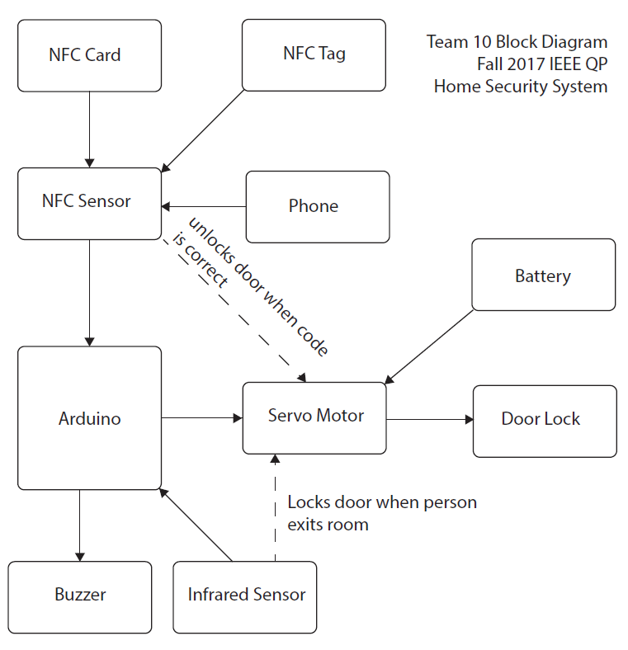

Ultrasonic Sensor

This project is composed of three sections.

1. Getting user input, which is reading the key.

2. Action based on access permission.

3. Detecting door status and unlock it.

Section 1.

When user tags the NFC card, NFC sensor reads the UID of the card. If the UID matches the one saved in the program, the programs gives an access to the user. If not, the program turns on the alarm system.

Section 2.

If access allowed: -Turns on the green light.

- Rotates the servo in order to unlock the door.

If access denied: -Turns on the red light.

- Turns on the buzzer.

Section 3.

Ultrasonic sensor tells if the door is closed or not, by detecting the distance between door and door frame. This is done by converting the pulse into distance. If the door is closed, program automatically rotates the servo and lock the door.

# Conclusion

[Potential improvements]

1. Replace the classic door knob to digital door lock.

2. Add a beam breaker sensor to detect illegal approach.

3. Add other options to unlock the door. (i.e. number pads or fingerprints)

4. Link home AI system (i.e. Alexa) to control the security system.

[Challenges]

1. Buzzer challenge

Initially there were two buzzers, both of which did not work properly. One of them kept making noise while the other one was constantly silent.

-First challenge: Found out that the consistently silent buzzer was short-circuited.

-Second challenge: Found out that resistor was not strong enough to make the buzzer silent.

2. Motor challenge

Motor did not move when tried to rotate the motor back to its original position.

-Found out that the motor function in Arduino library is based on absolute position.

3. Mechanical construction

It was another challenge to build the actual door and stick all the parts, especially connecting servo and door lock.

-First we tried out with wires, but wires were not strong enough to pull the lever back.

-Next we tried popsicle sticks based on the principle of gravity. But the popsicle stick was not heavy enough to fall back.

-Then we tried out with paper clips, attaching one to the door knob and connecting it with other stretched out clips which are connected to the servo. But the motor was not strong enough to rotate the lever.

-We came back to popsicle stick, this time pushing and pulling it by stretched out paper clips. When the door is unlocked, servo pushes up the paper clip which then consecutively pushes up the popsicle stick attached on the door knob.

When the door is locked, servo pulls back the paper clip, then the popsicle stick automatically drops down by gravity.

[Victories]

1. Successfully synchronizing software and hardware

-LED, Buzzer, Sensor and Motor all work correspondingly to the code.

2. Successfully putting all the parts together

-Built a wooden model door in order to make the demonstration more clear to see.

-3D printed the Arduino case in order to keep it organized.

-Soldered all the wires neatly on thin breadboard.

[Role distribution]

Personal focus:

Esther Soyoung kang: Writing code on reading NFC card and following actions.

Antony Nguyen: Writing code on reading Ultrasonic sensor and following actions.

Jianing Zhang: Building circuits and wiring.

Cooperation:

Brainstorming

Testing parts

Combining codes and Arduino

Building demo models

# References

NFC library: <https://github.com/miguelbalboa/rfid>

Referred to his ‘DumpInfo’ example to read the UID of the NFC cards.