CMPE 230
Systems Programming
Project #3

Name: Emin Şenay
Student ID: 2002103907
Instructor: Can Özturan
Assistant: Ali Haydar Özer

Design Document

Introduction
This software document is prepared to explain the first two questions of CMPE230 PROJECT #3 and answers of the remaining questions. First I will explain the CGI project, and then assembly project.

Problem 1

The program uses CGI.pm module to parse the input and Fcntl module to lock the file to prevent corruption of the file. It takes one parameter from the user, “name”. To cope with Turkish characters, the header and the start_html functions have characterset and encoding parameters, respectively. The program opens and then locks the file “last100.txt” which contains the old data. The file is stored in /tmp to prevent possible permission problems in some systems. First, name field and then IP field is stored in the file. There are commas between each separate information. After getting old names and IP’s from the file, the file is unlocked and closed. Then the information taken from the file is split and taken to @addresses. The program may need to write to the file later. But then the lock time of the file will get longer, which is undesired for internet programs. Therefore, if program needs to write to file, it will reopen it again. If a parameter is given to the program, the name and IP of the client, which is taken from environment variables, are unshifted to @addresses. Then this array is written to screen in table. Lastly, if any parameter is given to the program, the input file should be updated. Instead of updating, the program recreates the file and writes first 200 elements in the array. The program is recreating the file because writing first 200 elements to a file is the best solution. The other solutions would have to cope with the remaining elements in the file, if there are more than 200 elements of course, and the file size will always get larger. While updating the file, again file is locked. The program finishes with end_html function to end the html file.

Sample Output

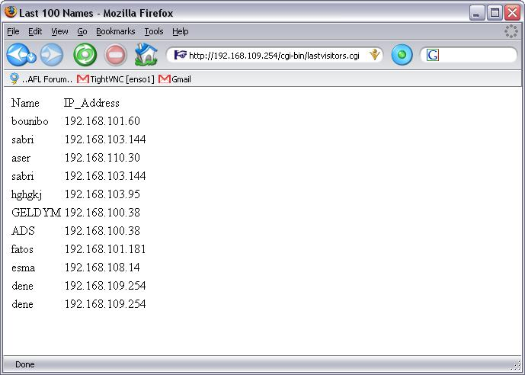

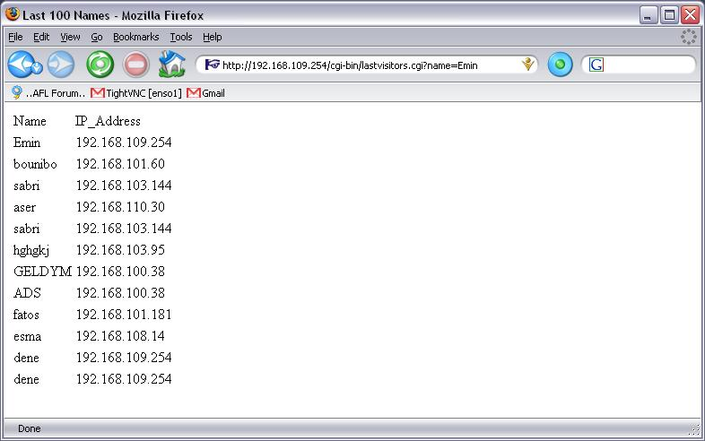

Problem 2

I will first overview what I have done generally, and then I will try to explain labels.
Program first prints the message “Please enter your strings:” by printmsg part. Then it gets first string character by character with readstr part using bp and si. The memory address of the beginning character is then moved to bx. After that, program gets second string again by readstr part. The memory address of the beginning character of the second string is now in bp. After taking strings, program searches second string in first by srcocc part, prints “y” or “n” and exits.

printmsg and msgloop

First 02h is moved to ah for 21st interrupt. Base pointer is pointing to the string to be written. Using dl, bp, si and 21st interrupt, all characters are printed to the screen until the 0h character. If 0h is found, the program jumps to endmsg part.

endmsg

Simply returns.

readstr

First, 01h is moved to ah for 21st interrupt. Base pointer points the beginning address of the free memory. Using bp and si, characters are read from screen with 21st interrupt. For all new characters, si is incremented 1 and the new character is read to [bp+si]. After taking the character from the screen, it is compared with enter or space to check the end of the string. If the character is enter or space, endstr is called. Otherwise, new character is taken from the screen recursively.

endstr

This part firstly adds enter character at the end of the string and then returns. The program uses the enter character to understand the end of the string. Enter character is chosen because given strings could not include this character, so when enter character is seen, it can only be the end of the string.

srcocc

This part is the main part of the program. It searches the occurrence of the second string in first. The algorithm is simple: Two strings are compared character by character. If first characters are equal, program compares the next character. If they are not equal, this process is started from the next character of first string. Somewhere in the process, the end of the first or second string will come. If the end of the first string comes, it means that searched string is not found. If the end of the second string is comes, it means that searched string is found. Now, I will explain how this algorithm is done by assembly:
It is known that the beginning address of the first string is stored in bx, and the beginning address of the second string is stored in bp. si is 0 at the beginning. The program first compares the [bp+si] to 0dh (enter character,which means string has ended). If they are equal, it jumps the matched part. Then it compares the [bx+si] to 0dh. If they are equal, it jumps the notmatced part. Then [bp+si] is compared with [bx+si]. To compare them, we need to use a register because two memory addresses cannot be compared instantaneously. al register is used for comparing them. If they are equal, program jumps the equal part, otherwise program jumps the notequal part.

equal

This part increments si to check the next character. Then it jumps the srcocc part again.

notequal

This part increments bx and sets 0 to si to repeat the process beginning from the next character of the first string. Then it jumps to the srcocc.

matched

This part is called when searched string is found in the first string. The aim is to print “y”. First, newline is printed by newline part, moving bp to beginning address of the string which contains ‘y’ and 0h, then it prints ‘y’ by using printmsg part. Lastly, it calls finish to end the program.

notmatched

This part is called when searched string is not found in the first string. The aim is to print “n”. So, all the things in matched are done with a difference of printing ‘n’.

newline

This part is used to print newline. Since there are two corresponding ASCII characters for newline, both of them are printed to the screen using 21st DOS interrupt.

finish

It calls the 20st DOS interrupt to end the program and exit to DOS.

Sample Output

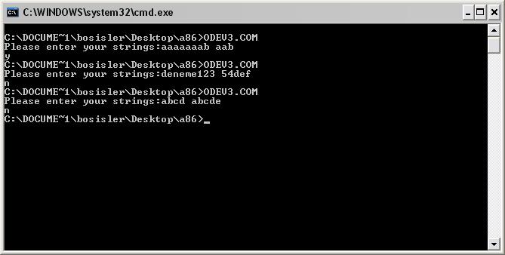

Problem 3

code segment
mov bx,number
mov di,2
mov si,10h
formatloop:
mov ax,[bx]
xor dx,dx
push 20h
mov cx,1d
more:
div si
cmp dl,0ah
jb digit
letter:
sub dl,0ah
add dl,"A"
jmp enddigit
digit:
add dl,"0"
enddigit:
push dx
inc cx
xor dx,dx
cmp ax,0h
jne more
writeloop:
pop dx
mov ah,02h
int 21h
dec cx
jnz writeloop
mov si,2d
dec di
jnz formatloop
progfinish:
int 20h
number:
dw 255d
code ends

Probem 4

#include<stdio.h>
func(int a,int b){
int c;
c=a+b+10;
printf("Value is %d\n",c);
}
main(){
int a,b;
a=3;
b=4;
func(a,b);
}

Problem 5

.file "1.c"
.text
.globl func
.type func,@function
func:
pushl %ebp
movl %esp,%ebp
subl $12, %esp
movl $-4, -4(%ebp) ;a=-4; //int
movl $-8, -8(%ebp) ;b=-8; //int
movl -8(%ebp), %eax ;c=a+b; //int
addl -4(%ebp), %eax
movl %eax, -12(%ebp)
leave
ret
.Lfe1:
.size func,.Lfe1-func
.globl main
.type main,@function
main:
pushl %ebp
movl %esp, %ebp
subl $8, %esp
andl $-16, %esp
movl $0, %eax
subl %eax, %esp
movw $-4, -2(%ebp) ;short x=-4;
call func
leave
ret
.Lfe2:
.size main,.Lfe2-main
.ident "GCC: (GNU) 3.2.2 20020222 (Red Hat Linux 3.2.2-5)"

Note: There is no d=c+a part. d is not used anywhere after assignment. GCC understands that and does not generate any assembly code for d.

Memory Layout
High address
Environment variables
STACK
x -- 4
func() activation records
a -- -4
b -- -8
c -- -12
Machine instructions of the code
Low address

Note: There are no initialized or uninitialized global variables, and there is no dynamic data. Therefore, HEAP and parts for global variables are not drawn.

