CmpE 321 Project #1

Paper Design of a Simple Storage Manager
for a DBMS

INSTRUCTOR | Taflan I. Gündem
STUDENT | Emin Şenay
STUDENT ID | 2002103907
YEAR | 2006/2nd Term

Contents

1. Introduction 3
1.1 Purpose 3
1.2 Summary 3
2. Data Structures 4
2.1 System Catalog 4
2.2 Table Format 5
2.3 Record Format 6
2.4 Page Format 6
2.4.1 Header_Page 6
2.4.2 Data_Page 7
3. Algorithms of Basic Operations 8
3.1 Table Operations 8
3.1.1 Create a Table 8
3.1.2 Delete a Table 9
3.1.3 List All the Tables in the Database 10
3.2 Record Operations 10
3.2.1 Insert a Record 10
3.2.2 Delete a Record According to the Primary Key 11
3.2.3 List all records in a specified table 12
3.2.4 Search for a Record According to the Primary Key Field 12
4. Conclusion 15

Introduction

Purpose
This document is about the design of a simple storage manager for a DBMS and it gives the necessary information about the storage manager. The document can be divided into four categories. These are:
    - Assumptions and brief summary of the work
    - Data structures which were used in storage manager
    - Algorithms of basic operations
    - Conclusion, i.e. evaluation of the work done

Summary
The brief summary of the storage manager will be given here. The storage manager does all the operations given below:

Table Operations:
    - Create a table of a certain type (fields of the table and the primary key will be determined by the user)
    - Delete a table.
    - List all the tables in the database.
Record Operations:
    - Insert a record to a specified table.
    - Delete a record according to the primary key from a specified table.
    - List all records in a specified table.
    - Search for a record according to the primary key field.
The names of the commands are not given in the project specification, so the programmer must decide them. There is no paging system for simplicity. Each database is stored in a separate folder, and there are two folders in the root folder of the database. These are header and data which contains the header file header.dat and the tablename.dat for all different tables of the database, respectively. Header.dat stores the general information about the tables and the database, and tablename.dat stores all necessary information for the table. The files are stored in binary format instead of sequential. This is for opening and reading random parts of files easily. The format of these files will be explained in next section.
For simplicity, all table and field names are assumed to be maximum 20 letters length. Also, all records are assumed to be character arrays containing 20 characters and there are at most 10 fields in a record. This length constraint is not really a constraint for end users; most of the time, they won’t be using tables more than 20 characters or working with records with more than 20 characters. Also, the probability that a user, who will use this simple storage manager, will work on records with more than 10 fields is very low. On the other hand, it really helps the implementation of the paging system, details of which will also be given in the next section.
There is no restriction on the maximum number of databases, tables and records.
The page size is a predetermined constant, 4096 bytes. This is again for simplicity of the algorithms. However, one can change some places of the algorithms and therefore can change the size of the page easily. The paging mechanism is implemented by requesting the pages needed from the disk, one or more at a time.
There are some input checking mechanisms that the storage manager does. First of all, all inputs related to constraints will be checked by the program, such as the length of the string given as a table name. Also, the commands entered to the program will be checked and necessary action will be done. For example, if user wants to delete a table which is not in the database, he will be notified.
These table or field names are equivalent in the project:
“ Name”
“Name”
“Name “
“ Name “
Space characters are not counted as a differentiator of the names.

Data Structures

Data structures used in the whole program will be explained in this section. These are:

- System catalog
- Table Format
- Record Format
- Page Format

System Catalog

As stated before, the system catalog is stored in a binary file called Header.dat in the Header folder. There is a page structure called Header_Page which is used to get the necessary information about the system catalog from Header.dat. Some of the fields in the system catalog are about this page organization, and they will be explained in Page Format part. The structure of the header file is illustrated in the following figure:

Number of Tables in Page | Number of Tables in Database | isEmpty | isFull
TableInfo[0]: | TableName | isFull
TableInfo[1]
TableInfo[2]
TableInfo[3]
TableInfo[4]
.
.
.
TableInfo[n-1]

Number of Tables in Page: An integer which stores the number of tables in current page.

Number of Tables in Database: An integer which stores the number of tables in the entire database.

isEmpty: A Boolean which keeps information about the current page.

isFull: A Boolean which keeps information about the current page.

Tables: An array which keeps information about the tables. Its elements are in TableInfo type. The size of the array is a fixed constant according to the page size. Since the page size is fixed as 4096 bytes, n is approximately 194 (calculated with the assumption that char = 2 bytes, int = 4 bytes, Boolean = 1 byte, which can change with the operating system and the programming language). The elements of this type are as follows:
TableName: Character array which stores the name of the table.
isFull: A Boolean which keeps information about the table. If false, this means that the current TableInfo field is empty. This variable is for deleting the table from the catalog logically and again helps to speed up the table deletion algorithm.

Table Format

Each table has its own binary file, tablename.dat. This file stores all the information about the current table, its records and fields. There is a page structure called Data_Page which is used to get the necessary information about the system catalog from tablename.dat. Some of the fields in table information files about the page structure, and they will be explained in Page Format part. The structure of the table format is illustrated in the following figure:

Number of Records in Table | Number of Records in Page | Primary Key | isEmpty | isFull | Number of Fields in Table
Field Names: | Field Name 1 | Field Name 2 | … |  |  | Field Name 10
Record[0] | isFull | Field Value 1 | Field Value 2 | … |  | Field Value 10
Record[1]
Record[2]
.
.
.
Record[m-1]

Number of Records in Table: An integer which stores the number of records in the entire table.

Number of Records in Page: An integer which stores the number of records in the current page.

Primary Key: An integer which stores the place of the primary key in the Field Names array.

isEmpty: A Boolean which keeps information about the current data page.

isFull: A Boolean which keeps information about the current data page.

Field Names: An array of character arrays, which stores the names of the fields. There can be at most 10 fields in the table. If there is less, remaining places will be empty. Also, field names can be at most 20 characters length. The length of the field names are also fixed, i.e. if the name of the field is less than 20 characters, space characters will be added to the end of the field to fix the field name with 20 characters.

Number of Fields in Table: An integer which stores the number of initialized fields.

Records: A Record array which stores information about the fields of the tables. The page size is fixed as 4096 bytes, so m is approximately 18. The calculation is the same as the calculation of n in the Tables array in the system catalog.

Record Format

The elements of the Record are as follows:

isFull: A Boolean which stores information about the record being empty. If false, it means that these fields are empty. It is useful to logically delete a field from the table.

Field Value 1…10: Character arrays which store the values of the fields. Length of the data which will be stored in the field can be at most 20 characters. Also, if the value of the field is less than 20 characters, space characters will be added to the end of the field to fix the field value with 20 characters.

Page Format

There are two types of page in the project. One of them is for header file and the other is for table files. Both of them read 4096 bytes from the disk, so they are same for the disk; however the data in pages are different. Both page structures are explained below.

Header_Page

The basic figure of the Header_Page is shown below:

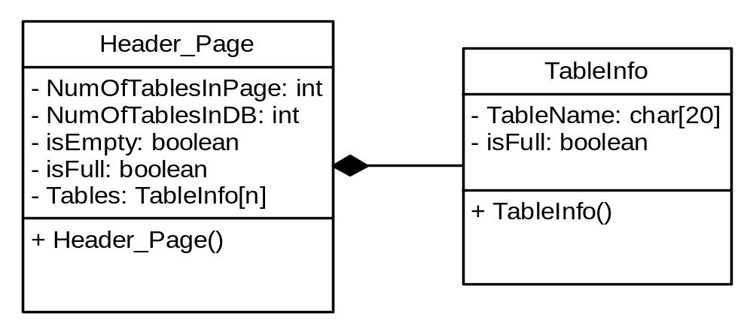

The variables in the header page were explained in the system catalog; however additional information related to the pages was left here. Now, it will be explained one by one.

NumOfTablesInPage: If the header page is too big to fit in one page, an additional page is allocated to the header page and this field stores the number of tables of only the page it is belonging to.

NumOfTablesInDB: If the system catalog never exceeds one page size, this number is equal to the number of tables in database. Otherwise, it may or may not be.

isEmpty: If true that means the current Header_Page is empty, i.e. there is no table information stored in this page. This variable helps to speed up the search used in some of the algorithms.

isFull: If true that means all of the TableInfo fields of the current page is full. This is again to speed up some algorithms used to satisfy the operations which were stated in the specification.

There is some redundancy in this page format. Actually, there is no need to repeat the variable NumOfTablesInDB, since it will be the same for all pages. However, the basic idea is to unify the Header_Page format here, if that variable would not be repeated in all pages, there will be two Header_Page formats and this would need extra controls and bring extra difficulty to the programmer.

Data_Page

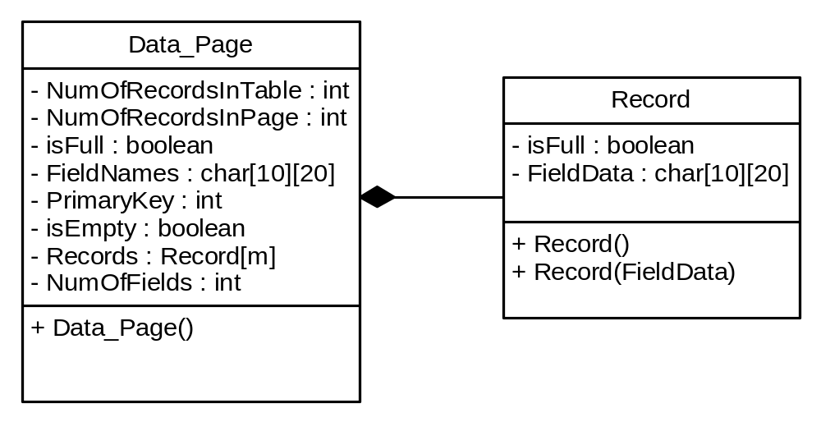

All variables in the data page were explained in table format and record format parts. The information related to pages will again be stated here.

NumOfRecordsInTable: If the records in the table never exceed one page size, this number is equal to the number of records in page. Otherwise it may or may not be.

NumOfRecordsInPage: If there are more records in the table than in one page, then the next free page is used for storing extra records. If there is no free page available, additional 4 data pages are allocated for the file. This field stores the number of records of only the page it is belonging to.

isFull: If all records in the record array are full, then this value will be true. It is for speeding up some functions in the implementation of this storage manager.

isEmpty: If true that means the current Data_Page is empty, i.e. there are no records in this page. It is used for speeding some functions like isFull variable.

There is some redundancy in this page format like in the Header_Page. The details are almost the same, however this time more data variables are being repeated each time. These are NumOfRecordsInTable and FieldNames.

Usually, only one instance at a time is read from the disk both for data page and the table page. However, if the operation needs to list all records all tables, then all pages are read once. For this reason, the linked list structure is used for reaching all these pages. The figure of this structure is shown below:
Pages
Pointers to Next Pages

Algorithms of Basic Operations

Table Operations

Create a Table

Ask the name of the table;
//checking the length of the table
if (tablename.length > 20)
error;
else
// Convert the string into character array and add necessary space characters
convert(tablename);
// Open the file and read the entire file
open(Header.dat);
Create Header_Page linklist;
while (!EndOfFile)
linklist.next_elem = read(Header.dat);

for (i = 0; i < linklist.length ; i++)
// Search the name of the table in the list of the tables created before
// If there is already a table with the specified name, give error
if (Search(tablename,TableInfo) == true)
error;
// Search the TableInfo of all pages and try to find an empty TableInfo place
if (search(empty TableInfo place ,TableInfo) == false)
Create a new page;
else
T_Info = empty TableInfo place;

Ask Field names and the primary key
// checking the field names
for each fieldname
if (fieldname.length > 20)
error
// Convert the field name strings into character arrays and add necessary space characters
for each fieldname
convert(fieldname);
// Check if the names of the fields are different from each other
if (checknames(fieldname) == true)
error;

// Write the name of the table to the header page
T-Info = tablename
// Increment the number of table variables
NumOfTablesInDB++;
NumOfTablesInPage++;
// Check if the page become full with the new table
if (NumOfTablesInPage == n)
isFull = true;

// Create tablename.dat and fill the necessary places
create(tablename.dat)
// Create 8 pages for efficiency
create pagearr = Data_Page[8];
for (i = 1 to 8)
pagearr[i] = create data_page;
fill(fields of the table);
write(tablename.dat);

Delete a Table

Ask the name of the table;
open(header.dat);
create(Header_Page);
while (1)
// If end of file has been reached, this means
// there doesn't exist a tablename given by the user.
if ((Header_Page = read(header.dat)) == EOF)
print (error);
break;
// Search the name of the table in the list of the tables created before
// If found, delete the table and exit the loop
if (Search(tablename,TableInfo) == true)
// Logically delete, x is the place of the tablename in the array
TableInfo[x].isFull = false;
// Decrement the number of tables
NumOfTablesInDB--;
NumOfTablesInPage--;
break;
change the tablename.dat to tablename.old;

List All the Tables in the Database

Open(Header.dat);
create Header_page linklist;
while (!EndOfFile)
linklist.next_elem = read(Header.dat);
for (i = 0; i < linklist.size; i++)
for (j = 0; j < n; j++)
if (linklist[i].TableInfo[j].isFull == true)
print (linklist[i].TableInfo[j].TableName);

Record Operations

Insert a Record

Ask the name of the table;
Ask the data to be entered;
Ask the Primary Key;
// Check if the given data obey the constraints
if (tablename.length > 20 or data.field[x].name.length > 20 or x > NumOf Fields)
error;
// Check if specified tablename exists in the database
open(header.dat);
create(Header_Page);
while (1)
// If end of file has been reached, this means
// there doesn't exist a tablename given by the user.
if ((Header_Page = read(header.dat)) == EOF)
error;
// Search the name of the table in the list of the tables created before
if (Search(tablename,TableInfo) == true)
break;

// Check Primary Key exists in the previous records
// Primary Key must be unique
open(tablename.dat)
create Data_Page linklist;
while (!EndOfFile)
linklist.next_elem = read(tablename.dat);
for (i = 0; i < linklist.length; i++)
for (j = 0; j < m; j++)
if (linklist.Records[j].primary_key == Primary_Key)
error;
// Check is complete, now enter the data
// Search the Records of all pages and try to find an empty Record place
if (search(empty TableInfo place ,TableInfo) == false)
Create 8 new pages;
Rec = empty Record place;
Rec = Entered fields;
NumOfRecordsInTable++;
NumOfRecordsInPage++;
write(tablename.dat,changedpages);
if (NumOfRecordsInPage == m)
isFull = true;

Delete a Record According to the Primary Key

Ask the name of the table;
Ask the primary key value;
if (tablename.length > 20 or primarykey.length > 20)
error;
// Check if specified tablename exists in the database
open(header.dat);
create(Header_Page);
while (1)
// If end of file has been reached, this means
// there doesn't exist a tablename given by the user.
if ((Header_Page = read(header.dat)) == EOF)
error;
// Search the name of the table in the list of the tables created before
if (Search(tablename,TableInfo) == true)
break;
open(tablename.dat);
create(Data_Page);
// Try to find the entered primary key by
// reading from the file one page at a time
while (!EndOfFile)
Data_Page = read(tablename.dat);
for (i = 0; i < linklist.length; i++)
for (j = 0; j < m; j++)
if (linklist.Records[j].primary_key == Primary_Key)
// if found, logically delete the record and break
linklist.Records[j].isFull == false;
NumOfRecordsInTable--;
NumOfRecordsInPage--;
if (NumOfRecordsInPage == 0)
isEmpty = true;
break;

List all records in a specified table

Ask the name of the table;
if (tablename.length > 20)
error;
// Check if specified tablename exists in the database
open(header.dat);
create(Header_Page);
while (1)
// If end of file has been reached, this means
// there doesn't exist a tablename given by the user.
if ((Header_Page = read(header.dat)) == EOF)
error;
// Search the name of the table in the list of the tables created before
if (Search(tablename,TableInfo) == true)
break;

open(tablename.dat)
create Data_Page linklist;
while (!EndOfFile)
linklist.next_elem = read(tablename.dat);

//Print all non-empty records
for(i = 0; i < linklist.length; i++)
for (j = 0; j < NumOfFields; j++)
if (linklist[i].Records[j].isFull == true)
print fields;

Search for a Record According to the Primary Key Field

Ask the name of the table;
Ask the Primary Key value;
if (tablename.length > 20 or Primary_Key.length > 20)
error;
// Check if specified tablename exists in the database
open(header.dat);
create(Header_Page);
while (1)
// If end of file has been reached, this means
// there doesn't exist a tablename given by the user.
if ((Header_Page = read(header.dat)) == EOF)
error;
// Search the name of the table in the list of the tables created before
if (Search(tablename,TableInfo) == true)
break;

found = false;
// Try to find the entered primary key by
// reading from the file one page at a time
while (!EndOfFile)
Data_Page = read(tablename.dat);
for (i = 0; i < linklist.length; i++)
for (j = 0; j < m; j++)
if (linklist.Records[j].primary_key == Primary_Key)
// if found, print the record and break
print(fields);
found = true;
break;

if (!found)
print ("Cannot be found");
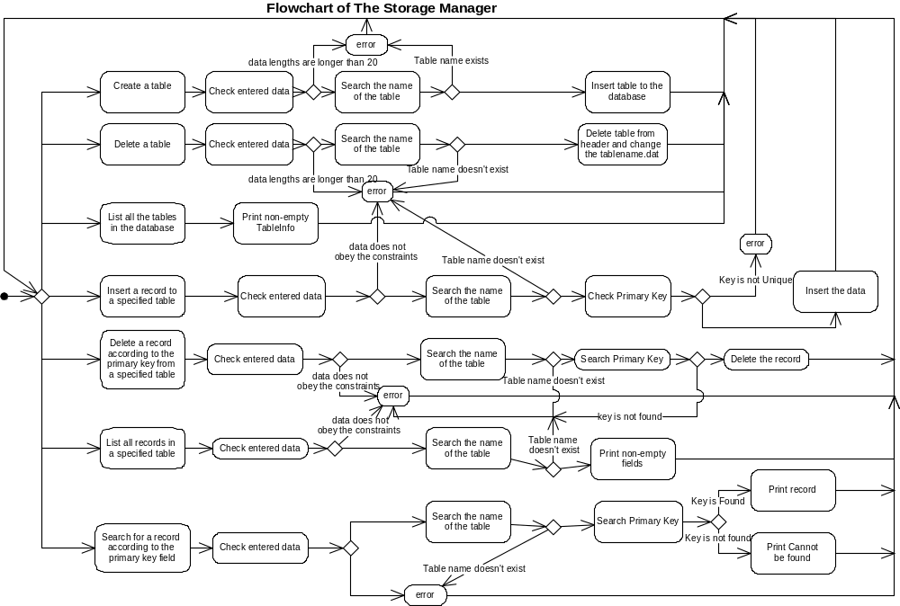

Conclusion

This part of the document describes the design choices of a simple storage manager for a DBMS.
The first major choice is using 2 different folders for the header and table files and using separate files for each table. The reason to create folders is that one can enter the name “header” with this method. If header file and the files of the tables are in one folder, either there will be confusion when user wants to create a table “header” or the system will check the table name and assures that the table name is not header. As a result, unnecessary constraint would be added. All tables are in different files, because with this method locating the start of any table in the database is very easy. If all of the tables were stored in one file, the program needs to traverse the file to find the start of a specified table. This would cause extra disk accesses, which slows down the performance of the system.
The second design choice is to set the maximum length of the fields and table names. This choice is explained in the first part, so it is skipped.
The third design choice is about the system catalog. As it can be understood from the number of fields, the system catalog stores only the general information about the current database. This is because of the fact that it is used very frequently. If there were more information about the database, this might help in some algorithms; however it would also increase the size of the table information. With the same number of tables, second design would need more pages to store the information. This would increase the number of disk accesses, and clearly decrease the performance of the system.
The fourth design choice is about the page format. It is about the redundancy, which is explained in part 2. In addition to all explanation given there, I need to clarify one point: Although there are some repeated places in the file, only the first one is initialized and used in the algorithms. So, performance does not decrease because of initializing or changing the same places for all pages.
Another design choice is about creating new table. When the table is first created, 8 pages are allocated and written to file. This is for storing most of the pages of one table in the same track in the disk. With this method, seek time of the disk is reduced when more than one page is needed at once. In search parts of some algorithms, all pages of the file are needed. The program reads all of them at once. Although the program needs more memory than reading one page at a time, it is known that most probably the pages are in the same track, so i/o time reduces.
The last major design choice is about indexing. The storage manager system does not use indexing. Without indexing, especially performance of search parts of the algorithms slows down. However, the writability of the code of the system increases, i.e. a programmer can write the code of this system easier than the system which uses indexing. Also, this system is a simple system and the major slow-down of the search parts are encountered when the database gets larger. It is assumed that the users of this system will not use very large databases.

